Monthly Report

Center Name | Alzahraa Medical Center (AMC)
Prepared by: | Youssef K. Aouli
Name of Coordinator / Manager:  Name, email, and phone | Name: Youssef K. Aouli  Phone Number : +961 3041125 Email : Health.PM@aica-lb.org
Reporting period  From – To | From first of January 2024 to end of January 2024

Management Update:

)Administrative decisions , new projects…)
- It is expected to sign a new project for a period of five months with Relief International in partnership with MoPH funded by UNICEF, The content of the project on vaccines for dropout children, in addition to the awareness session for PNC and ANC

Department Update:

(numb of ben, services, activity implemented on filed ….)

AMC is a Primary health care center located between Mankoubin& Jabal Mohsen- Tripoli operating under AICA. In partnership with MoPH, the center was established in November 2008 as a dispensary based on the gap in healthcare provision within the community and has evolved since then into a Primary Health Care Center in late 2016.The center has established a partnership with MoSA as of 2011 and has undergone several partnerships with Médecins Sans Frontières (2012 – 2017), Relief International (2017), and other two active partnerships with YMCA(2008)&Première Urgence – Aide Médicale Internationale(PU-AMI 2019 - 2023). AMC receives patients without any discrimination in gender, color, race, or religion providing general and specialist examination for minimal fees as well as free medicines, chronic medications and vaccination in addition to a bundle of health services. The center receives an average of 7000 beneficiaries / month visiting from different areas within the North governorate. Since the pandemic, AMC developed an emergency plan partnering with CRS to serve better the community.

● Activity 1: We kept all services at a price supported by AICA, as the GP Consultation became 200,000 LBP and the specialty consultation 400,000 LBP.
● Activity 2: All our work has become related to the ODOO system
● Activity 3: The vaccine project supported by UNICEF is still ongoing
● Activity 4: We launched a home care nursing training project, for 90 beneficiaries supported by World Vision in Lebanon
● Activity 5: Dispensing Medicines: The prescription that is given to the patient by the doctor in the center is given to the pharmacist to prepare and dispense it immediately. Each medication has a label indicating appropriate indication, use, administration, and timing. In addition, applications are submitted for patients suffering from chronic diseases to benefit from the Young Men's Christian Program in cooperation with the Ministry of Health, which provides chronic medicines for free.
● Activity 6: The Challenge of Achieving the Goal: We have a great challenge ahead of us in terms of the large number of services, the large number of patients, and the need to provide services to all.
● Activity 7: Relying on high quality standards.

Finance Update:
(Finance request – donation …. Payments)

Action plan for next Month:

Activities | Description of the activity | Modality (value, frequency…) | Location of activities | Number of Target Group
Activity 1: | Contact patients to book an appointment in advance | For all heart and diabetic patients who did not visit the doctor for more than 6 month and who suffer from chronic diseases | AMC | All referred patients
Activity 2: | Contacting patients to book an appointment in advance | People who are entitled to receive chronic medication | Pharmacy in AMC | All Medication (MOPH, PU-AMI, YMCA, and other donor)
Activity 3: | Prepare the patient to reduce waiting time | The patient enters the triage room, and all information is taken (vital signs, ECG, medications he uses...) and then he is given a number to ensure his turn. | Triage room in AMC | All patients who come
Activity 4: | Create New number For Vaccination | Contacting all children for whom the vaccine has become available | Vaccination room in AMC | All patients who come between (0 – 18Y)
Activity 5: | Training 90 beneficiaries, on home care nursing training, divided into 3 groups for 22 days | Within specific indicator | AICA Social Hall | Between 15 and 45 Year

Challenges
Overview of any challenges encountered during the reporting period and how they were tackled
Challenge(s) | Response(s)
Accreditation | Multiple and expensive requirements
We need a INGO to ensure the continuity of our center | We strive through our practical and personal relationship to network with international NGO to support the center

Monitoring
Indicators | Number achieved during the reporting period | Overall target | Progress towards target
Health activity 1: Services | 2,206 | 6,000 | 36.76%
Health activity 2: Individuals (with duplication) who benefited from services, disaggregation between male and female. | Female: 1,315  Male: 891 | Female: 3,000  Male: 3,000 | Female: 43.83%  Male: 29.7%
Health activity 3: Individuals who benefited from medication chronic | 490 | 1010 | 48.51 %

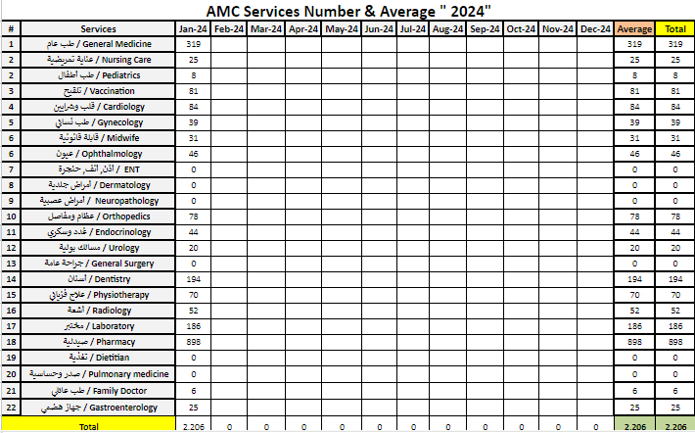

Monitoring tools used (satisfaction surveys, discussions with beneficiaries…) | Sample size | Primary findings from these tools | Actions taken/to be taken in response to these findings
Complaints Box | 13 | The papers were numbered and sorted according to their types, and divided as follows: (complaints - compliments and a canceled paper)  The first section included a category of complaints. Each complaint was dealt with objectively and was addressed by the concerned party. The beneficiaries were also contacted by phone and given a “full” clarification of the matter regarding their complaint. If they had any other inquiries, they should contact us to provide them with the required information and listen to them.  The second section included a category of compliments. The beneficiaries were thanked for their good opinions about the services provided at the center. If they have any other inquiries, they should contact us to provide them with the required information and listen to them.  As for the canceled paper, it has been cancelled. | Each complaint was dealt with objectively and was addressed by the concerned party. The beneficiaries were also contacted by phone and given a “full” clarification of the matter regarding their complaint.
Hot line | 0 | N/A | N/A
Individual interviews. | 15 | -Long waiting period for appointments.  - High cost about fees of consultation  -There should be more Gynecologist doctors.  -There should be more pediatric doctors.  - The presence of more specialist doctors... | - Odoo System for appointments  - Search for INGO to support fees of consultation
Beneficiaries Satisfactory | 0 | N/A | N/A

Coordination and communication

Please list any coordination meetings or communication with national response actors (Government of Lebanon, municipalities, local community, FGOs, INGOs…)
Date [dd/mm/yyyy] | Response actor | Type of coordination [meeting, email, phone call] and purpose
2,4,9,17 – January – 2024 | The Alawite Islamic Council – Sheikh Ahmad Assi | To coordinate with the MoPH to support the center
5 – January – 2024 | WVL – Dima Moussa | About Home care nursing training project
7 – January - 2024 | MSF - Field | About new support
11 – January - 2024 | UNHCR – Farah Malayani | Health Sector Meeting
22 – December – 2023 | MOPH – Chantal Lichaa | About New INGO to support our center

Annex II: Success Story

(About your team activity, or may be from beneficiary or good implementation for activity …)

It was nice to follow up with the beneficiaries by calling them and booking appointments to check on their health, and this was expressed by the beneficiaries that they are being taken care of despite all the adversities and circumstances we are going through. In the end, this remains our work that we always strive to improve.

