 Monthly Report

|  |  |
| --- | --- |
| Center Name | Alzahraa Medical Center (AMC) |
| Prepared by: | Youssef K. Aouli |
| Name of Coordinator / Manager:  *Name, email, and phone* | Name: Youssef K. Aouli  Phone Number : +961 3041125 Email : Health.Pm@aica-lb.org |
| Reporting period  *From – To* | From 1st of February 2023 to 28th of February 2023 |

# Management Update:

)Administrative decisions , new projects…)

# Department Update:

(numb of ben, services, activity implemented on filed ….)

AMC is a Primary health care center located between Mankoubin& Jabal Mohsen- Tripoli operating under AICA. In partnership with MoPH, the center was established in November 2008 as a dispensary based on the gap in healthcare provision within the community and has evolved since then into a Primary Health Care Center in late 2016.The center has established a partnership with MoSA as of 2011 and has undergone several partnerships with Médecins Sans Frontières (2012 – 2017), Relief International (2017), and other two active partnerships with YMCA(2008)&Première Urgence – Aide Médicale Internationale(PU-AMI 2019). AMC receives patients without any discrimination in gender, color, race, or religion providing general and specialist examination for minimal fees as well as free medicines, chronic medications and vaccination in addition to a bundle of health services. The center receives an average of 6000 beneficiaries / month visiting from different areas within the North governorate. Since the pandemic, AMC developed an emergency plan partnering with CRS to serve better the community.

* **Activity 1:** Focusing on providing vaccines that are provided free of charge by the Ministry of Health and strengthening children's immunity.
* **Activity 2:** The children's parents are contacted to remind them of the need to take vaccinations and book an appointment for them in advance. When there are any symptoms (fever, pain...) they are referred to the pediatrician
* **Activity 3:** Examination of sick children by the pediatrician, after which a medicine is prescribed that, can be used from the center's pharmacy for free.

**Activity 4:** It was agreed with the PU-AMI to cover the expenses general medicine consultation only, to ensure that vulnerable and marginalized groups have access to medicines that have become a burden on them.

**Activity 5:** Dispensing Medicines: The prescription given to the patient by the doctor at the center is given to the pharmacist to prepare and dispense it immediately. Each drug has a label for indication, use, administration, and appropriate timing. In addition, applications are submitted for patients suffering from chronic diseases to benefit from the Young Men’s Christian Program in cooperation with the Ministry of Health, which provides chronic medicines for free.

* **Activity 6:** The Challenge of Targeted Achievement: We have a great challenge in terms of the large number of services, the large number of patients, and the need to provide services for all.

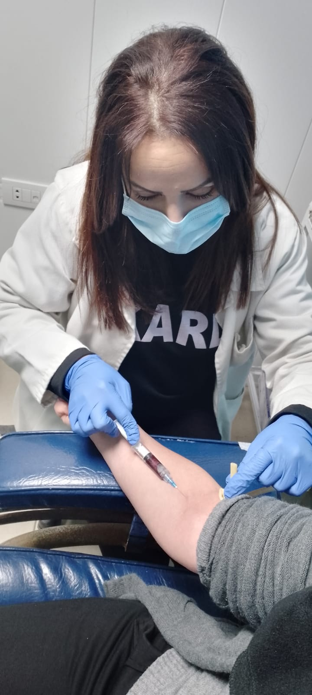 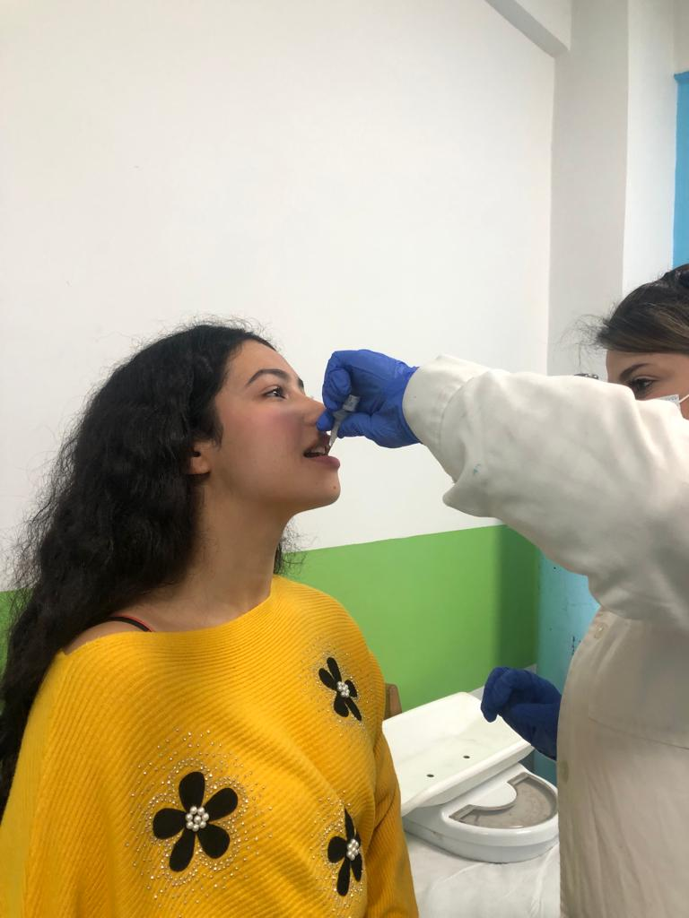

**Draw blood Vaccination of dropouts**

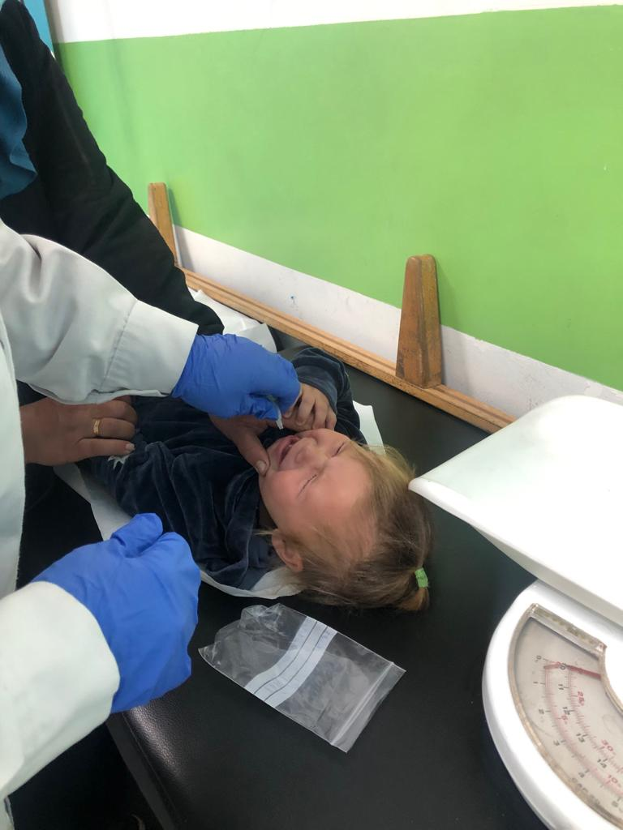 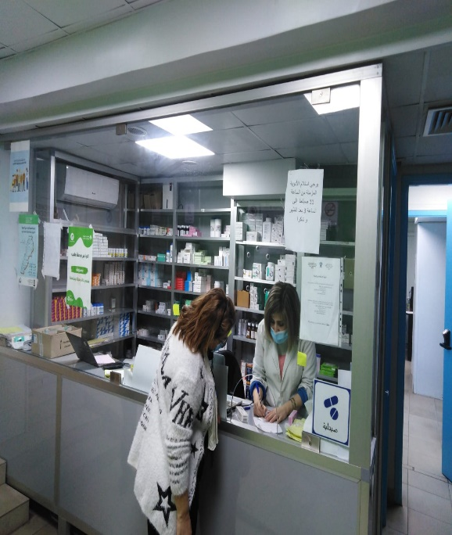

**Vaccination Submission of applications to patients**

**suffering from chronic diseases**

# Finance Update:

(Finance request – donation …. Payments)



Action plan for next Month:

|  |  |  |  |  |
| --- | --- | --- | --- | --- |
| Activities | Description of the activity | Modality (value, frequency…) | Location of activities | Number of Target Group |
| Activity 1: | Contact patients to book an appointment in advance | For all heart and diabetic patients who did not visit the doctor for more than 6 month and who suffer from chronic diseases | AMC | All referred patients |
| Activity 2: | Contact patients to book an appointment in advance | People who are entitled to receive chronic medication | Pharmacy in AMC | All Medication (MOPH, PU-AMI, YMCA, and other donor) |
| Activity 3: | Prepare the patient to reduce waiting time | The patient enters the triage room, and all information is taken (vital signs, ECG, medications he uses...) and then he is given a number to ensure his turn. | Triage room in AMC | All patients who come |

## Challenges

*Overview of any challenges encountered during the reporting period and how they were tackled*

|  |  |
| --- | --- |
| Challenge(s) | Response(s) |
| Stopping work with the supporting organization PU-AMI because of the delay in paying its dues | Agreement with them to cover general medicine patients in order to ensure that patients receive their medicines |
| Power outage | Turn off some machines to reduce clouds and refer patients to the centers with which an agreement has been settled |
| The high cost of backup electricity | Changing its operating hours from 24 hours to 12 hours, with reliance on refrigerators that operate on solar energy to save vaccines, and searching for a financier to present a project that includes extending solar energy to the center |
| Stop the line number authorized to take an advance appointment | It has been replaced with another one, and it depends on publishing the number through our Facebook and Instagram pages and WhatsApp groups |

## Monitoring

|  |  |  |  |
| --- | --- | --- | --- |
| Indicators | Number achieved during the reporting period | Overall target | Progress towards target |
| **Health activity 1:** Services | 3,562 | 6,000 | 59.36% |
| **Health activity 2:** Individuals (with duplication) who benefited from services, disaggregation between male and female. | Female: 2,156  Male: 1,406 | Female: 3,000  Male: 3,000 | Female: 71.86%  Male: 46.86% |
| **Health activity 3:** Individuals who benefited from medication chronic | 385 | 831 | 46.32 % |

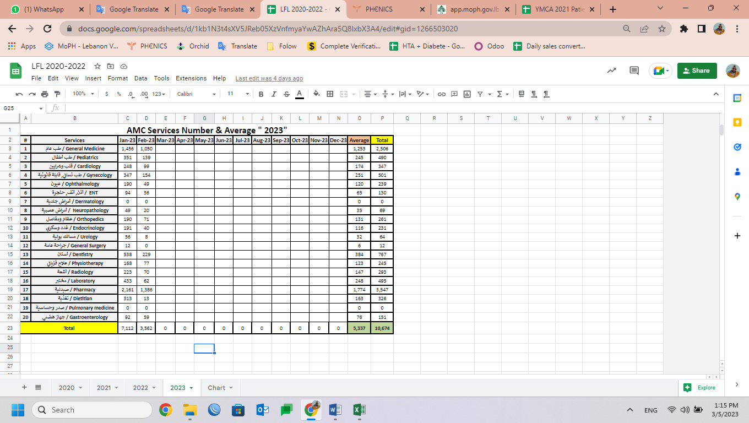

|  |  |  |  |
| --- | --- | --- | --- |
| Monitoring tools used (satisfaction surveys, discussions with beneficiaries…) | Sample size | Primary findings from these tools | Actions taken/to be taken in response to these findings |
| Complaints Box | 2 | 1. Changing the complaints box, because the box was easy to open.  2. Reducing the number of services, if any, has become more expensive. | 1. Withdraw complaints on a weekly basis  2. Return all services and cover them by PU-AMI. |
| Hot line | 0 | N/A | N/A |
| Individual interviews. | 0 | 10 /week | N/A |
| Beneficiaries Satisfactory | 2 | 1. Good services at AMC.  2. Good staff services | N/A |

## Coordination and communication

*Please list any coordination meetings or communication with national response actors (Government of Lebanon, municipalities, local community, FGOs, INGOs…)*

|  |  |  |
| --- | --- | --- |
| Date [dd/mm/yyyy] | Response actor | Type of coordination [meeting, email, phone call] and purpose |
| 17 – Feb – 2023 | AICA HQ | Base Meeting |
| 6,10,15,21,23,24,27,28 – Feb - 2023 | PUI | Phone Call |

## Annex II: Success Story

(About your team activity, or may be from beneficiary or good implementation for activity …)

The patients were very satisfied with the services provided and its price, which did not exceed one and a half dollars, with the possibility of benefiting from their medicines and taking medical consultations, despite the cessation of services that were covered for free by PU-AMI, and they thanked our endeavor and efforts.

They were with us in this ordeal, and that was evident from the comments on social media

