 Monthly Report

|  |  |
| --- | --- |
| Center Name | Alzahraa Medical Center (AMC) |
| Prepared by: | Youssef K. Aouli |
| Name of Coordinator / Manager:  *Name, email, and phone* | Name: Youssef K. Aouli  Phone Number: +961 3041125 Email: health.pm@aica-lb.org |
| Reporting period  *From – To* | From 1st December 2024 to 31st December 2024 |

# Management Update:

)Administrative decisions , new projects…)

* We are expecting to sign a new project with the World Bank in collaboration with the Ministry of Public Health. This project encompasses medical packages tailored for low-income individuals registered with the Ministry of Social Affairs.

# Department Update:

(numb of ben, services, activity implemented on filed ….)

AMC is a Primary health care center located between Mankoubin& Jabal Mohsen- Tripoli operating under AICA. In partnership with MoPH, the center was established in November 2008 as a dispensary based on the gap in healthcare provision within the community and has evolved since then into a Primary Health Care Center in late 2016.The center has established a partnership with MoSA as of 2011 and has undergone several partnerships with Médecins Sans Frontières (2012 – 2017 and from April 2024 till present), Relief International (2017), and other two active partnerships with YMCA(2008)&Première Urgence – Aide Médicale Internationale(PU-AMI 2019 - 2023). AMC receives patients without any discrimination in gender, color, race, or religion providing general and specialist examination for minimal fees as well as free medicines, chronic medications and vaccination in addition to a bundle of health services. The center receives an average of 7000 beneficiaries / month visiting from different areas within the North governorate. Since the pandemic, AMC developed an emergency plan partnering with CRS to serve better the community.

**Subsidized Medical Services**

In partnership with AICA and the Ministry of Public Health, the center offers medical services at subsidized rates. General consultations are priced at 400,000 LBP, while specialized consultations cost 600,000 LBP. Additionally, vaccinations and medications are provided free of charge to patients.

**Collaboration with Doctors Without Borders (MSF)**

A dedicated project for managing non-communicable diseases and mental health services has been implemented. This initiative has significantly reduced the cost of renewing chronic medications to just 50,000 LBP per patient, encouraging higher participation. Furthermore, free medical tests for chronic patients are expected to commence at the end of this month or the beginning of the next.

**Medication Distribution**

The center’s pharmacy ensures immediate dispensing of medications prescribed by its doctors, accompanied by detailed usage instructions. Moreover, applications have been submitted to enroll patients with chronic illnesses in the Young Men’s Christian Association (YMCA) program. This collaboration with the Ministry of Public Health aims to provide access to free medications. Chronic medications not available through the ministry are supplied by MSF.

**World Bank Project**

On September 1, 2024, the center launched a project in collaboration with the World Bank to distribute medical packages to low-income individuals registered with the Ministry of Social Affairs. To date, approximately 1,960 individuals from 380 families have been registered, with further registrations ongoing.

**UNICEF Project: “Aa Salama”**

A team of 12 professionals has been conducting home visits in underserved areas such as Jabal Mohsen, Al-Qobbeh, Al-Badawi, and Mankoubin. This project focuses on enhancing child health and continues to expand its outreach.

# Finance Update:

(Finance request – donation …. Payments)

Action plan for next Month:

|  |  |  |  |  |
| --- | --- | --- | --- | --- |
| Activities | Description of the activity | Modality (value, frequency…) | Location of activities | Number of Target Group |
| Subsidized Medical Services | Offering general and specialized medical consultations at reduced costs, free vaccinations, and medications. | General consultations: 400,000 LBP; Specialized consultations: 600,000 LBP; Free medications and vaccinations. | Center-based services | Open to all eligible patients. |
| MSF Collaboration | Management of non-communicable diseases and mental health services. | Chronic medication renewal: 50,000 LBP; Free medical tests (monthly). | At the center | All chronic patients. |
| Medication Distribution | Dispensing prescribed medications immediately; enrollment in YMCA for free chronic medications. | Immediate dispensing: YMCA and MSF provided medications as needed. | Pharmacy within the center | Chronic disease patients. |
| World Bank Project | Distribution of medical packages to low-income individuals. | Medical packages distributed monthly. | Registered with the Ministry of Social Affairs | 1,960 individuals (380 families). |
| UNICEF Project: “Aa Salama” | Home visits focusing on child health. | Ongoing home visits conducted regularly | Jabal Mohsen, Al-Qobbeh, Al-Badawi, Mankoubin | Children and families in these areas. |

## Challenges

*Overview of any challenges encountered during the reporting period and how they were tackled*

|  |  |
| --- | --- |
| Challenge(s) | Response(s) |
| High costs of medical consultations and chronic medications for low-income patients. | Subsidized prices for consultations (400,000 LBP for general and 600,000 LBP for specialized) and free medications. |
| Limited access to chronic medications not available through the Ministry of Health. | Collaboration with MSF to supply unavailable chronic medications and enrollment in the YMCA program for free meds. |
| Financial barriers to accessing routine medical tests for chronic disease patients. | Introduction of free medical tests under the MSF project, starting soon. |
| Lack of healthcare access for underserved children in marginalized communities. | UNICEF’s “Aa Salama” project conducts regular home visits to provide healthcare for children and families. |
| Difficulty ensuring immediate availability of prescribed medications. | On-site pharmacy ensures immediate dispensing of medications with proper instructions. |
| Growing demand for support among low-income families registered with the Ministry of Social Affairs. | Implementation of the World Bank project to distribute medical packages monthly to registered families. |

## Monitoring

|  |  |  |  |
| --- | --- | --- | --- |
| Indicators | Number achieved during the reporting period | Overall target | Progress towards target |
| **Health activity 1:** Services | 6,265 | 6,000 | 104.41 % |
| **Health activity 2:** Individuals (with duplication) who benefited from services, disaggregation between male and female. | Female: 3,162  Male: 3,103 | Female: 3,000  Male: 3,000 | Female: 105.4%  Male: 103.4 % |
| **Health activity 3:** Individuals who benefited from medication chronic. | 590 | 1630 | 36.19 % |

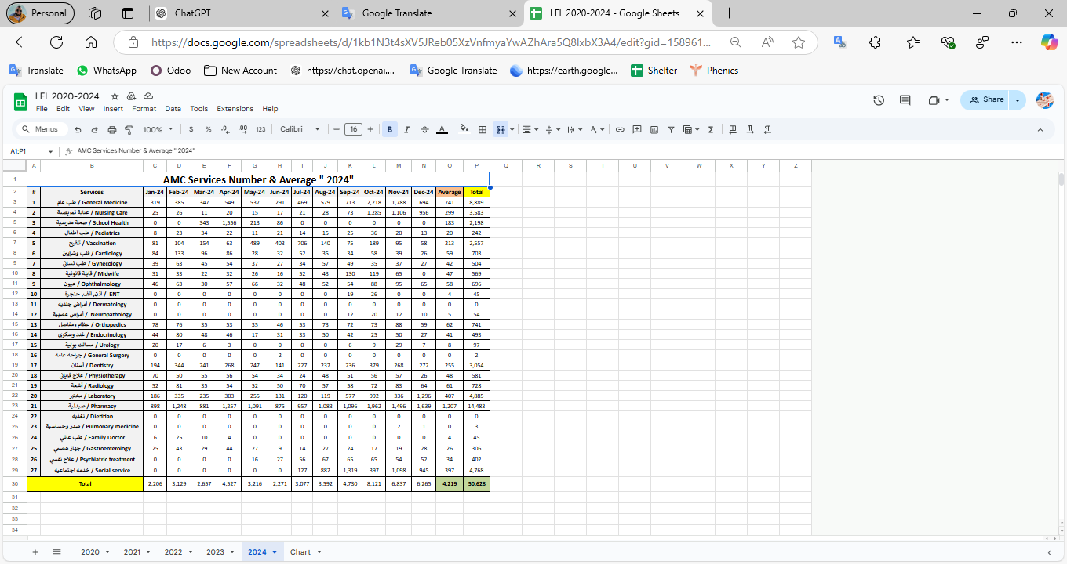

|  |  |  |  |
| --- | --- | --- | --- |
| Monitoring tools used (satisfaction surveys, discussions with beneficiaries…) | Sample size | Primary findings from these tools | Actions taken/to be taken in response to these findings |
| Complaints Box | 0 | N/A | N/A |
| Hot line | 0 | N/A | N/A |
| Individual interviews. | 22 | - Lack of availability of medicines  - No Electricity  - High cost of Consultation | - Agree with MSF to replenishment the missing medicine - Installed a solar energy system  - Review pricing structure of specialized services |
| Beneficiaries Satisfactory | 8 | N/A | N/A |

## Annex II: Success Story

(About your team activity, or may be from beneficiary or good implementation for activity …)

One of the most rewarding aspects of our work has been the opportunity to follow up with our beneficiaries and ensure they receive the care they need, even amidst challenging circumstances. Through regular phone calls and appointment bookings, we've been able to check on their health and well-being, providing a sense of reassurance and support.

The feedback from beneficiaries has been overwhelmingly positive, with many expressing gratitude for the attention and care they've received. Despite facing various adversities, our commitment to improving their lives remains unwavering.

This success story serves as a reminder of the importance of our work and motivates us to continue striving for excellence in everything we do.