 Monthly Report

|  |  |
| --- | --- |
| Center Name | Alzahraa Medical Center (AMC) |
| Prepared by: | Youssef K. Aouli |
| Name of Coordinator / Manager:  *Name, email, and phone* | Name: Youssef K. Aouli  Phone Number : +961 3041125 Email : health.pm@aica-lb.org |
| Reporting period  *From – To* | 1st August 2024 to 31st August 2024 |

# Management Update:

)Administrative decisions , new projects…)

* We are expecting to sign a new project with the World Bank in collaboration with the Ministry of Public Health. This project encompasses medical packages tailored for low-income individuals registered with the Ministry of Social Affairs.

# Department Update:

(numb of ben, services, activity implemented on filed ….)

AMC is a Primary health care center located between Mankoubin& Jabal Mohsen- Tripoli operating under AICA. In partnership with MoPH, the center was established in November 2008 as a dispensary based on the gap in healthcare provision within the community and has evolved since then into a Primary Health Care Center in late 2016.The center has established a partnership with MoSA as of 2011 and has undergone several partnerships with Médecins Sans Frontières (2012 – 2017 and from April 2024 till present), Relief International (2017), and other two active partnerships with YMCA(2008)&Première Urgence – Aide Médicale Internationale(PU-AMI 2019 - 2023). AMC receives patients without any discrimination in gender, color, race, or religion providing general and specialist examination for minimal fees as well as free medicines, chronic medications and vaccination in addition to a bundle of health services. The center receives an average of 7000 beneficiaries / month visiting from different areas within the North governorate. Since the pandemic, AMC developed an emergency plan partnering with CRS to serve better the community.

**Subsidized Services:** All services were maintained at subsidized prices in partnership with AICA and the Ministry of Public Health. General practitioner consultations were set at 400,000 LBP, and specialist consultations at 600,000 LBP. Vaccines and medications were provided free of charge.

**MSF Project Implementation:** The project with MSF was launched, offering services for non-communicable diseases and mental health. Support for renewing chronic medications was reduced to 50,000 LBP per patient, increasing patient interest. A new pharmacist was contracted, and the center was equipped with a pharmacist and assistants. Psychological treatment services began on May 1st.

**Medication Distribution:** Medications prescribed by the center’s physician were immediately distributed by the pharmacist, with labels providing detailed usage instructions. Applications were also submitted for patients with chronic diseases to benefit from the Young Men’s Christian Program, in cooperation with the Ministry of Health, to receive free chronic medications.

**Quality Standards:** The center adheres to high-quality standards in all its operations.

**World Bank Project:** Starting on September 1, 2024, the center will implement a project with the World Bank, which includes distributing medical packages to low-income individuals registered with the Ministry of Social Affairs.

**Solar Energy Installation:** A solar energy system provided by the Norwegian Association was installed, reducing operating costs and improving the quality of service by enabling the use of air conditioners for staff and patient comfort.

**Community Health Worker Field Survey:** CHW began conducting home visits as part of the "Aa Salame" project in the Jabal Mohsen, Al Kobbeh, Al Badawi, and Al Mankoubin areas. Through this effort, 302 children between the ages of two and four were recruited.

# Finance Update:

(Finance request – donation …. Payments)

Action plan for next Month:

|  |  |  |  |  |
| --- | --- | --- | --- | --- |
| Activities | Description of the activity | Modality (value, frequency…) | Location of activities | Number of Target Group |
| General Practitioner Consultations | Medical consultations by general practitioners at subsidized prices | 400,000 LBP per consultation | Center | All patients |
| Specialist Consultations | Specialist medical consultations for various health issues | 600,000 LBP per consultation | Center | All patients |
| Vaccination Program | Vaccines provided to patients | Free of charge | Center | All patients |
| MSF Non-Communicable Diseases & Mental Health Services | Services addressing chronic diseases and mental health | Support for chronic medication renewal at 50,000 LBP per patient | Center | Patients with chronic diseases |
| Psychological Treatment Services | Psychotherapy services for mental health support | Began on May 1st; ongoing service | Center | Patients requiring therapy |
| Medication Distribution | Dispensing prescribed medications with detailed instructions | Free of charge for chronic patients (via Young Men’s Christian Program) | Center | Patients with chronic diseases |
| World Bank Medical Package Distribution | Distribution of medical packages to low-income individuals | Starting September 1, 2024 | Center | Low-income individuals |
| Home Visits ("Aa Salame" Project) | Community Health Worker field surveys, focusing on child health | House-to-house visits; recruitment of 302 children | Jabal Mohsen, Al Kobbeh, Al Badawi, Al Mankoubin | 302 children (ages 2-4) |
| Solar Energy Installation | Solar system installed to reduce costs and improve service quality | Completed in 2024 | Center | N/A |

## Challenges

*Overview of any challenges encountered during the reporting period and how they were tackled*

|  |  |
| --- | --- |
| Challenge(s) | Response(s) |
| High volume of services and patients. | Continuously providing services to all patients despite high demand. |
| Low patient interest in renewing chronic medications | Reduced the cost of chronic medication renewal to 50,000 LBP per patient, increasing patient interest. |
| Need for affordable healthcare services | Maintained subsidized prices for general practitioner and specialist consultations through partnerships with AICA and the Ministry of Public Health. |
| Limited access to free chronic medication for patients | Enrolled patients with chronic diseases in the Young Men’s Christian Program to receive free medication, in cooperation with the Ministry of Health. |
| Insufficient psychological support for patients | Launched psychological treatment services on May 1st to address mental health needs. |
| Difficulty in reaching vulnerable populations | Conducted home visits as part of the "Aa Salame" project to directly engage and recruit children in underserved areas. |
| Need for enhanced medication distribution efficiency | Immediate distribution of medications prescribed by physicians with clear usage instructions provided by the pharmacist. |
| Demand for better quality service environment | Solar energy installation improved the center's operational environment by powering air conditioning for patient and staff comfort. |

## Monitoring

|  |  |  |  |
| --- | --- | --- | --- |
| Indicators | Number achieved during the reporting period | Overall target | Progress towards target |
| **Health activity 1:** Services | 3,592 | 6,000 | 59.86 % |
| **Health activity 2:** Individuals (with duplication) who benefited from services, disaggregation between male and female. | Female: 2,015  Male: 1,577 | Female: 3,000  Male: 3,000 | Female: 67.16 %  Male: 52.56 % |
| **Health activity 3:** Individuals who benefited from medication chronic. | 622 | 1386 | 44.87 % |

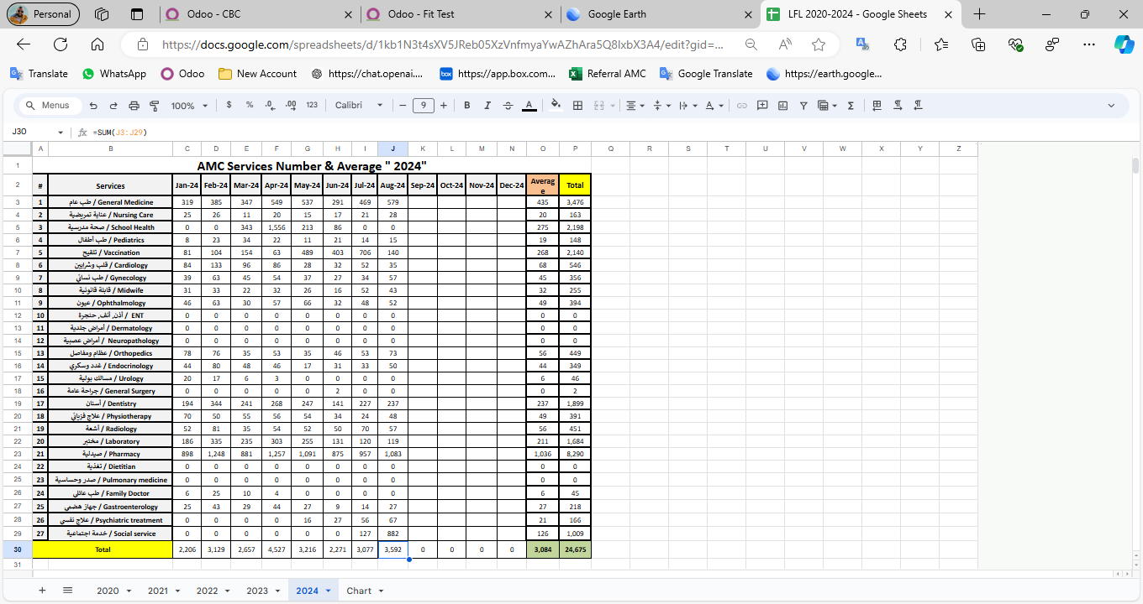

|  |  |  |  |
| --- | --- | --- | --- |
| Monitoring tools used (satisfaction surveys, discussions with beneficiaries…) | Sample size | Primary findings from these tools | Actions taken/to be taken in response to these findings |
| Complaints Box | 0 | N/A | N/A |
| Hot line | 0 | N/A | N/A |
| Individual interviews. | 22 | - Lack of availability of medicines  - No Electricity  - High cost of Consultation | - Agree with MSF to replenishment the missing medicine - Installed a solar energy system  - Review pricing structure of specialized services |
| Beneficiaries Satisfactory | 8 | N/A | N/A |

## Annex II: Success Story

(About your team activity, or may be from beneficiary or good implementation for activity …)

One of the most rewarding aspects of our work has been the opportunity to follow up with our beneficiaries and ensure they receive the care they need, even amidst challenging circumstances. Through regular phone calls and appointment bookings, we've been able to check on their health and well-being, providing a sense of reassurance and support.

The feedback from beneficiaries has been overwhelmingly positive, with many expressing gratitude for the attention and care they've received. Despite facing various adversities, our commitment to improving their lives remains unwavering.

This success story serves as a reminder of the importance of our work and motivates us to continue striving for excellence in everything we do.