 Monthly Report

|  |  |
| --- | --- |
| Center Name | Alzahraa Medical Center (AMC) |
| Prepared by: | Youssef K. Aouli |
| Name of Coordinator / Manager:  *Name, email, and phone* | Name: Youssef K. Aouli  Phone Number : +961 3041125 Email : health.pm@aica-lb.org |
| Reporting period  *From – To* | From 1st August 2023 to 30th August 2023 |

# Management Update:

)Administrative decisions , new projects…)

* It is expected to sign a new project for a period of five months with Relief International in partnership with MoPH funded by UNICEF, The content of the project on vaccines for dropout children, in addition to the awareness session for PNC and ANC

# Department Update:

(numb of ben, services, activity implemented on filed ….)

AMC is a Primary health care center located between Mankoubin& Jabal Mohsen- Tripoli operating under AICA. In partnership with MoPH, the center was established in November 2008 as a dispensary based on the gap in healthcare provision within the community and has evolved since then into a Primary Health Care Center in late 2016.The center has established a partnership with MoSA as of 2011 and has undergone several partnerships with Médecins Sans Frontières (2012 – 2017), Relief International (2017), and other two active partnerships with YMCA(2008)&Première Urgence – Aide Médicale Internationale(PU-AMI 2019). AMC receives patients without any discrimination in gender, color, race, or religion providing general and specialist examination for minimal fees as well as free medicines, chronic medications and vaccination in addition to a bundle of health services. The center receives an average of 7000 beneficiaries / month visiting from different areas within the North governorate. Since the pandemic, AMC developed an emergency plan partnering with CRS to serve better the community.

**● Activity 1:** We kept all the services at a subsidized price by PU - AMI, as the services returned to the amount of 30,000 LBP, until the end of August 2023, and they include consultation and medicine only.

**● Activity 2:** Continuous coordination with the PU-AMI to ensure the rights of beneficiaries with high standards.

**● Activity 3:** Patients are called to confirm their appointment

**● Activity 4:** A new system has been adopted (ODOO)

**● Activity 5:** Dispensing Medicines: The prescription that is given to the patient by the doctor in the center is given to the pharmacist to prepare and dispense it immediately. Each medication has a label indicating appropriate indication, use, administration, and timing. In addition, applications are submitted for patients suffering from chronic diseases to benefit from the Young Men's Christian Program in cooperation with the Ministry of Health, which provides chronic medicines for free.

**● Activity 6:** Target Achievement Challenge: We have a huge challenge in terms of the large number of services, the large number of patients, and the need to provide services to all.

Odoo ERP system is enterprise resource planning software used company-wide for the management of business processes. Odoo provides seamlessly integrated functional business apps called Odoo apps that form an ERP solution when combined.

# Finance Update:

(Finance request – donation …. Payments)



Action plan for next Month:

|  |  |  |  |  |
| --- | --- | --- | --- | --- |
| Activities | Description of the activity | Modality (value, frequency…) | Location of activities | Number of Target Group |
| Activity 1: | Contact patients to book an appointment in advance | For all heart and diabetic patients who did not visit the doctor for more than 6 month and who suffer from chronic diseases | AMC | All referred patients |
| Activity 2: | Contacting patients to book an appointment in advance and informing them that PU-AMI will be discontinued from the end of June 2023 | People who are entitled to receive chronic medication | Pharmacy in AMC | All Medication (MOPH, PU-AMI, YMCA, and other donor) |
| Activity 3: | Prepare the patient to reduce waiting time | The patient enters the triage room, and all information is taken (vital signs, ECG, medications he uses...) and then he is given a number to ensure his turn. | Triage room in AMC | All patients who come |
| Activity 4: | Create New Room For Vaccination | Contacting all children for whom the vaccine has become available, in addition to transferring all children to this room to ensure that he received all his vaccinations | Vaccination room in AMC | All patients who come between (0 – 18Y) |
|  |  |  |  |  |

## Challenges

*Overview of any challenges encountered during the reporting period and how they were tackled*

|  |  |
| --- | --- |
| Challenge(s) | Response(s) |
| Contract extension from PU-AMI but only includes consultation only | Intensify contacts for the existence of a new organization or for the extension of the contract from more than 1 month |
| The news of the PU-AMI suspension led to many resignations | Looking for daily workers until the end of the contract with PU-AMI |

## Monitoring

|  |  |  |  |
| --- | --- | --- | --- |
| Indicators | Number achieved during the reporting period | Overall target | Progress towards target |
| **Health activity 1:** Services | 3,744 | 6,000 | 62.4% |
| **Health activity 2:** Individuals (with duplication) who benefited from services, disaggregation between male and female. | Female: 2,126  Male: 1,618 | Female: 3,000  Male: 3,000 | Female: 70.86%  Male: 53.93% |
| **Health activity 3:** Individuals who benefited from medication chronic | 577 | 1020 | 56.56 % |

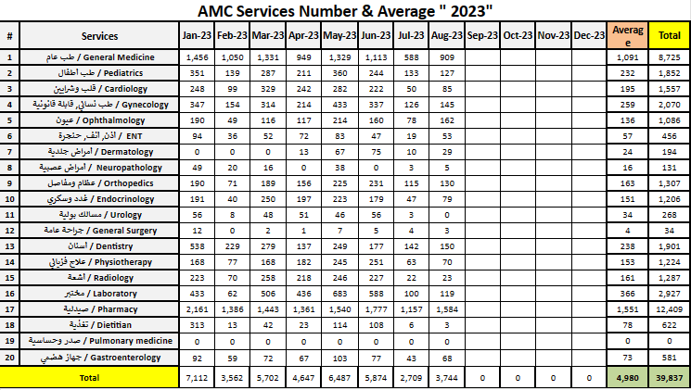

|  |  |  |  |
| --- | --- | --- | --- |
| Monitoring tools used (satisfaction surveys, discussions with beneficiaries…) | Sample size | Primary findings from these tools | Actions taken/to be taken in response to these findings |
| Complaints Box | 0 | N/A | N/A |
| Hot line | 0 | N/A | N/A |
| Individual interviews. | 0 | 10 /week | N/A |
| Beneficiaries Satisfactory | 0 | N/A | N/A |

## Coordination and communication

*Please list any coordination meetings or communication with national response actors (Government of Lebanon, municipalities, local community, FGOs, INGOs…)*

|  |  |  |
| --- | --- | --- |
| Date [dd/mm/yyyy] | Response actor | Type of coordination [meeting, email, phone call] and purpose |
| 8 – August - 2023 | Relief International – Hajar Radwan | Due Diligence |
| 17 – August - 2023 | PU-AMI – Ghada Chebo | Signe Contract and payment |
| 23 – August - 2023 | MOPH – Chantal licha | Visit |

## Annex II: Success Story

(About your team activity, or may be from beneficiary or good implementation for activity …)

It was nice to follow up with the beneficiaries by calling them and booking appointments to check on their health, and this was expressed by the beneficiaries that they are being taken care of despite all the adversities and circumstances we are going through. In the end, this remains our work that we always strive to improve.