Village Initiative for Empowerment
of Women(VIEW)



Organizational Profile

R.K.Road,Polashbari, Kurigram Sadar,Kurigram
Bangladesh

Acronym: VIEW

Full Name: Village Initiative for Empowerment of Women

Law under Organization has registered
- Registered with Government of Bangladesh under Department of Social Service (DSS) No –Kuri/ 229/80 Dated December 17, 1980, (Registration and Control Ordinance 1961)
- Registered with Government of Bangladesh under NGO Affairs Bureau, Number 1833, Dated: 24 May 2003
- Registered with Government of Bangladesh under Department of Youth, registration
# 40, Dated: 14 July 2009.
Contact Details

Contact Person: Md.Enamul Hoque
Executive Director
Cell: +88-01780536359
Fax# +88-621
E-Mail: enam.view@gmail.com
Website: www.kurigramgishub.org

Bank Account Details
Account Title : Village Initiative for Empowerment of Women (VIEW)
Account Number : 0100108036286
Branch Code : 0037
Swift Code : JANBBDDH
Routing Number : 135490169
Branch : Trimohani Bazar Branch
Name of Bank : : Janata Bank Limited
District : Kurigram
Country : Bangladesh

Introduction and Background

Village Initiative for Empowerment of Women (VIEW) is an independent registered non-government and nonprofit Non-Government Organisation (NGO) based at Kurigram District under Rangpur Division in Bangladesh. VIEW is the women rights organisation prime motto is to facilitate women empowerment in all sphere of their lives. Capacity building and services delivery for the deprived and marginalized women in the communities are the main focus of the organisation. In 1980 a group of dedicated, dynamic and like-minded youth working in the development sector got together to establish an organization, for addressing the most urgent and pressing needs of the disadvantaged women of Kurigram. True to this spirit the organization was named Village Initiative

for Empowerment of Women (VIEW).Considering their association with the development sector the group was cognizant of the plethora of problems plaguing the District. Consequently, the organization’s focus was not kept limited either in terms of geography or sector. Whilst operating in different areas of the District, VIEW has been carrying a range of interventions in the areas of education, health & hygiene, youth & women empowerment, emergency response & preparedness, governance, free legal aid, human rights, etc.

The type of activities undertaken by the organization ranged from capacity building to service delivery, with focus remaining on the deprived and marginalized segments of the society. Whereas in terms of operations what characterizes VIEW’s functioning are its efforts to (a) enlist involvement of the locals when initiating activities at the grass root level; and (b) mobilize women for bringing peace, tolerance, and development in society.
Although a new entry in the development arena, VIEW owing to the linkages of its members with national & international agencies enjoys a diverse portfolio, characterized by partnership with organizations like CIDA.USAID, Abilis Foundation, Finland,Taiwan Foundation for Democracy, LCD-UK, JOAC-UK, Oxfam Bangladesh Action Aid-Bangladesh Government of Bangladesh, and Private Sectors.
VIEW Governance: The General Committee (GC) of VIEW is consisted of 21 members are the supreme authority to make a decision for the organization. The committee holds a meeting bi- annually. Besides Executive Committee (EC) consisted of 7 members is elected by the general committee members. Executive Committee is empowered by the GC and responsible for guiding and policies making to review the progress of activities The EC Committee held a meeting by-monthly. During the meeting work done is evaluated, problems are threshed out, future strategies are chartered out for the well-functioning of the project activities.. The Executive Director of the organization is responsible to Executive Committee (EC) and supported by different professional and support staffs. He is also responsible for overall management includes budgeting, recruitment, supervision, monitoring , financial control and personnel management of the project are the day to- day routine management of the organization.
Mission Statement

The mission of VIEW is to empower the women in all spheres of human life, through a value system based to help build a better future where women are self-fulfilled as individuals and play a significant role in society. The Women's Empowerment Initiative is dedicated to impacting the lives of disadvantaged women by social or economic circumstances. The Initiative will enable women to enhance and develop their leadership quality of life and become architects of their future by presenting opportunities for spiritual, educational, and economic transformation in communities

Our Vision:

Our vision is the evolution of a human society around the country where there is equality of opportunity for women and men in access to education, health care, social advancement and representation in political and economic decision-making. End all forms of discrimination against

women and girls everywhere. The contribution of women as men are recognized and respected. The Women's Empowerment Initiative is committed to empowering women, thereby strengthening families and transforming communities.

Goal

The goal of VIEW is to contribute in improving the living standard of the vulnerable communities through community mobilization, capacity building, advocacy & strengthening of institutions at the grass root level.

Strategy

A sustainable strategy is devised to achieve the maximize needs based and right based approach initiated ascertains the problem with fully community involvement and mobilizing all indigenous and local resources. The program goal is materialized with a helping hand from members, donor agencies, Philanthropists.
Organizational Core Values:

- Courage
- Collaboration
- Inclusiveness
- Diversity
- Equality
- Integrity
- Compassion
- Respect
- Transparency
- Sustainability
- Community
- Empowerment
- Innovative
- Excellence

Thematic Programme / Areas of Focus
- Health
- WASH
- Youth Empowerment
- Education
- Community Physical Infrastructures
- Emergency Response and Preparedness
- Women Empowerment
- Free Legal Aid and Education
- Democracy
- Human Rights & Advocacy
- Disabilities in Development
- Senior Citizen Initiatives

Overall Objective

The overall development objective of VIEW is to enhance ability in the target communities to tackle their own economic, social and environmental problems for sustainable community development. Furthermore;

- To educate the deprived and under privilege common folk about the basic human rights and find basis to incorporate their efforts and mobilization to achieve maximum output
- To enable the community in development of local level institutions and assist them in undertaking community based welfare and development interventions.
- To Provide quality legal assistance to juvenile victims of sexual abuse, exploitation and
trafficking, especially street children in conflict with law and children in detention, vulnerable to sexual abuse
- To provide a place for students to relax and enjoy an inexpensive, healthy meal in a fun atmosphere.
- Promote Gender equality.
- To devise and organize for women and children particularly to their rights to acquire educations and improve their health and earnings.
- To ensure full participation of local level grassroots organizations in decision making process including problem identification, planning, management, implementation, monitoring, and evaluation aimed at sustainability.
- To facilitate easy access to credit and motivate communities for group saving leading towards small enterprise development and income generating activities aimed at economic empowerment.
- To work for environmental protection, pollution abatement, water supply and hygienic sanitation.
- To fight against drug abuse and launching programmes aimed at rehabilitation of drug addicts
- To establish a resource Centre aimed at facilitating target communities and local level institutions through information, education and communication.
- Assisting communities in disaster prediction and mitigation through various relief and rehabilitation programmes.
- To develop effective linkages with government line agencies, departments, non-government organizations, and donor agencies working for community development.

- Human resource development and training aimed at skill enhancement and knowledge up gradation in order to ensure better implementation of participatory rural development programmes by community partners.
- Conservation of natural resources, bio-diversity and environmental protection.
- Implementation of programmes aimed at basic health care services (preventive and curative) including maternal health, child health, safe drinking water, hygienic sanitation, management of waste disposal, population welfare, immunization, etc. leading towards reduced mortality.
- To establish new community schools and upgrade the existing ones in order to provide education facilities to those most in need with special focus on female child.
- Implementation of women welfare and development programmes aimed at socio-economic empowerment of women through their participation in all developmental programmes.
- Raising awareness on environmental issues through advocacy, networking, public interest litigation and education.
- Organizing issues-specific and objective-oriented campaigns building social pressure to influence decision-making at local, national and international levels in favour of deprived, marginalized and vulnerable segments of the community.

VIEW Policies/Manuals:

- Human Resources Management Manual
- Financial Management Manual
- Procurement Manuals
- Gender Policy
- Code of Conduct
- Child Protection Policy
- Disaster Contingency Policy

What VIEW Does?

Influenced by the new development paradigm, which puts people before things, VIEW follows a participatory approach in every sphere of its work. The traditional knowledge of the rural poor is valued and respected, and there is confidence that rural people are capable of self-reliant organization. On a practical level, the fundamental thrust of this approach is decentralization and empowerment. For a community to be able to work for its own development and reduce its dependency there is a need for full involvement at all stages of the development cycle. The participation of communities in identification, planning, management, implementation and evaluation of projects is a key factor in VIEW works. Internally a participatory approach is adopted in managing the affairs of VIEW.
Externally, VIEW role as a “change agent” helps to develop community management structures that are capable of managing their own development. This increases the ability of the community
to demand accountability in all their affairs, from leaders and officials. It reinforces the community's belief in the value of their own development choices and efforts. These communities
management structures are not parallel structures, but are built upon traditional institutions, promoting equitable representation and participation Human resource development is an essential part of our development work. This means ensuring that the community is trained and skilled, as well as organized, to maximize the potential of the community to take hold of its own development.

VIEW strongly believes in maximizing its impact by transforming field experiences into knowledge to influence the development policies and practices of NGOs, donors and government agencies. This is important for working towards the long-term goal of eradicating poverty.

Approach

During the process of social mobilization, VIEW adopted a participatory, self-help, self-sustainable approach through community involvement and formation of volunteer groups in remote rural areas of Kurigram.

Philosophy

Sustainable rural development is a dynamic process posing various needs at different phases of time. These can be dealt with continuous interventions based on designed frameworks that incorporate the requirements projected by the communities and with the help of the communities by strategizing for public-private partnership.

Scope of Work

VIEW has strong linkages with major NGOs and funding agencies working in Bangladesh and overseas. It has undertaken multiple initiatives in Bangladesh with special reference to Kurigram District through collaboration with local NGOs, CBOs and activists. VIEW enjoys a rich experience of working in the diverse socio-cultural environment of Bangladesh and an extensive networking with the District & Local Governments, civil society institutions, media and private sectors.

Organizational Values

- Honesty
- Respect for individual
- Integrity
- Participation in communal activities
- Transparency in all transactions
- Accountability to all the actions/deeds performed by an individual
- Cost efficiency
- Gender sensitivity

Guiding Principles:

VIEW follows the below mentioned guiding principles in implementation of its projects/
programmes:

- Use of indigenous knowledge
- Making efforts to achieve highest quality standards
- Promoting a culture of innovation and creativity
- Meeting deadlines
- Enhancing networking and coordination
- Meeting challenges

Professional and Technical Competency / Strength

- Highly qualified, experienced and devoted professionals and board members and staff;
- Adaptability to cope up and meet the requirements of diverse socio cultural environment.
- Overwhelming support of local people.
- Acceptance as a representative of common people of the area.
- Extensive network to undertake initiatives at grassroots;
- Strong partnerships for undertaking innovative initiatives;

VIEW Development Partners: There was some turnover of development partners as:
- ABILIS Foundation (Disabilities in Development Project).
- European Union(EC)/PRIP Trust, (Community Bases Disaster Preparedness Programme)
- DFID/LCD-UK/CDD. Promoting Rights Access to Inclusive Education
- Department of Youth, GO Networking Project
- ASHOKA-USA , Development through Self-Help
- World Fish Center (USAID), Aquaculture (Concluded)
- Canadian International Development Agency (CIDA), (Anti- Trafficking). (Concluded)
- NGO Forum for Drinking Water and Sanitation/ UNICFF, (Sanitation Project) .
- BRAC- ESP, Non Formal Primary Education (NFPE).BRAC- HR& Advocacy Unit (Targeting Ultra Poor) (Concluded).
- Gono Shahasthaya Kendra (GK), Health, Education and Micro finance.
- Department of Primary and Mass Education, Government of Bangladesh (Reaching Out of School Children).

- Manusher Jonno (MS)/ Steps towards Development (STD), (Gender and Development Project).
- Manusher Jonno (MS)/ ESDO, (Child Rights Project).
- World Food Programme (WFP) School Feeding Programme.
- CAMPE ,Education & Environment
- Abilis Foundation,Finland
- TFD-Taiwan
- Oxfam/MJSKS
- BFI/Action Aid Bangladesh
- JOAC-UK
- TMAD-UK
- ARI-Bangkok
- British Council/BARCIK

Memberships: Network/Alliance

- NGO Forum for Drinking Water and Sanitation/ UNICFF, (Sanitation Project) .
- Child Labour Elimination Action Network (CLEAN).
- Food Security Cluster Network.
- CAMPE ,Education & Environment
- Empowering Local and National Humanitarian Actors (ELANA),Bangladesh
- ALERT Consortium Bangladesh
- BBC Media Action Network
- National Alliance of Humanitarian Actors (NAHAB),Bangladesh
- Civil Society Alliance (CSA-SUN)
- Humanitarian Actors Platform (HAP)
- Civil Society Organisation Alliance (CSOA)

- Institute of Democratic Rights (IDR)
- International Association of Professionals in Humanitarian Assistance and Protection (PHAP),Geneva

Advocacy:

VIEW advocacy is achieving better results in the field of social/rural/community development, VIEW also believe in advocacy and therefore, the management has always
strongly advocated for the issues related to VIEW. For achieving this objective, VIEW through its strong advocacy as approached the line departments of Government of
Bangladesh NGOs, CBOs, Civil Society Organizations (CSOs), members of the community, notables and VIEW has always promoted the right based approach and supported the dialogue as an important tool for achieving the above mentioned objectives.

Service Delivery:
VIEW is staunch believer in a very strong and efficient service delivery in the fields of health, education and environment. For this purpose, VIEW management has always delivered services in the communities in a transparent manner taking care of quantity and quality. It is only because of this very reason that the VIEW interventions have always helped in meeting the community needs and achieving the desired objectives.

Net Working:

VIEW has always promoted the networking with other NGOs, CBOs, CSOs, media groups and concerned stakeholders for achieving the goal of sustainable development. Networking with other organizations has always proved very productive by playing as medium between the service providers and those at the receiving end. Networking basically provides opportunity for looking at the issues from different angles i.e. from local, national regional and finally in international level. At every level the perspective of issue changes, which then helps in comprehending the issue.

Child Protection: Under this theme VIEW focuses on holistic development of children its protection and rights, following interventions are planned over the time:

- Derive child rights education and protection awareness at different levels and different stakeholders.
- Development of safe learning places for children at schools, hospitals, and community centers.
- Children confidence building programs, walks, sessions, campaigns, and trainings.
- Development of children groups and developing leadership skills in them.

Women Empowerment

Women Empowerment aims at promotion women to take leading role in democratic norms and culture in the operational area. Two types of activities are undertaken in this theme: one aim at building capacities of women and communities and their groups to engage effectively with government and other stakeholders for getting their constitutional and legal social, economic and political rights, the other aims at working directly with state institutions for creating an Environment that can guarantee the rights of women citizens. It also focuses on enhancing women income generation skills through capacity building and micro credit.

Community Based Infrastructure

Under Community Based Infrastructure development, a wide variety of construction and rehabilitation of rural infrastructure schemes through community participation. Some examples are underground village drainage schemes, community latrines, water course lining, tube wells, and brick pavement in villages.

Some of VIEW projects: Community/Social mobilization:
VIEW while implementing its programme/projects as a first step undertakes community mobilization so that to raise awareness in community on health and hygiene, importance of education in modern day affairs, gender related issues, socio-economic development and environmental protection. For this purpose VIEW management holds meetings with the community members, conducts training/capacity building sessions and also launched campaigns.
Peoples Organization:
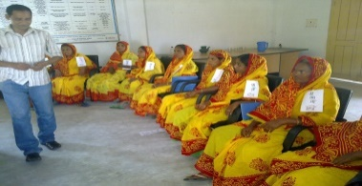
Since VIEW organized individual into group are to gain in strength through mutual support and economies of skill leading to promotion of internal resources mobilization and development the project areas. VIEW encouraged to men and women belonging to the target population to from their own group. Each group constituted of 15 to 20 members those who are distressed, disadvantaged and vulnerable in the communities.
Water and Sanitation:
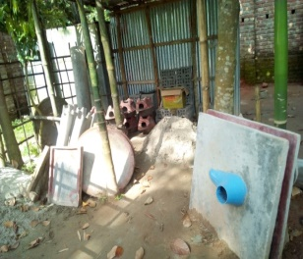
The Project area in Kurigram in contains high level of iron and some areas Arsenic contamination has already been detected. To combat the situation VIEW has lunched a program on Arsenic mitigation project seeks the raise community awareness, test tube well water for arsenic contamination and implement safe water strategies with the technical backstops of department of public Health Engineering and NGO- Form. VIEW is working closely with NGO- Forum and the Line Ministries, to achieve the goal of 100% sanitation in villages / project areas fit with the Government national plan.
Income Generating Activities:
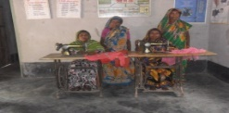
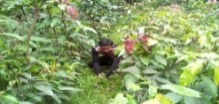
The income generation for vulnerable group development programs covers the poorest women who own no lend, have little or no income are to alleviate poverty of the hard – core poor provided with substantial income and substantial income and employment opportunities through soft credit support and training off farm sector.

Legal Aid Services: Affiliated with institute of democratic Right (IDR) VIEW has already established a paralegal cell in community aiming to facilitate local dispute the case at grass – root level rather in court. VIEW assists the poor peoples who are not in a position to file a case in the court through Legal Aid Cell.VIEW is providing free legal aid service and education through its assigned professional senior lawyers to help vulnerable and marginalized victims in society particularly to women and children.

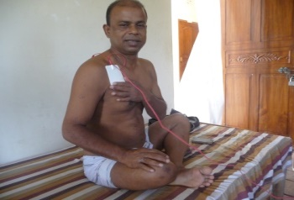
Disabilities in Development: Despite the progress made in recent years, persons with disabilities continue to face numerous barriers to their full inclusion and participation in the life of their communities. It sheds light on their disproportionate levels of poverty; their lack of access to education, health services and employment; and their underrepresentation in decision-making and political participation. This is particularly the case for women and girls with disabilities. The main barriers to inclusion entail discrimination and stigma on the grounds of disability; lack of accessibility to physical and virtual environments; lack of access to assistive technology, essential services and rehabilitation; and lack of support for independent living that are critical for the full and equal participation of persons with disabilities as agents of change and beneficiaries of development. Data and statistics compiled and analyzed in the present report indicate that persons with disabilities are not yet sufficiently included in the implementation, monitoring and evaluation of the SDGs.
Striving to achieve disability-inclusive development is not only the right thing to do; it is also the practical thing to do. Sustainable development for all can only be attained if persons with disabilities are equally included as both agents and beneficiaries as countries strive for a sustainable future. The success of the 2030 Agenda requires a participatory and inclusive approach in which all stakeholders, including persons with disabilities, are engaged. The 2030 Agenda therefore presents an important opportunity to advance the goal of the United Nations: to promote economic and social progress and human rights toward a peaceful and prosperous world for all. Access to health-care services remains a challenge for persons with disabilities, who are more than three times as likely to be unable to get health care when they need it. Access to rehabilitation services is also a challenge.
Examples of these activities include: Education and counseling programs that promote physical activity, improve nutrition or reduce the use of tobacco, alcohol or drugs; and. Blood pressure and cholesterol assessment during annual health exams, and screening for illnesses such as cancer, diabetes, and heart disease. Disability inclusion means understanding the relationship between the way people function and how they participate in society, and making sure everybody has the same opportunities to participate in every aspect of life to the best of their abilities and desires.
Village Initiative for Empowerment of Women (VIEW) has been involved in disability and health activities since 2003. VIEW’s mission is to promote the health and full participation in society by people with disabilities across the lifespan. VIEW supports work that improves overall health and quality of life for people with disabilities. It supports the inclusion of people with disabilities in public health programs that prevent disease and promote healthy behaviors and safety, while working to eliminate barriers to health care and improve access to routine preventive services.
To address the underlying factors VIEW worked together with Abilis Foundation, Finland, Justice Foundation and Center for Disability in Development (CDD).CDD has been provided technical supports to building technical human resources. Besides, in support of Island Aid for World Children, UK we have a well-equipped Health Service Center for peoples in disabilities.
Development through Self Help Group Approach:
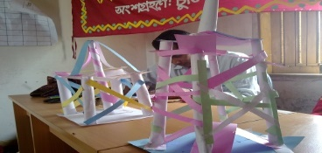
The approach is basically development to reduce participant, population drudgery and to ensure food and income security for their sustainable livelihood. To make them able for a strong leadership among the community, promote regular savings to raise a capital. The approach is based on local available resources linked with Union Parishad and Upazila administration. The project is finances by ASHOKA- USA.
Aquaculture:
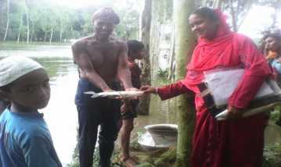
In Kurigram District there is many distract pond or water bodies have been brought under intensive fish cultivation by the potential group members to increase their income and to created self – employment round of year. Technical expertise is developed with the assistance of World Fish center a project of USAID. Local department of fisheries, Government of Bangladesh in involved boosting up the cultivation.

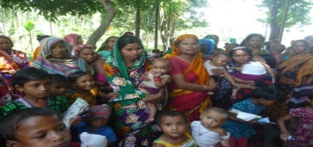
Targeting the Ultra Poor – Pushing Down the frontiers of Poverty Reduction: TUP aim the push down its interventions by development new instruments relevant to the livelihoods ultra-poor households. Five major components of TUP are Enterprise Development, Training, Asset transfer, Social Development, Essential Health care and action Research project through BRAC
Advocacy & Human Rights Union View implementing different interventions in communities like Popular Theater, Workshop, Community Meetings, Audio Visual Animation Program, Live Theater, Formation of communication Forum and Advocacy/ Lobbying to all level.
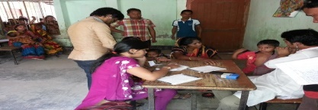
Primary Health Care Services:
The social determinants of health are the conditions in which people are born, grow, live, work and age, including the health system. These circumstances are shaped by the distribution of money, power and resources at global, national and local levels, which are themselves influenced by policy choices. The social determinants of health are mostly responsible for health inequities - the unfair and avoidable differences in health status seen within the Kurigram District. The fertility rate was also extremely high. Only 30 percent of the population had access to primary health care services, and overall health care performance remained unacceptably low by all conventional measurements. Life expectancy at birth in FY 1985, according to official Bangladesh statistics was estimated at 55.1 years, as opposed to 61 years in comparable developing countries. Morbidity and mortality rates for women and children were high. Infant mortality rates exceeded 125 deaths per 1,000 live births; the maternal mortality rate was 6 per 1,000 live births, and 56.1 percent of infants suffered from chronic malnutrition. More than 45 percent of rural families and 76 percent of urban families were below the acceptable caloric intake level. About two-thirds of all families received insufficient protein and vitamins. Literacy rate of women aged 15-24 years who are literate 61.7%. Comprehensive knowledge of HIV and AIDS among young women .Percentage of women aged 15-24 years who have comprehensive knowledge of HIV and AIDS.
Women’s Rights and Gender Awareness:
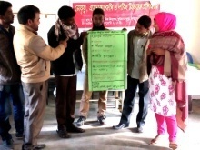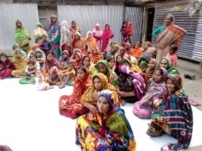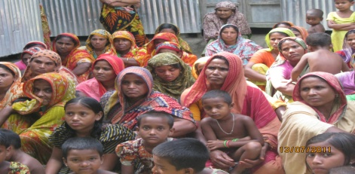
The ultimate objective of the programme is to raise a level of consciousness and to acquire skills so as to reduce their dependence and drudgery to improve their lot through self- efforts to access of locally available resources to promote and facilitate emerging of their won leadership ultimately leading to their sustainable development. The training course aims to broaden perspective to the participants on nature and social norms of gender equity and to enhance their analytical skills to integrate different issues in formulation and empowering in all of human life in the – development process. VIEW has been produced a well- defined Gender Policy to guide is staffs and beneficiaries in order to remove the inequities in relation to gender perspective.
Primary Education (Formal)
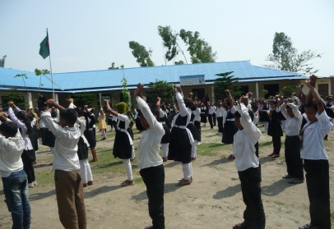
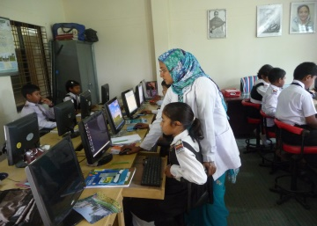
Education has been addressed children’s in rural areas in consonance with the cultural and intellectual level of peoples and buildup on their innate artiste perception and skills leading to their functional capability.

This program is being implemented with the financial and technical assistance of Island Aid for World Children and JOAC-UK since 2012 Teaching curriculum and materials is been used Department of Primary Education, Government of Bangladesh.

Primary Education (Non-Formal)
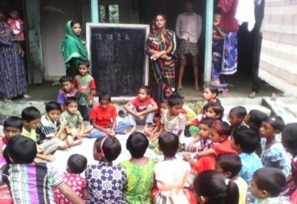
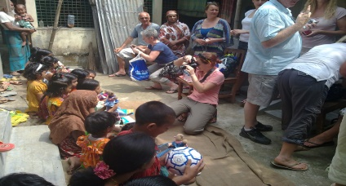
VIEW Non-Formal Primary Education was initially implemented for children who are disadvantaged and vulnerable in rural communities where there was no access of education. Children considered
Children were considered those aged 6 to 11 years and to progress them through Grade-I to Grade-V. The ratio of girls to boys was 60:40.Teachers strongly considered from the vicinity based on their experiences and qualification. Each school composed of 30 learners.
Livelihood for the Extreme Poor: There has been some positive trend in poverty reduction globally, regionally and nationally. The number of people living in poverty has come down to 836 million in 2015 from 1.9 billion in 1990. In Bangladesh, poverty ratio has come down to 24.8% (GED 2015) from 42% in 2000. Still millions live in extreme poverty in the hard to reach areas (HTR) and in the climate affected zone e.g., coastal area and off-shore islands, haor basin, riverine charland, hill areas, drought prone upland and in urban slums. Many of them do not have good employment, adequate income, access to safe water and sanitation, health service and suffer from insecurity, deprivation and injustice. Human induced rapid climate change are affecting their lives and livelihoods making them most vulnerable. The poor has very limited livelihood assets, capacity and options, which are affected by many externalities including market force and climate change making the livelihoods and outcomes fragile and un-sustainable. This process pushes with different insecurities and uncertainty. Three main aspects have been identified in relation to poverty dynamics in Bangladesh.
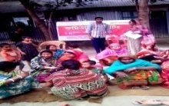
“We Can Mobilize Youth Groups towards Social Change”
This a Action Aid Bangladesh supported project is implementing from November, 2017 aiming to empower of youth to make them change maker in communities.
The main focus of the project is preventing early marriage and sexual harassment of girls. Main activities are campaign, workshop Sensitization, drama etc
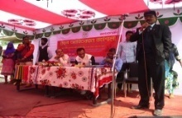
Capacity Building Programme:
Building capacity is about building an organization’s ability to perform well. These interdependent elements provide the framework for successful capacity building, as they are important elements of a nonprofit organization’s and performance. This a partnership programme as supporting partner Mahideb jubo Somaj Kallyan Somity(MJSKS) and funded by Oxfam-Bangladesh implementing from March,2017 to December, 2018.The project implementing under Empowering Local and National Humanitarian Actors (ELNHA) funded by Oxfam-Bangladesh The broader objectives of the project is to develop capacities of local organization in implementing different projects/programmes..

Photo Gallery

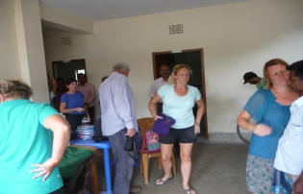
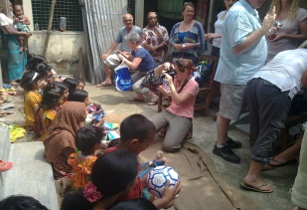
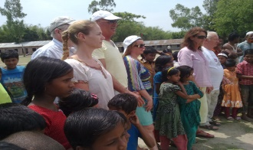
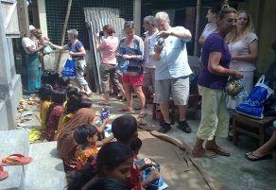


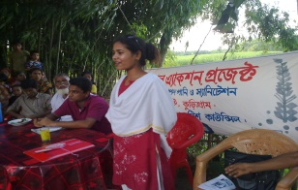
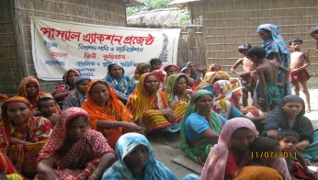
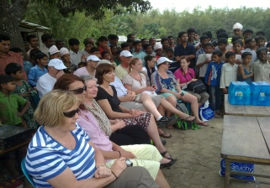
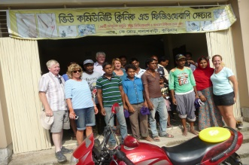

Md.Enamul Hoque
Executive Director

Organizational Organogram of VIEW

General
Committee
Executive
Committee
Project Implementing
Committee
Executive Director
Advisory
Committee
Finance & Admin
Deputy Director
Monitoring Unit
Project Coordinators
Supervisory Staffs
Field Staffs
Support Staffs

