HEREAFTER GHANA (MHP)
QUARTERLY REPORT FOR GLOBAL GIVING (JULY-SEPTEMBER 2026)
PROJECT TITLE: GIVING FOR HEALTH (PATIENT RESCUE FUND HEALTH CASE
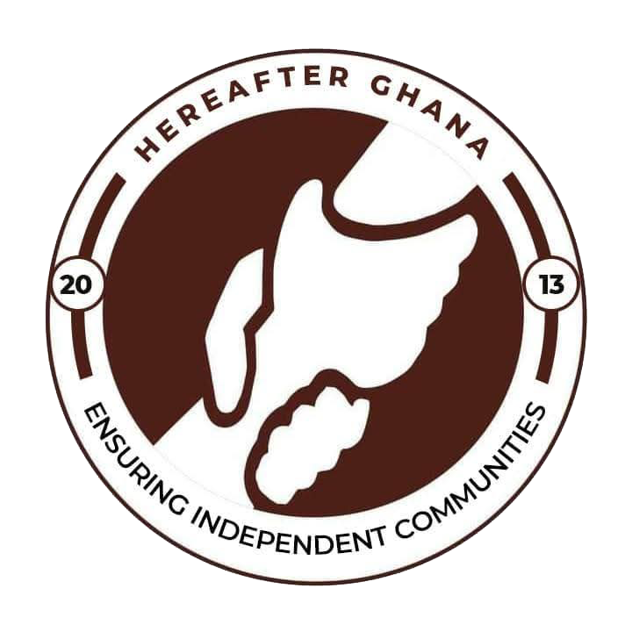

Prepared by Sulemana Suabira Suhuyini
Patient Rescue Fund Officer
Date Prepared: 10th September 26

INTRODUCTION
Hereafter Ghana’s Patient Rescue Fund is a core humanitarian initiative designed to provide financial assistance for healthcare to vulnerable individuals within the community. The project previously termed as the Health Finance Project, went through strategic rebranding to better reflect its evolving scope and impact.
During the third quarter of 2026, Hereafter Ghana was presented with five (5) cases. Each presenting unique challenges and requiring tailored interventions. This report offers a summary of the medical conditions addressed and the progress made by each beneficiary.
This report is a summary of the cases presented during the quarter.

CASE REFERENCE 240
Patient name: Muhaimin
Diagnosis: Stage IV Wilms Tumor
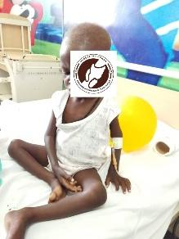
Abdul Muhaimin Abdulai was diagnosed with a disease called Stage IV Wilms also known as (Nephroblastoma). A kidney cancer which spreads through the blood stream and affects mostly children. His condition had spread to his brain, liver and lungs which posed as life-threatening and required immediate attention. After some investigations, the medical team needed an estimated amount of GHS 70,000 for him to undergo surgery, take the necessary laboratory test, equipment for his surgery and medications.
PROGRESS
A total amount of GHC 70,000 was donated to his family for his necessary treatment. Muhaimin had a successful surgery at the Korle Bu Teaching hospital and is currently responding very well to treatment. He currently goes for review at the Tamale teaching Hospital and is on medications. The total amount was funded by Oracle.
CASE REFERENCE 241
Patient name: Iddrisu
Diagnosis: Rickets
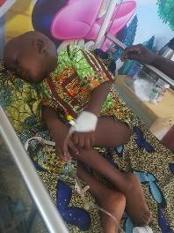
Little Iddrisu was diagnosed with rickets at only the age of two. After medical investigations, it was determined that delayed medical intervention would lead to other severe complications. The total amount needed for his treatment was GHS 3000.
PROGRESS
The total amount was raised and donated to his family for his treatment to proceed. Little Iddrisu did not initially respond well to the treatment but after continued efforts and investigations, he started to respond well to his treatment. Little Iddrisu is currently recovering and has since been discharged to continue with home care and treatment.

CASE REFERENCE 242
Patient name: Amina
Diagnosis: Second degree burns
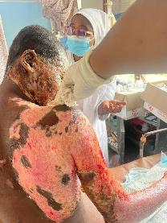
Miss Amina sustained second degree burns after being involved in an unfortunate gas explosion. She sustained major injuries and needed immediate medical intervention as her condition could easily turn fatal. She needed to undergo multiple surgeries including a plastic surgery. The medical officers gave an estimated amount of GHS 15,000 for the treatment.
PROGRESS
Hereafter Ghana immediately mobilised and donated the full amount with the help of the public. Miss Amina’s treatment began immediately as it was critical. Any further delay in her treatment could lead to Sepsis.
Upon follow up, medical officers mentioned she responded well to treatment. Due to the severity of her case, she is still undergoing her treatment but is foreseen to make full recovery.

CASE REFERENCE 244
Patient name: Latif
Diagnosis: Evacuation of Spinal Abscess
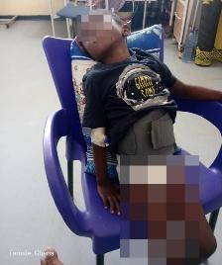
Baby Latif was diagnosed with a race infectious condition that had caused a build up of puss in his spine that was causing a restriction of blood flow from that area downwards. His condition needed immediate medical attention as any further delays could cause further infections and complications. He needed an additional amount of GHS11,750 for evacuation of the abscess and medication.
PROGRESS
Through the support of Oracle, Hereafter Ghana donated the full amount to his guardians to continue his treatment process. Latif is currently on medications and responding well to treatment.

CONCLUSION
This report summarises the medical support cases addressed during the third quarter. Hereafter Ghana remains committed to improving the health and well-being of underserved people nationwide and will continue to provide assistance without geographical limitation.
ACKNOWLEDGEMENT
Hereafter Ghana extends its heartfelt appreciation to all esteemed donors and the committed staff as well as volunteers for their invaluable contributions to the Health Financing project.
Your unwavering support and collaboration have been instrumental in ensuring that vulnerable children in underserved communities gain access to essential healthcare services. The success of this initiative reflects your shared commitment to safeguarding the health and well-being of every child, and we are deeply grateful for the trust and partnership you continue to show.

