HEREAFTER GHANA (MHP)
QUARTERLY REPORT FOR GLOBAL GIVING (JULY-SEPTEMBER 2025)
PROJECT TITLE: GIVING FOR HEALTH (HEALTH CASES)
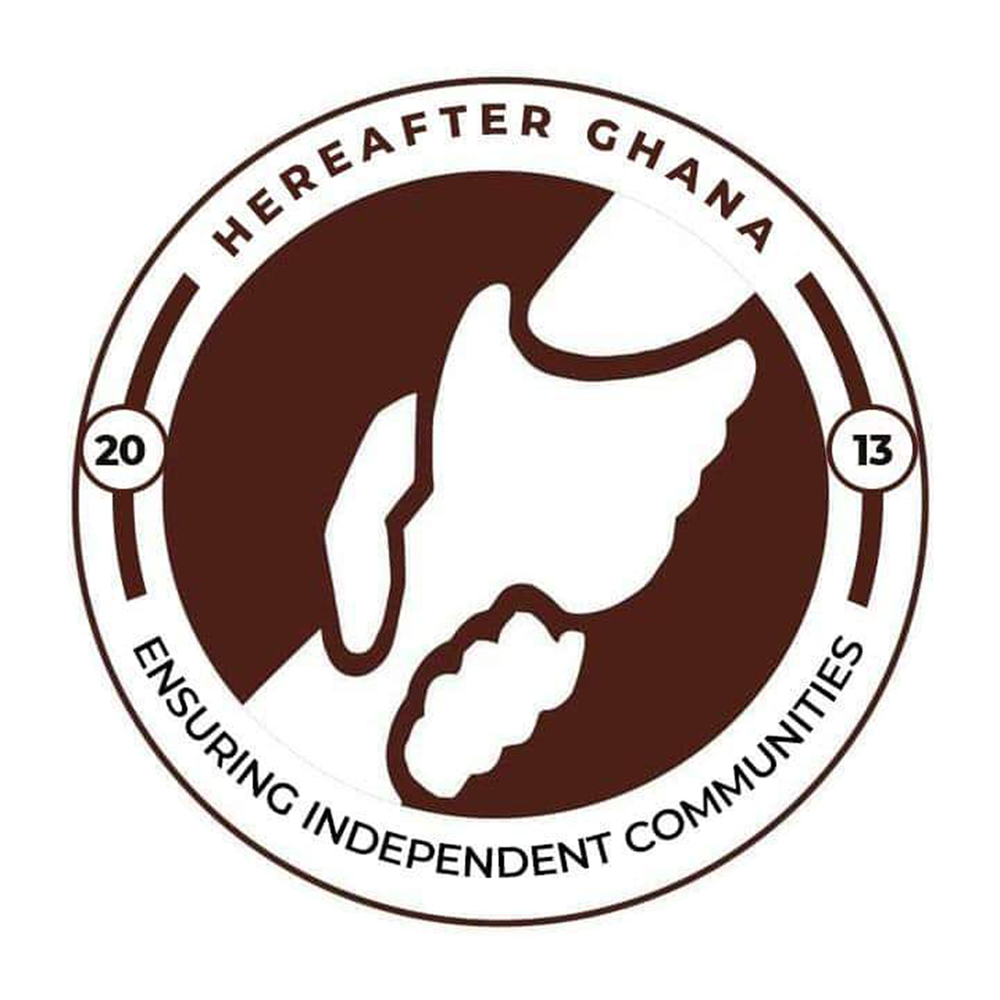

Date: 14th September, 2025
Prepared by Sulemana Suabira
Administrative Assistant

Introduction
The Hereafter Ghana Health Financing Project is a core humanitarian initiative designed to provide financial assistance for healthcare to vulnerable individuals within the community. Its primary objective is to reduce the burden of medical expenses for those who are unable to access health services due to financial limitations.
In the third quarter of 2025, Hereafter Ghana supported a total of health cases, each presenting unique challenges and requiring tailored interventions. This report offers a summary of the medical conditions addressed and the progress made by each beneficiary.
CASE 189
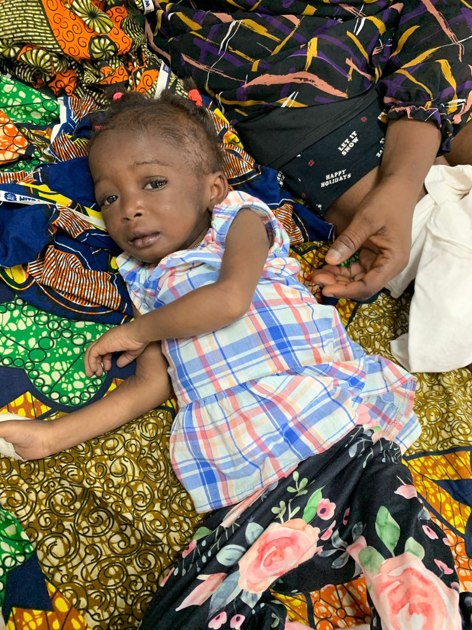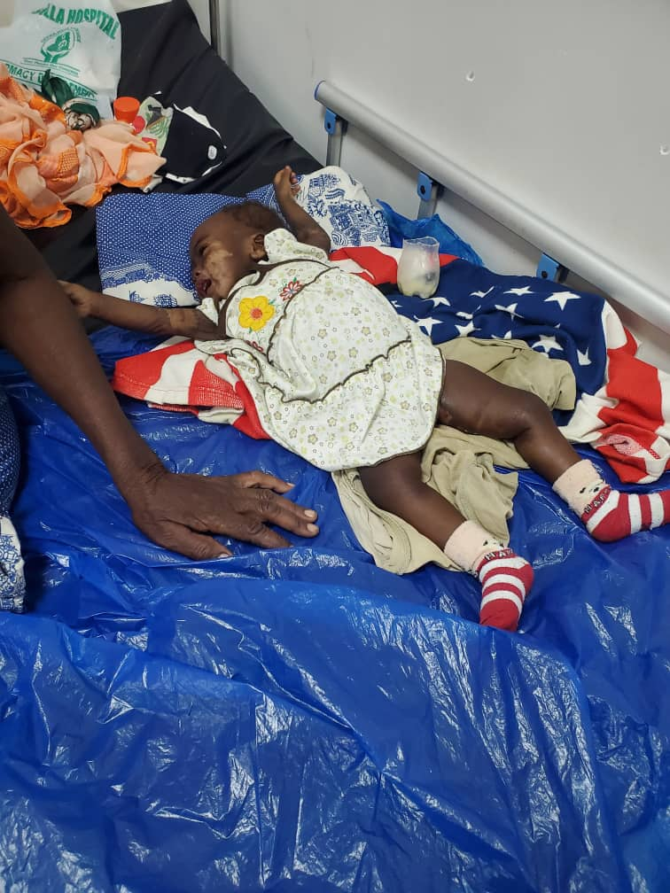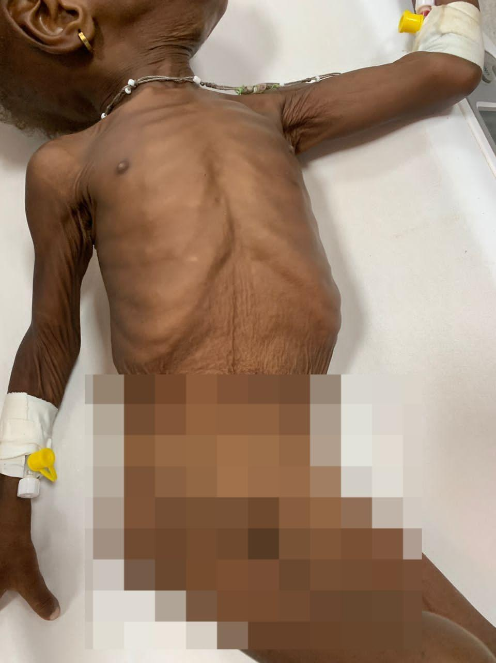
Patient name: Mawadda, Lamisi and Melody(Zebila kids)
Condition: Severe Malnutrition
Mawadda, Lamisi and Melody were admitted at the Zebilla District Hospital due to severe malnutrition. They had severely lost weight and it posed threats to their lives as it resulted in other health complications like anemia. They needed urgent intervention to aid in their recovery as their conditions became increasingly fatal.
PROGRESS
A total amount of Ghs 2625.00 was donated to them, from Madam Rashida Saani’s zakat fund. The funds were used for medications, lab tests, hospital bills and the preparation of therapeutic(F 75 and F 100) feed to help the kids recover swiftly.
The kids have since been discharged as their health has significantly improved.
CASE 190
Patient name: Hamida Yakubu
Condition: Chronic Synovitis with nasal polyps
Madam Hamida was diagnosed with Chronic Synovitis with nasal polyps at the Tamale Teaching Hospital which caused severe joint swelling and affected her nasal passage. Her condition caused her not only pain but also discomfort in breathing almost causing her to lose her sense of smell. She needed an urgent surgery to correct her condition. She needed Ghc 6000 for the surgery and medications.
PROGRESS
The total amount of Ghs 6000.00 was donated to her from the Ghs 5 monthly charity support. She had a successful surgery and has since seen massive improvement in her condition and her health in general.
CASE 191
Patient name: Iddrisu Adamu
Condition: EVD
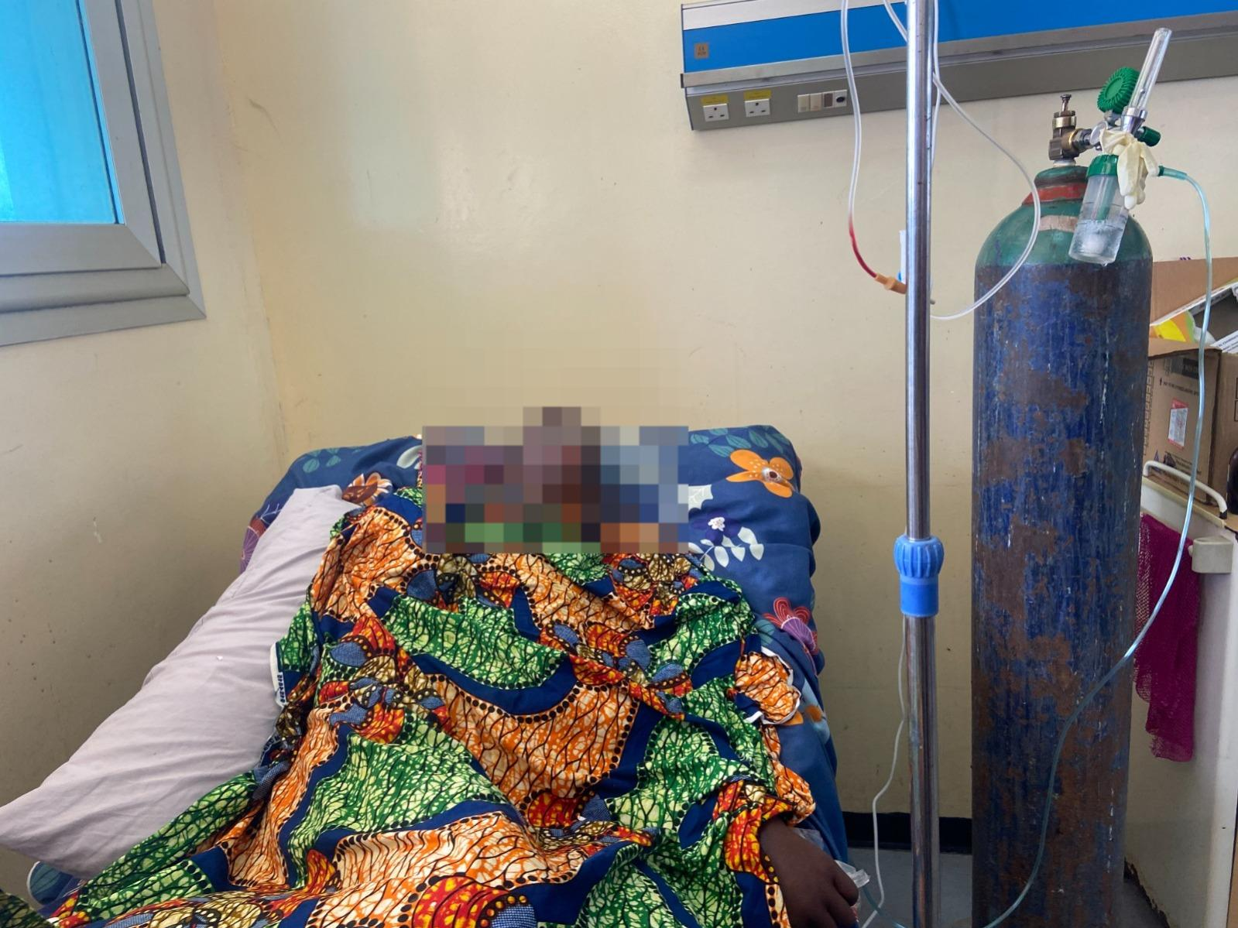
Madam Adamu was admitted at the Tamale Teaching Hospital. She was treated for EVD and other conditions. Her condition left her comatosed. She needed an urgent surgery as her condition was proven to be fatal. An amount of Ghs 17000.00 was needed for surgery and medications.
PROGRESS
Madam Adamu and her family received an amount of Ghs 15,000 for her treatment. Ghs 7000 was raised from the donations of the general public and Ghs 8000 was obtained from the zakat fund. She had a successful surgery and is still recovering.
CASE 192
Patient name: Mohammed Zuberu
Condition: Partial Edentulism 20 trauma and Asthma
Mr. Zuneru suffered from severe tooth ache that affected his ability to grind food properly that led to improper mastication of food. It also caused his gum to swell. After a dentist review, he needed immediate treatment as it posed the risk of getting infected. He also suffered from severe asthma and needed to replace his inhaler and buy his medications. He needed Ghs 1900 for the total treatment process and medications.
PROGRESS
From the Ghs 5 charity fund, the total amount was donated to him. He received both treatment and was able to purchase his medications. His tooth has completely healed and he has been faring well.
CASE 193
Patient name: Mohammed Ghazale
Condition: Spinal tumor Extramedullary
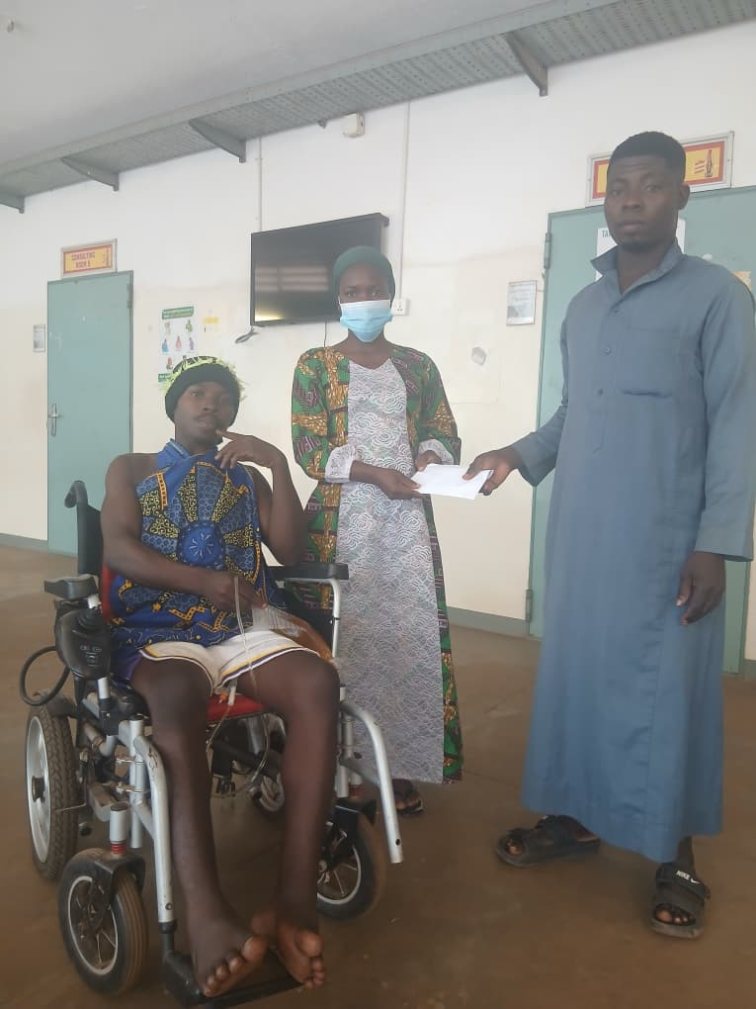
Ghazale was 22 years old and was diagnosed with Spinal tumor Extramedullary at the Tamale Teaching Hospital. His condition caused him to be paralysed in his left leg. He was met with persistent pain and this led to several other complications. He needed an amount of Ghs 4010 for an MRI of the Lumbosacral and Thoracic spine for further investigations of his required treatment.
PROGRESS
Ghazale and his family received a total amount of GHS 4,000 from the GH₵5 Charity Fund to support his medical tests. The amount facilitated the successful completion of his MRI scan in Accra, after which he continues to receive ongoing treatment.
CASE 194
Patient name: Mohammed Abdul Rahim
Condition: Fusion of Craniocervical Junction
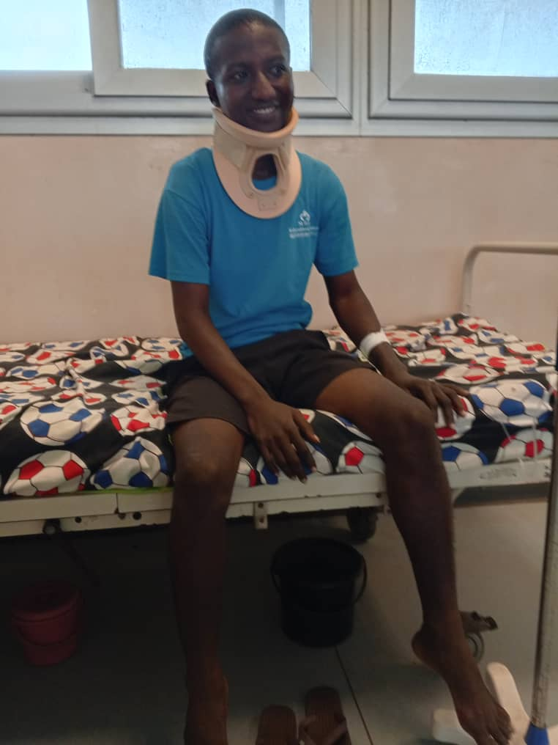
Abdul Rahim suffers from a condition that caused a fusion between his skull and upper cervical spine. This affected the motion of his neck and left him with severe constant pain. He needed a correction surgery and required an amount of Ghs 10,000 to add up for the surgery and medications.
PROGRESS
An amount of GHS 5000 was donated to him from the Zakat Fund to support his family in purchasing the required medications following his successful surgery. He has since shown significant improvement in his recovery.
CASE 195
Patient name: Ayisha Iddrisu
Condition: Post traumatic Ulcer
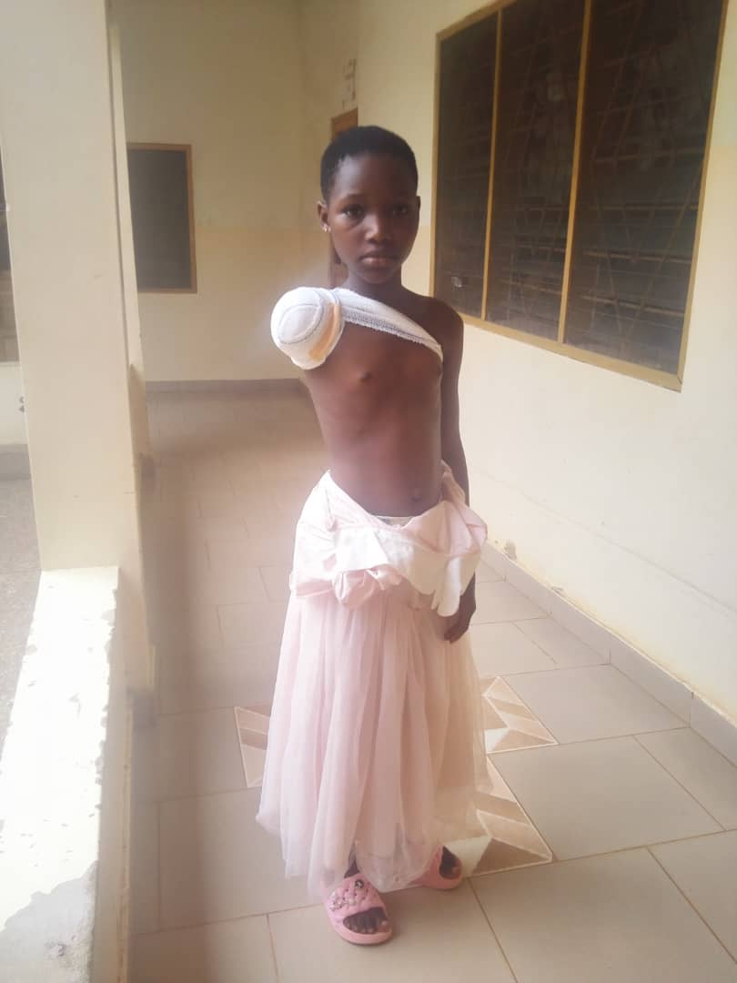
Ayisha suffered a post traumatic ulcer due to an accident. She was admitted at St. Patricks Hospital in Kumasi. Due to the accident, her right arm was amputated. Ayisha needed an urgent surgery as the impact of the accident posed a severe threat to her life. She needed an amount of Ghs 3000 for her surgery.
PROGRESS
From the generous donations of the public, she received Ghs 3000 and had a successful surgery. Ayisha shows a progressively slow recovery and the ulcer no longer poses a threat to her life.
CASE 196
Patient name: Ameer Suhudoo Jibril
Condition: Seizures
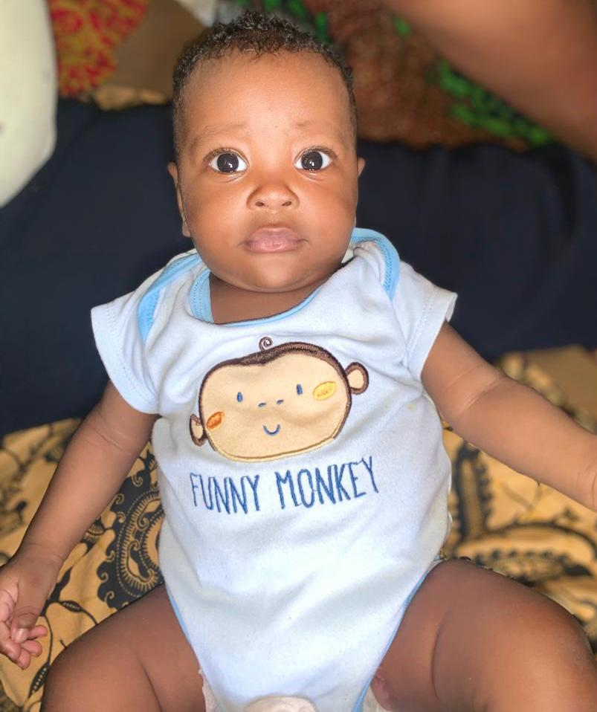
Jibril was a two year old that suffered a severe seizure disorder. Doctors needed further tests to clearly understand the root cause of the seizures. They needed an amount of Ghs 2500 for the test to to purchase some medications he needed at the hospital.
PROGRESS
From the Ghs 5 donations, the total amount Ghs 2500 was donated to his family to support medical tests and prescribed medications. He is currently showing gradual signs of recovery.

CASE 197
Patient name: Abdul Jalil Muaz
Condition: Intussusception
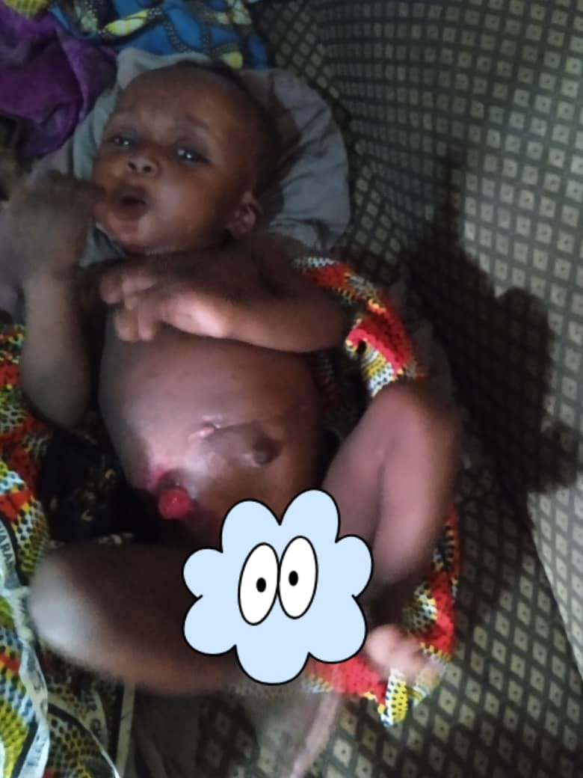
Baby Muaz suffered a rare condition where part of the intestines folds into an adjacent section. This caused blockage that prevented foods and fluids from passing through the intestines properly.Following the initial procedure, a reversal surgery was necessary to restore normal bowel function. The estimated cost for the reversal surgery and medications amounted to GHS 4000.
PROGRESS
The total amount was donated to him from the Ghs 60,000 zakat fund. This supported his family in the purchases of equipment for the surgery and the surgical procedure. Baby Muaz is showing signs of recovery.
CONCLUSION
This report presents a summary of medical support cases addressed during the third quarter. Hereafter Ghana remains committed to improving the health and well-being of underserved populations across the country and stands ready to offer assistance regardless of geographical location.
ACKNOWLEDGEMENT
Hereafter Ghana extends its heartfelt appreciation to all our esteemed donors and the committed staff as well as volunteers for their invaluable contributions to the Health Financing project.
Your unwavering support and collaboration have been instrumental in ensuring that vulnerable children in underserved communities gain access to essential healthcare services. The success of this initiative reflects your shared commitment to safeguarding the health and well-being of every child, and we are deeply grateful for the trust and partnership you continue to show.

