HEREAFTER GHANA (MHP)
QUARTERLY REPORT FOR GLOBAL GIVING (APRIL-JUNE 2025)
PROJECT TITLE: GIVING FOR HEALTH (HEALTH CASES)
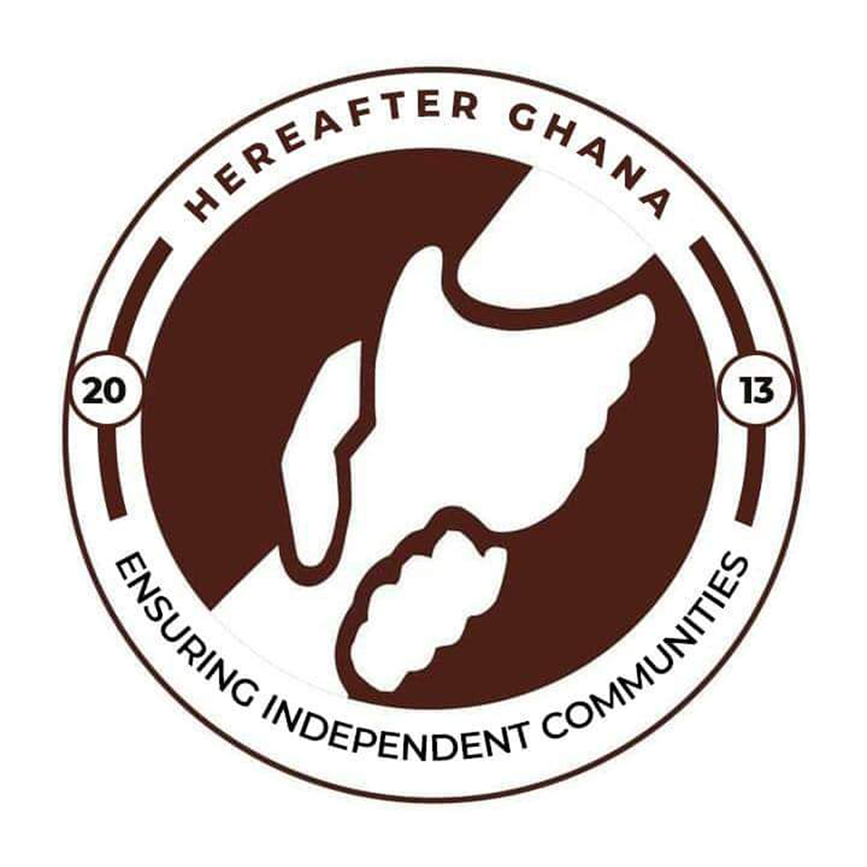
Date:20th July 2025
Prepared by Sulemana Suabira
Administrative Assistant

Introduction
The Hereafter Ghana Health Financing Project is a core humanitarian initiative designed to provide financial assistance for healthcare to vulnerable individuals within the community. Its primary objective is to reduce the burden of medical expenses for those who are unable to access health services due to financial limitations.
In the second quarter of 2025, Hereafter Ghana supported a total of 15 health cases, each presenting unique challenges and requiring tailored interventions. This report offers a summary of the medical conditions addressed and the progress made by each beneficiary.
CASE 175
Patient name: Baby Hadiza Sumaila
Condition: Abdominal Fluid and Mass
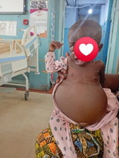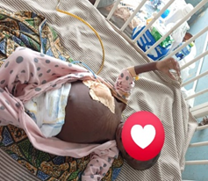
Baby Hadiza was admitted with a significantly distended abdomen caused by the presence of abnormal fluid and a mass in her stomach. This condition resulted in an unusually enlarged belly, far exceeding the typical size for an infant.Following admission, initial laboratory tests, imaging scans, and prescribed medications were administered to support a comprehensive diagnosis. The medical team proceeded to drain the excess fluid as part of the treatment plan.
PROGRESS
Hadiza remained hospitalized for two weeks, during which time she received medical care aimed at stabilizing her condition. She received Ghc10,500 from the zakat donations that was used to drain the fluid.
Regrettably, despite these efforts, we received the heartbreaking news of her passing just one week later.
CASE 176
Patient name: Charles Agitteh
Condition:Accident/Plastic surgery
Mr. Agitteh was admitted at the Korle Bu Teaching Hospital due to an accident. The impact left him with a post traumatic disfigurement. His situation was very critical and he needed immediate plastic surgery. He needed an amount of Ghc3,100 for his surgery.
PROGRESS
Hereafter Ghana donated the full amount of Ghc 3100 to Mr. He had a successful surgery and is still in the recovery process. This fund was obtained from the April Ghc5 charity.
CASE 177
Patient name: Baby Ibrahim Sumaya
Condition: Premature birth
NOTE: A picture of the baby couldn’t be taken since she was admitted to the NICU.
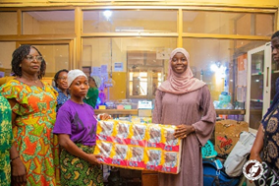
Baby sumaiya was born premature with a weight less than 2kg (Picture attached). She was admitted at the NICU of the Tamale Regional Hospital where she was to undergo intensive nutrition and health support. The hospital reached out for financial aid to purchase toiletries, baby foods and feeding stipend for the family as the parents couldn’t afford any.
PROGRESS
An amount of Ghs 2000 worth of items were donated which included diapers, feed, toiletries, wipes and a stipend of Ghs 500 was given to the mother to help during their stay in the hospital.This was gotten from the ramadan zakat donations.
NOTE: The NICU unit of the Tamale Regional Hospital also received violet and yellow cannulas and a flow meter to assist in the wards.
CASE 178
Patient name: Baby Alhassan Umar,
Condition: Premature birth
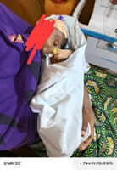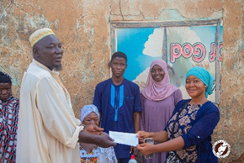
Baby Umar was born to a blind dad and a mentally challenged mum (pic attached). He was born with a very low weight and signs of severe malnutrition; mother couldn’t produce enough breastmilk as she couldn’t afford quality food. Baby umar was received at the NICU of the Tamale regional hospital for intensive care. We met the family after discharge.
PROGRESS
From the Zakat fund donated to help hospital cases, items worth Ghs 2000 which included toiletries, feed, wipes and other essentials were donated to them. Her mother also received a stipend of Ghs 500 for the upkeep of her baby.
CASE 179
Patient name: Amina Sefiyatu
Condition: Cognitive Hearing Loss
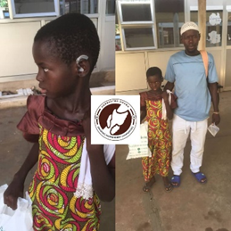
Aminu Sefiyatu suffered Hearing Loss since she was little and needed hearing aids to assist her in hearing. An amount of Ghc 8,000 was required to purchase hearing aids for both ears that are left and right.
PROGRESS
The total amount was donated to her to purchase hearing aids for her. The amount was obtained from the Zakat donation.
CASE 180
Patient name: MR. Ibrahim Aidoo
Condition: E.U.A Larynx and Biospy
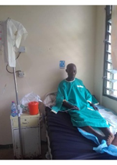
Mr. Ibrahim, a devoted Muazin who has served his local mosque in Cape Coast for over two decades, experienced a significant decline in his vocal and auditory abilities due to a chronic throat condition. His deteriorating health hindered his ability to perform his duties and communicate effectively within his community.
It was determined that corrective surgery at the Cape Coast Hospital was necessary, with a total cost of GHC 5,000.
PROGRESS
With support from the Zakat Fund, Mr. Ibrahim received the full amount required for his surgery. He had a successful surgery and is still in his recovery process.
CASE 181
Patient name Yaw- Kan- Afoe
Condition: Bloated eyes
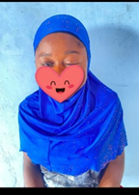
Afoe, was diagnosed with a critical eye condition that left one of her eyes severely swollen and persistently teary. Medical professionals expressed concern that the damage was nearing irreversible levels, with the risk of permanent loss of vision.
Her treatment required an urgent intervention, estimated at GHC 3,000.
PROGRESS
Hereafter Ghana, with support from the Zakat Fund, the full amount was provided, allowing Afoe to receive the necessary medical care. This timely intervention not only helped save her vision but also restored hope for her and her family.
CASE 182
Patient name: Iddrisu Muazu
Condition: Empyema Intracranial
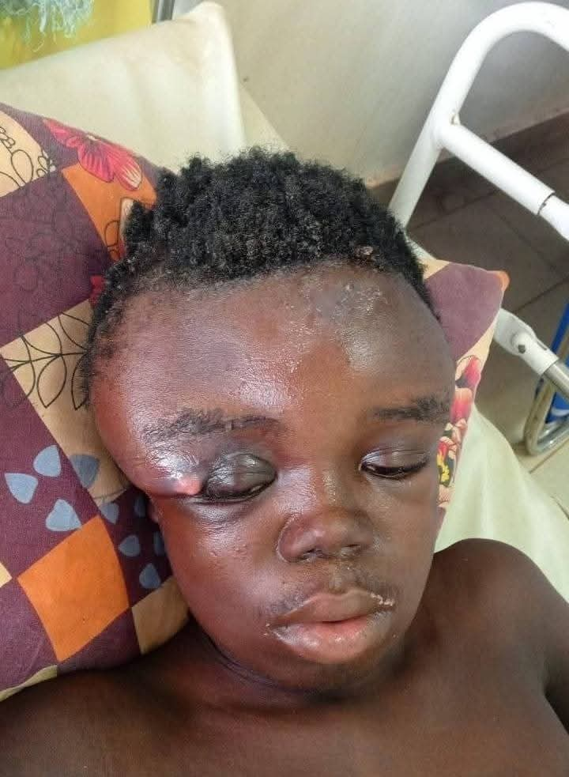
Iddrisu was diagnosed with Empyema Intracranial at the Tamale Teaching Hospital and admitted to the Neurology Ward for urgent care. His condition involved a significant accumulation of pus within the cranial cavity, leading to visible swelling of the head and causing him intense and persistent pain.
The total estimated cost for the required surgery, post-operative care, and associated medical expenses amounted to GHC 25,400. This amount was necessary to ensure timely treatment and support Iddrisu’s recovery process.
PROGRESS
An amount of Ghc 7000 was donated to him from the Ghc 5 monthly donations from may. This amount was to aid in his treatment and medications as it couldn’t cater for the surgery.
CASE 183
Patient name: Moomin
Condition: End Stage Kidney Failure
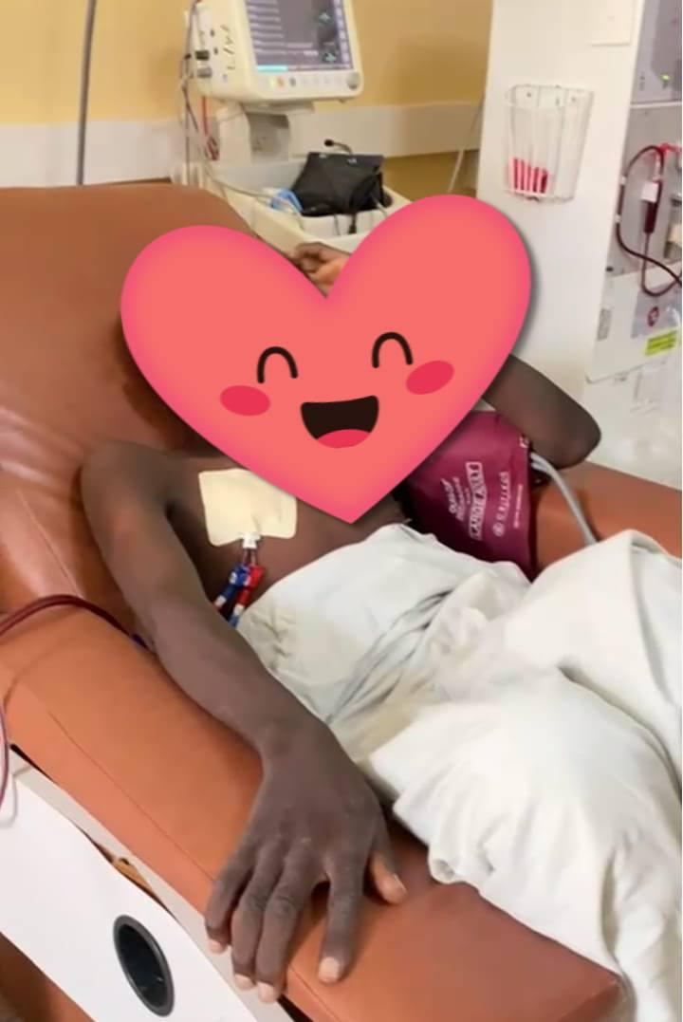
Brother Moomin was admitted at the Tamale Teaching Hospital and diagnosed with End stage kidney failure. He needed a kidney transplant as his condition was fatal to his health.
PROGRESS
Hereafter Ghana due to the urgency of the situation and lack of funds could not pay for the transplant but paid for a month's worth of dialysis. An amount of Ghc 3600 was donated to cater for a month’s worth of dialysis. This was obtained from the Ghc 5 monthly charity donations.
CASE 184
Patient name: Blessing Asimenu
Condition: lumbosacral mass at birth
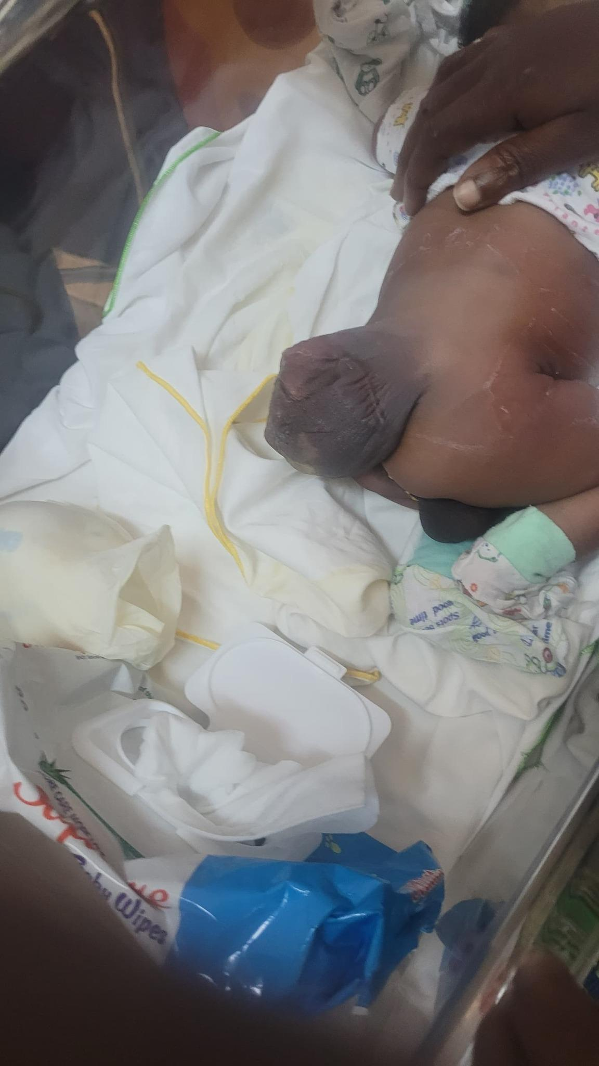
Blessing was born with a mass between her lumbar spine and her sacrum. This mass caused her severe pain that needed to be removed.
PROGRESS
From the Ghc5 and Arafah day donations, a first intervention that was the need for an MRI scan was paid for by Hereafter Ghana to facilitate timely intervention.
CASE 185
Patient name: Khadijah Mohammed and her baby
Condition: Child Birth
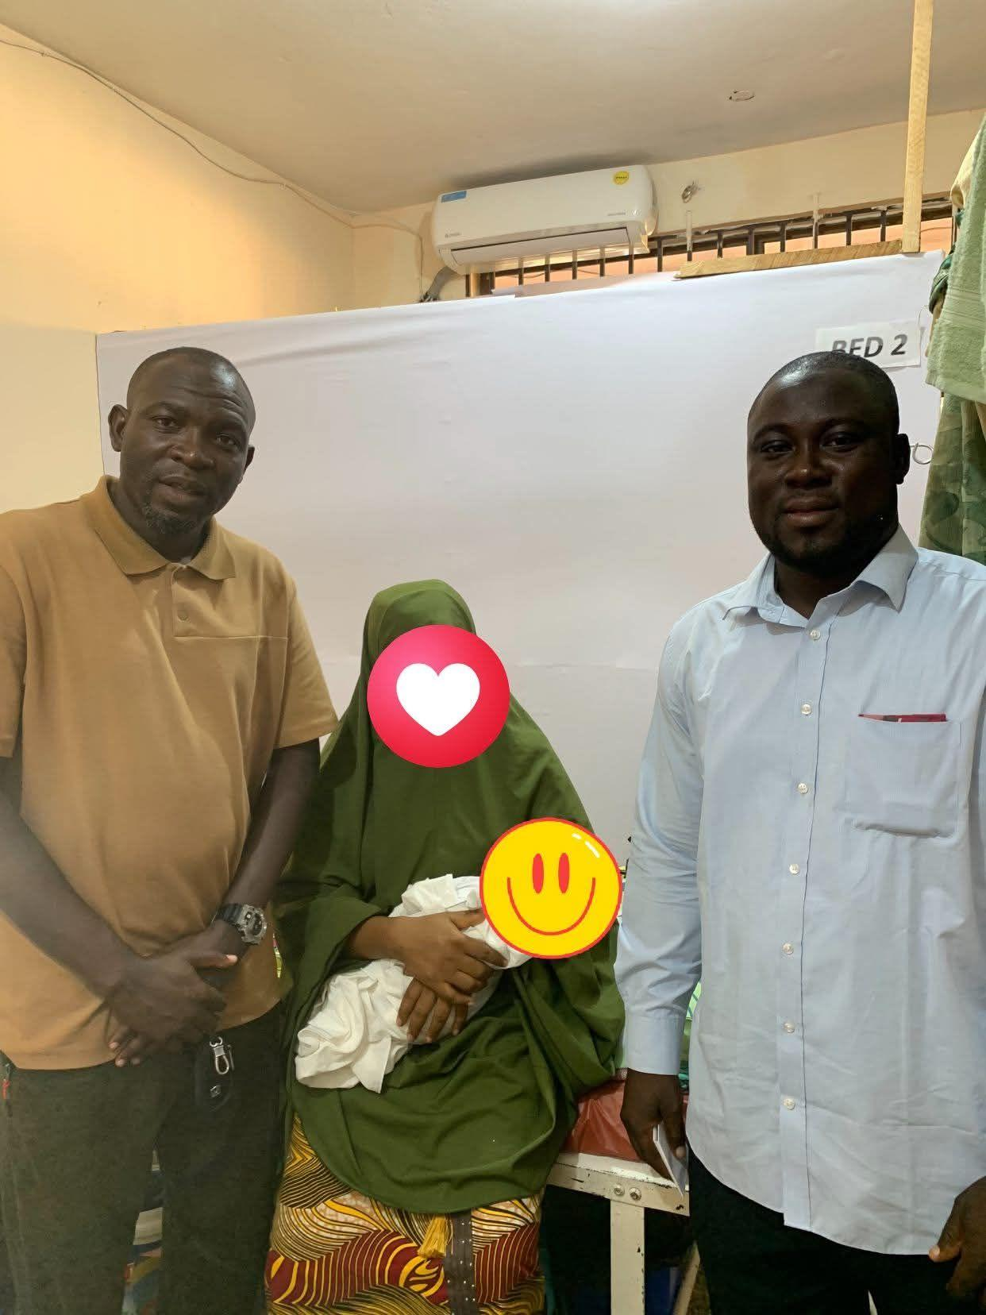
Following the delivery of her baby, Madam Khadijah experienced a series of postnatal complications that required ongoing medical attention. Unfortunately, due to financial constraints, she was unable to afford the necessary medications for both herself and her newborn.
This situation resulted in an accumulation of hospital bills, placing significant emotional and financial stress on her.
PROGRESS
Hereafter Ghana, through the generous contribution of a donor committed to supporting underprivileged children, intervened to assist Madam Khadijah in settling her medical expenses. A total amount of GHC 3,995 was paid to cover the outstanding hospital bill in full, enabling both mother and baby to be discharged and return home in stable condition. In addition to settling the hospital costs, other donations were given to Madam Khadijah as business capital. This support aims to empower her economically, promote financial independence, and ensure a sustainable livelihood for her and her child.
CASE 186
Patient name: Wuntima
Condition: Nephrotic Syndrome
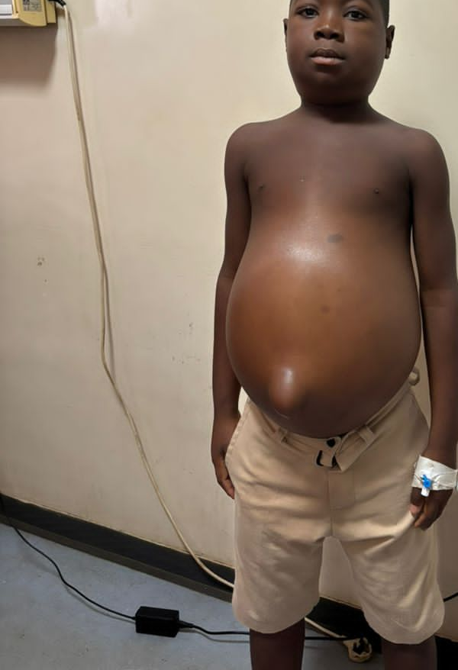
Sandra Wuntimah, a resident of Dindane in the North East Region, suffered from Nephrotic Syndrome, a condition requiring consistent medical attention, including laboratory tests and prescribed medications
PROGRESS
To assist in her treatment process ,Hereafter Ghana provided her with an amount of GHC 2,000 to support the cost of her medications and diagnostics.
CASE 187
Patient name: Niyaasangma Yajache
Condition: Relapse Nephrotic Syndrome
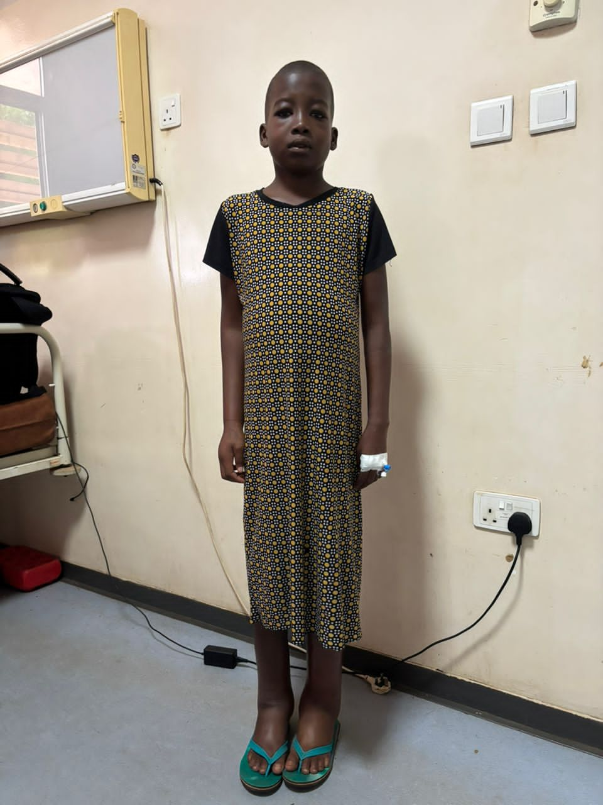
Niyaasangma Yajache, an 11-year-old from Sabina, is currently battling a relapse of Nephrotic Syndrome. She required Methylprednisolone and Prednisolone, essential medications for managing her condition, at a total cost of GHC 780.
PROGRESS
The total amount was donated to him for the purchase of his medications to aid in his treatment.
CASE 188
Patient name: Ramadan
Condition: Malnutrition
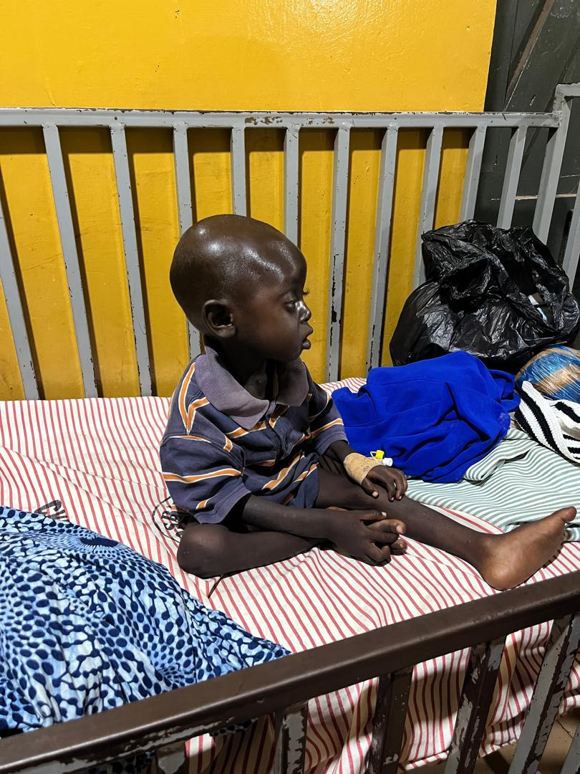
Ramadan, from Kunyevila, was diagnosed with severe malnutrition and received initial emergency care at the hospital. Following his discharge, there was a critical need for a structured nutrition plan and dietary support to sustain his recovery.
PROGRESS
To assist his family in continuing the recommended feeding regimen, an amount of GHC 300 was donated, enabling the purchase of all necessary items to prepare a special therapeutic food for him.
CASE 168
Patient name: Elsie Kyilu
Condition: Cochlear Implant
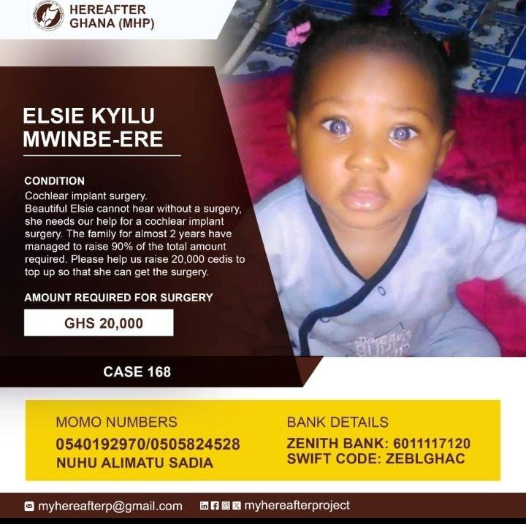
Baby Elsie suffered from a condition that caused her not to be able to see and hear. She needed cochlear implant surgery to restore her hearing. She needed an amount of Ghc 20000 to top up to be able to do her surgery.
PROGRESS
With the help of the general public, Hereafter Ghana donated an amount of Ghc 10,000 to her to be able to proceed with her surgery.
CONCLUSION
This report presents a summary of medical support cases addressed during the second quarter. Hereafter Ghana remains committed to improving the health and well-being of underserved populations across the country and stands ready to offer assistance regardless of geographical location.
ACKNOWLEDGEMENT
Hereafter Ghana extends its heartfelt appreciation to all our esteemed donors and the committed staff as well as volunteers for their invaluable contributions to the Health Financing project.
Your unwavering support and collaboration have been instrumental in ensuring that vulnerable children in underserved communities gain access to essential healthcare services. The success of this initiative reflects your shared commitment to safeguarding the health and well-being of every child, and we are deeply grateful for the trust and partnership you continue to show.

