HEREAFTER GHANA
QUARTERLY REPORT FOR GLOBAL GIVING (JULY-SEPTEMBER 2024)
PROJECT TITLE: GIVING FOR HEALTH (HEALTH CASES)
INTRODUCTION
During this quarter, Hereafter Ghana (MHP) handled a total of 8 cases. Each case showcased its distinctive challenges and required specific attention. This report provides an overview of the various conditions and the progress made by each individual.
CASE 141
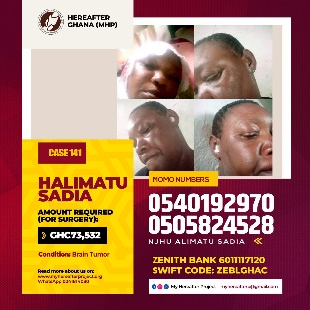
Patient name: Halimatu
Condition: Brain tumor
Madam Halima has been battling with brain tumor while taking care of her four kids. Unfortunately, her life is at risk as it has worsen causing discharges from her ears. Madam Halima required about 73,534 Ghana cedis to undergo surgery.
Progress: A sum of Ghc 8,000 was solicited from the general public and donated to Madam Halima to support her start the required treatment for her brain tumor.

CASE 142

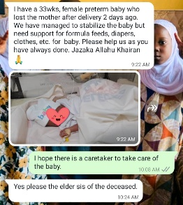
Patient name: Newly born
Condition: Preterm orphan

A female baby born Preterm lost her mother at the Bongo District hospital needs basic necessities like clothes, formulae, socks and others in order to survive.
Progress: Hereafter Ghana was able to provide the hospital and family of the baby with Cash of GHS1, 000 (For upkeep), 9 formula (NAN 1), 3 preterm formula; In all a carton (12) of formula, A bucket of kleesoft powdered soap, Half box of obolo soap, Clothes including overalls, Socks, Baby cap, bathing soap, Baby oil, Pomade, Power zone, Packs of softcare diapers, and wipes for the upkeep of the baby.
And this was done through the generous donations made by the public.
A busniness support capital of 1000 cedis was given to her caretaker to expand her business. Also baby is entitled to 200 cedis monthly stipend for feeding and clothing

CASE 143
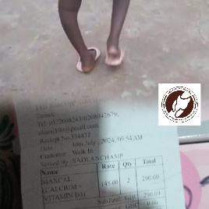
Patient name: Adila
Condition: Thigh Fracture

Adila, who had a fracture in the thigh at 4weeks of birth from a fall is faced with a continuous curvature of the leg which causes her pain and a lot of discomfort during walking. An amount of 800 Ghana Cedis was requested for laps to determine the progress of the treatment.

Progress: From the monthly 5 cedis donations, the total amount of the labs were paid and 3 months’ worth of medications were summed to a total of Ghc 1,100. This allowed her to start healing as the treatments proceeded. Following up after 3 months of medication. Another 2months was requested which was purchased for her at 350 Ghana cedis.
CASE 144
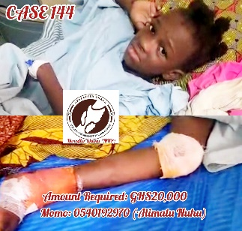
Patient name: Doka
Condition:
Little Doka met with an unfortunate motor accident which caused her severe injuries as a result. Unfortunately, it worsened to a point she cannot get up and go on with her daily activities. An amount of Ghc 20,000 is needed for a correction surgery to help little Doka back on her feet.

Progress: An amount of 8,000 Ghana Cedis was raised by the general public in support of little Doka’s surgery. This was donated to her family to support her surgery. Currently she has had a successful surgery and in her recovery stage.

CASE 145
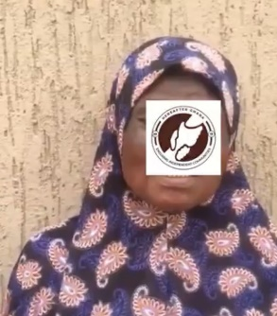
Patient name: Abu
Condition: Breast Cancer
She was diagnosed of breast cancer at the Tamale Teaching Hospital which is unfortunately posing as a treat to her life. She was then seeking for support for her treatments and chemotherapy sessions to survive to able to take care of her six kids.

Progress: Through the monthly Ghc5 donations, a sum of 2,000 Ghana cedis was donated to her to support in her treatments and chemotherapy sessions.

CASE
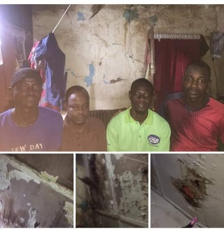
Condition: Dilapidated Home Of Disabled Men
Four disabled men, three with speech and hearing disability but with the forth man with both disability and no eyesight live in a home of which its conditions is much deteriorated. From cracked ceiling to walls, untilled floor, lighting problems to mention but few. Three have been battling side jobs to support their friend. An estimated amount of Ghc 20,000 is needed for the renovation of their home to help improve their living conditions.
Progress: An amount of Ghc 8700 was raised for the renovation. An amount of Ghc 4040 have been used for wood, Plywood, Roofing sheets, Nails, Workmanship, Transportation, Woodcutting and more. The room has been renovated and handed back to them as well as an amount of 1000 Ghana Cedis. Food and other items were also purchased and handed over to them.

CASE 146

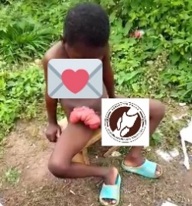
Patient Name: Chnimal
Condition:
Chnimal suffered from a condition that caused his intestines escaping out of his skin. He needed urgent surgery that was estimated to cost 15,000 Ghana Cedis.
Progress:
Chnimal visited a specialist at the Tamale Teaching Hospital on Monday 30th September 2024 to schedule for surgery as the full amount was made. It was indicated that he needs to use a bag after which the surgery will be done. Chnimal then had a successful first surgery of which all medications and labs including cost of the surgery was paid for. Current post surgery care expenses are also being handled. Chinmal has been booked for a final surgery after 3 months.

CASE 147
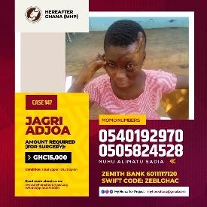
Patient Name: Jagri
Condition: Total Upper Lid Ectropion
Jagri suffered burns as a child which affected some parts of her skull and caused her eye not to close even when she’s asleep. An estimated amount of 15,000 Ghana cedis was required for surgery to help repair her eyelid.
Progress: An amount of 10,000 Ghana Cedis was raised and donated to her family with the help of the general public.

In a quest to improve the health conditions of the Ghanaian people, we at Hereafter Ghana are always ready to come to the aid of these individuals who call upon us irrespective of the part of the country they are located.

