HEREAFTER GHANA (MHP)
QUARTERLY REPORT FOR GLOBAL GIVING (JANUARY - MATCH2026)
PROJECT TITLE: GIVING FOR HEALTH (HEALTH CASES)

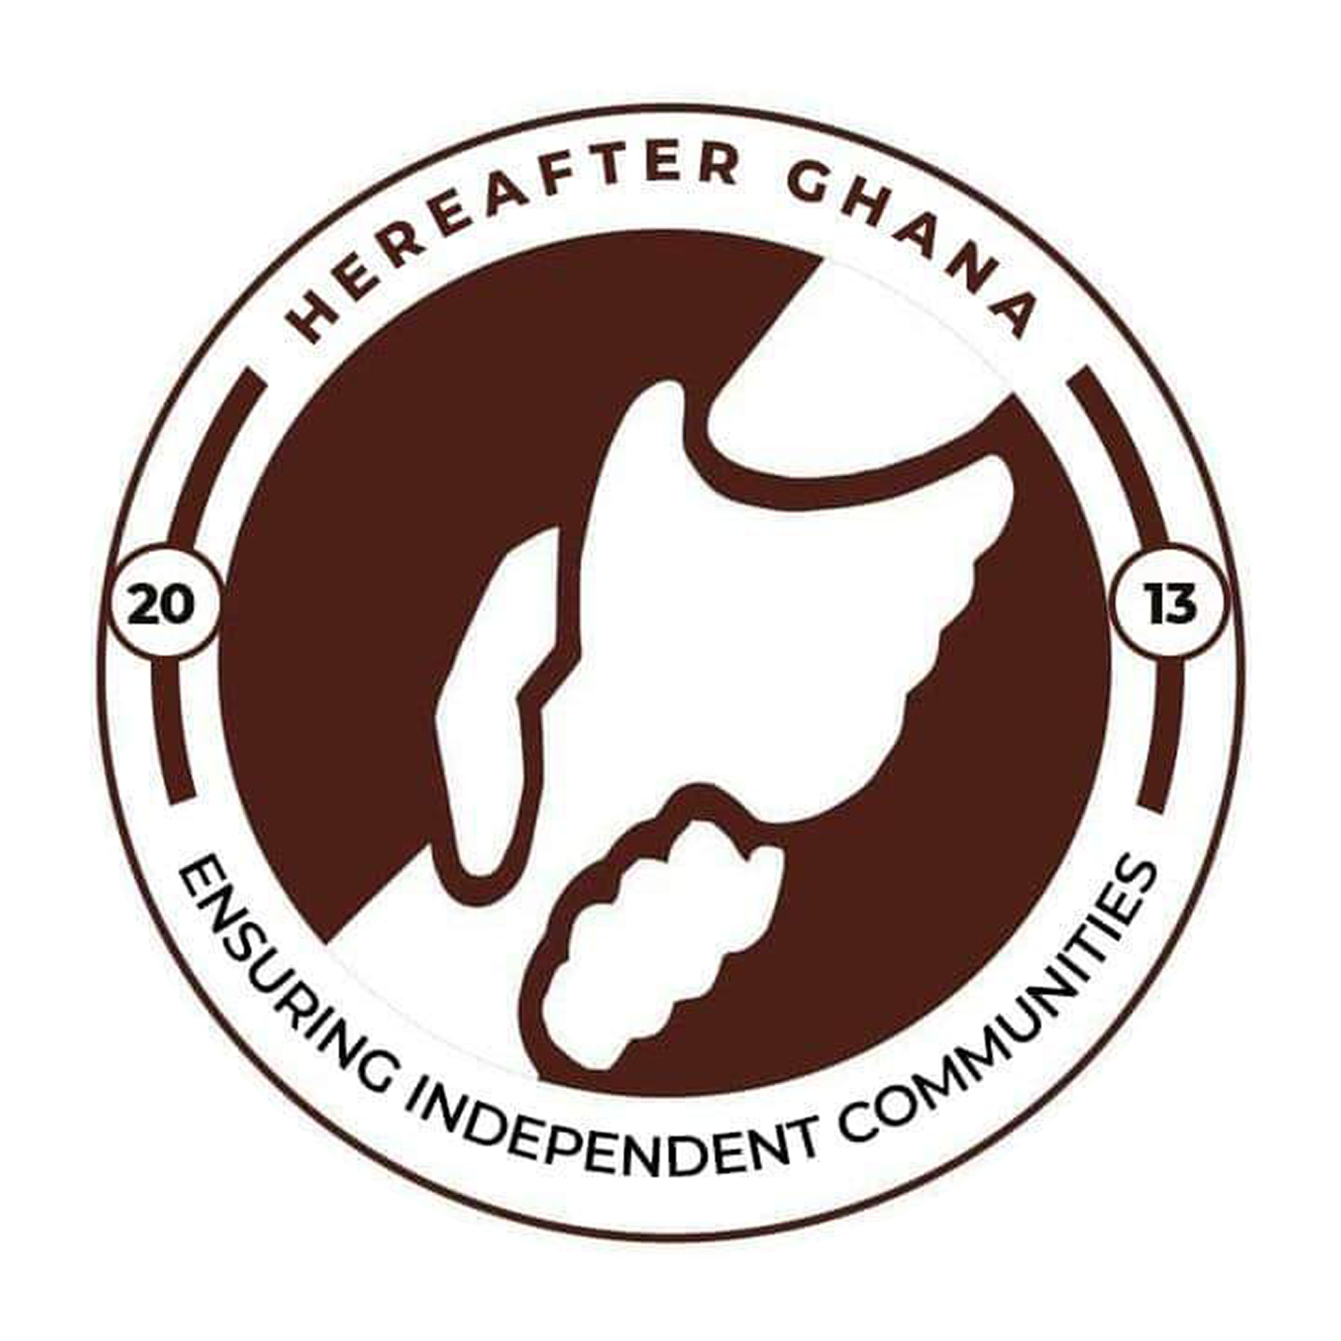

INTRODUCTION
Hereafter Ghana’s Patient Rescue Fund is a core humanitarian initiative designed to provide financial assistance for healthcare to vulnerable individuals within the community. The project was previously termed as the Health Finance Project, went through strategic rebranding to better reflect its evolving scope and impact.
During the first quarter of 2026, Hereafter Ghana was presented with cases. Each presenting unique challenges and requiring tailored interventions. This report offers a summary of the medical conditions addressed and the progress made by each beneficiary.
CASE 203
Patient name: Abdul
Condition: Retinoblastoma
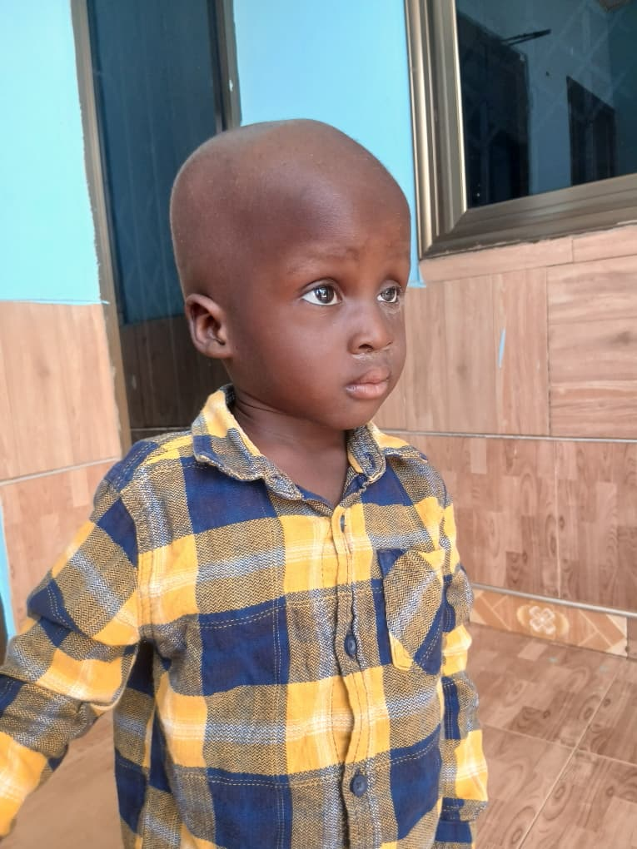
Little Abdul was diagnosed with retinoblastoma, a cancer in the retina. It caused him a temporal pause in his education as he had to seek out treatment. After careful examination, medical officers mentioned he needed multiple surgeries and a chemotherapy session to help kill the cancer cells completely.
He needed an amount of GHC 16800 to be able to go through his treatment plan.
PROGRESS
An amount of GHC 5000 was donated to his family as the first stage of his treatment process. He underwent two sessions of chemo and was requested to visit the hospital for further tests for the surgery to be scheduled. This fund was raised from the general public.
CASE 206
Patient name: (Iddris)
Condition: Waaedenburg syndrome
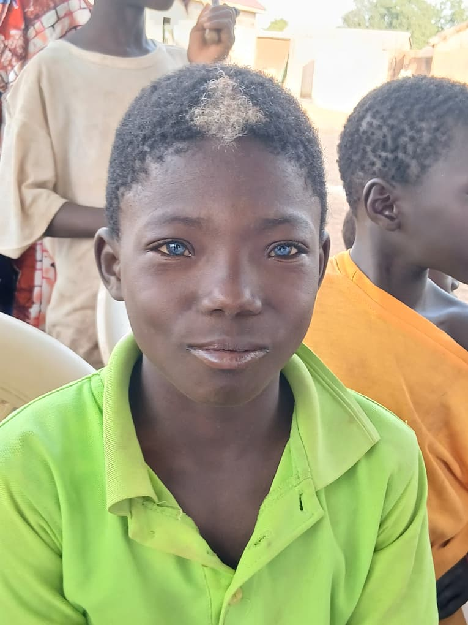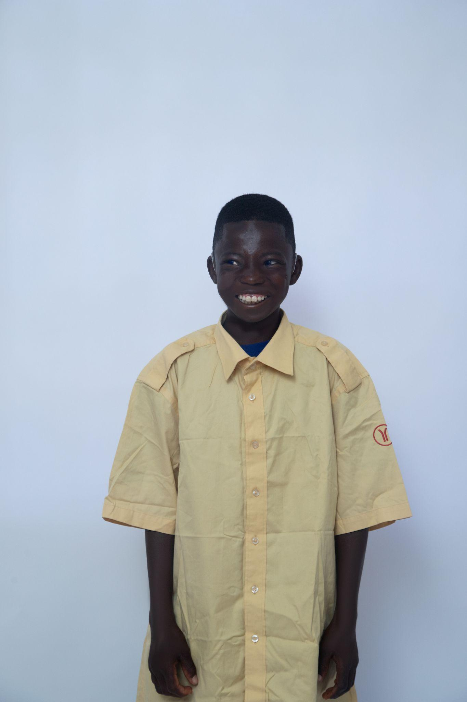
During a community Health Outreach, the team discovered Yabdoo who had striking blue eyes and a patch of grey hair but was discovered to be deaf. From an experience of a previous case, it was discovered that it was a condition called Waardenburg syndrome. A genetic condition that primarily affects the pigmentation of the hair, skin, and eyes, and can also cause hearing loss.
Subsequent medical examinations and investigations conducted at the hospital confirmed the diagnosis. Based on the clinical findings, the recommended intervention was the provision of hearing aids to support his auditory function.
A total amount of GHC 20,000 cedis was estimated for the treatment process.
POGRESS
The total amount of GHC 20,000 was successfully mobilized and disbursed in accordance with his treatment plan. Following this, he was provided with hearing aids for both ears to improve his auditory function.
In addition, as part of the comprehensive treatment plan, he was scheduled for sessions with a speech therapist to support his communication and speech development.

CASE 207
Patient name: Kadir
Condition: Hydrocephalus
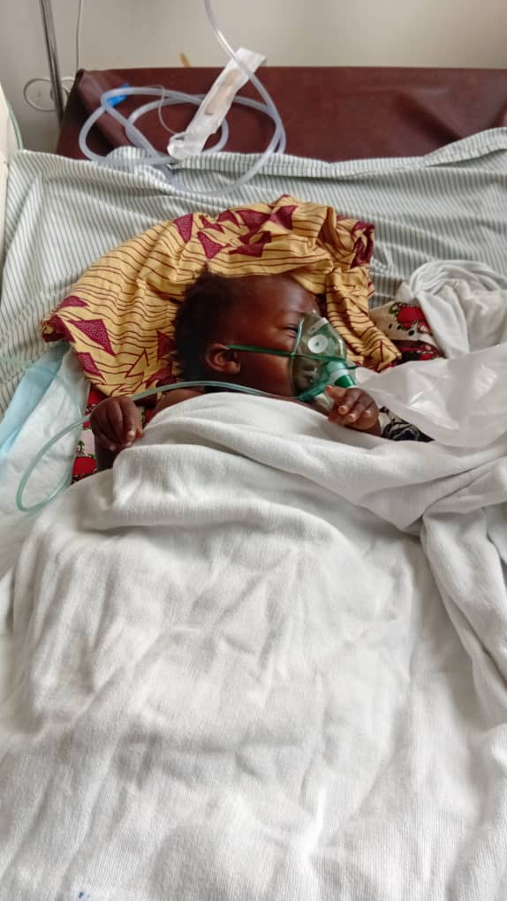
Blessing was diagnosed with Hydrocephalus, a medical condition characterized by the accumulation of fluid in the brain, resulting in swelling and increased intracranial pressure. The severity of her condition required urgent medical intervention, as it posed a significant risk to her life.
An estimated amount of GHC 18,000 was required to cover the cost of her treatment, which included a surgical procedure.
PROGRESS
The total required amount was successfully raised and disbursed to the family to facilitate the commencement of her treatment. She subsequently underwent a successful surgical procedure and is currently in the recovery phase.
CASE 209
Patient name: Mumina
Condition: Liver Injury
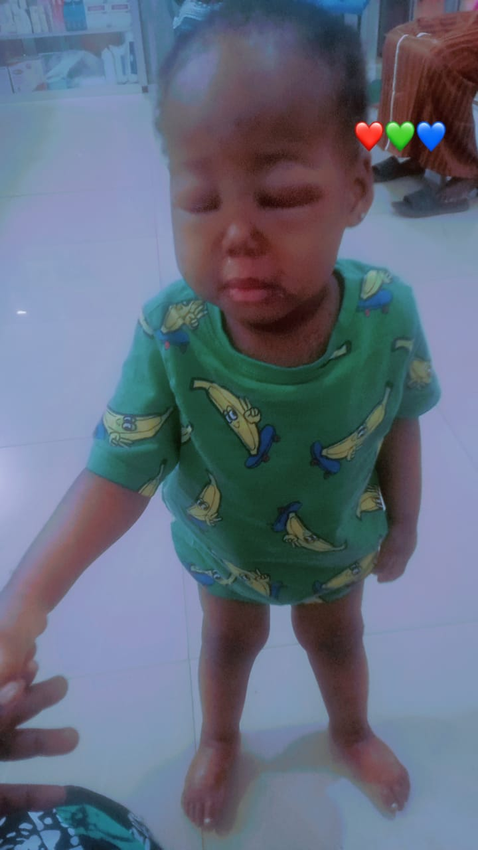
Mumina presented with severe infections that resulted in significant liver damage, leading to a progressive deterioration of her condition. Following careful observation and comprehensive medical investigations, it was confirmed that the infections had adversely affected her liver function. This subsequently caused generalized body swelling.
As part of her treatment plan, she required appropriate medications to manage and eliminate the infections from her system. She needed an amount of GHS3700 for her treatment.
PROGRESS
Hereafter Ghana successfully raised and disbursed the required funds to Mumina’s family to facilitate the commencement of her treatment. Over time, her condition showed significant improvement, with a noticeable reduction in the swelling.
During the course of her treatment, she experienced intermittent episodes of fever. In response, Hereafter Ghana provided additional financial support of GHC 300 to assist with ongoing medical care. She is currently in the recovery phase.
CASE 211
Patient name: Suraiya
Condition: Cervical Cancer
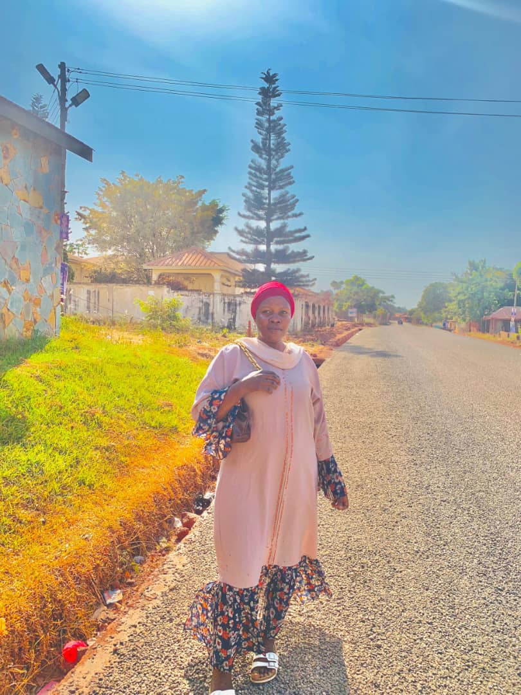
Suraiya was diagnosed with cervical cancer, a condition in which malignant cells develop in the cervix. Due to the severity of her condition, immediate surgical intervention was required to prevent the spread of the cancer to other parts of the cervix and uterus.
An additional amount of GHC 3,000 was needed to supplement existing funds in order to facilitate the surgical procedure.
PROGRESS
Hereafter Ghana provided the full required amount to Suraiya’s family to facilitate the surgical procedure. The funds were sourced from the remaining balance of Mumina’s support allocation.
Following the intervention, Suraiya underwent a successful surgery and is currently in the recovery phase.
CASE 212
Patient name: Fatima
Condition: Chronic tinnitus associated with eardrum dysfunction
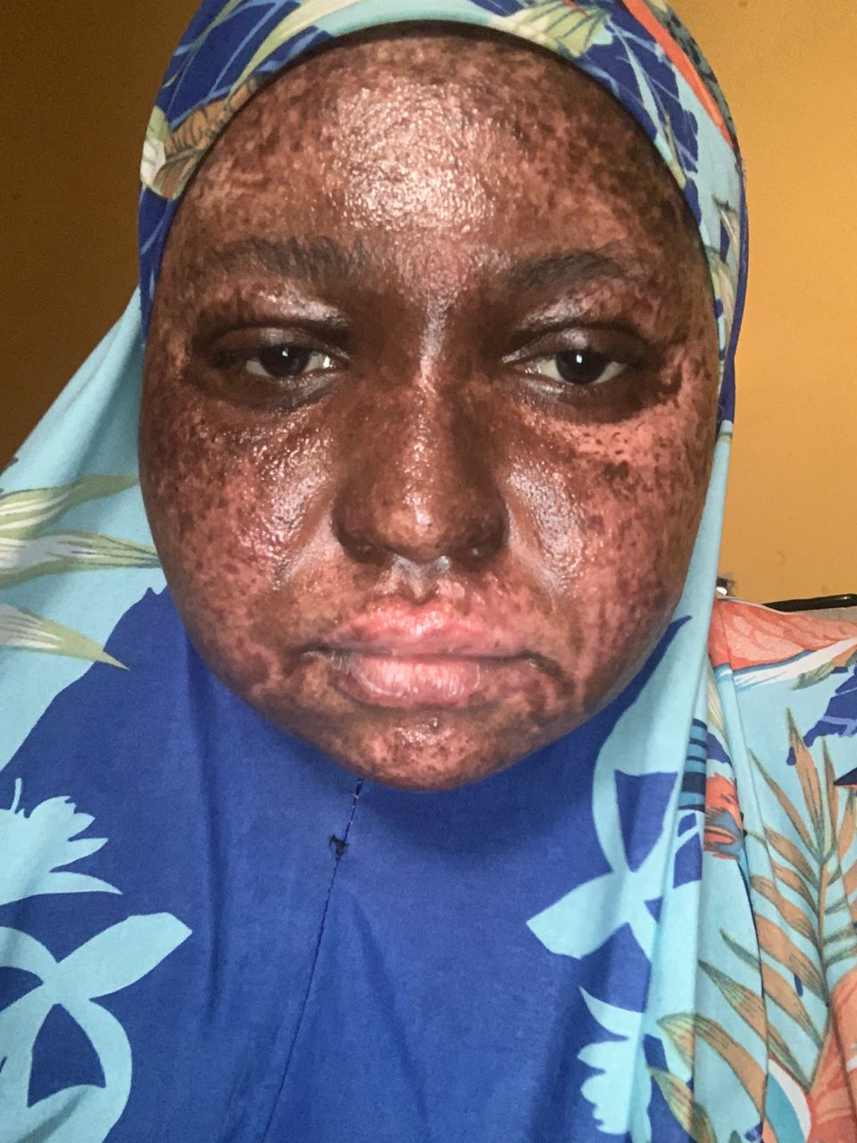
Fatima sustained severe burn injuries as a result of a gas explosion, which subsequently led to additional complications, including ear dysfunction.
Due to the extent of her condition, she required surgical intervention to address the ear dysfunction, alongside comprehensive medical treatment for the burn injuries.
PROGRESS
Hereafter Ghana donated an amount of GHS 2,500 to start with medical examinations to help determine the further infections and draw a treatment plan. The funds also covered her medications as medical officers continued with the examination.
CASE 213
Patient name: Rahman
Condition: Rectinoblastoma
Abdul Rahman was diagnosed with Eye cancer at the age of four. Following a series of medical examinations, healthcare professionals recommended immediate surgical intervention to remove the tumor, citing a high risk of permanent damage to the eye if treatment was delayed.
To facilitate the procedure, his family required an additional amount of GHC 2,500 to meet the total cost of the surgery.
PROGRESS
Hereafter Ghana donated the total amount of GHS 2,500 to Abdul Rahman and his family to continue with their treatment to prevent further damages of the eyes.
CASE 214
Patient name: Yussif
Condition: New born baby who lost his mother at birth
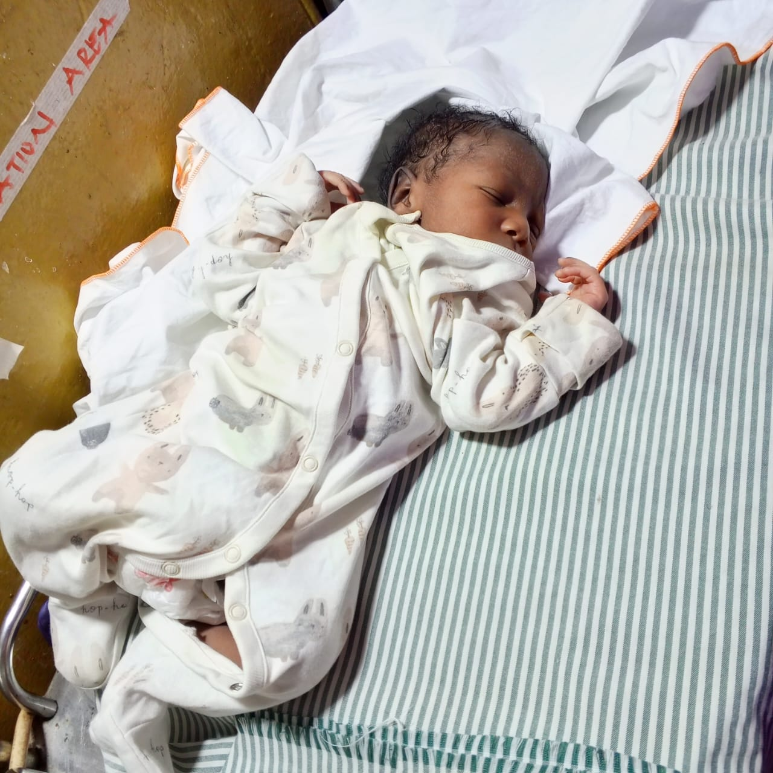
Following the loss of his mother due to postnatal complications at Northern Regional Hospital, baby Yussif was left in need of immediate care and support.
As a result, essential items were required to ensure his wellbeing, including baby food, clothing, and basic toiletries.
PROGRESS
Hereafter Ghana successfully mobilized and donated items valued at GHC 7,000 to support Yussif’s care. The items, which were sourced through contributions from the general public. Items donated included clothing, baby food, diapers, wipes, toiletries, and other essential supplies necessary for his wellbeing.

CASE 215
Patient name: Chinedu
Condition: New born baby was abandoned at birth
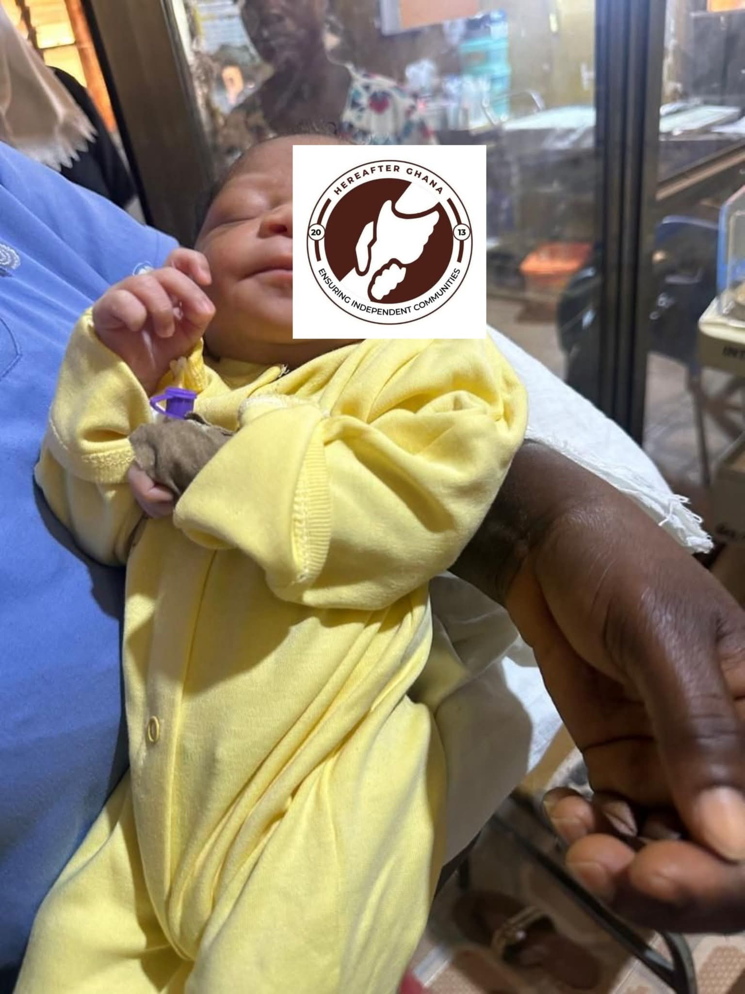
Little Ramadan was found abandoned at the Tamale Police Station and was subsequently referred for medical assessment at the Neonatal Intensive Care Unit (NICU) of Northern Regional Hospital. For identification and documentation purposes, he was given the name “Ramadan” at the hospital.
Following initial medical evaluation, it was determined that he required essential care items to support his wellbeing, including baby food, clothing, and other basic necessities.
PROGRESS
Hereafter Ghana successfully mobilized and donated items valued at GHC 2,000 to support Ramadan’s care. The items, which were sourced through contributions from the general public. Items donated included clothing, baby food, diapers, wipes, toiletries, and other essential supplies necessary for his wellbeing.
CASE 217
Patient name: Harira
Condition: Single Live Fetus, multiple uterine myoma
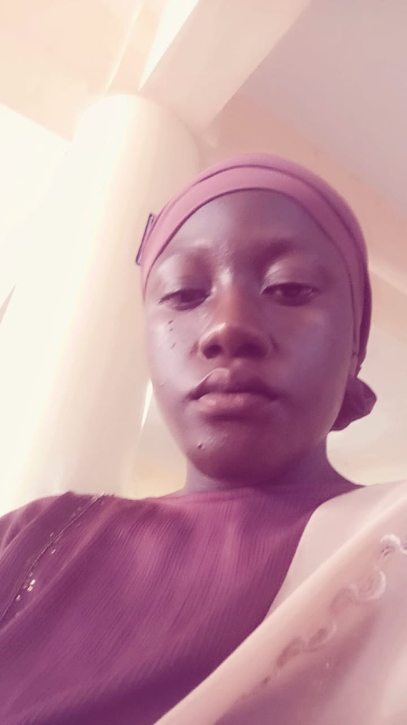
Madam Harira experienced a miscarriage as a result of uterine fibroids, which led to further medical complications requiring urgent attention. Due to the severity of her condition, immediate surgical intervention was recommended.
To facilitate the procedure, an additional amount of GHC 3,000 was required to meet the total cost of the surgery.
PROGRESS
The total required amount was successfully mobilized and donated to support her treatment. She subsequently underwent a successful surgical procedure and is currently in recovery. The funds were obtained from the GHS 40,000 zakat fund.
CONCLUSION
This report provides a summary of medical support cases addressed during the first quarter. Hereafter Ghana remains committed to improving the health and well-being of underserved populations across the country and continues to extend assistance without geographical limitation.
ACKNOWLEDGEMENT
Hereafter Ghana extends its heartfelt appreciation to all our esteemed donors and the committed staff as well as volunteers for their invaluable contributions to the Health Financing project.
Your unwavering support and collaboration have been instrumental in ensuring that vulnerable children in underserved communities gain access to essential healthcare services. The success of this initiative reflects your shared commitment to safeguarding the health and well-being of every child, and we are deeply grateful for the trust and partnership you continue to show.

