HEREAFTER GHANA
QUARTERLY REPORT FOR GLOBAL GIVING (APRIL – JUNE 2024)
PROJECT TITLE: GIVING FOR HEALTH (HEALTH CASES)
INTRODUCTION
In this quarter, Hereafter Ghana has handled a total of twenty (20) health cases. Each case presented unique challenges and required individualized care and attention. The following report provides an overview of the conditions and progress of the individuals involved in these cases.
CASE 122
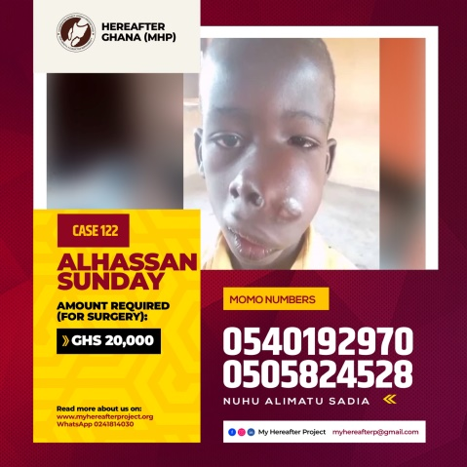
Patient Name: Sunday
Condition: Tumor on the face
Sunday was diagnosed of a mysterious face tumor at the Tamale Teaching Hospital. As a result of this tumor, Sunday suffers a swell in his gum area causing severe pain especially when he tries to eat. He has been scheduled for a surgery and an amount of Ghc 5,000 is requested for surgery bill, medications and other hospital expenses.
Progress: The full of Ghc 5,000 was raised and donated to Sunday’s family. He went through a successful surgery and has been discharged home.

CASE 123
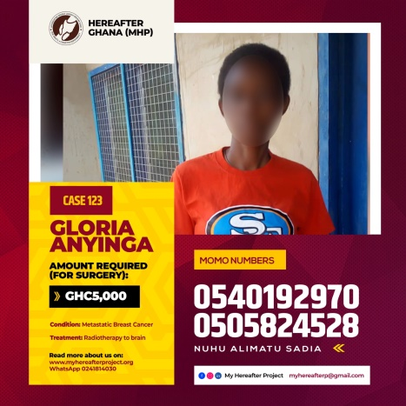
Patient Name: Gloria
Condition: Metastatic Breast Cancer
Gloria was diagnosed of metastatic breast cancer and needs to undergo surgery and chemotherapy processes. An amount of Ghc 5,000 is required to help Madam Gloria through the series of chemotherapy.
Progress: the sum of Ghc 5,000 was solicited from the general public and donated to support her get a chemotherapy and surgery done. However, we received sad news of the demise of Madam Gloria while she was receiving treatment.
CASE 124
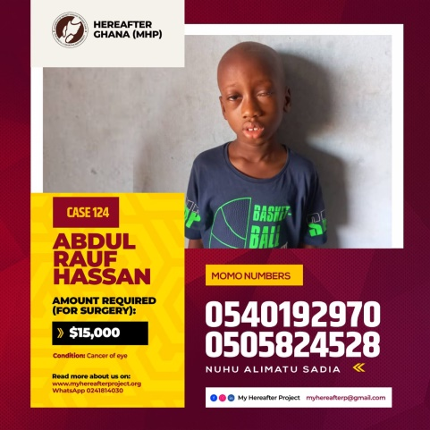
Patient Name: Rauf
Condition: Rauf is an eight year old boy who suffered cancer of one of his eyes at birth and has led to the loss of his vision in that eye. Unfortunately for him, the cancer has currently affected the second eye and if urgent treatment is not done, he could go full blind. An amount of USD 15,000 is required for complete treatment to help improve his vision.
Progress: Unfortunately, the amount required for his full treatment process could not be raised by the organization. However, an amount of Ghc 21, 000 was donated to the family to support in the treatment process. It is our hope that the family would be able to raise the full amount to cater for his treatment as they look for support elsewhere.
CASE 125
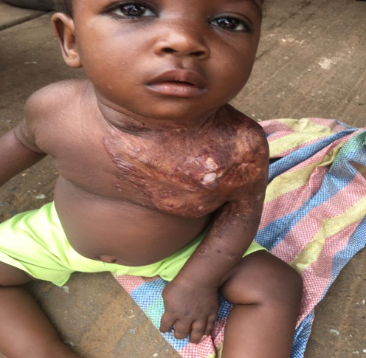
Patient Name: Naadiya
Condition: Naadiya, a one year old girl was diagnosed of post cellulitis scaring of the left chest area at the Tamale Teaching Hospital in the Northern Region. She has been scheduled for a correction surgery and an amount of Ghc 3,000 is required for the surgery.
Progress: Ghc 3,000 was donated to the family of baby Naadiya to help her get the surgery done. The exciting news is that, she had a successful correction surgery at the Tamale Teaching Hospital and has been discharged home. She has been kept on monitoring as well to ensure the surgery did not come with complications.
CASE 126
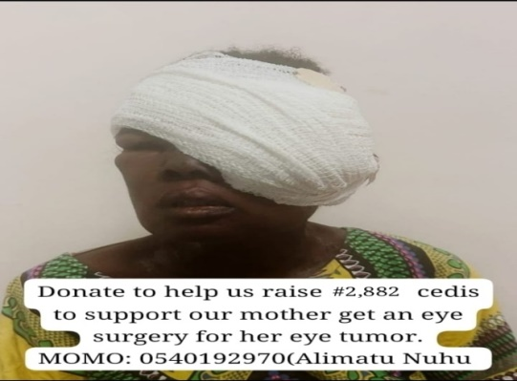
Patient Name: Florence
Condition: Madam Florence from Tamale suffered from a painful left orbital eye tumor and had to go through series of surgeries. After receiving the sad news, the team at Hereafter Ghana through the support from the public was able to raise funds of Ghc 2,000 to support Madam Florence get laboratory tests and scans done before the actual surgery.
Progress: After raising the required amount, tests and screening from the hospital revealed that the tendency of Madam Florence surviving the surgery was very low, since there was a high chance of her losing her life in the process. This led to her discharge from the hospital. We later received the news of the demise of Madam Florence a week after she was discharged from the hospital.
CASE 127
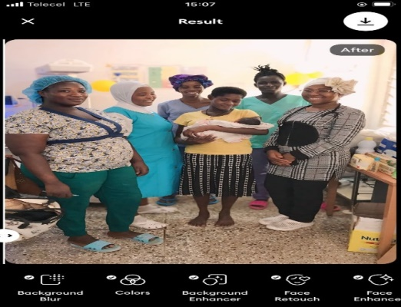
Patient Name: Evelyn
Condition: Born Premature
For the case of baby Evelyn, she was born premature at thirty-two weeks at the Bongo district hospital in the Upper East region. She needed an amount of GHc 800.00 to undergo monitoring at Neonatal Intensive Care Unit.
Progress: Hereafter Ghana supported the family with GHc 800.00 to pay for her hospital bills and to support in buying of toiletries and other items needed to sustain them during the period of stay in the hospital.
CASE 128
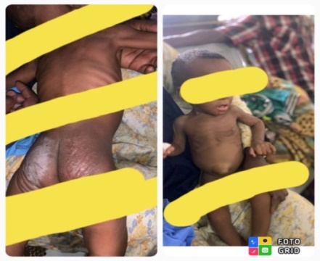
Patient Name: Farhan
Condition: Severe Acute Malnutrition
Farhan is a nine months old baby on admission at Northern Regional Hospital. He suffers from severe malnourishment and some other underlining health conditions, and needed a quick treatment to save his life. An amount of Ghc 5,700 was required to purchase vital nutritional supplements, medications, toiletries and paying of hospital bills.
Progress: We raised and donated the required amount of Ghc 5,700 with the support of the public. Few weeks after treatment, Farhan gained his good health back and was discharged home.
CASE 129
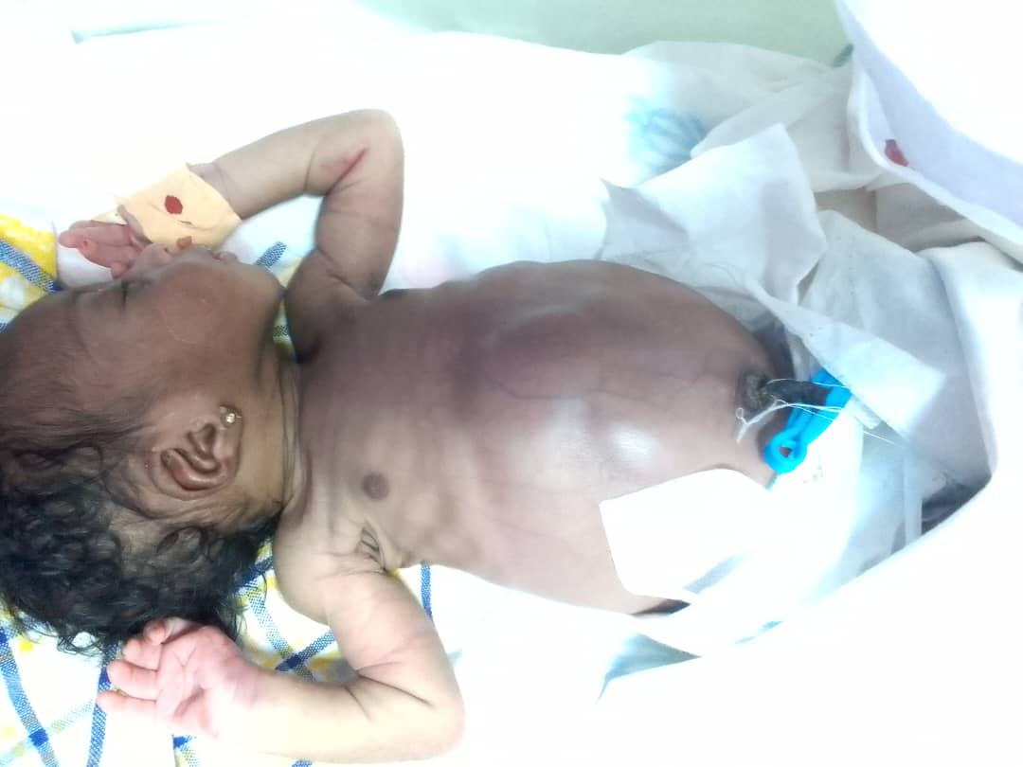
Patient Name: Samantha’s Baby
Condition: Samantha’s newly born baby suffers from the hirschsprung’s disease which is a congenital condition that affects the large intestine and causes problems with passing stool. She has been admitted at the Tamale Teaching Hospital and an amount of Ghc 1,000 is required for treatment.
Progress: Samantha was supported with the required amount of Ghc 1,000 unfortunately her baby passed on few days after birth.
CASE 130
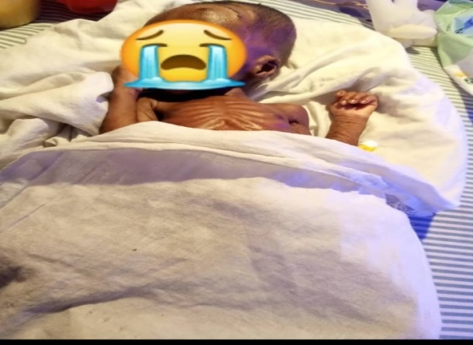
Patient Name: Ziyadatu
Condition: Severe Acute Malnutrition
Baby Ziyadatu is a seven weeks old baby on admission at the Tamale Regional Hospital’s Neonatal Intensive Care Unit. She suffers from severe intestinal obstruction, a condition that comes with severe acute malnutrition. An amount of Ghc 3,000 is required to purchase nutritional supplements, medications and other basic necessities needed for treatment.
Progress: A cash donation of GHc 3,000 was presented to the parents and staff of the hospital to aid in her treatment process. Unfortunately, baby Zayida was already in a devastating condition and could not make it.
CASE 131
Patient Name: Abdul Latif
Condition: Latif was involved in a car accident leading to a fracture in his right leg. He went through two successful surgeries awaiting the third surgery. He is scheduled for a surgery at the trauma and specialist hospital in Winneba and an amount of Ghc 2,000 is required for the process.
Progress: The full amount required was donated to Latif and he has a successful third stage surgery.
CASE 132
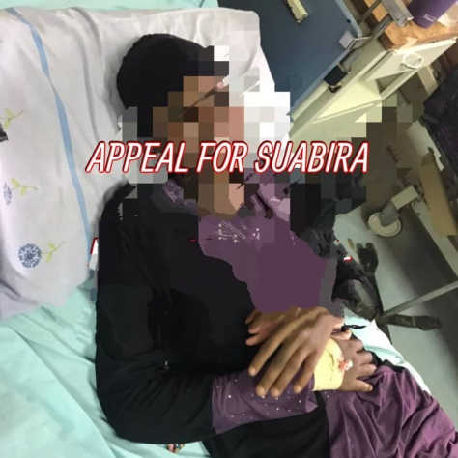
Patient Name: Suabira
Condition: Suabira suffers from demylenating disorder with differential of A. neuromyletis optical spectrum disorder B. multiple sclerosis C and toxic Leukoencephalophathy. She has been scheduled for an MRI of the head and an amount of Ghc 6,000 is required for the MRI.
Progress: Ghc 6,000 was donated to Suabira to get the MRI done. She was later placed on medications after the results from the MRI indicated no severe condition that needed surgery.

CASE 133
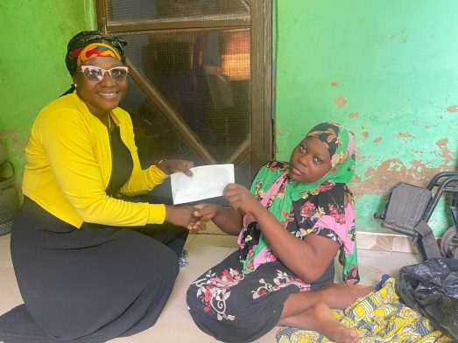
Patient Name: Rahana
Condition: Rahana who is receiving treatment at the Focus Orthopedic Hospital suffers from a spinal condition characterized by an excessive curvature of the thoracic spine called kyphosis. She needs a total hip replacement surgery and an amount of over Ghc 80,000 is required.
Progress: Hereafter Ghana could only support her with Ghc 2,000 to add up to her existing money hoping she would be able to raise the full amount to get her surgery done.
CASE 134
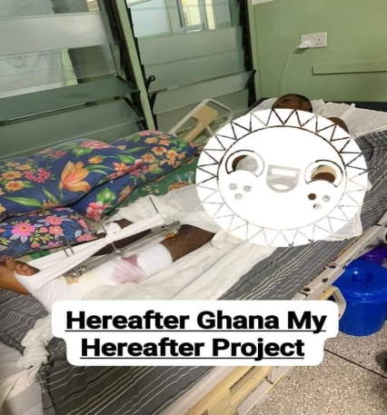
Patient Name: Abubakari
Condition:
Mr. Abubakari had a severe accident that could lead to losing his leg. As urgent as his condition was, he urgently needed Ghc 6,000 to undergo a surgery.
Progress: The required amount of 6,000cedis was donated to support him and we are happy to announce that he Mr. Abubakari had a successful surgery on the 13th June and currently receiving treatment.
CASE 135
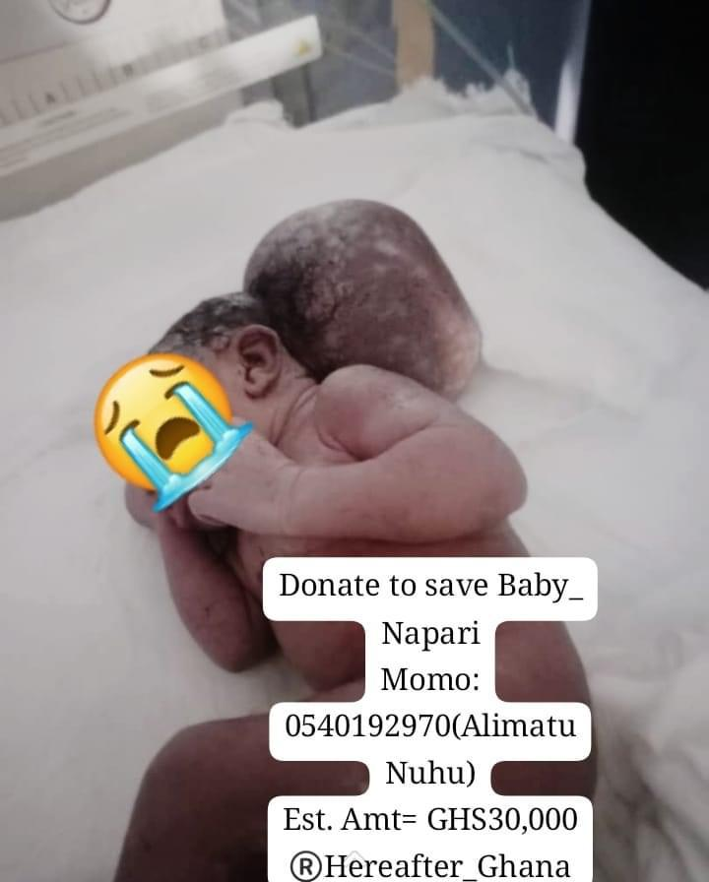
Patient Name: Napari
Condition:
Napari was born with a life threatening condition on 5th June and needed swift medical intervention to undergo 3 stages of surgery. An MRI at the Korle-bu teaching hospital is needed and the estimated amount of Ghc 30,000 is required to be able to save her life.
Progress: Unfortunately, she passed on during the fundraising period and an amount of Ghc1,000 was donated to support her mother’s treatment since she underwent cesarean section and was still admitted at the hospital.
CASE 136
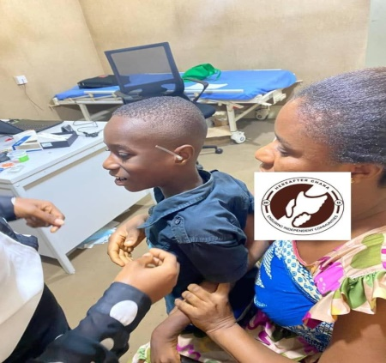
Patient Name: Christian
Condition: Hearing impairment
Christian was born with a hearing impairment meaning he can’t hear nor speak unless with a help of a hearing aid to enable him process sound and be able to speak and live like a normal child and attend school.
Progress: Hereafter Ghana was able to support him with a hearing aid worth Ghc 4,000. Christian also started speech therapy class to enable him process sound to be able to hear and speak well.
CASE 137
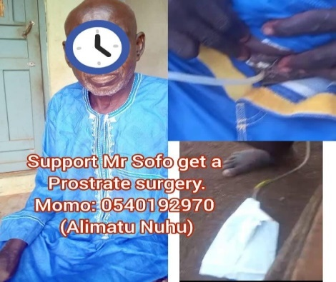
Patient Name: Mumuni
Condition: Prostate hyperplasia
90years old Mumuni cannot urinate on his own unless with a support of a catheter due to prostate hyperplasia and needs an amount of Ghc 7,000 for a correction surgery.
Progress: Mr. Mumuni is currently booked for surgery and we are hopeful his surgery will be a success.
CASE 138
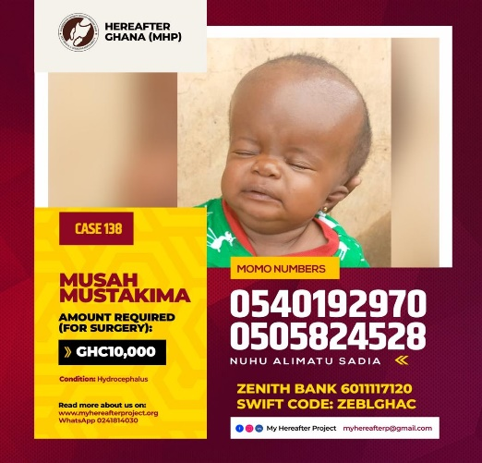
Patient Name: Mustakima
Condition: Hydrocephalus
Mustakima is a 2weeks old baby who suffers from Hydrocephalus and is on admission at the Tamale Teaching Hospital. This condition increases the fluid content in her skull making the head grow bigger and putting pressure on the brain hence an emergency intervention is needy to help her undergo surgery. An amount of Ghc 3,000 is needy for her surgery.
Progress: The required amount was donated to the family for her surgery at the Tamale Teaching Hospital.
CASE 139
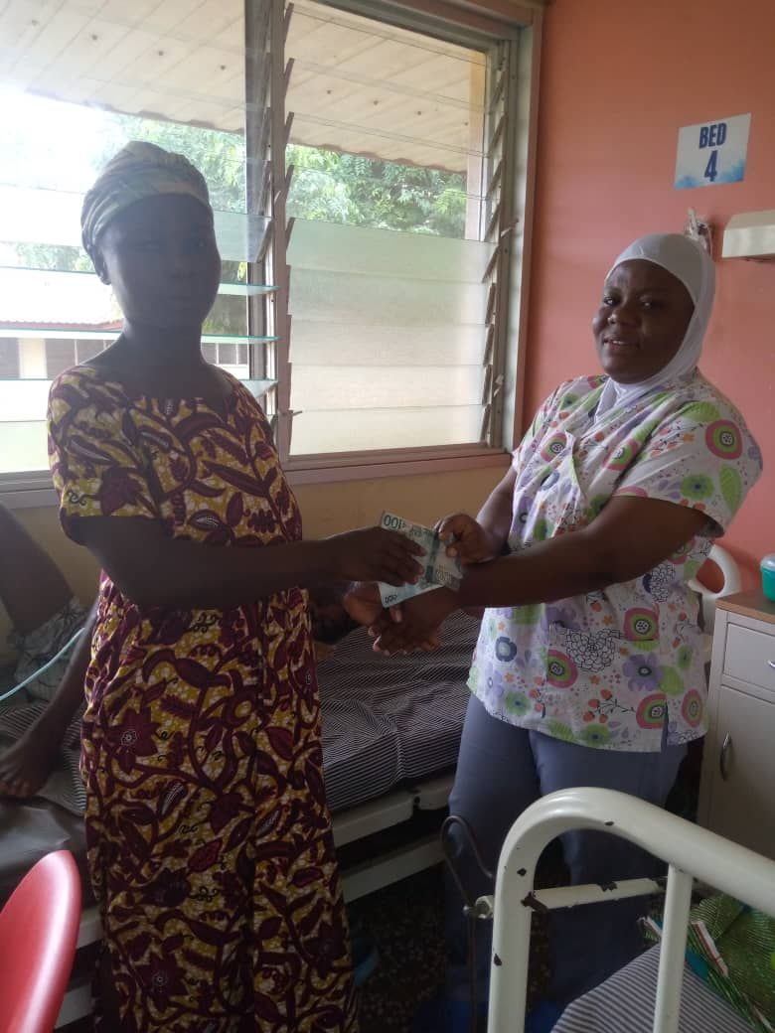
Patient Name: Bismarck
Condition: Bismarck suffers diabetes mellitus and is currently on admission at the Sunyani Teaching Hospital. For the purchase of medications to support his treatment, an amount of Ghc 3,00 is required.
Progress: The organization mobilized and donated the requested amount to aid in the treatment process of Bismarck.
CASE 140
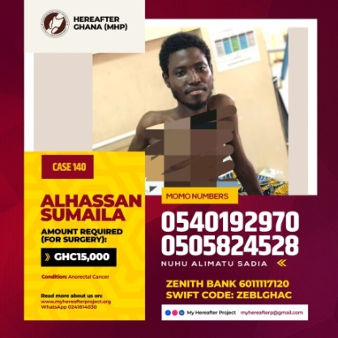
Patient Name: Sumaila
Condition: Sumaila suffers from anorectic cancer and is currently on admission at the Tamale Teaching Hospital. He needs to undergo series treatment process which includes chemotherapy and that would cost an amount Ghc 15,000 to see him through the entire treatment process.
Progress: The full amount of Ghc 15,000 was donated to the family of Sumaila to aid in his treatment process. Sumaila is currently undergoing treatment at the Nelly Oncology Clinic at the Tamale Teaching Hospital and we are hopeful of a speedy recovery.
In a quest to improve the health conditions of the Ghanaian people, we at Hereafter Ghana are always ready to come to the aid of these individuals who call upon us irrespective of the part of the country they are located.

