HEREAFTER GHANA
QUARTERLY REPORT FOR GLOBAL GIVING (JANUARY – MARCH 2024)
PROJECT TITLE: GIVING FOR HEALTH (HEALTH CASES)
INTRODUCTION
During this quarter, Hereafter Ghana has handled a total of six (6) health cases. Each case presented unique challenges and required individualized care and attention. The following report provides an overview of the conditions and progress of the individuals involved in these cases.
CASE 116
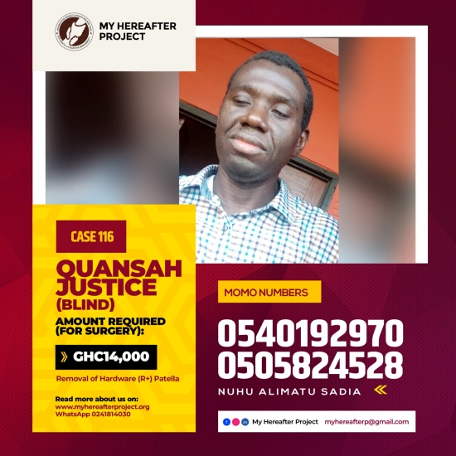
Patient Name: Quansah
Condition: Fracture of the left knee
Quansah is a visually impaired (blind) individual who due to his condition, constantly falls when not assisted. With this condition, he had an unfortunate fall one day which caused a fracture in his leg and seeks for support for a correction surgery to help him walk normal again. An amount of Ghc 4,556.00 is needed for the correction surgery.
Progress: Out of the amount required, Ghc 4,300.00 was raised to support his surgery. Quansah has visited the hospital twice, done the necessary lab tests and scans and is currently scheduled for a surgery in May.
CASE 117
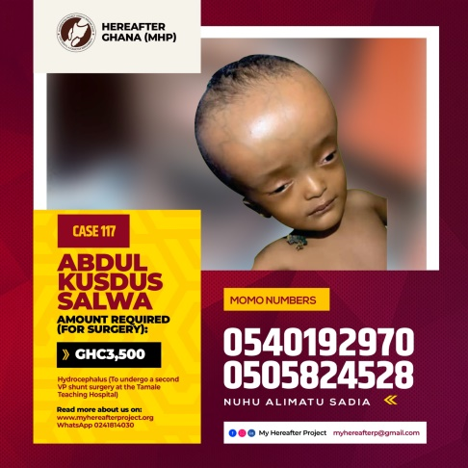
Patient Name: Salwa
Condition: Salwa suffers from hydrocephalus which is puts her through excruciating pain due to the fluid in her skull that puts pressure on her brain. An amount of Ghc 3,100 is needed to undergo a second VP shunt surgery at the Tamale Teaching Hospital.
Progress: Ghc 3,500 was raised to support the family in Salwa’s treatment. She has undergone two successful surgeries and recovering gradually. She is also currently placed on regular visits to the hospital where she will be monitored until fully recovered.
CASE 118
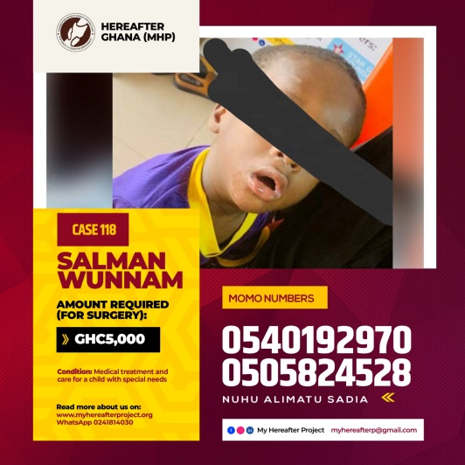
Patient Name: Salman
Condition: Salman needs medical treatment and care for a child with special needs. He cannot respond to basic reflexes and a CT scan is required as well as series of laboratory tests. An amount of Ghc 5,000.00 was raised and donated to start the treatment process of Salman at the Tamale Teaching Hospital.
Progress: Results of the CT scan indicated that Salman suffers from right apical lung consolidation of which he has been placed on series of medications to help him recover. Salman has also been kept on monthly monitoring at the hospital to ensure a successful recovery.
CASE 119
Patient Name: Mohammed
Condition: Mohammed was diagnosed of previous out-of-Hospital Cardiac Arrest, Brugada Syndrome and Post-Implantation of a single Chamber ICD which was implanted in this heart in June 2014. He is due for re-implantation of the ICD which will cost about USD16,500. However, he has been placed on monthly medications to help sustain him before the surgery. An amount of Ghc 2,500 is required for the monthly medications.
Progress: An amount of Ghc 2,000 was raised and donated to Mohammed Iddriss Jamal to support in buying the medications needed to sustain him until the surgery is performed.
CASE 120
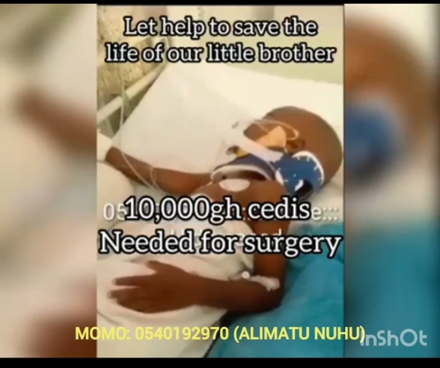
Patient Name: Hamza
Condition: Hamza fell from a three story building school facility while school was in session. He had multiple fractures as well as an internal bleeding in the neck. Ghc 10,000 is the amount needed for an emergency surgery to save his life.
Progress: the full amount of Ghc 10,000 was raised and donated to the family to help foot the bill of the surgery. Hamza had a successful surgery though he came out of the hospital with a partial memory loss. Doctors recommend staying in an environment with friends and family who will be of help in his recovery process.
CASE 121
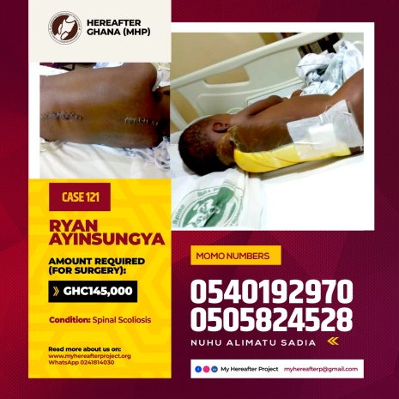
Patient Name: Ryan
Condition: Ryan suffers from spinal scoliosis. He went through a first stage correction surgery and needs a second correctional surgery to help him recover. An amount of Ghc 143,154 is required for the correctional surgery.
Progress: the family of Ryan received a raised amount of Ghc 5,000 from Hereafter Ghana. The surgery is yet to be done as we are yet to raise the full amount needed for the surgery to be carried out.

