Project Title: SAVE THE DISABLE CHILDREN IN BANGLADESH
IMPLEMENTED BY : SONAKHALI MANOBKOLLAN SEBA SANGHA (SMSS)

Project Summary:
SonakhaliManobkollanSebaSangha is an association for working the development of poor special children with disabilities in Bangladesh, we are planning, Measuring, Counting and educating to implement adequate service delivery in action of special Education, health and rehabilitation. Through this project our- organization intends to achieve remarkable improvement of destitute, disadvantaged and most vulnerable children groups in the community. A total 250 disable children would be benefited from this project. we are doing it by employing more staff in the school. We also assisting Governmentineducating providing in-adequate first aid, food and health services. Children with disabilities received tution fees, session charge, school uniform, Educational materials, Tiffin, mobility and assistive device for their development. This project is Implemented by SonakhaliManobkollanSebaSanghaTungipara, Kotalipara, KashianiMuksudpur and GopalgonjSadarUpazilla, under District of Gopalgonj, Bangladesh. It is expected that this project could make a positive impact in the community for an effective Development.
Requested Funding Amount: $47500.00

Donation Options :
 | USD | Qty | Total
● 10 usd will buy 01 school uniform and shoes in a year | 10 | 250 | 2500
● 20 usd will provide books for 01 student in a year | 20 | 250 | 5000
● 30 usd will provide therapy and rehabilitation service for 01 student in a year. | 30 | 250 | 7500
● 40 usd will provide to 01 student transporting cost for regular schooling in a year | 40 | 250 | 10000
● 50 usd will provide all the educational expenses 250 student in a year | 50 | 250 | 12500
● 60 usd will provide for assistive device like wheelchair, white cane, Walking frame, Crutch, smart cane etc for 50 student in a year | 60 | 50 | 3000
● 70 usd will provide 100 student nutritional tiffin food for 01 year | 70 | 100 | 7000
Total |  |  | 47,500

PROBLES OF CHALENGES:
SonakhaliManobKollanSebaSanghaare addressing,illiteracy, Intellectuality, poverty, unhygienic and risk of disability. In context of Bangladesh, Disability are deep rooted and complex problem. According to WHO, About 16 million people are disable in Bangladesh and the rate of prevalence is increasing day by day. In Bangladesh 80% people living in rural area and most of the disable Children also live in rural areas. Disable children are living with most underprivileged, Disadvantaged and vulnerable groups in the community. They are neglected and deprived of most of their basic human rights. Negative attitude of the community, lack of awareness, lack of scope and facilities of education of children with disabilities have significantly increased the number of the child with disabilities in the community. According to socio-economic structure Disable Children are mostly dependent upon their Family and family is consider them as a burden. Lack of awareness of Children with disabilities right of participation and accessibility in the community are out of the development process by their families and communities. Children with disabilities are consider as a stress of their families. They do not have access to schooling, go to outside and involved in community activities. As a result Children withDisabilities and their family suffer from Inferiority complex and exclusion of Daily living activities. Children with disabilities are the worst sufferer as without proper education. They fail to realize their potential and unable to contribute in community as well as national and International development process.
PROBLEM SOLUTION:
Community based rehabilitation is a recognized approach to solve the problem. Illiteracy, Intellectuality, poverty, unhygienic and risk of disability will be solved by this project. It is established that disable person have enormous potentials. To achieve a better life and contribution to the community, those potential of disable person could be explored and utilized properly in a planned way, so that they are Integrated to the mainstream development program of the nation. By focusing on quality of education, appropriate therapy approaches, proper health and nutritional foods, and mobility, they could achieve different abilities. Proper Education and training grow up as a productive resource of the community. This project empowering 250 disable Children living remote areas as a Global citizen.

LONG TERMIMPACT:
SonakhaliManobKollanSebaSangha will educate 250 disable Child under this project. Under this project 250 Children with Disabilities will received educational support, Therapy facilities, counseling services, Interested to education, increasing attendance in the school, reduce drop out from school and empowerment. Children with disabilities will have access to mainstreaming and increasing acceptance in the community and grow up as a valuable resource. Illiteracy, poverty, unhygienic and risk of disability will be solved by this project. This project fulfill the fundamental needs of Children with disabilities and meet with the Integrated special education system.
PROJECT MESSAGE:
The project promoting special education and therapy facilities and access to mainstreaming in the community of Children with disabilities in Gopalgonj District, Bangladesh.
Additional Documents: Project profile and organization profile.
Organization Information:
SONAKHALI MANOBKOLLAN SEBA SANGHA (SMSS)
Location: VILL: SONAKHALI, P. O: JOARIA, UPAZILA: TUNGIPARA, DISTRICT: GOPALGONJ, COUNTRY: BANGLADESH.

Website: www. smssbd. org
Face book page:sonakhalismss
Twitter: @smss
Project Leader :
DR. NAZMUL ISLAM, CEO.
VILL: SONAKHALI, P. O: JOARIA, UPAZILA: TUNGIPARA, DISTRICT: GOPALGONJ, COUNTRY: BANGLADESH.
OrganizationalProfile of SMSS
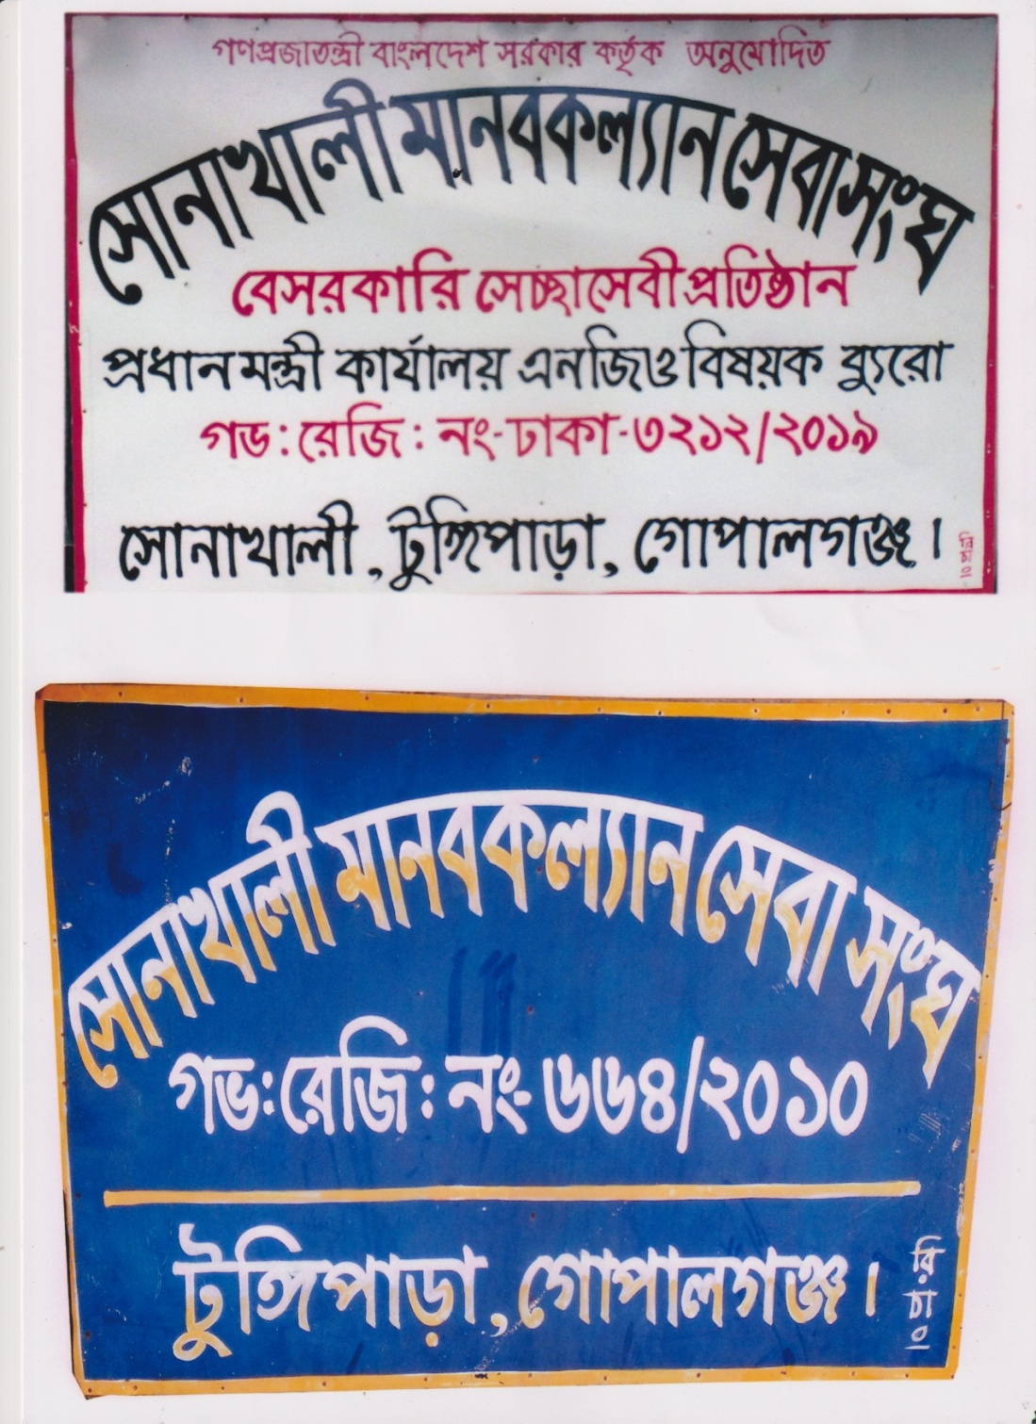
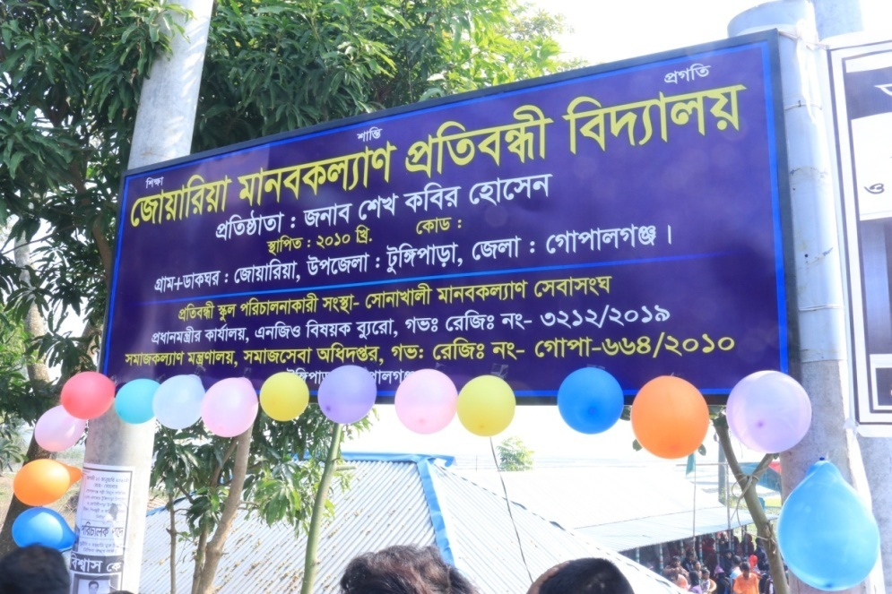
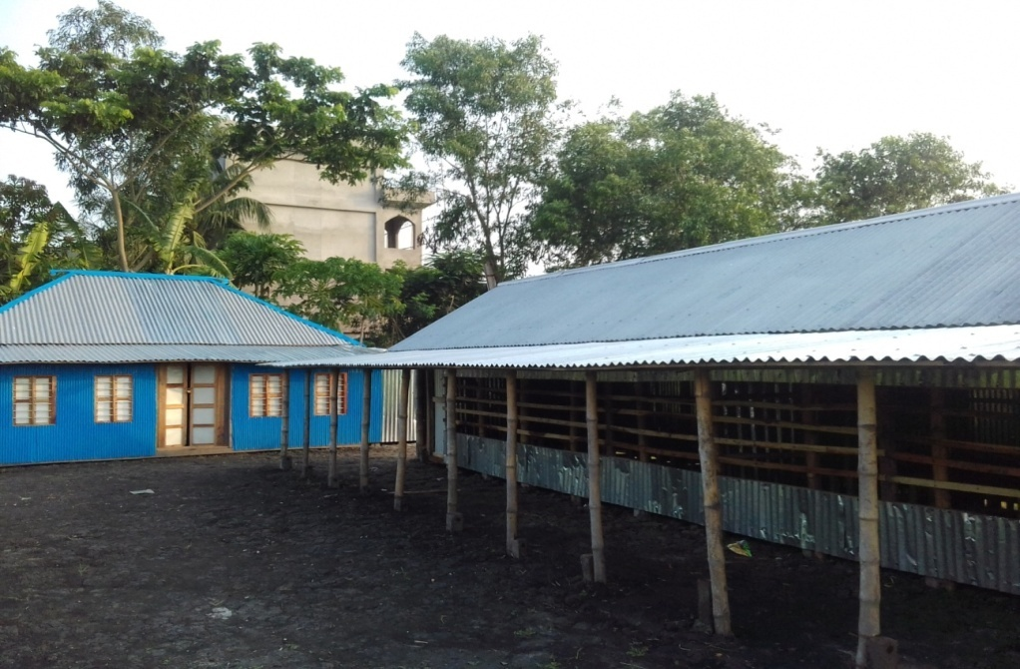
Address:
SONAKHALI MANOBKOLLAN SEBA SANGHA (SMSS)
VILL: SONAKHALI, P. O: JOARIA, UPAZILA: TUNGIPARA,
DISTRICT: GOPALGONJ, COUNTRY: BANGLADESH.
E mail: smkssangha@gmail.com
Cell Phone: 01755863688, 01778217488
Name of the Organization :SONAKHALI MANOBKOLLAN SEBA SANGHA (SMSS)

Registered office Address:
SONAKHALI MANOBKOLLAN SEBA SANGHA (SMSS)
VILL: SONAKHALI, P. O: JOARIA, UPAZILA: TUNGIPARA,
DISTRICT: GOPALGONJ, COUNTRY: BANGLADESH.
E mail: smkssangha@gmail.com
Web: www. smssbd.org
Cell Phone: 01755863688, 01778217488

Contact Person and Address:
Contact person Name | Dr. Nazmul Islam
Designation | Chief Executive officer
Head office Address | SONAKHALI MANOBKOLLAN SEBA SANGHA (SMSS)  VILL: SONAKHALI,  P. O: JOARIA,  UPAZILA: TUNGIPARA,  DISTRICT: GOPALGONJ,  COUNTRY: BANGLADESH
Phone no. | Mobile: 01755863688, 01778217488
E mail: | E mail: smkssangha@gmail.com
Brief history:
SONAKHALI MANOBKOLLAN SEBA SANGHA (SMSS) has been established in a1999 as a non-profitable, non-governmentcharity organization, with development orientation aimed at servingdistressed humanity being inspired by the universal value. As a development partner of Bangladesh government the organization was registered with the department of social service, GOB in 2010 and the NGO Affairs Bureau, Prime minister secretariatin 2019. Most of the people live in rural area. They live in under development situation. They always embraced with poverty. the government initiative is not available for our under developed economy. So we need most to make people more conscious and to alleviate poverty to having participation of NGO and donor agencies is essential.
Year of Establishment: 1 January 1999
Legal status of the Organization:
SL.No. | Registration Authority | Registration No. | Registration Date
01 | Directorate of social services, Govt. of Bangladesh | No- Gopa 664 | Date 01/03/2010
02 | NGO Affairs Bureau for foreign donation received.  Govt. of Bangladesh | 3212 | Date -23/07/2019

GOAL OF ORGANIZATION:
SMSS Goal is to improve the ultimate socio-economic and cultural condition of the community through the development of the most
disadvantaged, vulnerable people, women, children and the people with disabilities to ensure their equal rights and opportunities for
participation in the mainstream development.
Vision of the Organization:
SMSS has been working with the vision to promote development programs in the community to improve the overall socio-economic and cultural condition of thedisable, most disadvantaged children, adolescent, of the community. Special emphasis is given on preventing disability, ensuring maternal child health, adolescent family life education and reproductive health education, awareness on Sexual Abuse, and HIV/ AIDS and its prevention, restoration of child/ human rights andhuman resource development. SMSS have been trying to implement action programs with the active involvement and participation of the community people. SMSS aspire for a suppression free society with prosperity, peace and equity where all people could get proper opportunity and equal rights to develop.
Objectives Of the Organization :
1. To reduce poverty through capacity building and appropriate livelihood support for the poor persons with the disabilities,
2. Implement programs to promote health, education and socio-economic development of the most disadvantaged, vulnerable groups and the disabled people;
3. To contribute to overall development of Bangladesh through achieving the targets of the SDGs.
4. Undertake programs for prevention of disability in the community;
5. To provide special assistance to orphans, widows, refugees and destitute section for their self-reliance.
6. To conduct Research to find replicable and innovative models for better improvement of our development activities
7. Provide emergency relief materials to disable, destitute and disadvantaged children and their families of any catastrophe
8. Advocacy and lobbying with the policy makers, local authority and the elite groups to restore the rights of the disabled children and persons;
9. Operate the activities with Marginal community in order for taking the marginal and disable community in to mainstream development activities of the society.
10. Take action to prevent the loss due to Climate Change and others natural calamities and operation relief Program combat then on urgent need Basis.
11. To assist toward livelihood and food security create the provision of self-employment among the target peoples.
12. Women development.
13. Disaster management and climate change activities.
14. To increase disaster awareness and prepareness at the disaster-prone area, reduce suffering of disaster victims and help them to recover normal life with emergency relief and rehabilitation.
Primary and Secondary Stakeholder:
01. Primary and Secondary School Students, Family members, community leaders, school teachers, religious leader, representative of the localauthorities and other people will be the secondary beneficiaries.
02. Children with disabilities, different disadvantaged and affected children groups will be primary target beneficiaries.
Working Areas:

No | Name o the District | Name of the Upazilla | Remarks
01 | Gopalgonj | Tungipara
01 | Gopalgonj | Kotalipara
01 | Gopalgonj | Kashiani
01 | Gopalgonj | Muksudpur
01 | Gopalgonj | GopalgonjSadar

Program Implementation approach:
SMSS has been implementing its entire program through community based approach. It is consider community based rehabilitation (CBR) is the only effectiveapproach that ensure development of the disable Children through optimum utilization of available resources of the community. Available resources in this regard included material resources, human resources and existing services and facilities of the communities.

Coordination and network:
SMSS has been maintaining coordination and functional network with the specialized groups as community leaders, local elite, social
communicators and activists, specialist professional groups, traditional health practitioners, environmentalists and all people of goodwill.

S. L | Name | Types | Nature of the Networks | Remarks
1 | Center for disability in development (CDD) | General member | It is Networking agencies and development agencies for person with disabilities.
2 | National Forum ofOrganizations working Disabled (NFOWD). | General member | It is a national Networking agencies for promoting right with person with disabilities.
3 | ADAB | Chapter Member
4 | JPUF | Donor Member
5 | MoH | Donor Member
6 | WBB TRUST | General Member
7 | BASUNDHARA FOUNDATION | Donor Member
8 | MoWC | Donor Member
9 | INC-USA | Donor Member
10 | CDF | General Member
11 | SEEP NETWORK -USA | General Member

Acknowledgement:
We are very much grateful to our partner /donors contributor for our implementing project activities through financial and kind support.
Those are –INC USA,JatioProtibndhiUnnoyan Foundation, Ministry of Social Welfare, Govt. of Bangladesh and Directorate of Primary
Education, Govt. of Bangladesh. We are also thankful Ministry of Health and family welfare, National Forum of working organization with
disabled (NFOWD) for information services on Child rights and disability issues.

Ongoing Projects :

No. | Name of Projects | Activities of this Project | Geographical Areas of Working | Name of Partners/ Donors
01 | Community based rehabilitation activities for development of the person with Disabilities. | Educational Material support  Treatment and Medicine support  IGAs support for Person with Disabilities | Upazilla: Tungipara,  Dist: Gopalgonj | JatioProtibandhiUnnoyan Foundation, Ministry of Social Welfare, Govt. of Bangladesh.
02 | Maternity Allowance Program for Poor Mother | Training Program on Personnel hygiene, Safe maternity and Care of Pregnant period, Nutrition, Education, Prevention of Early marriage, Family Planning, reproductive health (Prevention of AIDS/HIV),Breast Feeding, Gender and women rights, IGAs, Care of mother and child, Disability and Disaster management | Upazilla: Kotalipara  Dist: Gopalgonj | Directorate of Women affairs, Govt. of Bangladesh
03 | Assistive Device  Distribution Program | Device support for the Persons with Disabilities and  Vulnerable women | Upazilla: Kashini  Dist: Gopalgonj | JPUF, MOSW
04 | Smile Train avisina Cleft  lip palate operation  program | Free of cost Cleft lip palate surgery operation of PWD | Upazilla: Muksudpur  Dist: Gopalgonj | INC USA

Previous Working Experience with National and Foreign Donors Agencies supported Project:

Year | Name of Project | Major activities of this Project | Name of donors  /Development agency
1999-2015 | Development of the  Disabled Children | Educational Material support  Treatment and Medicine support | JPUF, Ministry of Social  Welfare, Govt. of Bangladesh.
2016 | Strengthening Capacity and Networking of NSA-S &LA-S on Disability (SCANNED) Project  (Technical partner) | Disability Assessment, Awareness raising on Therapy services and information Disseminate, Primary health services, Eye diseases examination, Hearing Assessment, Assistive Device support and referral for advance treatment. | Centre for Disability in Development (CDD), European Union and Light for the World, The Netherlands.
2016 | Maternity Allowance  Program for Poor Mother | Training Program on Personnel hygiene, Safe maternity and Care ofPregnant period, Nutrition, Education, Prevention of Early marriage,Family Planning reproductive health (Prevention of AIDS/HIV),BreastFeeding, Gender and women rights, IGAs, Care of mother and childDisability and Disaster management | Directorate of Women  affairs, Govt. ofBangladesh
2017 | Promotion of Human Rights of Person with Disabilities in Bangladeshthrough Disabilities Inclusion. (PHRPBD-DI) | SHGs formation and operation, Conduct Awareness and advocacy program, Conduct Group meeting on Disability Law, CRC, Violence against Women, Legal aid support and Health issues( Mental illness, HIV/AIDS,Disability Prevention, Orientation with student on Disability issues, Early Hearing loss and prevention deafness) etc, Training on skill development-Livelihood/IGAs | Centre for Disability in Development (CDD) and CBM - Australia
2017 | Community based  rehabilitation activities for  development of the person  with Disabilities. | Educational Material support  Treatment and Medicine support  IGAs support for Person with Disabilities | JatioProtibandhiUnnoyan  Foundation, Ministry of  Social Welfare, Govt. of  Bangladesh.
2018 | Improving basic Health and effective education of the Deaf people in Bangladesh | Awareness and advocacy program for Deaf Blind People and Home based therapy for improving health, Counseling service to the Parents. | Centre for Disability in Development (CDD) – Sense International –India and Irish Govt.
2018 | Health, Nutrition and  Population Program | Treatment and Medicine support,  Nutrition support to Children with Disabilities. Material support on Reproductive health and Awareness on AIDs andits prevention | Ministry of Health and  Family Planning, Govt. of  Bangladesh

At present SMSS is implementing programs on:
01. Community Awareness and advocacy Program:
• Awareness campaign would be carried out on the importance and necessity of reducing the rate of disability and primary health in thecommunity.
• Observation on International Human rights Day, Child rights week on CRC, International /National day on Disability (Autism Day,
International Ear car Day, International White cane safety day) World Health Day and, International Day of Disaster Reduction etc.
• Conduct community awareness and advocacy program through discussion meeting, Workshop, Mass gathering, Human Chain for
disabilities issues, Violence against Children (VAC) Awareness on HIV/AIDS and its Prevention etc.
02. Networking, Coordination and Information Dissemination:
• Establish strong coordination and communication with the others organizations for Inclusion of Govt safety net Program.
• Maintain network with different disability and child development agencies.
• Introduce proper referral services for the treatment, training and rehabilitation support of the persons with disability and destitute
disadvantaged children.
• Published newsletter for child rights, disabilities information and contemporary development issues information dissemination.
03. Empowerment Program:
• Formation of School based Child Club for Participation in Mainstreaming activities and increasing their knowledge of Child rights
issues. .
• Formation Disability rights promotion Committee (DRPC) with Local Elites, Teacher, UP members and Disable person for
ensuring rights of Person with Disabilities in the community.
• Self Help group (SHGs) formations with Adult Children and Person with Disabilities and their family members for mainstreaming
. • Child Rights Advocacy Forum (CRAF) forming with Young adult Children with Disabilities Empowerment for Inclusive
Development.
• CWDs Parents group and School based Committee for all type of Disable children for Experience sharing on their Child
development and voice raising on behalf of their Children.

04. Livelihood and Training Program:
• Conduct orientation/training on disability and child rights issues with School Students and others stakeholder.
• Orientation /Training on different IGAs for Person with disabilities(Adult and young Adolescents) on changes of their livelihood.
• Conduct continued skill development training for smss staff members

05. Education Program:
• Operating learning Centre for the Development of Children with Disabilities (CWDs) in the community.
• Integrating the physically disabled and mildly hearing impaired children, Low vision children and mild intellectually disable into the existing primary schools to promote education among the disabled children of the community.
• Organize School Based inclusive Sports and Cultural activities for mainstreaming and improving quality life of CWDs.
• Provide Need based direct Special and Inclusive Educational Support to CWDs to ensure their Continuation and Promote Participation in
school and improving their performance.
• Operate Special need school for the all type of disabled children in the Community.
• Conduct Quarterly meeting with SMC for facilitating school enabling environment.
• Provide educational resource materials to Develop class resource /library for Providing quality education of CWDs.
06. Primary health care Program:
1. Door to door counseling, motivational campaign for rate of reduce disability.
2. Conduct community awareness and advocacy program through discussion meeting, Workshop, for water and sanitation issues with women and adolescent girls.
3. Conduct orientation on disability prevention measures with different stakeholders (School students, community people in thecommunity.
4. Conduct eye diseases treatment camp and ear diseases treatment and Prevention of Early hearing loss for preventive disabilities.
5. Necessary assistive devices distribution in to disabled like as Hearing aid, wheel chair, crutch for their increase mobility and accessibility in the community.
6.Conduct orientation on disability prevention measures, Awareness on HIV/ AIDS and its Prevention with different stakeholders (Adolescent girl, New couple and pregnant mother) in the community.
7. Operation /surgical treatment like as eye, clap-foot, clap-lip; clap-flat etc., to disable children for preventive and rehabilitation measures.
8.Provide cluster based / home based primary rehabilitation therapy service for their better improvement of CWDs.
Org, Recognize From Govt. and Foreign:
SMSSis committed to works for Promoting Children with Disabilities Rights and Dignity with Creating enabling environment in the
Community. SMSS got recognize from Govt. of Bangladesh and Different Ministry and Foreign bodies.

ORGANIZATIONAL MANAGEMENT OF SMSS:
SMSS has got a three tier organizational structure. Those are ---
• The General Body
• The Executive Committee
• The Advisory Committee
SMSS comprise a 21 member's General body and 9 members Executive Committee (EC). The Executive Committee is elected for a two-year term by the general body in every alternative annual general meeting. The executive committee is solely responsible for all the activities of the organization. The Executive Committee selects an Advisory Committee comprising members, including the persons with varied expertise and knowledge in the relevant field, dedicated community organizers, local elites, members of the local authority and most popular and acceptable personalities of the community. Members of this Advisory Committee would contribute to SMSS for its proper implementation of programs and survival. The General Secretary is carrying out the responsibilities of program implementation, all administrative and support services of the SMSS secretariat. The General Secretary of the organization is working as the ex-officio Member Secretary and the Executive Director of SMSS Secretariat. The Executive Director is responsible for day-to-day activities of the organization. The staff members provide their every support to the Executive Director and perform their activities with full responsibility. A well-motivated and well-coordinated team of staff is making their endeavors to contribute to the mainstream development of the community. Performances of all the staff members are evaluated systematically and periodically.

List of names of executive councils
Election Year: 2019-20 Duration: Two (02) Years

SL No. | Name | Father/Husband Name | Mother Name | Address | Age | Profession | Educational Qualification | Designation | Mobile No.
1 | NimaiChandroMalakar | NagendronathMalakar | NaliltaMalakar | Tungipara | 44 | Lecturer | MA | President | 01718913430
2 | BirenBiswas | RobidasBiswas | SurodhoniBiswas | Bonnabari | 59 | Social Worker | SSC | Vice-President | 01992168743
3 | GourangoMondal | MoharajMondal | Debi Mondal | Sonakhali | 47 | Social Worker | SSC | General Secretary | 01778217488
4 | BinoyKrishnoMondal | Bisshu Charon Biswas | KajuliBiswas | Joaria | 71 | Teacher | SSC | Assistant General Secretary | 01913716373
5 | SudhirKirtunia | SasodhorKirtunia | BakfulKirtunia | Mittodanga | 63 | Social Worker | Eight | Treasurer | 01776735090
6 | Maya Mondal | GourapadMondal | AlomotiMajumder | Sonakhali | 42 | Social Worker | SSC | Member | 01920514594
7 | Tripti Rani Chowdhury | NittanandoChowdhury | KanokChowdhury | Balargati | 43 | Social Worker | Eight | Member | 01747158293

FINANCIAL MANAGEMENT :
Over all financial activities of this organization will be governed by specific organizational financial management system. Financial Management team of SMSS well organized. Regular participation of the general members is a great source of inspiration of the management team of SMSS. Accountability of the Organization management to its members is positively controlling the behavior, attitude and role of the members of the management team. The Financial management of the organization is very much systematic and transparent. So, that any difficulties or problem of this organization could easily be removed or solved without hampering the activities or objectives. There is no history of mismanagement and misappropriation of resources of the organization so far. The financial matters are handling with special care and due accountability. All financial transactions and accounts are maintained systematically and through a bank account.
• The Chief Executive would be the overall responsible person of all activities of the organization. He would be accountable to the Executive Committee (EC) regarding the implementation of the Project.
• The General members of this organization are the main steers of financial monitoring. The General members review and approve the annual financial budget and activities in the Annual General meeting (AGM) each year.
• The Executive Committee would also be done through quarterly meeting and regularly verifies all organizational activity expenses.
• The Executive Committee is the responsible tire for implementation of activity and finance of the organizational decisions taken by thegeneral members.
• The member secretary / Chief Executive, on behalf of the executive committee takes over al responsibility of executing the decisions of EC and the General Body.
• The staff members and senior staffs provide their every support to the chief executive and perform their activities with fullresponsibility.

PROCUREMENT MANAGEMENT:
The procurement of goods or services will require complete recording and the expenses must be substantiated by proper documentation. Note that expenditure may not be accepted to the management or donor for procurement if those are not budgeted, allowable and reasonable. A procurement procedure must befollowed. In case of extreme emergency which prevents to follow the procedure, prior permission must be sorted from the management. Administrativenegligence or delays caused by poor management cannot be invoked to skip the normal procedure. The procedures to be followed for procurement of suppliesare listed below.

Approval Committee:

A list of approval authorities for procurement along with their approval limit should be kept prior to procurement. The Executive Director
/Executive Committee of the organization must approve this list.
Procurement committee:

The organization should form a procurement committee consisting of at least 2/3 members. The Executive Director and the accountant should not be included in this procurement committee. The Procurement committee will send their recommendations to ED or his/her designated person will finally approved but ED will remain accountable for all procurement.
Reporting System:
SMSS Follow a regular and systematic reporting process using different monitoring and format Accounts coordinator collect data and prepared quarterly, half yearly and annual report of the organization. Chief executive /Director verify all information of the reports and presents in the EC meetings and General meetings regularly. . Every donor give their prescribe financial format for monthly, quarterly and yearly report. SMSS follow all of those format for financial reporting. SMSS also prepared trail balance, R&P, income expenditure report and balance sheet every year for face internal, External and Donor Audit. SMSS s have no extra computerized Accounting system but they prepared all of report in computer donor prescribe format.
Audit System:
SMSS recruitment of Audit system was very transparent. The project accounts of the organization shall be audited at the end of project or
yearly or as to be suggested by concerned donor/funding organization. The consolidated account of the organization as a whole would be
audited at the close of each financial year or above mention period. The auditor shall be appointed by the Chief Executive with the
approval of the Annual General committee(AGM). For ensuring better financial control the Chief Executive may arrange internal audit for
any of the projects or the organization at interval. The Auditors will submit their report addressing the Executive committee.

Bank Information:
The financial matters are handling with special care and due accountability. All financial transactions and accounts are maintained systematically and through a bank account. All the Grants are handling through Bank account. SMSS have a Bank account with Name of Organization.
Account name: SONAKHALI MANOBKOLLAN SEBA SANGHA (SMSS)
Account Number:6111901012069
Bank Name: Sonali Bank Ltd. TungiparaBranch, Tungipara, Gopalgonj, Bangladesh
Swift Code :BSONBDDH
Manpower of the Organization:
A Group of young and dedicated professionals of varying expertise have been managing the program implementation and technical
areas of organization. (SMSS).A team of well –experienced and well equipped Physiotherapist, and local consultant rendering their every
supports for smooth implementation of SMSS activities. Staffs members are trained From SWID Bangladesh, USC Canada Bangladesh, ManusherJanno Foundation (MJF) NFOWD, DRRA etc. The well-motivated staff members provide all administrative support and
services of the organization under the supervision of the Executive Director, the ex –officio member secretary of SMSS.

Present staff Member of the Organization

SL No. | Name | Father Name | Mother Name | Address | Designation
 | Dr. Nazmul Islam | Rafiqul Islam | MohsenaAkter | Tungipara | Chief Executive
 | GourangoMondal | MoharajMondal | Debi Mondal | Sonakhali | Executive Director
 | PurnendhuMondal | AkhilMollik | LilabotiMollik | Aruakandi | Accounts Officer
 | MrittunjayBiswas | MolayanduBiswas | MandaBiswas | Mittradanga | Information Supervisor Officer
 | SukantoMondal | ProfullahMondal | KaliraniMondal | Bajua | Field Officer
 | PalashBaiddya | MadhusudhanBaiddya | SubhashiniBaiddya | Sonakhali | Training Officer
 | Linkon Bain | Dulal Bain | Sanuka Bain | Joaria | Office Assistant
 | SukantaKirtunia | SudhirKirtunia | BilluKirtunia | Mittradanga | Office Assistant
 | Pabitra Rani Poddar | Husband: PromodBiswas |  | Joaria | Union workers

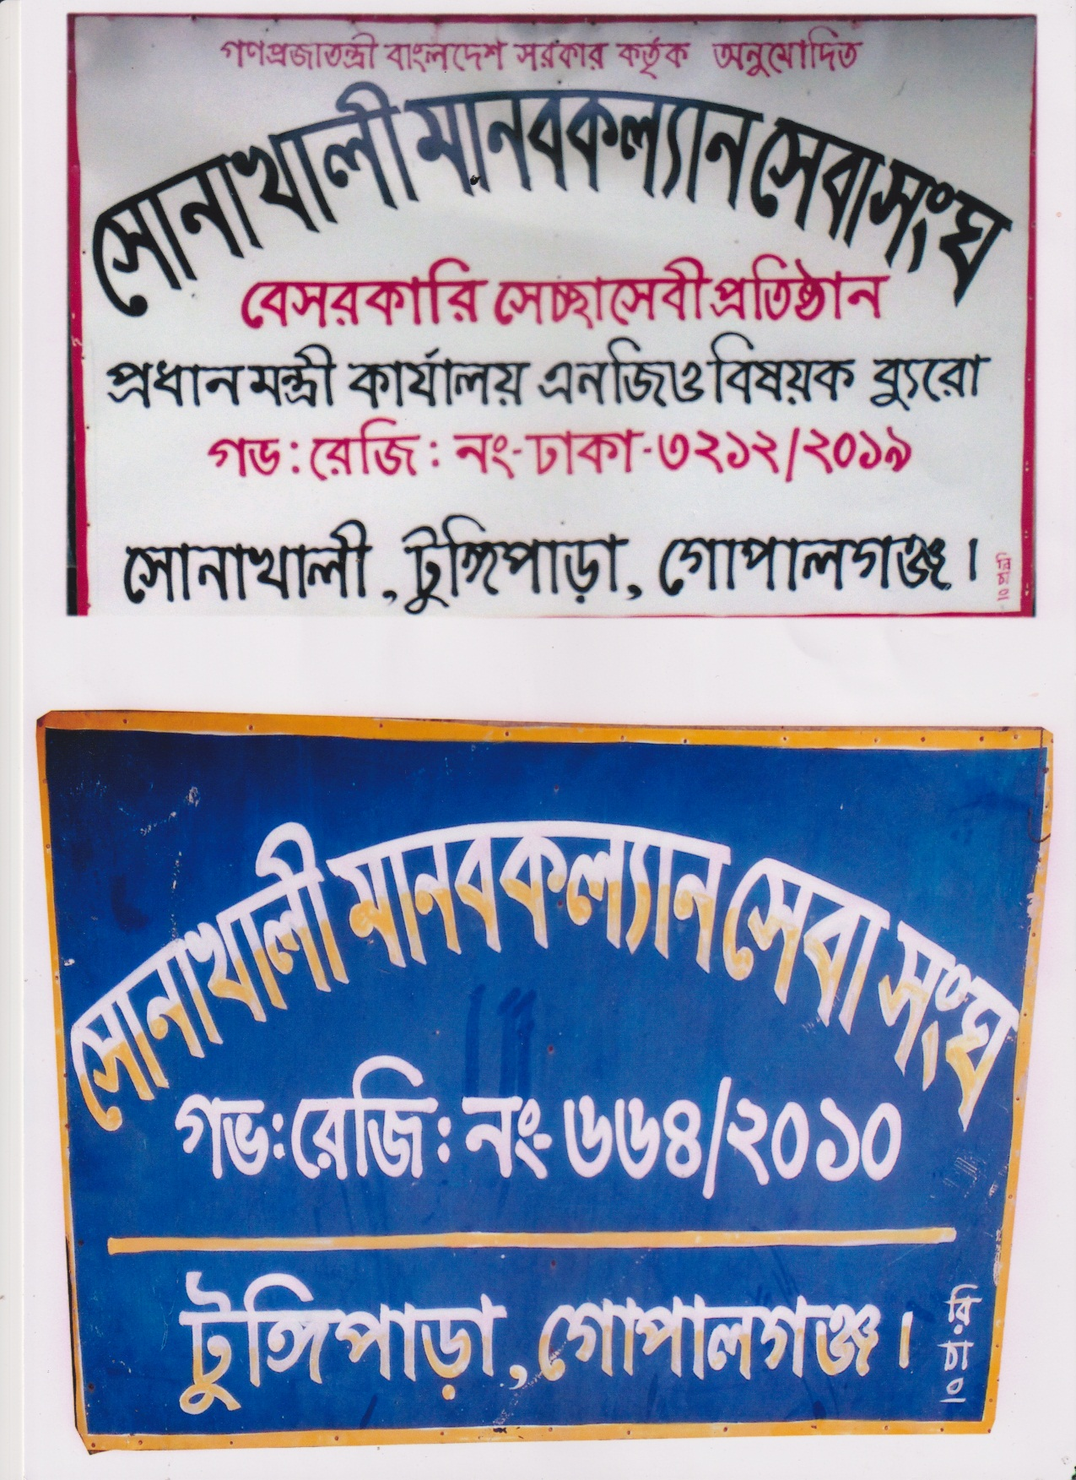
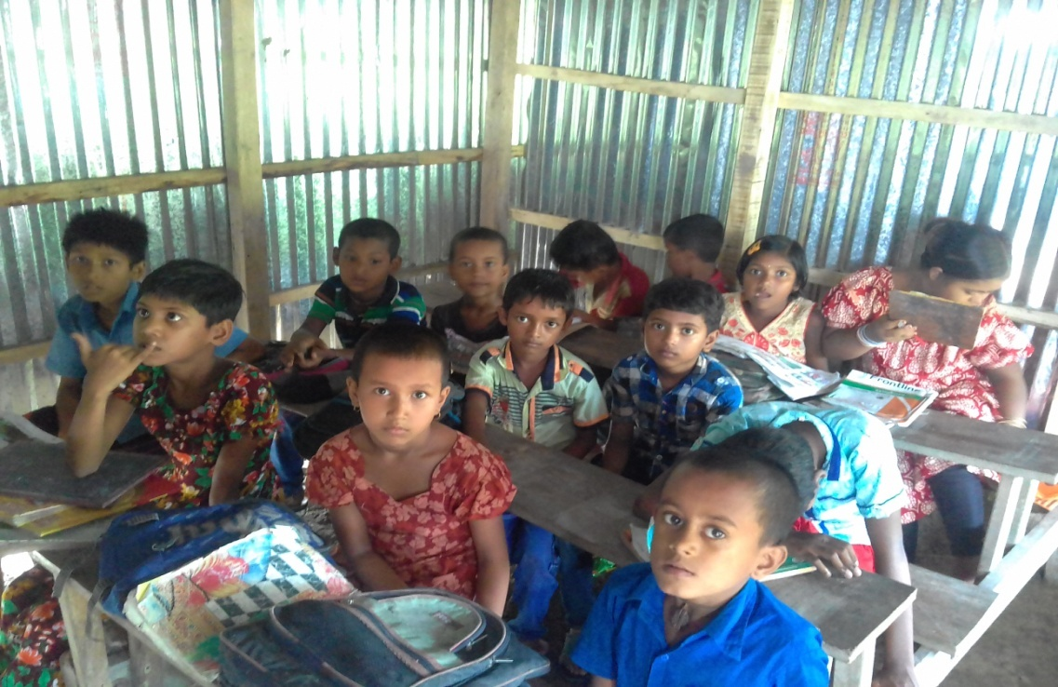
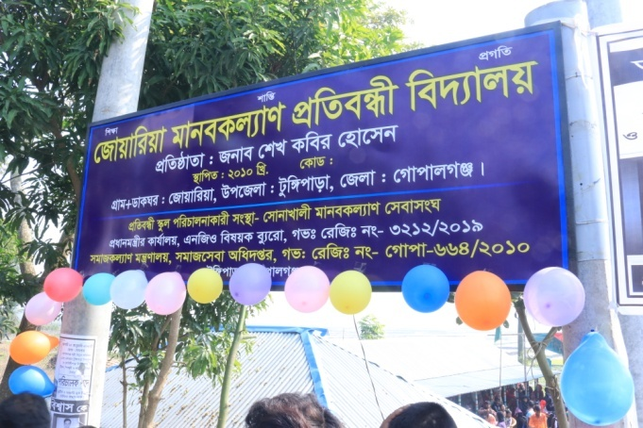

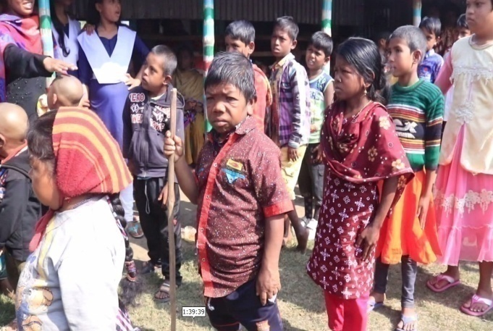

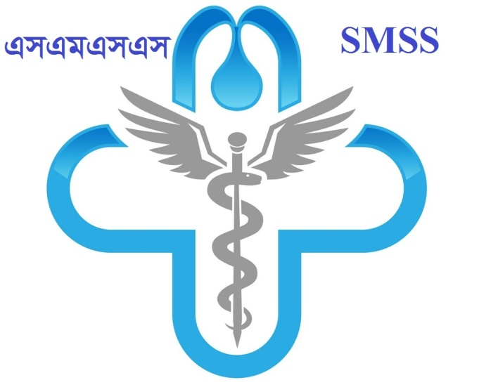
SONAKHALI MANOBKOLLAN SEBA SANGHA

Address:

SONAKHALI MANOBKOLLAN SEBA SANGHA (SMSS)
VILL: SONAKHALI, P. O: JOARIA, UPAZILA: TUNGIPARA,
DISTRICT: GOPALGONJ, COUNTRY: BANGLADESH.
E mail: smkssangha@gmail.com
Cell Phone: 01755863688, 01778217488
Introduction:
SONAKHALI MANOBKOLLAN SEBA SANGHA (SMSS) has been established in1999 as a non-profitable non-governmentcharity organization, with development orientation aimed at servingdistressed humanity being inspired by the universal value. As a development partner of Bangladesh government the organization was registered with the department of social service, GOB in 2010 and the NGO Affairs Bureau, Prime minister secretariatin 2019. Most of the people live in rural area. They live in under development situation. They always embraced with poverty. The government initiative is not available for our under developed economy. So we need most to make people more conscious and to alleviate poverty to having participation of NGO and donor agencies is essential.
Vision & Mission:
SMSS has been working with the vision to promote development programs in the community to improve the overall socio-economic and cultural condition of the disable, most disadvantaged children, adolescent, of the community. Special emphasis is given on preventing disability, ensuring maternal child health, adolescent family life education and reproductive health education, awareness on Sexual Abuse, and HIV/ AIDS and its prevention, restoration of child/ human rights and human resource development. SMSS have been trying to implement action programs with the active involvement and participation of the community people. SMSS aspire for a suppression free society with prosperity, peace and equity where all people could get proper opportunity and equal rights to develop.
Objectives:
1. To reduce poverty through capacity building and appropriate livelihood support for the poor persons with the disabilities,
2. Implement programs to promote health, education and socio-economic development of the most disadvantaged, vulnerable groups and the disabled people;
3. To contribute to overall development of Bangladesh through achieving the targets of the SDGs.
4. Undertake programs for prevention of disability in the community;
5. To provide special assistance to orphans, widows, refugees and destitute section for their self-reliance.
6. To conduct Research to find replicable and innovative models for better improvement of our development activities
7. Provide emergency relief materials to disable, destitute and disadvantaged children and their families of any catastrophe
8. Advocacy and lobbying with the policy makers, local authority and the elite groups to restore the rights of the disabled children and persons;
9. Operate the activities with Marginal community in order for taking the marginal and disable community in to mainstream development activities of the society.
10. Take action to prevent the loss due to Climate Change and others natural calamities and operation relief Program combat then on urgent need Basis.
11. To assist toward livelihood and food security create the provision of self-employment among the target peoples.
12. Women development.
13. Disaster management and climate change activities.
14. To increase disaster awareness and preparedness at the disaster-prone area, reduce suffering of disaster victims and help them to recover normal life with emergency relief and rehabilitation.

Scholarship Program :
Under the program school and core but meritorious students are offered monthly cash support to meet there educational and other needs. The Objective is to promote the career towards a health generation equipped with necessary knowledge skill and high moral qualities in the near future.
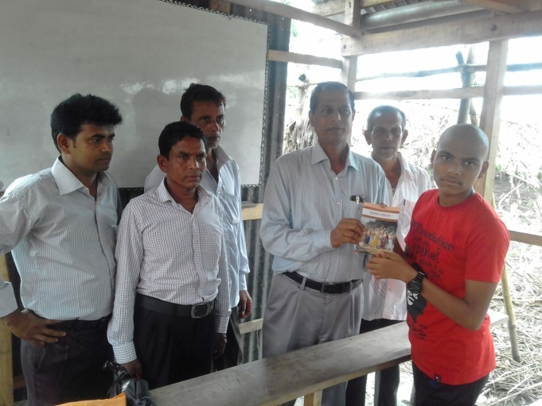
Fact Sheet :
Amount of Monthly stipend university student: BDT 300
Amount of Monthly stipend Higher Secondary student: BDT 250
Amount of Monthly stipend High School student: BDT 200
Number of Awardees: 50
Program Duration: 2015
Health Care Program:
The main objective of this program to provide health awareness Through holding health sessions, to provide medical prescription by qualified physician, to provide diagnosis service, physiotherapy,Nutrition food and life saving medicine free of cost.
Destitute Children's Education program:
This is on Education program Children for the Ultra-poor Children especially dwelling in slum areas within Gopalganj District. The Project has been designed to cover 100 boys and girls of 5-12 years of age with abut 50,50 ratio from among the drop out boys and girls, out of school boys and girls, Child labors, orphans and disabled Children etc.
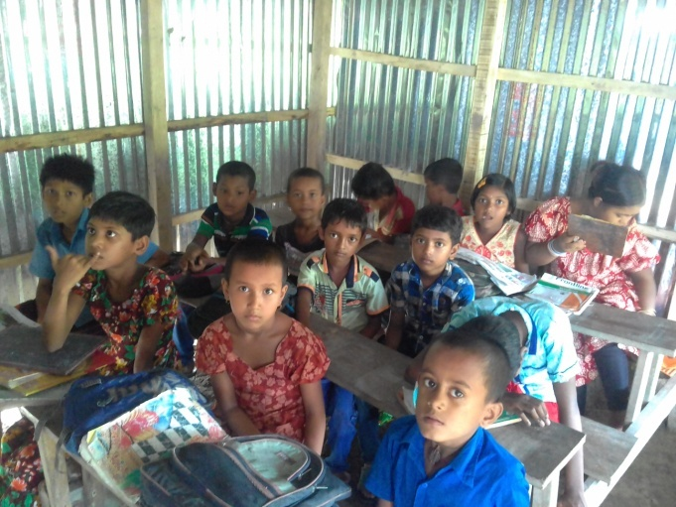
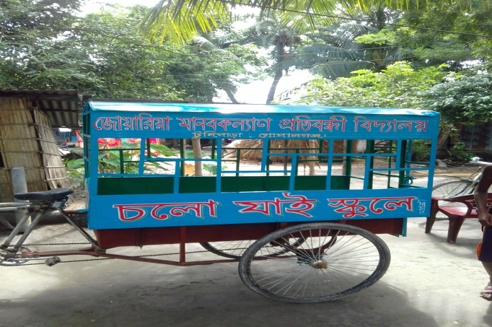
Fact Sheet:
Number of School :01
Number of student :90 (Girl-48, boy-42)
Number of teachers :05
Project Location :Sonakhali, Tungipara,Gopalgonj
Project Duration : Since 2010

Hospital and Shelter Home Services:
SMSS future plan to establisheda hospital Including old age and orphan Children with disability supported program in the TungiparaUpazilla District of Gopalgonj, Bangladesh.

Ambulance Service:
SMSS provide a Ambulance Service support for the poor patients in the grass roots level of TungiparaUpazilla to Gopalgonj District going for hospital.

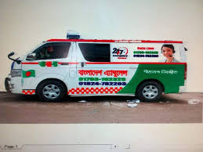

Eye Camp:
Eye camp is organized from time to time especially in rural areas to conduct major and minor operations with the help of eminent Eye Specialists for a few days to treat the eye patents of a particular location. The Camp often moves or place to place to cover more beneficiaries and locations. Poor patients are served free of cost while well offfamilies may avail the service on payment of reasonable cost.
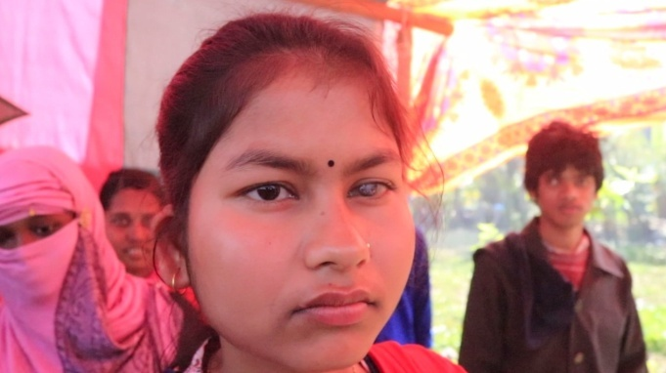

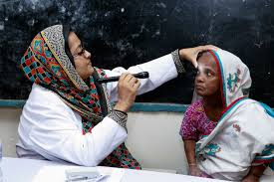

Fact Sheet:
Number of Eye Comps Held : 02
Number of Cataract patients served : 200
Number of other eye patients served : 400
Major donors : SMSS
Project duration : Since 2014
Water & Sanitation Program:

SMSS water initiatives aim to improve sustainable access to safedrinking waterand basic sanitation through installation of shallow/hand and deep tube-wells and sanitary latrines free of cost. this program covers mostly side and AILA affected areas as well as some other deserving locations of the country.
Fact Sheet:
Number of Hand/Shallow tube-wells installed:100
Number of beneficiaries served :5,000
Number of Sanitary Latrines installed : 200
Number of Semi-deep tube-wells installed:20
Program duration : Since 2015

Orphan Support program :

SMSS has been implementing orphan support program since inception in 2001 with the objective to improve the lives of the helpless orphan girls and boys through offering them different supports like personalized support for each individual orphan as well as institutional support meant for development of the orphans of the concerned orphanage. The overall objective of this program is to ensure welfare of the orphans who as deprived of the love and care of their father and mother.
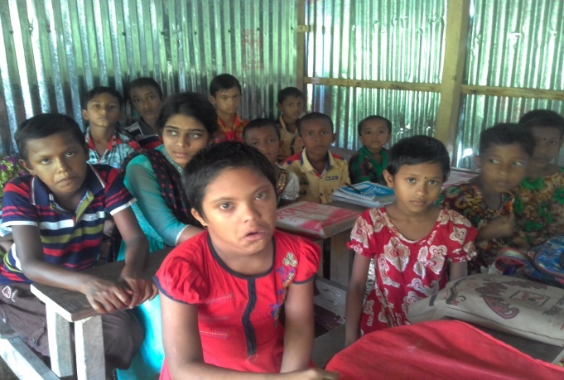
Disaster Relieve and rehabilitation program:

Under this program, food packets, medicine, other daily necessities are rushed to the disaster affected location and are distribute on the spot among the most affected families. Initiativesare taken to rebuild/repair houses and institutions like school, madrasa, mosque and arrangements are made for pure drinking wateronan urgent basis.

Fact Sheet:
Number of food packets distributed : 1000
Number of School/masque/Madrasharepaired: 5
Number of beneficiaries covered : 5000
Program duration : Since 2007
Number of School/Masque/MadrashaRebuilt: 2

Distribution of Assistive Device:
SMSS distributed many assistivedevice (like- Wheel-chair, Crutch, toilet Chair, White Can) in favour of poor parson with disabilities in the Gopalgonj District.

Vocational Training Program:

As part of post: sidor rehabilitation program, the types of vocational training courses are organized in TungiparaUpazilla, Gopalgonj District. These are Computer illiteracy and sewing and embroidery TungiparaUpazilla. Under this project, unemployed youths including females and males receive the rationing that help them get self-reliant through self-employment.

Fact Sheet:
Number of youths trained in computer literacy : 100
Number of women trained in sewing and embroidery: 50
Number of youths trained in welding work : 100
Number of Youths and womenattaining self-reliant: 300
Program duration: since 2014

Winter Clothes Distribution Program:

The Objective of the program is to assist the cold wave victims including children age-old and working men and women through distributing warm clothes to meet their emergency need for survival. Blankets, sweaters and children are distributed among poor and ultra-poor families especially those in northern cold and southern disaster his districts.
SMSS Executive Director distributes blankets among cold over victims.
Name of blankets distributed : 1000
Number of swathed distributed : 500
Number of beneficiaries covered : 3000
Number of ChildrenNumber of districts Covered: 5
Program duration :Since 2012

Partners & members in Development:
Strong net-work/Association at different lives with other organizations and other professional bodies
SL no | Name | types | Remarks
01 | Center for disability in development (CDD) | General member
02 | National Forum ofOrganizations working Disabled (NFOWD). | General member
03 | ADAB | Chapter Member
04 | JPUF | Donor Member
05 | MoH | Donor Member
06 | WBB TRUST | General Member
07 | BASUNDHARA FOUNDATION | Donor Member
08 | MoWC | Donor Member
09 | INC-USA | Donor Member
10 | CDF | General Member
11 | SEEP NETWORK -USA | General Member

Legal Status:
SL No | Registration Authority | Registration No. | Registration Date
01 | Directorate of social services, Govt. of Bangladesh | No- Gopa 664 | Date 01/03/2010
02 | NGO Affairs Bureau for foreign donation received.  Govt. of Bangladesh | 3212 | Date -23/07/2019

Bank Information:

Account name:
SONAKHALI MANOBKOLLAN SEBA SANGHA (SMSS)
Account Number : 6111901012069
Bank Name: Sonali Bank Ltd. TungiparaBranch, Tungipara, Gopalgonj, Bangladesh

Editor:
Executive Director (Honorary)

