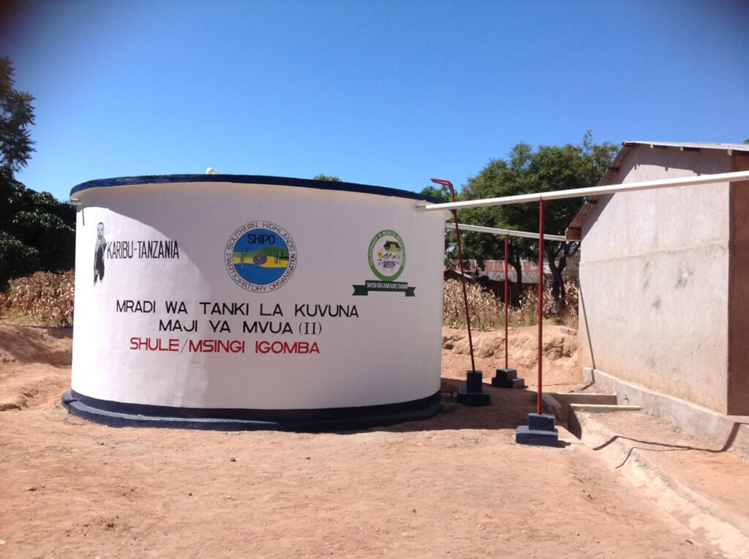
ENHANCING WATER INFRASTRUCTURE IN SCHOOLS FOR SUSTAINABLE ACCESS AND HYGIENE IN MAKAMBAKO TOWN COUNCIL AND WANGING’OMBE DISTRICT, TANZANIA

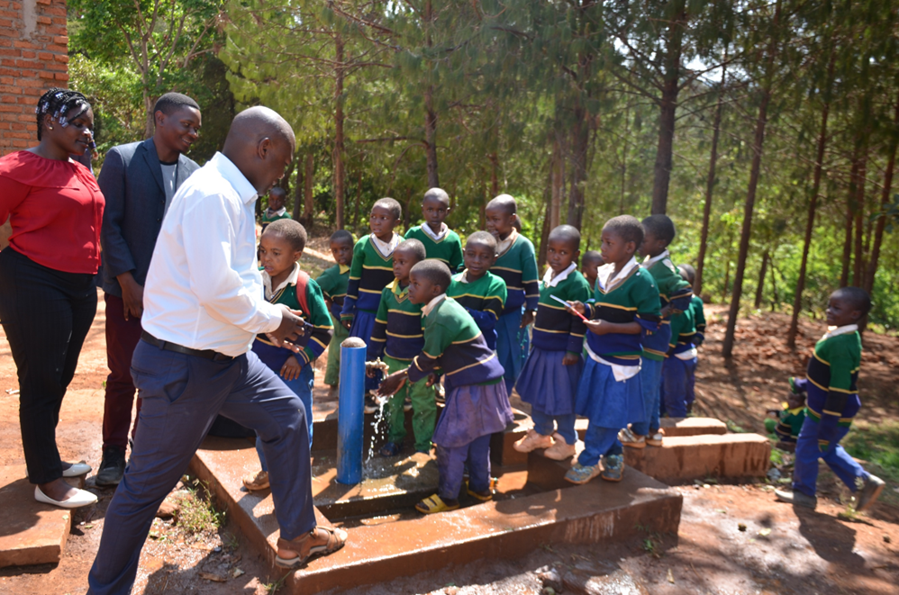

PROJECT FORMULATION



1. AREA'S CONTEXT AND GEO-LOCATION

Njombe region in Southern Highlands of Tanzania acquired a fully recognition to a regional status in 2012 whereby before that it was part of Iringa region. Njombe region comprises four districts these are Njombe, Makete, Wanging’ombe and Ludewa. On the southern is bordering Ruvuma region, on west is bordering lake Malawi and on the north, north-east and east it is bordering Mbeya, Iringa and Morogoro regions, respectively.

The project is going to be implemented at four (4) primary schools whereby Lungwa and Ngamanga are located in Makambako Town Council (which is Njombe district) while Jitegemee and Igeleheza are located in Wanging’ombe District.

Its location is detailed in Figure 1 and Table 1.
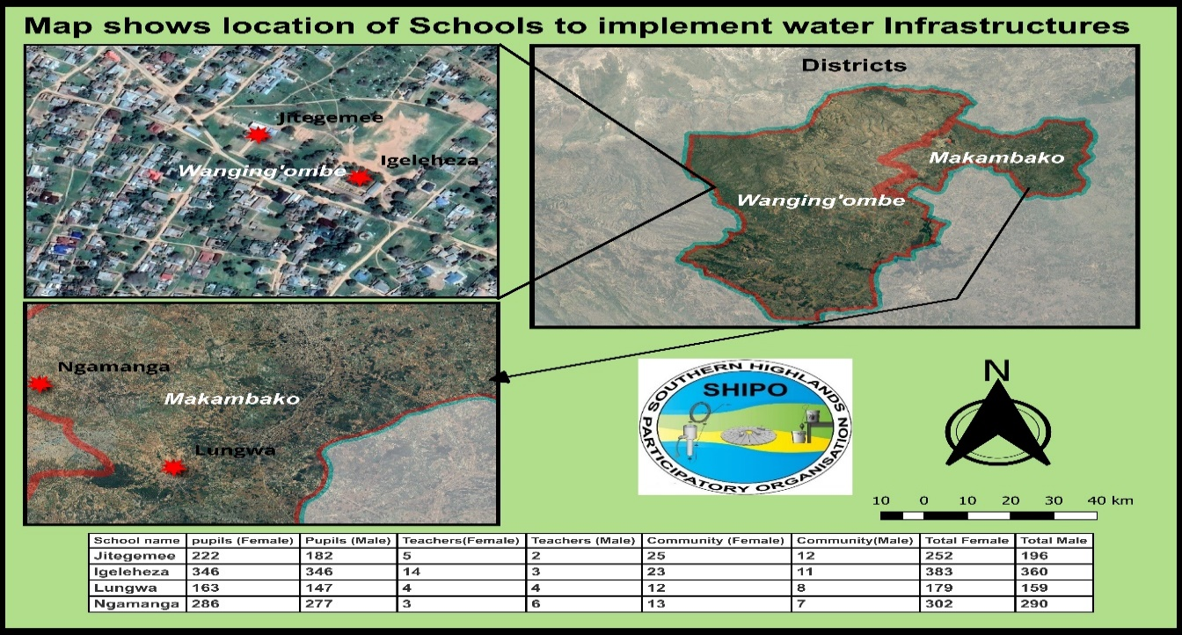

Figure 1: Location of the 4 primary schools in Wanging’ombe district and Makambako TC - Njombe region, Tanzania.
 | Wanafunzi |  | Walimu |  | community |  | Jumla |  | Geocoordinates
School name | Female | Male | Female | Male | Female | Male | Female | Male | Latitude | Longitude
Jitegemee | 222 | 182 | 5 | 2 | 25 | 12 | 252 | 196 | -8.89673 | 34.584117
Igeleheza | 346 | 346 | 14 | 3 | 23 | 11 | 383 | 360 | -8.89764 | 34.585065
Lungwa | 163 | 147 | 4 | 4 | 12 | 8 | 179 | 159 | -8.958373 | 34.786962
Ngamanga | 286 | 277 | 3 | 6 | 13 | 7 | 302 | 290 | -8.914119 | 34.741784

 | Total Students | 1969
 | Total teachers | 41
 | Total population | 2121
Table 1: Details of the location of the 4 primary schools

2. PROJECT DESCRIPTION

2.1. General context of WASH situation in Tanzania
Access to clean and safe water is a fundamental human right that significantly impacts health, education, and overall well-being. Unfortunately, many schools, particularly in underserved communities, face challenges in providing reliable water sources and promoting proper hygiene practices. The lack of adequate water infrastructure not only affects the health of students and staff but also hinders the learning environment. This project addresses these challenges by implementing a comprehensive approach to enhance water infrastructure in schools, fostering sustainable access and promoting hygiene.
Efforts to address water, hygiene, and sanitation challenges in Tanzania require a holistic approach that combines infrastructure development, community engagement, education, and policy initiatives. Ongoing collaboration between government agencies, non-governmental organizations, and the international community is crucial to making sustainable improvements in WASH conditions throughout the country. For the latest and more specific information, it's advisable to refer to recent reports and updates from relevant authorities and organizations working in Tanzania.
Water Access in Tanzania, like many other sub-Saharan African countries, faces challenges in providing access to clean and safe water for all its citizens, especially in rural areas. Access to improved water sources has increased in recent years, but disparities still exist between urban and rural areas.
Sanitation and hygiene conditions in Tanzania have shown improvement, but there is still a need for increased access to proper sanitation facilities, particularly in rural communities. Open defecation remains a concern in some areas, contributing to water contamination and the spread of waterborne diseases.
Waterborne diseases, such as cholera and diarrhea, are significant public health challenges in Tanzania, often linked to the consumption of contaminated water. Poor sanitation practices contribute to the prevalence of these diseases, impacting the health and well-being of communities. The Tanzanian government has implemented various initiatives and policies to address water, sanitation, and hygiene (WASH) issues. This includes the National Water Policy and the National Sanitation Campaign.
2.2 The background information in the project location
The current WASH condition in the selected 4 primary schools is a worst scenario. Pupils and teachers struggles extremely to get water for use at school throughout the year despite of 5 months with adequate rainfall that could provide adequate water to use during rain and after season ends (almost six 6 months) year round if the RWH infrastructure could be installed. The worst scenario is major driving force behind SHIPO taking initiatives to find the solution that can improve or curb the problem.
There is not only lack of adequate water supply but also lack of safe WASH facilities in those four schools contributing to poor learning environments, hence, make pupils and teacher not enjoy the learning environment(inconvenient). SHIPO is motivated with this project due to seeing insufficient provision of water infrastructure to enable adequate quality water for pupils and teachers use at school. Therefore, the anticipated project is going to solve the problem of water availability, sustainable supply and its infrastructure maintenance.

Njombe district council (Njombe-DC) and Njombe Town council (Njombe –TC) are characterized by a mountainous and gently sloping features whereby occupants in the downstream of water sources are benefited by water gravity flow. Rural Water Supply and Sanitation Agency (RUWASA) is the responsible governmental organ to provide water in rural areas of the country. The Tanzania Water and Sanitation Act of 2019 establishes that the water schemes in rural areas are managed by Community-Based Water Supply Organisations (CBWSOs), established in every village.

2.3. Objective
The primary objective of the Rainwater Harvesting Infrastructure Project (RAWAHI-Project) in Schools is to improve availability and sustainable access to clean and safe water, as well as promote hygiene practices among pupils, staff, and the surrounding community. The project aims to contribute to a healthier learning environment, reduce waterborne diseases, and empower the school community with the knowledge and tools necessary for proper water management.

2.4. Project activities.

- Survey, drill and establish boreholes or wells to provide a sustainable and reliable source of clean water.
- Implement rainwater harvesting systems to supplement water supply during the rainy season.
- Install/construct water storage tanks to store an adequate supply for the school and surrounding community.
- Conduct hygiene awareness campaigns and workshops for students, teachers, and the community.
- Provide training for school staff on water management, maintenance, and emergency response.
2.5 Expected Outcomes:
- Reliable access to clean water for students, staff, and the community.
- Improved hygiene practices leading to a reduction in waterborne diseases.
- Increased community awareness and involvement in water management and hygiene promotion.
- Empowered students and staff with the knowledge and skills for sustainable water use and infrastructure maintenance.
2.6 Expected Output:
- Rainwater harvesting tanks at Igeleheza, Jitegemee, Lungwa and Ngamanga Primary Schools installed/constructed.
- Safe WASH and hygiene practices improved to pupils and teachers
- Water harvesting infrastructure maintenance guidelines developed and trained the relevant person responsible for maintenance works.

3. BENEFICIARIES, PROFILE

  - Social economic context of the project area

Majority of occupants in the project area are the peasants with subsistence production whose Livelihoods depend mainly on the cultivation of food crops (maize, beans, and potatoes). Therefore food security to majority is the produce harvested from their own farms kept for foods with exception to a few percent who cultivate surplus foods for sales to the local markets.. Most of them obtain food from their own fields, while only some wealthier farmers sell their surplus on the local market.

Poor subsistence farmers are often forced to sell part of their yield immediately after the harvest at the lowest price in order to earn some cash purchases purchase goods such as clothes and to meet the health and educational needs. These households, whose production is not enough to sustain them for a full year, must look for alternative income generating activities in order to purchase food and cover the period until the next harvest.

The majority of poor farmers, during periods of stress, look for casual employment in rural areas performing land preparation, weeding, and harvesting for better-off households, or travel to nearby towns or outside their area offering unskilled services. Individuals, who cannot access casual employment opportunities, normally try to make some profit out of selling forest products, mainly fuel wood, wild fruit and honey.

Some better-off households complement subsistence productions with small cultivations of cash crops Avocado, tea and pyrethrum sold on the local and international markets and also keep some livestock. Poultry is the primary livestock kept in the area; however, there are also a number of cattle, goats and sheep. A minority of households are engaged in small businesses such as trading, running small stores, restaurants or micro-scale processing activities (mainly mills and jam production for local market).

  - Why a need for donor support
Following the description of the social economic profile of the community in the project area, it is hardly possible to curb the problem by raising money from their own pocket. This necessitate to seek for a help from donor support while the community can participate in-kind support (i.e some workforce and foods to support labour on construction sites. A part from general livelihood life depends on agriculture, and meals (Lunch) in schools is taken into consideration aiming to improve and increase in performance in studies. The only means is to keep students get food during studies. Unfortunately, water as the main important in schools to facilitate students and teachers in schools.

  - Beneficiaries status
The direct beneficiaries of the project are the 1969 pupils (1017 Girls and 952 Boys) studying in the 4 primary schools. The staff working in the schools are also directly benefited by this project. The parents and families of the children are indirect beneficiaries of the project. See table number 1 with detailed information. The following paragraph provides a summary of the general living conditions in the project area where the schools are located:

4. IMPACT AND SOURCES OF VERIFICATION

The final impact of the project is to improve the quality education in Jitegemee, Igeleheza, Lungwa, and Ngamanga primary schools in Wanging’ombe district and Makambako town council. Through the improved access to clean and safe water in the schools, the learning and living environment of pupils will improve. It will also make some activities easier in the schools, like cooking and gardening of vegetables.

The functionality status of the constructed water systems (functional or not functional) and the effectiveness of the performance of the CBWSOs at village level are the indicators to evaluate the project’s impact. These indicators will be monitored during five years through visits to the schools and meeting with LGAs.

Monitoring and Evaluation:

Establish a monitoring and evaluation framework to assess the effectiveness of the water infrastructure project. Regularly collect data on water quality, usage, and hygiene practices. Solicit feedback from the school community to identify areas for improvement and sustainability.

Partnerships:
Collaboration with local government agencies, non-governmental organizations, and community stakeholders will be essential for the success of the project. Partnerships will be established to leverage resources, expertise, and support for the long-term sustainability of the water infrastructure and hygiene initiatives in schools.

5. TIMELINE OF THE PROJECT

The project is expected to start on June 2024 and to be finalized by the end of September 2024. It is important to start mobilizing the communities early enough so that work can start at the beginning of July on the 4 sites. The works are expected to be carried out during around 4 months.

6. PROJECT SUSTAINABILITY AND RISKS

Numerous water projects remain functional during one or two years and after that, become non-functional due to poor operation and maintenance by the water users. In order to improve the sustainability of water projects it is key to involve the local community and to make them contribute to the project. One of the indirect beneficiaries of the project is the surrounding community in the project, the criteria shall be set to have contributions of the service during access of the service that will help operational and maintenance of the water tanks, and water points.

Also the in-kind contribution of the local communities - in terms of local material like sand, gravel, stones, bricks, etc.; voluntary labour by both community masons and unskilled labour; food and accommodation for the SHIPO mason based at the site during the construction phases – is a key strategy to ensure their sense of ownership, as well as the engagement of district officers and local leaders is also key for the local ownership.
The maintenance works that cannot be done by the local communities will be requested to the CBWSO and LGAs which shall set the mechanism the modality of the community getting the service to contribute.

SHIPO will do a 5-year follow-up of the project and will report to the donor the water point’s functionality and performance of CBWSOs yearly.

7. BUDGET

The total project cost is 27,247.92 euros: 22,957.74 euros to be contributed by the donor and 5,792.08 euros to be contributed by SHIPO and the local communities. The budget for the completion of the project is presented in Table 4, Table 5 and 6 show the budget for the construction of the infrastructures in 4 schools.

BILLS OF QUANTITY FOR CONSTRUCTION OF RAIN WATER HARVESTING TANK AT IGELEHEZA PRIMARY SCHOOL
 | DISCRIPTION | UNIT | QTY | UNIT PRICE | TOTAL PRICE |  | SHIPO/Com contribution |  | DONOR FUNDS
A | FOUNDATION AND EARTH WORTH
1 | Supply of hardcores for foundation work transport cost | Trip | 5 | 80,000 | 400,000 |  |  |  | 400,000
2 | Excavation of foundation trench | m cubic | 4 | 100,000 | 400,000 |  |  |  | 400,000
3 | aggregate for foundation work | tip | 2 | 150,000 | 300,000 |  | 300,000 |  | -
4 | Sand for foundation work | trip | 2 | 150,000 | 300,000 |  | 300,000 |  | -
5 | Cements for foundation | Bags | 15 | 19,000 | 285,000 |  |  |  | 285,000
6 | Binding wire | kg | 5 | 5,000 | 25,000 |  |  |  | 25,000
7 | Cheep boards | pc | 3 | 23,000 | 69,000 |  |  |  | 69,000
8 | Reinforcement for foundation 12mm diameter | Roll | 9 | 25,000 | 225,000 |  |  |  | 225,000
9 | mash wire | pc | 4 | 20,000 | 80,000 |  |  |  | 80,000
10 | 6mm iron bar | Roll | 2 | 800,000 | 1,600,000 |  |  |  | 1,600,000
11 | Transportation cost for industrial material | Trip | 1 | 1,500,000 | 1,500,000 |  |  |  | 1,500,000
 | Sub Total |  |  |  | 5,184,000 |  | 600,000 |  | 4,584,000
B | PRODUCTION OF CONCRETE BLOCKS
1 | Production of cement block | Pcs | 770 | 5,000 | 3,850,000 |  |  |  | 3,850,000
2 | Transportion cost of blocks to Ilembula (Igeleheza) | Trip | 3 | 200,000 | 600,000 |  |  |  | 600,000
 | Sub Total |  |  |  | 4,450,000 |  | - |  | 4,450,000
C | CONSTRUCTION OF TANK
1 | Cement for construction | Bag | 70 | 19,000 | 1,330,000 |  |  |  | 1,330,000
2 | Supply of sand for construction | Trip | 5 | 250,000 | 1,250,000 |  | 1,250,000 |  | -
3 | Reinforcement 10mm for walling | Pc | 41 | 21,000 | 861,000 |  |  |  | 861,000
4 | Supply binding wire | Kg | 5 | 4,000 | 20,000 |  |  |  | 20,000
5 | Supply water proof and mixture | Kg | 40 | 3,000 | 120,000 |  |  |  | 120,000
6 | Supply Reinforcement for top cover 12mm | Pc | 33 | 25,000 | 825,000 |  |  |  | 825,000
7 | Supply aggregates | Trip | 1 | 350,000 | 350,000 |  | 350,000 |  | -
8 | Transport cost sand | Trip | 2 | 200,000 | 400,000 |  |  |  | 400,000
9 | Supply timber 1*8 for formwork | Pc | 55 | 8,500 | 467,500 |  |  |  | 467,500
10 | Supply timber 2*3 for formwork | Pc | 26 | 5,500 | 143,000 |  |  |  | 143,000
11 | Plastic sheet | m | 15 | 3,500 | 52,500 |  |  |  | 52,500
12 | Ladder fabrication | 1ms | 1 | 600,000 | 600,000 |  |  |  | 600,000
13 | Different nails | Kg | 10 | 5,000 | 50,000 |  |  |  | 50,000
14 | Transport cost for industrial material | Trip | 2 | 1,500,000 | 3,000,000 |  |  |  | 3,000,000
15 | Mid term Evaluation (authorty) | Day | 1 | 45,000 | 45,000 |  |  |  | 45,000
 | Sub Total |  |  |  | 9,514,000 |  | 1,600,000 |  | 7,914,000
D | GUTTER, PIPE AND CONNECTIONS
1 | Supply timbers for farcial board 1*8 | Pc | 13 | 9,000 | 117,000 |  |  |  | 117,000
2 | Supply gutters | Pc | 8 | 42,000 | 336,000 |  |  |  | 336,000
3 | Supply gutter supports | Pc | 40 | 7,000 | 280,000 |  |  |  | 280,000
4 | Gutter - ends | Pc | 4 | 15,000 | 60,000 |  |  |  | 60,000
5 | Gutter connectors | No | 8 | 8,000 | 64,000 |  |  |  | 64,000
6 | Gutter screws | Box | 2 | 5,000 | 10,000 |  |  |  | 10,000
7 | T-connectors | Pc | 2 | 10,000 | 20,000 |  |  |  | 20,000
8 | Down pipe | Pc | 4 | 20,000 | 80,000 |  |  |  | 80,000
9 | Gs pipe for overflow and washout 2" | Pc | 1 | 60,000 | 60,000 |  |  |  | 60,000
10 | Gs pipe for domestic point 3/2" | Pc | 1 | 40,000 | 40,000 |  |  |  | 40,000
11 | Water tap of 3/4" | Pc | 1 | 20,000 | 20,000 |  |  |  | 20,000
12 | Gs socket 3/4" | Pc | 1 | 4,000 | 4,000 |  |  |  | 4,000
13 | Gs socket of 2" | Pc | 1 | 4,000 | 4,000 |  |  |  | 4,000
14 | Gs Elbow 3/4 | Pc | 2 | 4,000 | 8,000 |  |  |  | 8,000
15 | Gs plug ¾ | Pc | 1 | 3,000 | 3,000 |  |  |  | 3,000
16 | Gs plug 2" | Pc | 1 | 3,000 | 3,000 |  |  |  | 3,000
17 | Different iron nails | Kg | 20 | 5,000 | 100,000 |  |  |  | 100,000
19 | Black pipe for collum | Pc | 2 | 100,000 | 200,000 |  |  |  | 200,000
8 | Transport of staff | Km | 2016 | 1,500 | 3,024,000 |  |  |  | 3,024,000
21 | Hand over Ceremony | Day | 1 | 45,000 | 45,000 |  |  |  | 45,000
 | Sub Total |  |  |  | 4,478,000 |  | - |  | 4,478,000
 | SALARIES
1 | Technical Officer | Day | 66 | 65,000 | 4,290,000 |  | - |  | 4,290,000
2 | Community Officer | Day | 44 | 65,000 | 2,860,000 |  | - |  | 2,860,000
3 | Mason Salary (3) | Day | 44 | 30,000 | 1,320,000 |  | - |  | 1,320,000
5 | Finance Manager | Day | 16 | 160,000 | 2,560,000 |  | 2,560,000 |  | -
22 | plumber | Day | 3 | 350,000 | 1,050,000 |  | - |  | 1,050,000
6 | Program Manager | Day | 10 | 200,000 | 2,000,000 |  | 2,000,000 |  | -
7 | Monitoring & supervision T/O | Day | 44 | 45,000 | 1,980,000 |  | 1,782,000 |  | 198,000
9 | Final evaluation (government authority) | Day | 1 | 120,000 | 120,000 |  | - |  | 120,000
 | Sub Total |  |  |  | 16,180,000 |  | 6,342,000 |  | 9,838,000
 | Sub Total |  |  |  | 39,806,000 |  | 8,542,000 |  | 31,264,000
 | Organisation cost |  | 7% |  |  |  |  |  | 2,188,480
 | Grand Total |  |  |  |  |  |  |  | 33,452,480
 |  |  |  | EURO | 16,586 |  | 3,559 |  | 13,939
 | Total RWHT costs | 16,586
 | Total SHIPO and Community contribution | 3,559
 | Total Donor contribution Needed for the project for this infrastructure | 13,939

ESTIMATIONS FOR THE INSTALLATION OF WATER STORAGE INFRASTRUCTURES IN 4 SCHOOLS (EGELEHEZA, JITEGEMEE, LUNGWA and NGAMANGA )
Items | Unit | Quantit y | Unit Costs | Total Costs | Community contrib. | Donor Funds
 |  |  |  | (TZS) | (TZS) | (TZS)
Cement | Bags | 40 | 15,000 | 600,000 | - | 600,000
Iron bars | 12mm | 12 | 18,000 | 216,000 | - | 216,000
Binding wire | kg | 4 | 3,000 | 12,000 | - | 12,000
Bricks | pc | 1200 | 150 | 180,000 | - | 180,000
Sand preparation | trip | 16 | 20,000 | 320,000 | 320,000 | -
Sand transport | m3 | 8 | 250,000 | 2,000,000 | 2,000,000 | -
Aggregates | Buckets | 24 | 1,000 | 24,000 | 24,000 | -
Timber 1*6 | pc | 32 | 3,000 | 96,000 | - | 96,000
Iron nails | kg | 12 | 3,000 | 36,000 | - | 36,000
Pump and its connections (depending on distance) | lumpsum | 4 | 600,000 | 2,400,000 | - | 2,400,000
Tank | 5000lts | 4 | 1,200,000 | 4,800,000 | - | 4,800,000
Pipe connections and accessories | lumpsum | 4 | 600,000 | 2,400,000 | - | 2,400,000
Stones | m3 | 8 | 30,000 | 240,000 | - | 240,000
Transport |  | 4 | 650,000 | 2,600,000 | - | 2,600,000
Technical Officer | Days | 60 | 65,000 | 3,900,000 | - | 3,900,000
Labour costs (masons, plumber, electrician) | lumpsum | 3 | 500,000 | 1,500,000 | - | 1,500,000
Community labour | days | 90 | 7,000 | 630,000 | 630,000 | -
Meals for the masons | days | 90 | 10,000 | 900,000 | 900,000 | -
Community Development officer | days | 20 | 50,000 | 1,000,000 | 500,000 | 500,000
Monitoring and Evaluation officer | year | 5 | 150,000 | 750,000 | - | 750,000
Stationaries + calls | lumpsum | 1 | 985,000 | 985,000 | 985,000 | -
Total costs |  |  |  | 25,589,000 | 5,359,000 | 20,230,000
Administration | 7% |  |  |  |  | 1,416,100
Grand Total |  |  |  |  |  | 21,646,100
Total cost of water infrastructure | 10,662
Tota Community and SHIPO contribution | 2,233
Total Donor contribution Needed for the project for this infrastructure | 9,019

COST SUMMARY
Rain water harvesting tank costs
Total RWHT costs | EUR 16,585.83
Total SHIPO and Community contribution | EUR 3,559.17
Total Donor contribution Needed for project | EUR 13,938.53
Water infrastructures costs
Total cost of water infrastructure | EUR 10,662.08
Tota Community and SHIPO contribution | EUR 2,232.92
Total Donor contribution Needed for project | EUR 9,019.21
Total fund requests | EUR 22,957.74

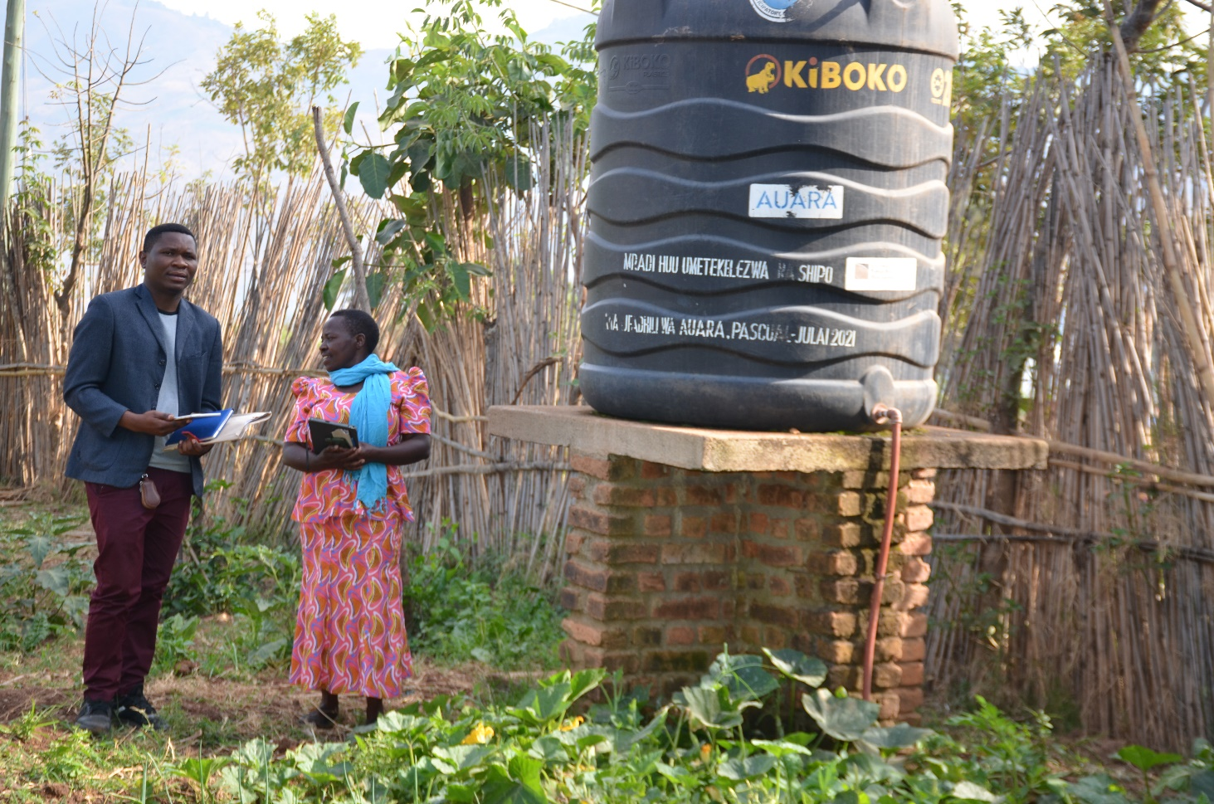
Figure 1: One of the water project in the previous in the primary schools

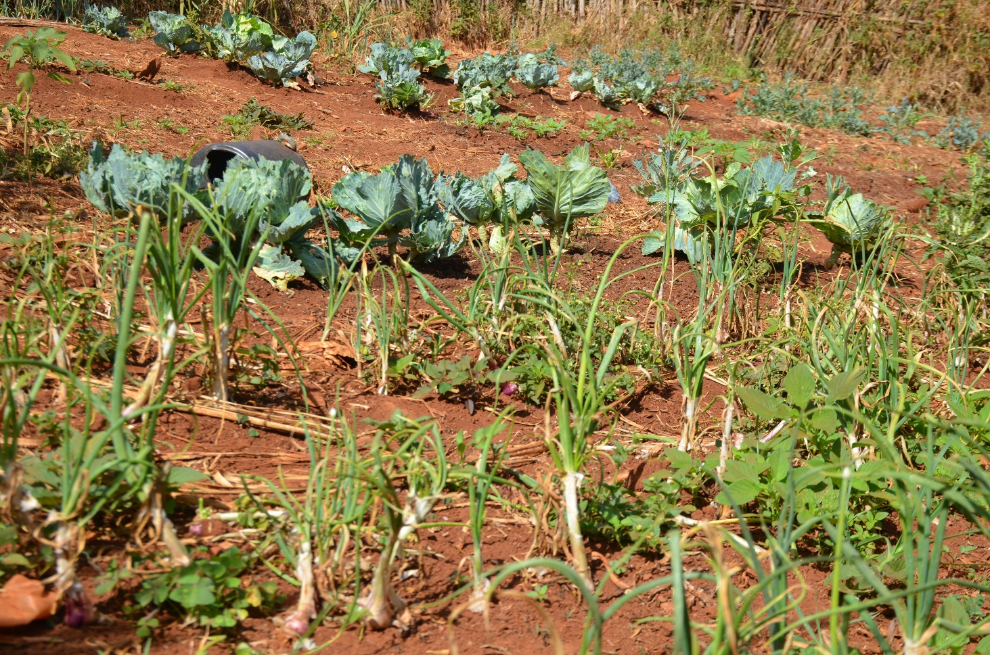
Figure 2: One of the use of water infrastructure implemented in the previous project IN THE PRIMARY SCHOOLS

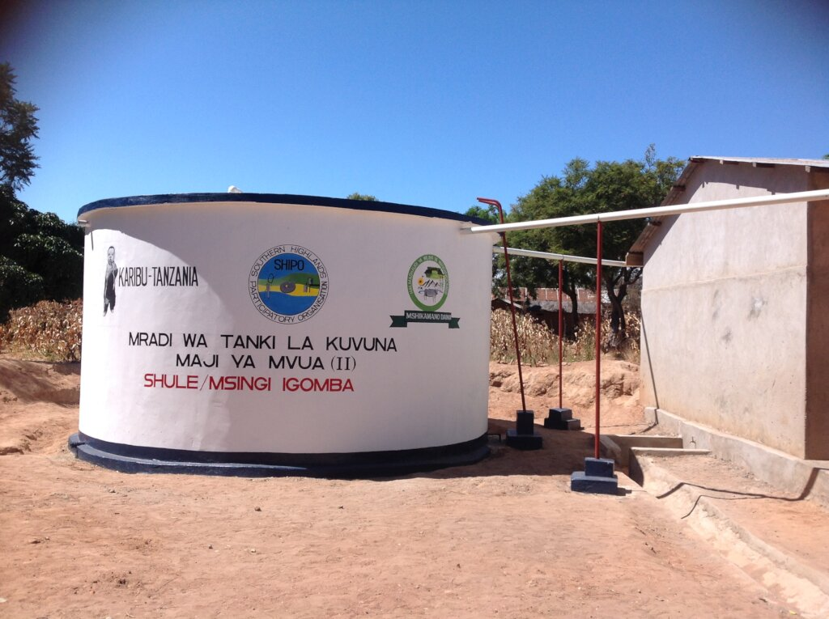
Figure 3:Previous project implemented RWHI in the primary schools

