COLLECTIF DES ORGANISATIONS DES JEUNES SOLIDAIRES DU CONGO KINSHASA

« COJESKI/RDC »
COORDINATION PROVINCIALE DU NORD-KIVU

Projet : Global Refugee Leaders Forum

Personnalité Juridique : N°385/CAB/MIN/J & GS/2003 du 30 avril 2003, NGO with a Special Econsultative Status at the Economic and Social Council of the United Nations (ECOSOC) & Jouissant duStatut d’Observateur auprès de la Commission Africaine des Droits de l’Homme et des Peuples / UA

REPPORT OF OUR FIELD VISIT TO RWANDAN REFUGEE WOMEN AROUND GOMA WHO HAVE BENEFITED FROM OUR FINANCIAL SUPPORT 14/05/2024 IN NORTH PART OF GOMA.
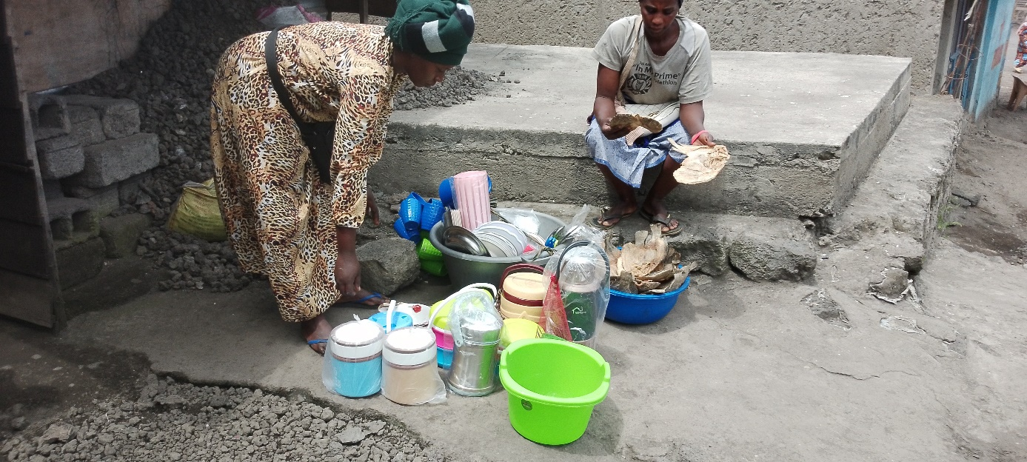

Two Rwandan Refugee around Goma who have benefited from our financial support displaying what they are selling to members of the Communities.

For security reasons we shall call the first one Aziza, she has an interesting story.
Aziza entered in DRC in 1994 during the Genocide in Rwanda at the age of one year, her father died during the genocide because he refused to join the militia groups, she crossed then the border with her mother. But also in 1996 Rwandan forces invaded Congo and destroyed the refugee camp in Goma where she lived, during that attack of the Rwanda Army in Goma her mother was killed alongside others, she was then saved by a neighbor who also later died from the forest where they went in order to hide because they could not get medical treatment. She now grew up and she was married at the age of 12 in order to survive, in the process she got married to now four men in order to be protected. Later one she left the village and came to Goma where she is living, she is among those Rwandan Refugee who are not yet registered by UNHCR and the DRC Government. As we started refugee community meetings in Goma, she also started coming and managed to get associated with others, sharing their stories and knowing each other.
In 2022 as we approached towards the World Refugee Day, TV5 and France 24 TV Stations based in France wanted stories of most vulnerable refugee women especially, the journalists contacted to help them to get these women, we asked the group and later on fellow refugees proposed us three (3) people among them Aziza. We moved in their different places, when we reached her home, we were all touched with the miserable life she was living in with her children, after the interview we gave her some little money we had, and in the process the journalist kept on asking me about her, so as this project got some money in 2023 we opted to include her in the group because she believed she can do some business in order to feed her five (5) children. She also benefited from the money and since that time she become much active.
Today she is doing much better, now every time you can see her with a smile and she is a proud of the whole group.
She is the one on the picture selling fish, she is involved in various types of fish and sometimes she supplies even to staff members here at the office. She wants more money so that she can make more profit in order to buy a plot land where she can fully settle with her children and become one among successful business women in Goma.

ACTIVITIES
- To put these Refugee Women into an Association
- Date : 14/05/2024
- Time : 11 :00 – 13 :20’
- Location : Goma North

OBJECTIVES

N° 1. To give the name of the Association and its objectives, mission and vision,
N° 2. Identify activities of the Association of the first refugee women in Goma,

The Association
During the meeting the Refugee Women agreed to the call the Association by the name of «ASSOCIATION DES FEMMES REFUGIEES COURAGEUSE » “Courageous Refugee Women Association” they also identified their mission, vision and objectives. They also asked COJESKI North Kivu to help to make a constitution and support them to register as non-profit organization. The Association will bring together Refugee Women in the Democratic Republic of Congo, and will focus mainly on economic development and empowerment of refugee women.

Overview about their activities

They are all involved in businesses mainly in trade, they do sell their things from the roadside which is not safe, as the rest of the population in Goma, they are also highly affected by the current war and it is now difficult for them to sell off their products, something they used to sell in two days is now taking one week because people do not have money in order to buy. The little profit they are making is generally for their basic needs and they are not in position to save anymore. They believe in case they get more financial support they can increase their businesses but also shift to what is being consumed quickly currently such as food items.

Refugee Women Resilience activities in Goma

Anastasia keeps on going, she also one among those who benefited from our financial support, she is involved in plastic items which are used by community members, she told us that with this she can still ensure that her children are supported in order to go school, she gets food, she pays her house rent, and can also afford her basic medical care. “You may look at what I’m doing as a joke, but know there are so many refugee women here who did not get this chance, I’m just lucky, there are also Congolese women who did not get this chance but now every day I know I will eat, other women like me do know where to get even food for their children. My only regret is that I do not know those who supported us, I want to thank them but I have never seen them, please share my gratitude to them”.
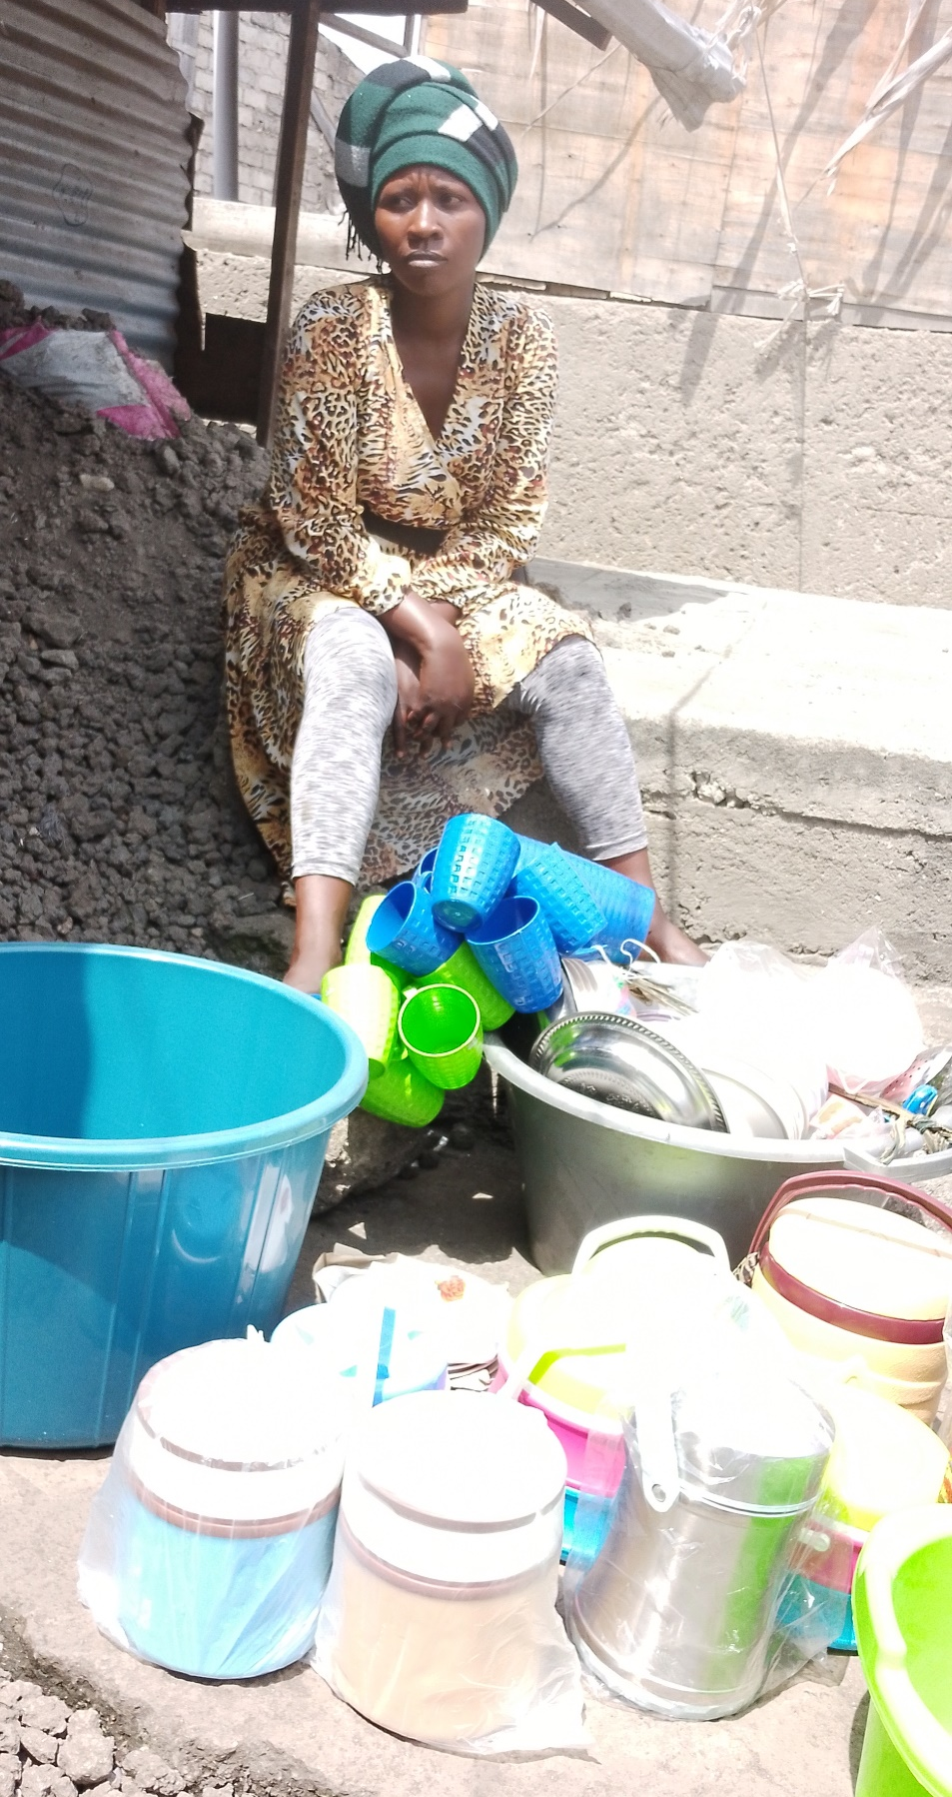

Both Aziza and Anastasia are now ready to go, we met them when they have just come from town to buy their products. They always come and meet from this place in order to share ideas with others.
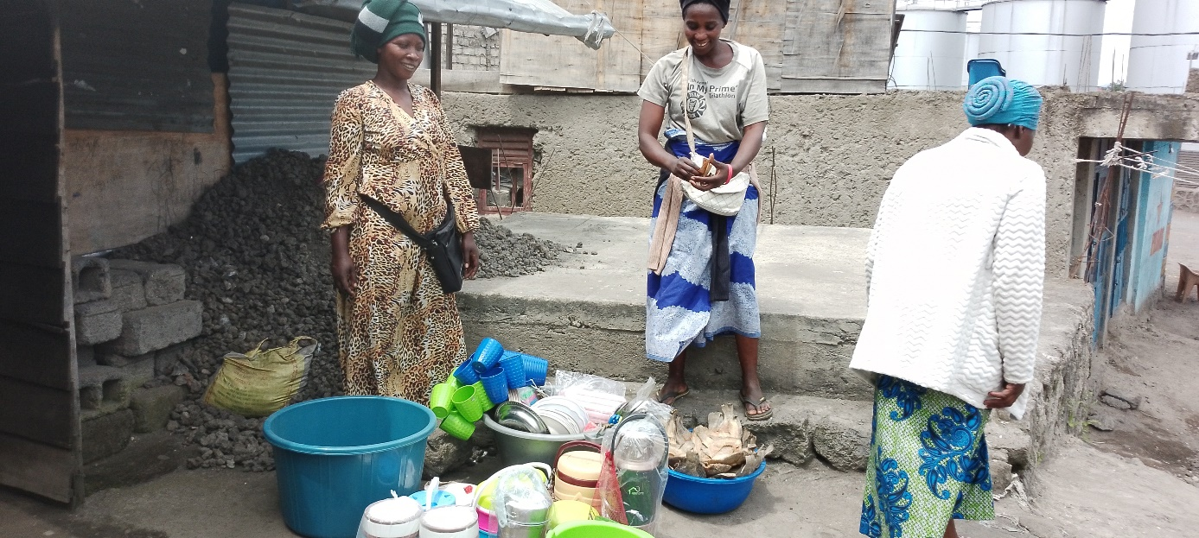

RECOMMANDATIONS BY THESE WOMEN DURING OUR VISIT
The need to add more money to their businesses and also help others who are in similar situations,
They also need counselling services in order to manage various situations which they faced, and help them fully integrate the communities,
They pointed out the fact that they do not have yet Refugee Identifications which can help them to freely move in the country,
At least 60% among them have challenge with reading and writing so there is need to arrange for education program,

