Project: "A health center to bring health care closer to the population of the Kpangalam district - Château de Sokodé"

PROJECT ACTIVITY PROGRESS REPORT 1

Réf. : ONG CAV / GG / Projets 2023 / 001

MARCH 2023

In order to contribute to the most vulnerable populations, the NGO CAV has proposed to implement the support project for the construction of a health center in Kpangalam-Château, a suburb of the city from Sokodé in Togo.
This project falls within the framework of Result 2 of the 2021-2025 strategic plan, relating to the reduction of the rate of morbidity and maternal and infant mortality by the end of 2025 with a total cost of Sixty million four hundred and forty five thousand three hundred and sixty ten (60,445,370) CFA francs or ninety-two thousand eight hundred and fifty (92,850) US dollars.

In November 2022, this project was submitted for consideration by GlobalGiving with a view to raising funds for its implementation.
This report summarizes all activities carried out from November 2022 to March 15, 2023.
During this period, actions were carried out:

1. Promotion of the project:
Since the publication of this project, the technical staff of the NGO CAV has created a link leading to public awareness of the project. It was put online through the website of the NGO CAV (https://ongcavtogo.org/en/faire-un-don/). It was also shared on social media. (https://www.facebook.com/1619251601/posts/10227078159052754/?app=fbl)

2. Fundraising
The project received funding of $10 on February 07, 2023. These funds were funded by Mr. Andrew A MacGregor. A thank you note was sent to him by the Coordinator of the NGO CAV.

Done in Sokodé, March 15, 2023.
For the NGO CAV, the Coordinator 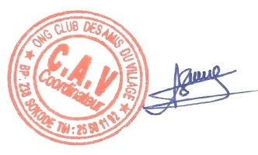
GBELE-GUEWE Djobo Ousmane

