

CHARITABLE INCORPORATED COMMUNITY ORGANIZATION UGANDA
P.O.BOX 308, TEL: 0786265321, 0778215102, Email: cicouganda940@gmail.com

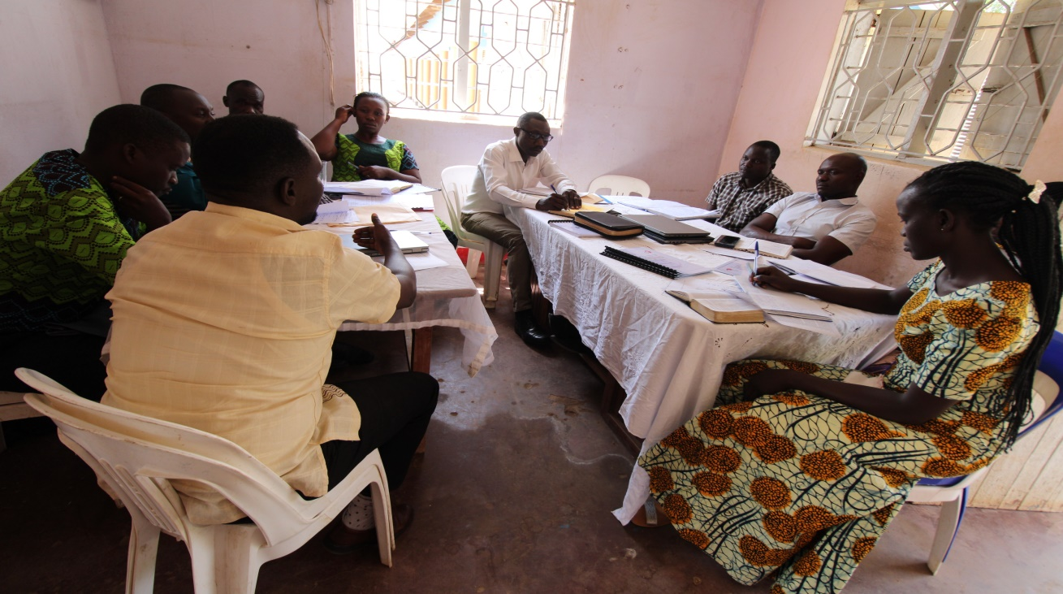
The community leadership, BoD and staff meetings conducted to support in the process of food relief distribution phase 2

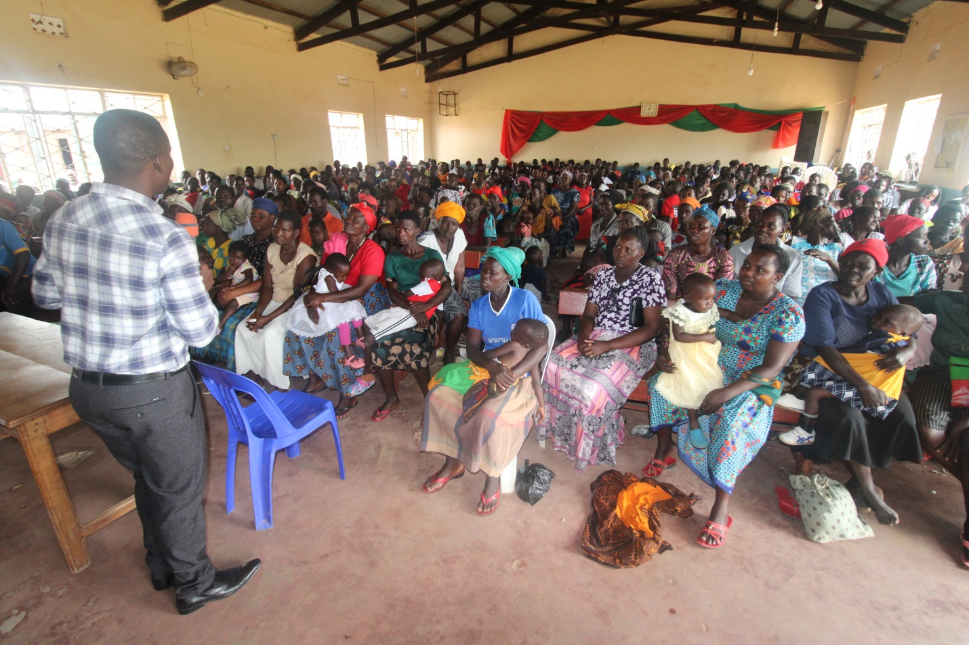
The project Director Sensitizing caregivers and participants on how to use the food distributed to them.

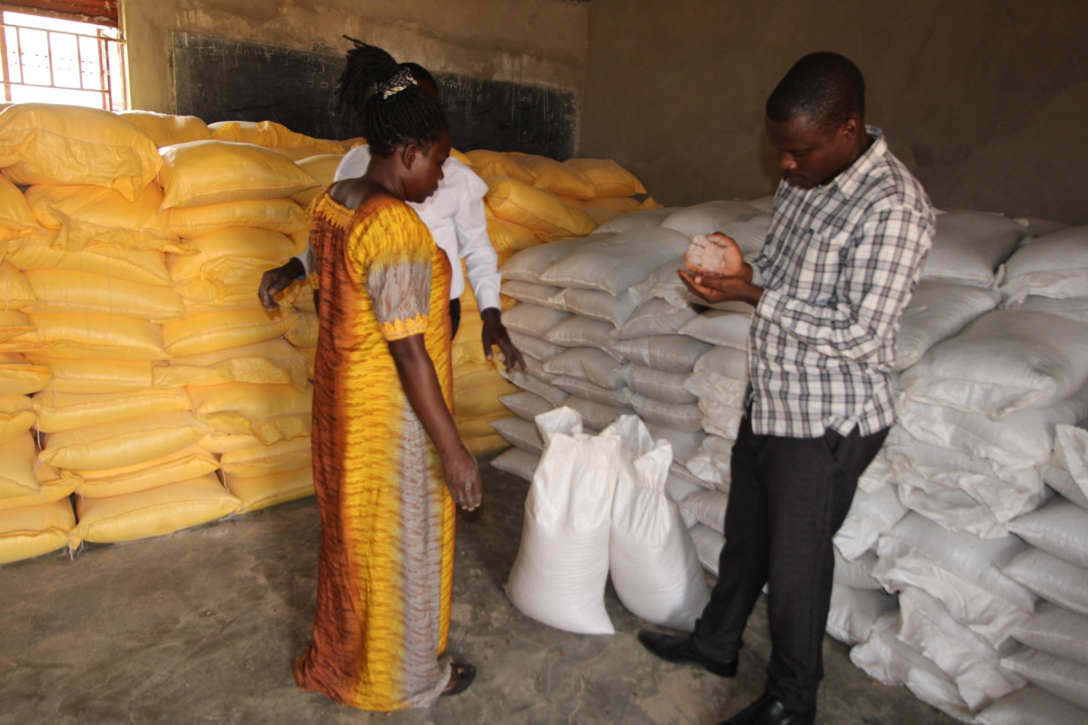

Figure The community leaders verify the quality of food procured

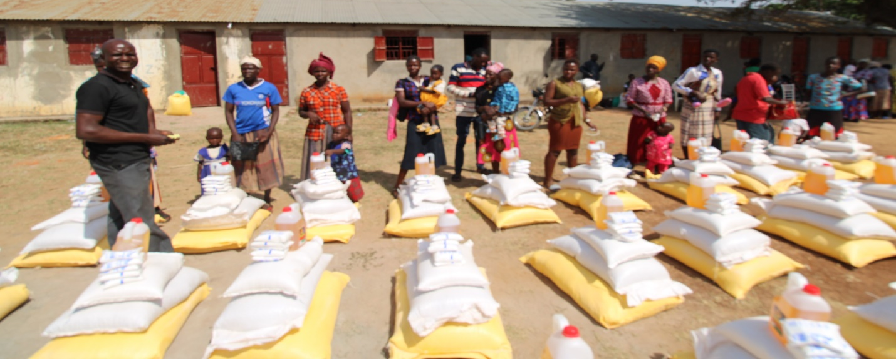
BoD member supports to distribute food to caregivers and participants
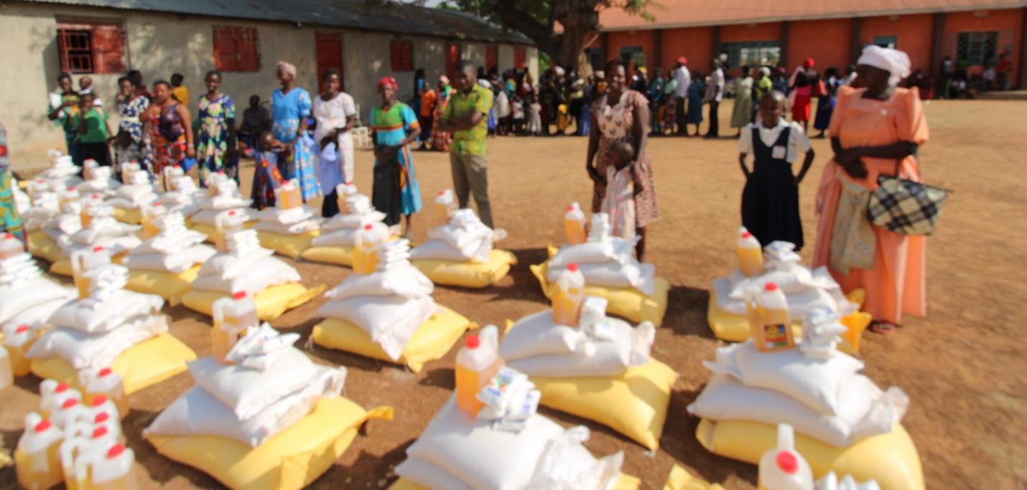
Participants and caregivers line up to receive food
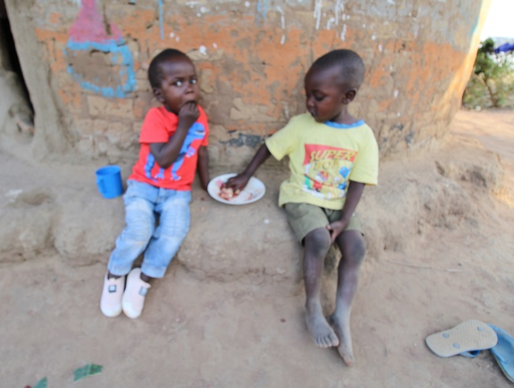
Participants at home sharing their lunch, home visitation to monitor the impact of food distribution

