Humanitarian Assistance in Context with Build Back Better Pakistan
October – January 2024
 | 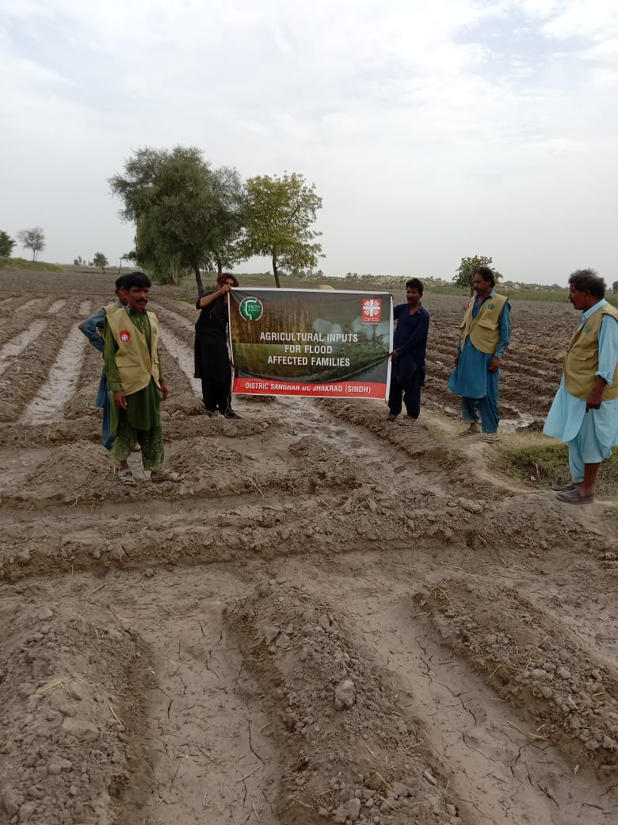
Agricultural Input Distribution
 | 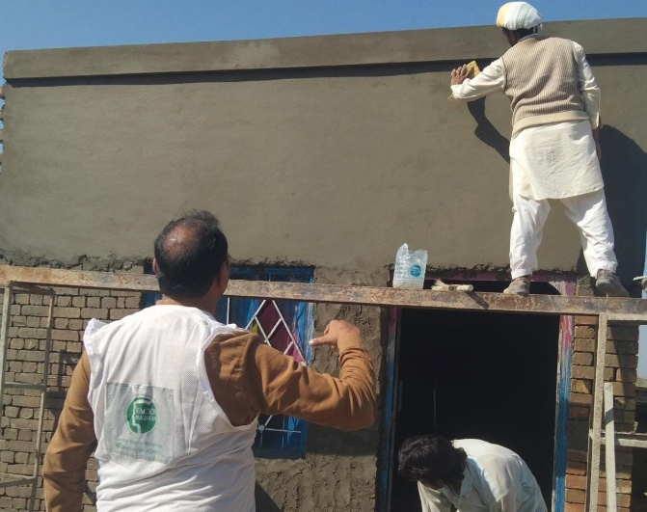
Reconstruction on Houses
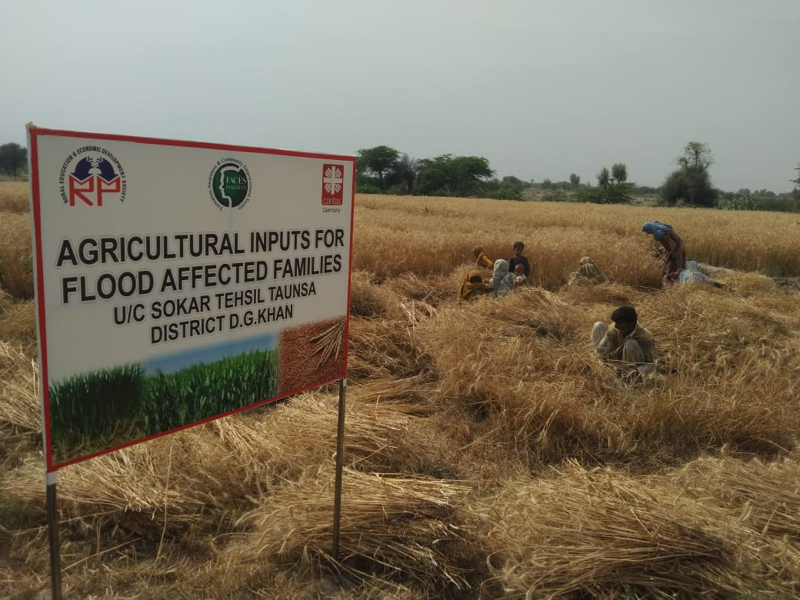 | 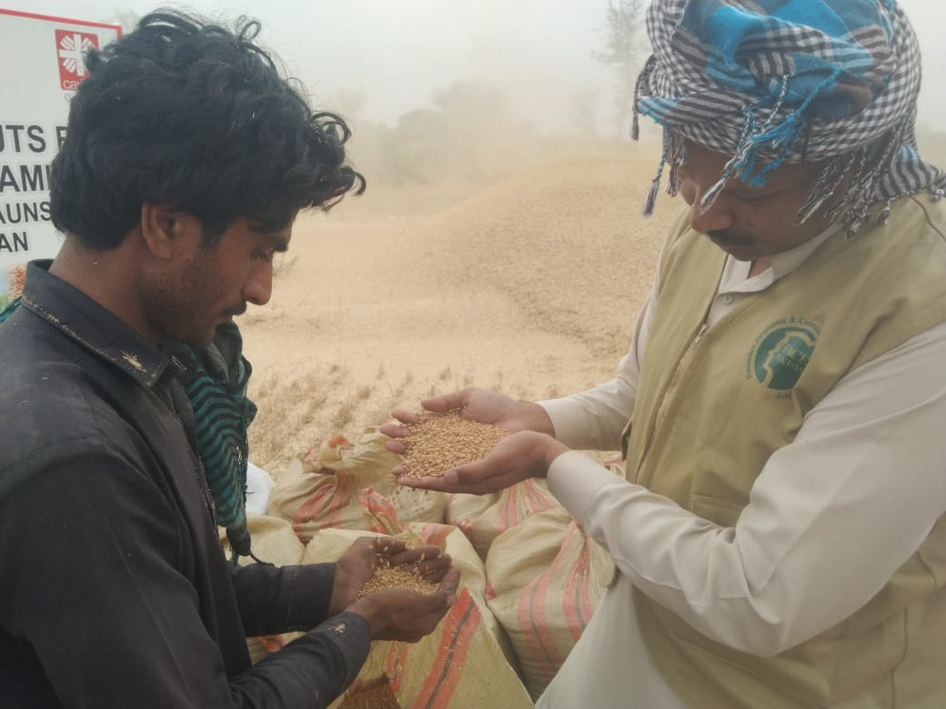
Output from Agricultural Inputs Distribution

