Humanitarian Assistance in context with Build Back Better

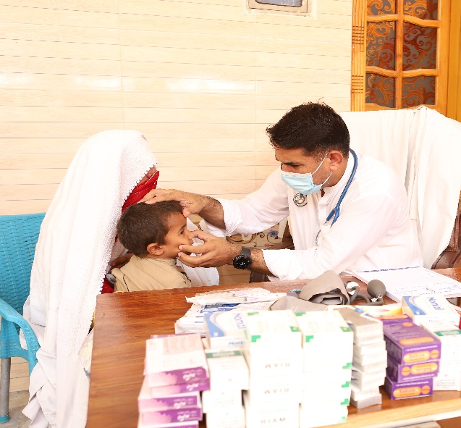 | 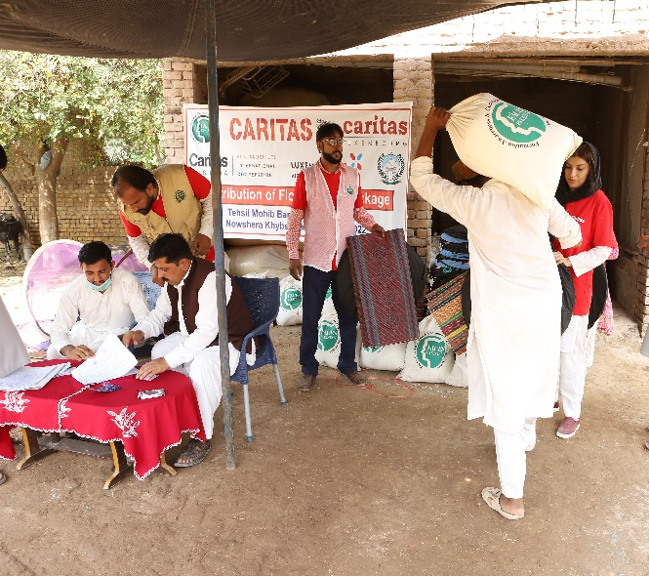
Health Screening through Medical Camps | Distribution of Food Package
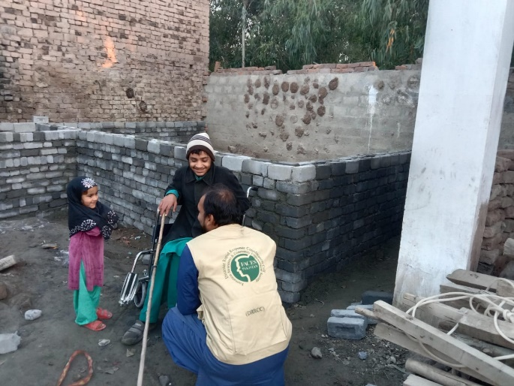 | 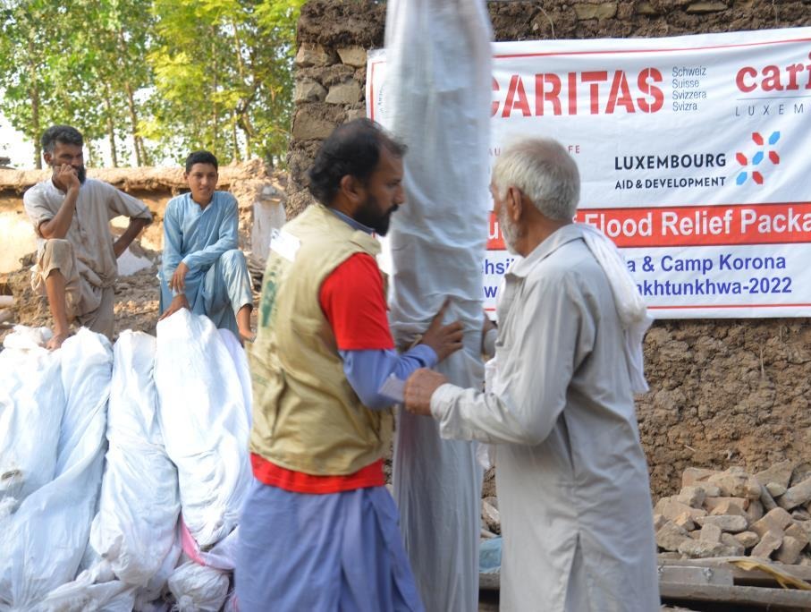
Reconstruction on Houses | Meet the immediate need for shelter
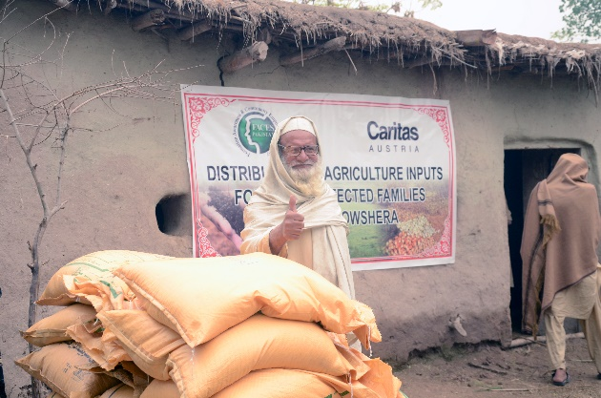 | 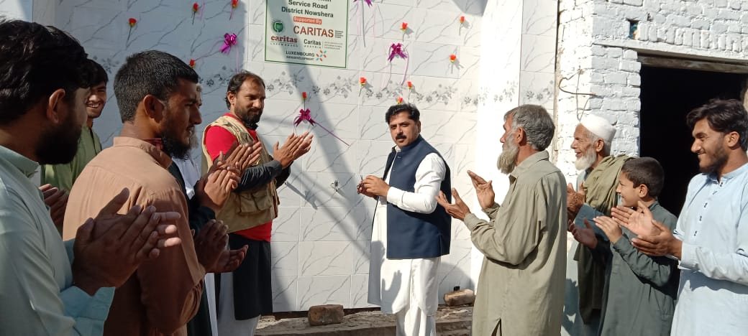
Agricultural Inputs Distribution | Water Filtration Plant
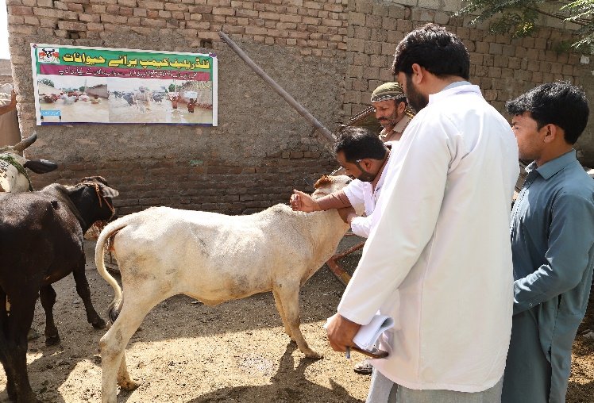 | 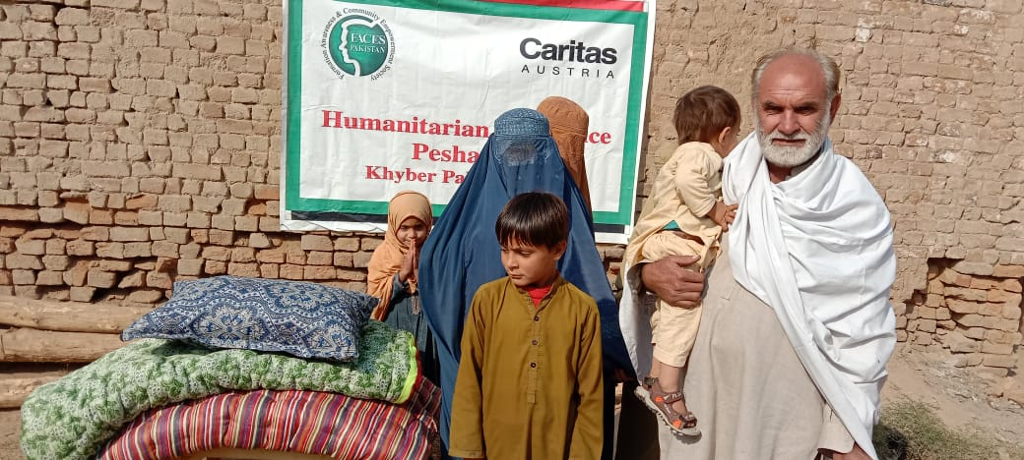
Veterinary Camps | Winterization Support

