Humanitarian Assistance in Context with Build Back Better
 | 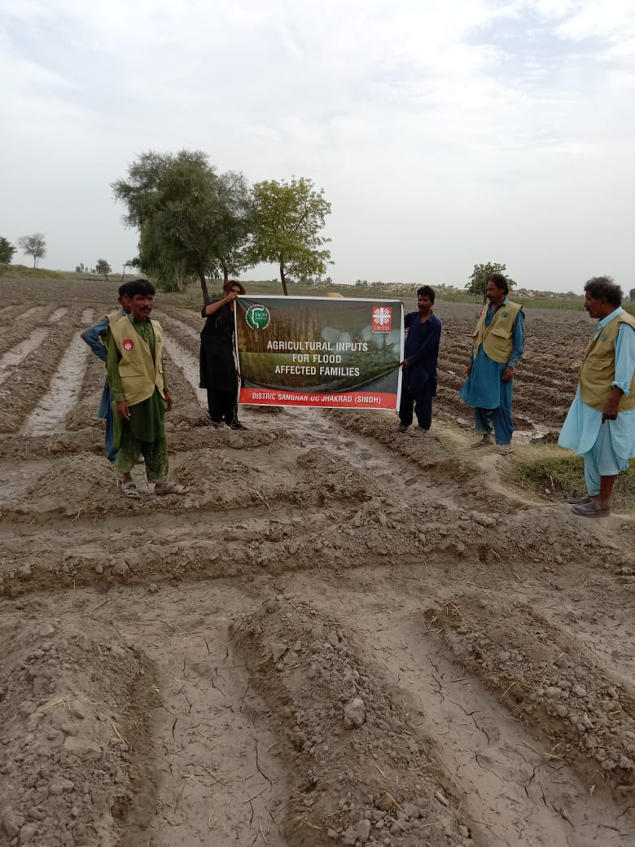
Agricultural Input Distribution
 | 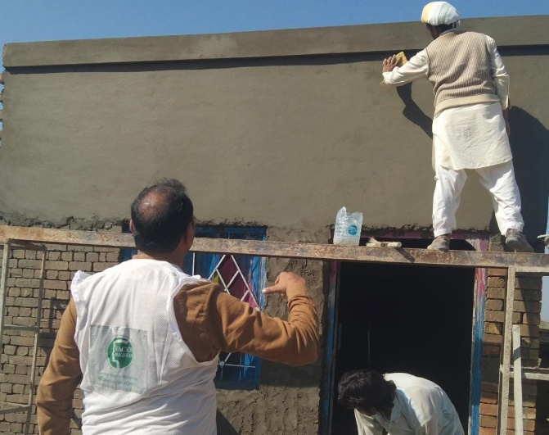
Reconstruction on Houses
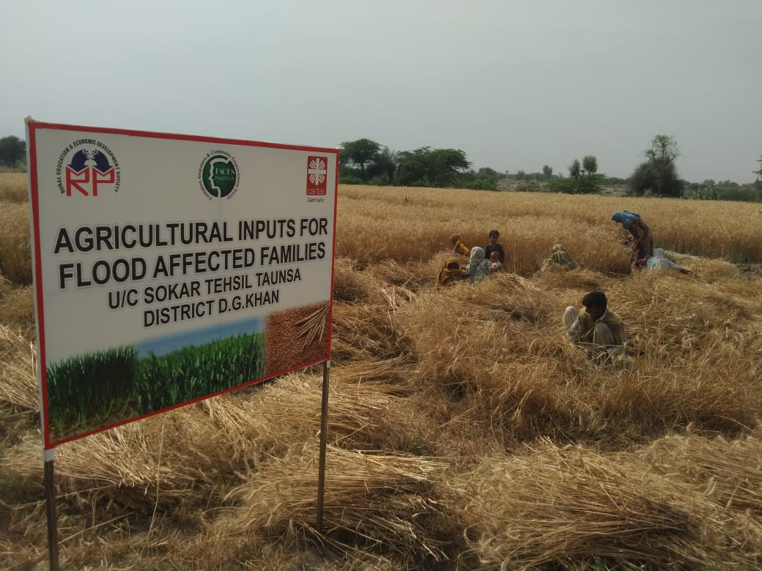 | 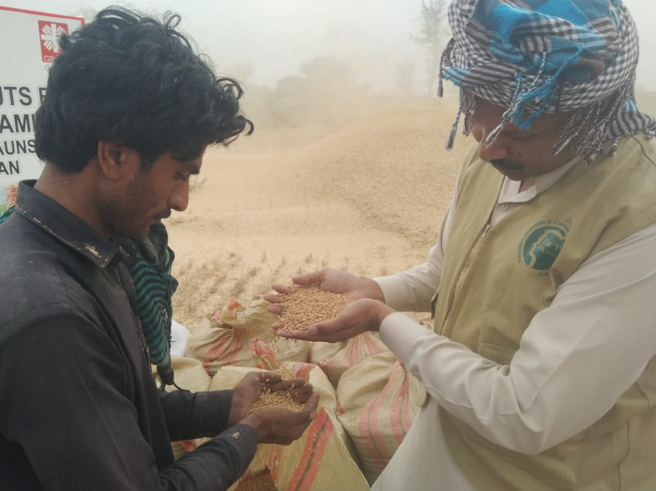
Output from Agricultural Inputs Distribution

