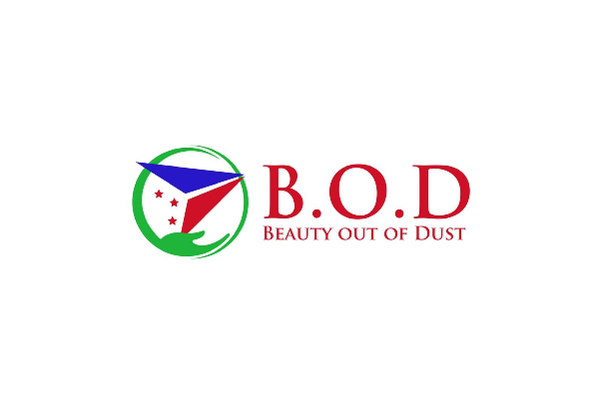
Project: Medical Relief for patients of CDS Nyakira

Description:
- One of the goals that Beauty out of Dust prides itself on is providing medical relief to improve health and healthcare for those in dire need. Beauty out of Dust wishes to partner with CDS Nyakira, a clinic located in Kanyosha and benefiting the inhabitants of Kanyosha. Our goal as an organization is to provide financial and medical relief to patients of CDS Nyakira who are unable to clear their medical debt.

Budget: 2,500 USD to 3,000 USD
- We have a personal organization budget that we can use
Although we will attempt to fundraise some of the money using Network for Good, Flipcause, and social media to see if we can help more individuals

Goal:
- To alleviate struggling families, women, and children’s financial pressures of medical debt.
- A continuance of aid for extreme cases

Target audience:
- Families that demonstrate a lack of financial means to clear medical debt
- Single mothers
- Children in critical medical conditions and needing immediate medical attention

Anticipated outcome:
- Clearing medical debts for individuals and or families
- Helping CDS Nyakira accept more patients in their clinic
- Provide awareness of several gaps in the healthcare system and how CDS Nyakira works to helps patients through those gaps
- Exposure for CDS Nyakira to drive more donations and patients to the clinic
- Meeting the families of cleared debt

Drafted project proposal by: Alice Innocent

