Santa Rosalía, B.C.S. September 2022.

**Enhance social wellbeing in small scale fisheries in Santa Rosalía corridor, Mulegé, B. C. S., México.**

**Summary**

This project is designed to strengthen cohesion and social responsibility in several fishing communities on the western shores of the Gulf of California: Santa Rosalía, San Bruno, and H. Mulegé. Principal species for these artisanal fisheries include horse mackerel, snapper and grouper. Men and women typically participate with different, but essential roles; in general, men carry out the fishing tasks and women manage the business.

A Fishery Improvement Project is underway that currently addresses environmental impacts, sustainable fish populations, and best technology for the fisheries. The intention of the project presented here is to incorporate and promote social responsibility in the developing Fishery Improvement Project to increase the competitiveness of the fishing communities in an integral way.

**Keywords:** Sustainable fisheries, Gulf of California, FIP, Social Responsibility, Fishing communities and Social development.

**Challenge for the project**

As in most small-scale fishing communities, the economic support of the fishermen and their families is based primarily and directly on the resources they harvest. Lack of awareness regarding the advantages of fully embracing social responsibility principals in the fisheries shows itself in community isolation, inability to access government programs, poor quality of life, and reduced competitive advantage compared to other fisheries. Such isolation, particularly regarding communication and utilization of sustainable practices and most appropriate technology, puts the communities at a less competitive level.

Isolation also impairs the relationship between the members of the fishing community and gives rise to a lack of commitment in the conservation of natural resources. Without the transparent communication that is fundamental to a viable program of social responsibility, there is also the danger of the presence of unfair competition between the fishermen themselves. Secrecy and isolation decrease productivity and hinders the attraction of new clients and new members of the fishing community.

**Solution**

The fishing communities served by this project will have the opportunity to receive training on the importance of social responsibility. Awareness workshops according to FisheryProgress and the Marine Stewardship Council standarts will allow fishermen to recognize their human and labor rights, as well as their responsibilities to their communities. Specific activities aimed at consolidating social cohesion between families and recognizing the importance of individual commitment to the community itself will also be developed. Men, women, and children will be encouraged to recognize their landscape and its components of social and environmental relevance, which will promote a sense of belonging. A sense of belonging will allow the communities to develop and maintain an image based on conservation and the sustainable use of their natural resources.

**Long-term impact in the communities**

A more complete incorporation of social responsibility principles in the day-to-day activities of the artisanal fisheries of Santa Rosalía, San Bruno and H. Mulegé position those fisheries at a more competitive social level, which will improve social cohesion and quality of life for the participants. It will enhance the reputation and image of the fisheries making their products more attractive to socially responsible buyers.

Through an expanded fishery improvement project that touches on social responsibility as well as environment, biology, and technology, unfair competition will be avoided and the conservation of fishing resources will be promoted. Technological improvements will increase fish catch at greater efficiency. With these changes, it is expected that product prices will increase and the fisheries will be able to attract a more engaged clientele and reach new markets.

**Table 1.** Working plan to the first year of Social Responsibility implementation in the fishing communities of Santa Rosalía, San Bruno, and H. Mulegé.

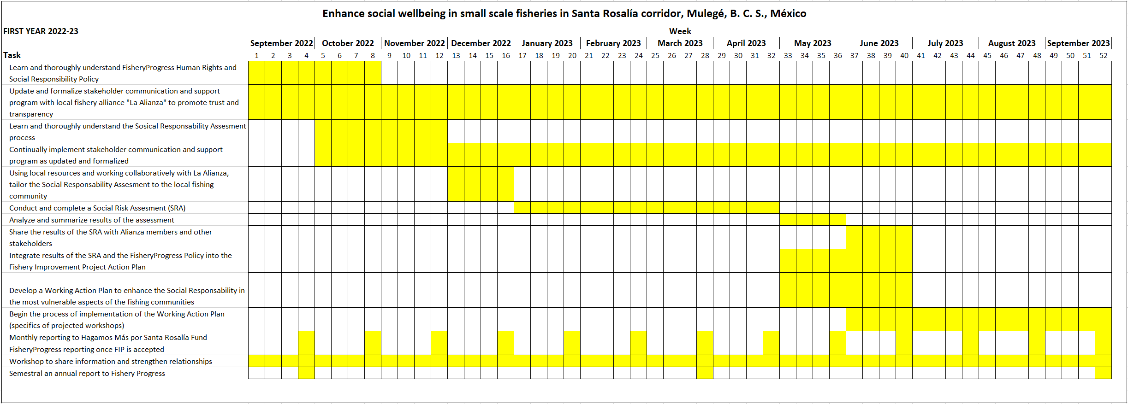

**Table 2.** Approximate costs of specific tasks to promote social responsibility in the Santa Rosalia corridor.

|  |  |
| --- | --- |
| $ 30 | Train 1 fisherman on the recognition of their human rights and how to report and redress issues of abuse, harassment or violation of their human or labor rights |
| $50 | Train 1 fisherman to promote the long-term profitability of fishing |
| $100 | Hold an awareness workshop for 15 members of the fishing community on the social responsibility concepts of “freedom of association” and “collective bargaining” |
| $150 | Hold an awareness workshop for 15 people on types of abuse and harassment |
| $200 | Sponsor a workshop for 15 people on issues of competitive improvement for rural social groups |
| $250 | Promote awareness of the importance of social cohesion to empower the fishing communities of Santa Rosalía, San Bruno, and H. Mulegé |
| $280 | Conduct a social risk assessment the fishing communities of Santa Rosalía, San Bruno, and H. Mulegé |
| $300 | Develop a detailed and collaborative social work program to address vulnerabilities in the social responsibility of the Santa Rosalía, San Bruno, and H. Mulegé communities |

**What is a Fishery Improvement Project and which one we’re working on?**

A FIP is a collaborative effort of the different actors involved in the supply chain to guide sustainability to a fishery. They help restore the health of the oceans while taking fisheries to a more competitive level, improve their reputation, promote the motivation, commitment and productivity of the fishing community, and open the possibility of reaching new markets.

Fisheries improvement projects are published on the FisheryProgress Internet platform.

These are built on the standards set by the Marine Stewarship Council, these are the three principles:

**Principle 1)** seeks to achieve sustainable stocks, seeking to ensure that fisheries are conducted on a continuous basis and that stocks subject to exploitation remain productive and healthy.

**Principle 2**) aims to minimize environmental impacts, seeking to ensure that fishing activities are carried out in a way that other species in their environment, habitats and ecosystems, remain healthy.

**Principle 3)** seeks to ensure effective management, so that fishing takes place within an appropriate regulatory framework to achieve the objective of sustainability and that this framework is effectively implemented in fishing practice.

Nongovernmental nonprofit organizations, Fundación Hagamos Más por Santa Rosalía (HMSR) and ECOWB, have been working for more than 5 years with the fishing communities of the Gulf of California, specifically the Santa Rosalía Corridor, Mulegé, B. C. S. Mexico. The work has mainly consisted in promoting the community and productive development of the communities of San Bruno, H. Mulegé and Santa Rosalía. It has been identified that these artisanal fishing communities have the potential to implement an FIP, the relevant preevaluations have been made in terms of technology, capture and environment aspects, however, it is important to incorporate a social risk assessment to obtain a comprehensive development of these communities.

The FIP proposal has been called: “**Mexico Gulf of California yellowtail, snappers and groupers - hook & line/encircling gillnets**”.

**Implementing members of the project**

|  |  |
| --- | --- |
|  | Alma A. Colorado Betanzos, BSc. Director of HMSR Fund. *Social worker with work experience in the Federal, State and Municipal Government, private companies and founder of Emos Mas por Santa Rosalía, A.C., with administrative, accounting and tax knowledge, as well as sufficient capacity to achieve monitoring and compliance with this project with excellent results and communication with key actors.* |
|  | Mickey Steward, PhD. *Doctor of Science with a passion for nature and social development. She firmly believes in the idea of leaving a respectable legacy in the world. She is a founder of HMSR and serves on its board of directors.* |
|  | Claire Coiration, PhD. Mulegé Sustainable Fisheries Project Manager. ECOWB. *PhD in marine biology graduated from UNAM with a Master’s degree in Integrated Coastal Area Management and a Bachelor’s degree in Marine Biology and Ecology, 11 years of experience in research work in associated fishing communities in Mexico, Costa Rica and France, Responsible for coordinating the pilot committee of the Ecologists Without Borders FIPs program, providing technical advice and support to the management and development of new FIPs in Latin America, Africa and Europe. This has provided it with the scientific skills, rigor, organization and communication as well as the integrated vision necessary to efficiently and successfully address the coordination of this project and all the problems that arise in its framework.* |
|  | Victor Montero, MsC. Mulegé Fisheries Improvement Project implementer. HMSR. *Fisheries Engineer with a Master of Science in Marine Resource Management. Since 2019 he has worked on sustainable fishing projects, closely linked to small-scale fishing in Baja California Sur, he has also participated as an observer on board the industrial purse seine-sardine fleet operating in the Gulf of California. His work has mainly been promoting sustainable fisheries through the generation and analysis of fisheries data. Victor works in coordination with FHMSR and ECOWB in the development and implementation of the Fisheries Improvement Project (FIP) in the Sta Rosalía corridor, Mulegé, B. C. S.* |
|  | Conrado Lopez, BSc. HMSR. *Engineer in business administration with 3 years of experience as project manager of sustainable fisheries, establishing direct contact with CSRM fishermen, maintains constant communication, will clear doubts, help catalyze the ideas of fishermen and train volunteer fishermen in the filling of fishing logs, is also in charge of monitoring marine fauna. In addition to directly supporting the project coordinator.* |
|  | Cipriano Villavicencio, BSc. HMSR. *Is one of the pillars of HMSR, helps in all matters pertaining to the administration of HMSR resources and coordinates the efforts of its members.* |
|  | Julio Parra, PhD. Social assesment and comunity development consultant.  *Fisheries biologist with 7 years of experience in natural resource and community development management, project development and data creation, management and analysis.* |