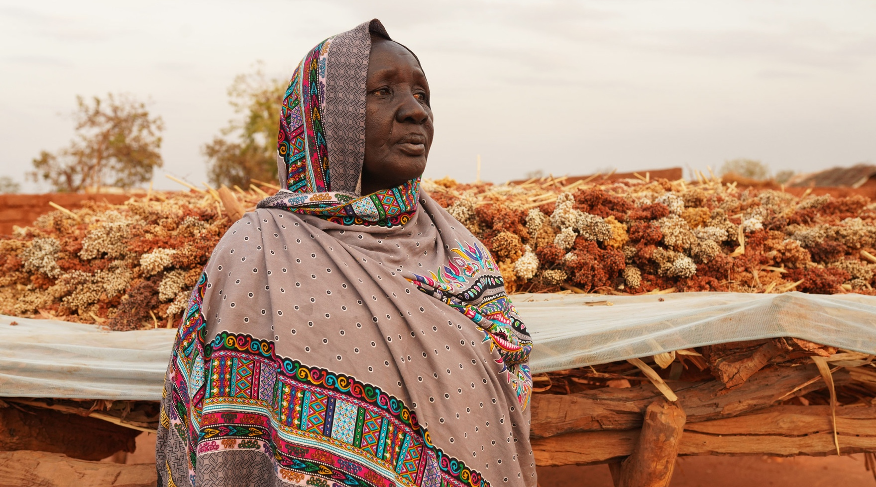
Thousands of miles away from the fighting, the ongoing war in Ukraine is affecting people of all ages, demonstrating how interconnected the world is.
©Andrea Campeanu/CARE

War in Ukraine Creates Deadly Shock Waves of Hunger
Help CARE prevent severe hunger now before millions face starvation
Invest in the power of women and girls to break the cycle of hunger and malnutrition

The makings of a global hunger crisis
In February 2022, war broke out between Russia and Ukraine. As the world bears witness to its atrocities, a global hunger crisis looms for an estimated 863 million people in 91 countries facing hunger and insufficient food consumption.

When crisis happens in one part of the world, it can send shock waves across the globe. For decades, Ukraine has been the breadbasket to the Global South. Ukrainian and Russian grains provide more than one-third of the wheat imported by 45 African and least-developed countries. Shortages of food, fuel and fertilizers from Ukraine and Russia is having a compounding effect—the resulting rise in fuel and fertilizer costs are hampering the ability of smallholder farmers (roughly half of them women) to produce and store enough food in the coming seasons. In the last five months alone, prices of major food crops have risen by 40%, accounting for 400 million of the people who are now

food insecure. The war in Ukraine could be the tipping point that plunges already fragile families into deeper states of malnutrition.

If we do not act now, 50 million people who face emergency levels of food insecurity in the Global South could be on the brink of famine. Among the most vulnerable are women and children. Women and girls often eat last and least, and without proper nutrition, mothers can die during pregnancy, experience stillbirths, or their babies suffer developmental delays from the start. For the children who do survive, malnutrition can cause permanent, widespread damage to their growth, development and overall wellbeing, particularly in the first five years when their brains develop most rapidly. Not investing in healthy women puts future generations—both boys and girls—at risk of unhealthy lives. To reverse that outcome, CARE invests in breaking the cycle of malnutrition, and that starts with women and girls.

With 76 years of experience responding to natural and human-caused crises, CARE has a solid evidence base that shows women and girls are disproportionately impacted by food insecurity and other humanitarian emergencies. But the humanitarian community, including the Integrated Food Security Phase Classification (IPC, considered the gold standard in assessing food security levels globally), systematically overlooks the needs of women and fails to adequately analyze and quantify how gender differences impact food-insecure communities. Given gender norms and roles, women are often responsible for shopping and preparing the family’s food, yet far too frequently they are the ones who eat last and least. Men often lead decision-making around addressing hunger in their communities. These imbalances hurt entire communities because the cycle is perpetual—people living in poverty are more susceptible to malnutrition, which can lead to increased healthcare costs, reduced productivity and limited ability to earn income.

Providing immediate food and basic needs support, along with investing in accelerated agricultural support to build resilience for families on the periphery of malnutrition, are short- and medium-term measures that, when implemented in tandem, move families and communities onto a path to better health. But we must do more to ensure that families can weather future crises. We must also influence change in the policy structures that support them so that women, children and their families avoid harsh outcomes like migration, further conflict, sexual exploitation and death. These are all well-documented outcomes of food and nutrition insecurity. We simply cannot stand idle as the consequences of the hunger crisis are compounding, especially for women and children.

With your investment and partnership, CARE can respond to the millions of families nearing the brink of famine and ensure that communities we work hard to empower survive the shocks that threaten their access to nutritious food.

CARE’s full-scale strategy for response
Women and children facing hunger and severe malnutrition need more than food aid. Since 1945, CARE has proven time and again that the best safety net, particularly for women and children, combines both emergency response and building resilience long before needs are life-threatening.

That’s why CARE has launched a $250 million comprehensive response to the global hunger crisis—so that families now on the brink of famine avoid the direst of consequences and smallholder farmer communities on the cusp of malnutrition ramp up production and tip the balance of nutrition in their favor. Our response bridges the full spectrum of food and nutrition insecurity—from emergency response and treatment for severe malnutrition, to the transition to short-term

recovery and longer-term resilience building that prepares families to weather future shocks. We also seek to ensure that governments and communities in less-developed nations build strength and policies that help these interventions stick.

CARE’s two-year response includes a three-pronged approach: 1) immediate food and nutritional assistance for families most at risk of hunger and severe malnutrition; 2) accelerated training and inputs for smallholder farmers—especially women farmers—who are most susceptible to fertilizer and fuel shortages and thus, reduced harvests and deeper malnutrition this year; and 3) rallying key stakeholders in the food security and nutrition arena—from engaging private sector partners to advocating with developing country governments, donor country governments like the U.S., and global actors like international donors, to prevent repeat crises.
IPC is the gold standard for measuring food insecurity by country. Classifications range from 1 to 5 with:
- Minimal
- Stressed
- Crisis
- Emergency
- Famine

Country | % Population IPC Level ≥ 3% (CRISIS)
Afghanistan | 45%
Ethiopia | 37%
Guatemala | 25%
Haiti | 45%
Honduras | 28%
Kenya | 27%
Madagascar | 32%
Malawi | 9%
Mozambique | 10%
Somalia | 45%
South Sudan | 63%
Sudan | 13%
Syria* | 60%
Tanzania | 17%
Yemen | 60%
Zambia | 13%
Zimbabwe | 35%
*WFP # (Syria does not participate in IPC)

To save lives now and sow resilience for tomorrow, we must look beyond food aid to address food and nutrition security and let women lead the way. CARE’s strength as a global organization allows us to lean into broad expertise and simultaneously fortify three components of food security—increasing the supply of food, improving effective demand by increasing access and a person’s ability to pay, and addressing the true impacts of food scarcity on nutrition.

Given the unfolding nature of the hunger crisis, CARE’s immediate humanitarian assistance will prevent women, children and families in countries where severe malnutrition rates are highest from reaching possible famine levels. Simultaneously, we will address fuel and fertilizer shortages and rising costs in as many as 540 communities in countries where farming is becoming cost prohibitive, and families are on the cusp of deeper malnutrition. Countries like Afghanistan, Ethiopia, Guatemala, Haiti, Honduras, Kenya, Madagascar, Malawi, Mozambique, Somalia, South Sudan, Sudan, Syria, Tanzania, Yemen, Zambia and Zimbabwe are showing alarming declines in access to nutritious food and alarming malnutrition levels. To create a safety net for the future and strengthen less-developed nations’ ability to mitigate crises of this magnitude, CARE will work with the private sector, governments and bilateral donors to access alternate food, fuel and fertilizer supplies, and change the policies and systems that create unstable environments and unfavorable conditions at local, country

and international levels. Our comprehensive approach will be adapted to the specific needs and contexts of each country or region and scale up as need and resources warrant. These initial focus countries and communities are ones CARE knows well, where our presence will allow us to act quickly—with a core focus on women, children and vulnerable groups.

Beyond food aid
CARE’s humanitarian assistance goes far beyond handing out meals. Beginning with a critical needs assessment and rapid gender analysis, we identify those most in need of nutritional support, drivers of malnutrition, and the power dynamics of household food security and nutrition.

In the Horn of Africa, we are seeing challenging situations like drought, political turmoil, violent civil unrest and COVID-19 deteriorate social support systems and thwart access to nutritious food. In the Middle East, sub-optimal feeding practices, high prevalence of disease, inadequate sanitation conditions and hygiene practices, limited access to health and nutrition services are reversing health gains of the past and leading to acute malnutrition and severe acute food insecurity. And in the Central American Dry Corridor and Haiti, drought, migration, COVID-19, poor infant feeding practices and little to no access to sanitation services are escalating malnutrition rates.

These compounding situations have a multiplier effect on annual cereal shortages now exacerbated by reduced wheat and grain imports from Ukraine and embargoes on Russian fuel and fertilizers. In Afghanistan, for example, the U.N. reports that 95% of Afghans are not getting enough to eat. In Somalia, the number of people facing extreme levels of acute food insecurity has nearly doubled since the beginning of 2022. Millions of women and children across the Horn of Africa, Middle East, Central America and Haiti are reaching their breaking points and we must act now so that families can move out of this critical phase into a place of stability and hope. To do that, we must partner with women to empower them with information and resources that will break malnutrition cycles now and for future generations.

CARE listens to women because they are integral to their families’ and communities’ health, particularly when it comes to food security and nutrition. They also have specific needs including those related to reproductive and maternal health, caregiving, hygiene, and access to education and livelihoods. CARE leverages women’s insight and partners with them to identify and reach the most vulnerable groups, households, and individuals: children under 5; pregnant and lactating women; the elderly and/or disabled; orphaned children; women and girls at risk of gender-based violence (GBV); and minority groups. We also work with respective authorities, other humanitarian stakeholders and local partners, especially women-led organizations, to ensure that more people can be reached faster and in ways specific to their needs.

At the outset of every intervention, CARE conducts detailed a Response Analysis Consideration. This analysis assesses available contextual information and applies strategic thinking to facilitate decision-making on the most appropriate level in each scenario. Factors we consider are:
- Timeliness: Can one intervention be implemented faster than others?
- Feasibility/Scale: Is one intervention more practical and convenient than others given the emergency context? Is the target population easier to reach physically with one intervention compared to others?
- Suitability to project objectives: Does one intervention better meet the program objectives (e.g., improve dietary diversity, reduce malnutrition, mitigate family asset depletion) than others?

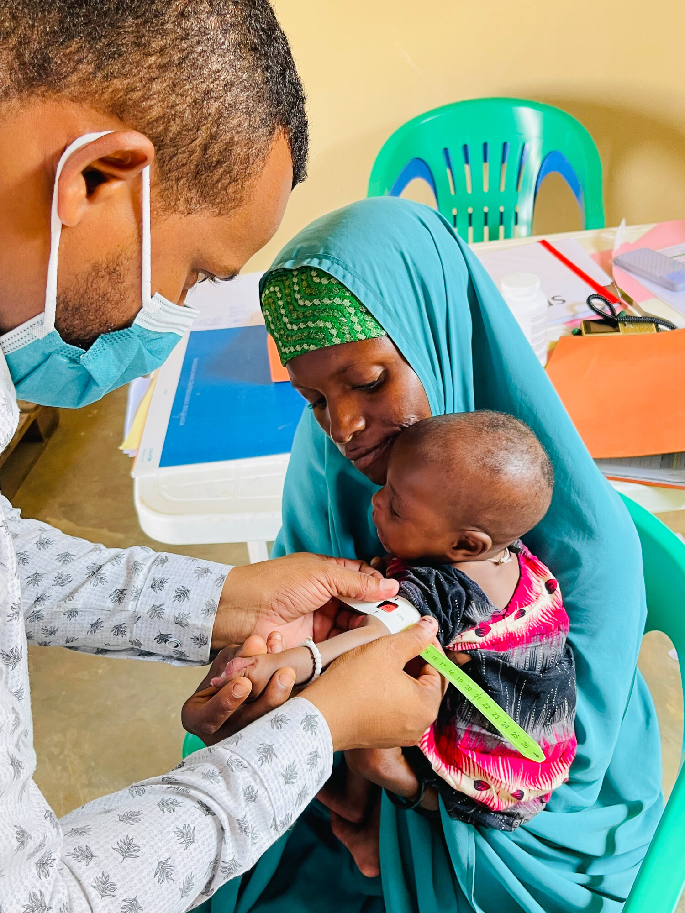
©CARE/ Saddam Mohamed

In Somalia, the number of acutely malnourished children admitted to CARE-supported health facilities increased by 60% during the first four months of 2022 compared to the same period in 2021. A mother holds her 7-month-old daughter as a health officer measures her Mid-Upper Arm Circumference (MUAC) at Kismayo Health Centre. MUAC is used for the assessment of nutritional status. Red indicates severe acute malnutrition (SAM) - the child should be immediately referred for treatment. Yellow indicates that the child is at risk for acute malnutrition and should be counselled and followed-up for growth promotion and monitoring.

- Value for money/cost-effectiveness and cost-efficiency: Can significantly more community members be served with one intervention compared to others?
- Local market readiness: Do markets have adequate supplies of food and will increased purchases disrupt the markets?
- Community preferences, priorities and capacity: Do project participants prefer one intervention over another?
- Security: Does the proposed intervention pose a significantly increased security risk to project participants and/or aid workers?

With thorough assessments complete, CARE and our partners provide a suite of interventions to treat life-threatening malnutrition, increase self-reliance, safety nets, and community representation, and establish market linkages through:
- Provision of dry ration foods;
- Cash assistance, including cash for work (CFW), food vouchers and multipurpose cash grants where markets allow;
- Prevention and treatment of acute malnutrition, coupled with social and behavior change communication to support learning and set families up for future health;
- Protection of remaining productive assets by providing seeds and vaccinations for livestock; and
- Integration of a new model of Village Savings and Loan Associations in Emergencies (VSLAiE) contexts that combines advocacy, support for broad adoption of best practices in cash and voucher assistance, and innovations that strengthen women’s ability to respond to crises.

An impactful and sustainable food security and nutrition response that boosts local production requires an integrated approach with protection considerations (especially gender-based violence, common in food-scarce situations) mainstreamed. The full scope should support food consumption, health, increased household income, nutrition, water, sanitation and hygiene. CARE works closely with affected communities to ensure a holistic strategy in combatting hunger and malnutrition while reducing negative coping mechanisms and building resilience. Once the nutrition situation is stabilized, CARE teams work with families to regain longer-term strength through agricultural and livelihood support, including supply of fertilizer, seeds and tools, and market- and value chain-based longer-term interventions.

A primary cause of intergenerational cycles of poverty is the recurrence of shocks – both manmade and natural – that entrench people in poverty. CARE has adapted our proven Village Savings and Loan Association (VSLA) model to emergency settings (VSLAiE), providing a stable pathway for

women and girls to access crucial services that meet their immediate needs, while also building the assets, networks and skills that will enable them to achieve their long-term goals. Applying this model to people in crisis helps to bridge the divide between short-term humanitarian aid and longer-term recovery, a conundrum that has created disjointed and ultimately ineffective programs without a sustainable future for people displaced by conflict, climate change or other crises. VSLAiE, like more traditional VSLAs, are simple, highly replicable and scalable. And as with VSLAs, they are the first step in creating a pathway out of crisis and into recovery.

Our comprehensive approach goes beyond food aid to remove barriers that hinder a person’s ability to achieve improved nutrition. CARE seeks to understand the complexities of situations faced by individuals—especially women and girls—and to involve them from the outset of our response.

Building resilience through farmer support
Without urgent humanitarian action, we risk letting millions more women, children and families reach the brink of famine. And without immediate investments in increased agricultural production, improved storage and expanded crop diversification, we could face a critical tipping point between under-nutrition and malnutrition in communities already on the margin.

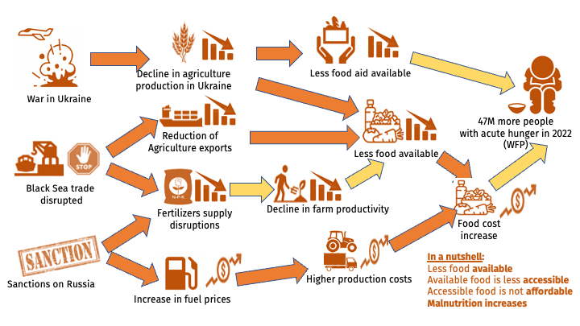
Embargoes on staple foods and fertilizers due to the war in Ukraine have devasting consequences for communities. The impact of limited fertilizer availability takes about six months to realize in crop yields—yet, by April 2022, limited food supply and higher production costs in many countries, like those across Southern Africa and Central America’s Dry Corridor, had already driven food prices to the highest levels ever recorded. This combination of less food, higher fuel prices and lack of fertilizers will certainly have negative consequences on food security and nutrition in many low-income countries by the Fall of 2022.

Southern African countries and the Central American Dry Corridor are feeling the effects with rising prices and bracing for further shocks as the war in Ukraine continues and outlooks for harvest season look dim. Zimbabwe already has the highest gasoline and diesel prices in the southern Africa

region due to government taxes. Further increases could render access to fuel for irrigation and food transport almost impossible for small producers. And in Madagascar, delayed and below-average harvests coupled with international price spikes for fuel, fertilizer and food could prompt continued reliance on humanitarian food assistance and imports of staples. In Central America, food reserves of many poor households in rural areas have run out, while prices of food and other inputs remain high. As the lean season progresses, labor opportunities will decline, and food insecurity is expected to increase.

CARE is applying an accelerated resilience-building response that will ensure sustainability, productivity, equity and self-sufficiency for as many as 540 communities. We are prioritizing countries where the effects of fertilizer shortages coupled with rising costs of food and fuel could mean they cannot afford to reap successful harvests this Fall and safely store food for future months. This is a first step to prevent the global hunger crisis from turning other regions into an emergency situation similar to that in the Horn of Africa. As resources and funds allow, CARE is considering expansion of this accelerated model to other communities, particularly in the Dry Corridor of Latin America, Asian countries facing a host of climate challenges, and other African communities in need.

Through an accelerated version of our successful Farmers Field and Business Schools (FFBS) model, this two-part response comprises rapid knowledge transfer and adds matching grants to purchase solar technology to help reduce reliance on fuels, increase crop yields and reduce post-harvest losses. These two critical interventions will help communities stabilize production levels, supply local markets and avoid further impacts of the hunger and food insecurity crisis.

CARE’s FFBS projects currently span 18 countries, support smallholder farmers (more than half of whom are women) and have improved gender equality, increased household income and nutrition,
and reduced impact of shocks for more than 500,000 farmers to date. We will continue to work with private sector partners and governments to assess critical needs and expand these programs into other regions as needs and resources allow.

Knowledge transfer
CARE’s FFBS puts farmers, especially women, at the heart of skills building and decision-making on agricultural techniques. Women are key participants because in most families, they are responsible for their family’s nutritional status given their role in shopping for and preparing the family’s food, and their role as mothers who provide nutritional support to their babies through nursing.

The FFBS model promotes agroecology practices, a transdisciplinary field that includes the ecological, sociocultural, technological, economic and political dimensions of food systems, from production to consumption. This multidimensional approach allows farmers to sustain yields despite lack of access to fertilizers; reduce the risk of lower food availability; and reduce higher production costs due to the global increase in fuel prices.

Farmers learn improved farming practices such as how to use fertilizers more efficiently, how to improve soil health, how to produce organic compost and/or how to plant leguminous crops that add nitrogen to the soil. Trainings on diversification of food production, establishing businesses and reaching local markets, and augmenting household nutrition and income also form part of the curriculum. FFBS is a game changer for improving the status of women, by helping them to be successful farmers, businesspeople, leaders and agents of change. It is also extremely cost efficient, with a $31 average return on every $1 invested in women smallholders. To date, the program has

generated $158 million worth of benefits in the areas of food and nutrition security, poverty reduction, women’s empowerment and resilience to shocks.

Technology transfer
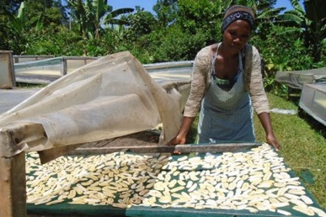
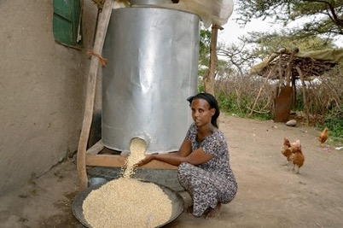
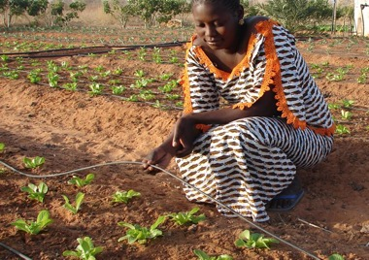
In each community, CARE will introduce a new complement to the FFBS. We will establish a co- investment fund to provide matching grants for capital investments in technologies and resources that save money by lowering dependency on chemical inputs; efficiently use natural resources through tools like drip irrigation technology that save water and nutrients; reduce post-harvest food losses through investments in food storage and processing technologies like solar drying; and reduces dependency on gasoline using renewable energy technologies such as solar-powered irrigation systems that do not rely on high-cost fossil fuels. Providing access to this technology can reduce costs exponentially, stabilize crop production with irrigation solutions, and drastically reduce post-harvest food spoilage, which is as high as 30 to 40% in Africa due to improper use of inputs, lack of proper post-harvest storage, processing or transportation facilities.
Renewable energy technologies
Food storage technologies
Food processing technologies
Irrigation technologies

As mentioned, CARE’s response will prioritize working with women farmers, building on existing
programming and our Village Savings and Loan Association base. These women will receive the knowledge and technology they need to increase crop production to fight hunger, improve nutrition, augment their income, adapt to climate change, and build more sustainable and resilient livelihoods.

Between 2017 and 2020 CARE’s global programming improved the food security, nutrition and resilience to climate change of 9.3 million people in the southern Africa region. This program will build on that experience but will pivot to urgent actions that address the impacts of food and fertilizer deficits on a two-year cycle, with continued program extension as needed to limit any setbacks on the gains communities have worked hard to achieve. CARE will scale our impact by leveraging funding from other sources, including foundations and government support, to complement community interventions such as existing programming in water-smart agriculture, natural resource management, climate change adaptation, and agriculture. We will build upon rigorous research and evaluation of program results so that communities can better cope with food crises. At the same time, CARE will advocate for the model to be implemented by governments and partners (see next section).

Sowing the seeds of lasting change
Hunger and food crises are complex and neither humanitarian assistance nor development programs alone can rid the world of the underlying causes that perpetuate situations like conflict,

climate change, pandemics or food shortages. CARE’s size and trusted relationships make us uniquely effective in solving these kinds of intricate issues. Promoting a full-scale approach to reduce hunger, we will serve as convener to pull together the private sector, governments and donors in increasing production of alternate food supplies, while changing the policies and systems that create unstable environments and unfavorable conditions in food crisis countries.

Assessing food supply chains to determine where to access cost-effective supplies for a humanitarian response, opportunities for shared value in food production, resources for technical knowledge, and alternative supplies for food and fertilizers ensures that we can address multiple aspects of the global hunger crisis by applying the expertise of appropriate actors. If we are to solve problems like this for good, we must fully leverage the resources we have and advocate for long-term change.

CARE advocates at all levels of government to mobilize the resources needed to respond now, avert an expanded hunger crisis, and prevent future crises. Country governments and many donors have been supporting unsustainable agriculture systems dependent on foreign energy, seeds, and fertilizers, weakening local systems. CARE advocates for a shift towards agriculture practices that strengthen communities’ ability to mitigate and respond to shocks and stressors in the future. A key aspect of this is centering the roles women and girls play in growing the food their families eat.

CARE’s policy guidance for decision makers is backed by successful on-the-ground practices--a formidable combination for lasting change.

Addressing emergency food needs
Make sure resources match the scale of the challenge. We know the global need for food this year and next is close to $20 billion. Private philanthropy will never reach that scale, but private donors can use their funds to leverage billions of dollars in resources from donor governments like the U.S. and other G7 nations. Advocacy is also critical to making sure that emergency food assistance helps everyone in families equally and does not skip over women and girls.

Make food aid more flexible now. Right now, there are legal requirements that mean food aid
commodities like wheat, corn, sorghum and rice from American farmers can only be shipped around the world by certain companies. In addition, current U.S. food aid must include, by law, a high percentage of products grown in America. These requirements add millions of dollars to the cost of food aid and add months to the time it takes for food to reach hungry people. CARE is advocating right now for an emergency waiver so that food produced in Southern Africa can help Africans and food grown in Latin America can be distributed using U.S. funds. If we are successful in this emergency advocacy, food aid will reach millions more people and get there faster to prevent millions of deaths. This hunger crisis needs food to move as fast and as cheaply as possible. Right now, the focus should not be on benefiting a small set of American farmers and shipping companies through U.S. food aid programs; it should be on the fastest, cheapest and best ways to save lives.

Make the IPC gender sensitive. The use of IPC is a landmark in the fight against food insecurity. Widely accepted by the international community, IPC describes the severity of food emergencies, however it is largely gender blind. IPC focuses on household/groups of households as unit of analysis and not on individuals. It lacks data on distribution of food within the household, and often the share of households headed by women is low. As a result, in-depth guidance for gender-sensitive analysis is lacking; so far, no pilots of gender-sensitive analysis have been conducted and

therefore, no practical experiences regarding feasibility and results of gender-sensitive analysis are available. We are equipping decision makers with evidence and information on how gender inequality affects food insecurity, impacting women and girls differently and disproportionately. We aim to prove to the international community that current food security and nutrition analysis methodologies leave out women and are not the most efficient use of precious global resources. We will do this by conducting pilot projects in two countries to make the IPC more gender sensitive and communicating the results with external stakeholders. The results will transform the way governments and other humanitarian actors understand a food insecurity crisis- or potential crisis and take actions that are gender-sensitive.

Practical measures to avoid or minimize conflict-induced hunger. When famine or acute hunger occurs today, it is often the result of armed conflict. Armed conflict is the single biggest challenge to achieving zero hunger, with 139 million people in 24 conflict-affected countries experiencing acute hunger. IHL—or the Law of Armed Conflict—sets out measures to minimize the impact of armed conflict on civilians. The link between conflict and hunger has been gaining more attention and there have been key developments including the UN Security Council unanimously adopting a resolution to call on parties to armed conflict to comply with their obligations regarding protecting civilians and taking constant care to spare objects necessary for food production and distribution. Despite these developments, conflict-induced hunger has increased in a number of countries such as Afghanistan, and Yemen in the last two years alone. This suggests that there is a gap between rhetoric and practice and that more needs to be done to address the harmful conduct of parties to conflicts, guided by a strong evidence base and thoughtful engagement by humanitarian actors. In partnership with InterAction, CARE is leading an initiative to prevent or minimize conflict-induced hunger. We are leading a group of academics and non-governmental organizations to develop a guidance document that clearly articulates what armed actors can do to prevent food insecurity during conflict, thereby filling a gap in international humanitarian law. Drafting this document and lobbying for successful uptake from states, non-state actors and humanitarian organizations around the world, we can help stop one of the primary drivers of hunger.

Addressing the root causes of food crises
Change donor investments to create resilient local food sources. The U.S. and U.N. agencies provide the lion’s share of resources for agricultural development around the world. But unfortunately,
these investments have too often promoted dependence on foreign energy sources, seeds and fertilizers, and paid little attention to creating local food sources that are diverse, nutritionally sound, climate-proof and based on local inputs. And virtually no resources reach women farmers who grow the nutritious foods that most families eat. If this does not change, we risk future food shortages, and billions in donor investments could move us in the wrong direction. There is a moment now to influence the global community to address the real root causes of food crises.

Help country governments move to resilient agriculture. While donors can support resilient agriculture, country governments must also invest their own resources soundly to create the right environment for long-term food and nutrition security. Many country governments do not invest adequate resources in women farmers, climate-proof farming practices, renewable energy sources, local inputs of seeds and fertilizers, rural infrastructure or other agriculture supports. However, CARE country offices are often seen as trusted partners to country governments and have influence. We will leverage these relationships to help countries steer their own recovery towards national food and nutrition security. This is where the real long-term solution to food crises lies.

Hunger waits for no one
Crisis can strike anywhere, anytime. The past few years have brought levels of uncertainty that some people have not experienced in their lifetime. From COVID-19 to climate shocks, economic decline and conflict, we are reminded that hardship knows no boundaries—economic, social or otherwise. Now, an ongoing war in Ukraine is demonstrating how interconnected the world is, with reverberations reaching the farthest corners of the earth. The global hunger crisis will not wait until the world is ready to respond, it is happening now. CARE needs your help so that millions of women, children and families can access nutritious food, with women leading the way to better support their families’ nutrition, set future generations up for successful growth and development, and build communities that weather future shock waves.

Budget
CARE’s response approaches the global hunger crisis using a wide lens but starting where we can affect real change now. A crisis of this magnitude requires coordination among multiple humanitarian and development partners, large-scale funding from private and government sources, and a commitment to making sure people in less-developed countries gain the strength they need to withstand future shocks. Over two years, at least 15 million people—women, children, families—across 17 countries will experience greater levels of nutrition and food security, including access to nutritious food.

Our humanitarian assistance will reach at least 5 million women, girls and their families with lifesaving nutrition support and treatment. The FFBS acceleration program will ensure that as many as 540 communities can salvage or improve their next harvests with better, more cost-effective farming and food storage practices. And CARE will work hard at local, national and international levels to leverage billions of dollars from donor governments like the U.S. and other G7 members to advance real change and make it stick so we can prevent future food crises of this magnitude.

To bring this comprehensive response to fruition and reduce hunger and severe malnutrition, CARE seeks $250 million to support the following for two years:
- Humanitarian assistance and recovery including dry ration foods; cash assistance, including CFW; food vouchers; and multipurpose cash grants where markets allow; prevention and treatment of acute malnutrition, coupled with social and behavior change communication to support learning and set families up for future health, and emergency livelihoods support through VSLAiE linked to cash assistance programming.
- Resilience building through farmer support including FFBS training on efficient use of fertilizers, diversification of food production, access to loans, support in establishing businesses and reaching local markets, matching grants for technology, and augmenting household nutrition and income.
- Advocacy including policymaker education, research, publications, media outreach, public education, citizen engagement, grants to local women’s organizations, travel, and translation services.
- Contingency and operational support to effectively manage our global hunger crisis response and monitor for potential expansion, CARE will reserve 13% of donations as flexible funding to cover things like operational oversight, reporting, administration, cost fluctuations and emergency preparedness expenses.

https://news.un.org/en/story/2022/04/1116152?msclkid=a6509192cf9d11ec8a46224fc042ff3a
https://www.un.org/press/en/2022/sc14894.doc.htm
A hunger catastrophe | World Food Programme (wfp.org).
https://news.un.org/en/story/2022/03/1113982
https://fortune.com/2022/04/08/un-record-high-food-prices-lead-to-global-food-crisis/
https://fews.net/southern-africa/madagascar/food-security-outlook-update/may-2022
https://www.fao.org/in-action/seeking-end-to-loss-and-waste-of-food-along-production-chain/en/
IPC is a widely accepted classification system that describes the severity of food emergencies. The five-phase system is the “gold standard” among the international community and helps governments and humanitarian actors quickly understand a crisis or potential crisis.

