PAKISTAN

Unprecedented floods cause death and destruction

Introduction
While the monsoon season has always brought the risk of flooding and landslides in Pakistan, this year’s monsoon rains have proven especially deadly and destructive. The Pakistan Meteorological Department estimates that the country has already experienced more than twice the amount of normal rainfall – and more is still expected to come. The heavy rains have already damaged nearly 1,900 miles of roads, 130 bridges and 495,259 homes. An estimated 33 million people have been affected throughout the country, and the government has declared a national emergency. The National Disaster Management Authority reports that almost 1,000 people have died as a result of the floods, with another 1,293 people injured.

The government of Pakistan has launched an emergency response through provincial and district disaster management authorities in affected areas, but the limited availability of local supplies has hampered their ability to reach those in need. Rescue and relief efforts are also undermined by severely damaged infrastructure, not just in rural areas, but also in major urban centers. The monsoon floods come at a time when the country is still struggling to recover from the economic and health impacts of the COVID-19 pandemic, as well as an influx of refugees from neighboring Afghanistan. As a result, the government has appealed to the United Nations and other humanitarian organizations operating in the region to support its emergency response and early recovery efforts. In response, CARE has committed to providing life-saving assistance to the flood-affected people of Balochistan province and supporting early recovery efforts to help people rebuild their homes and lives.

Humanitarian Response
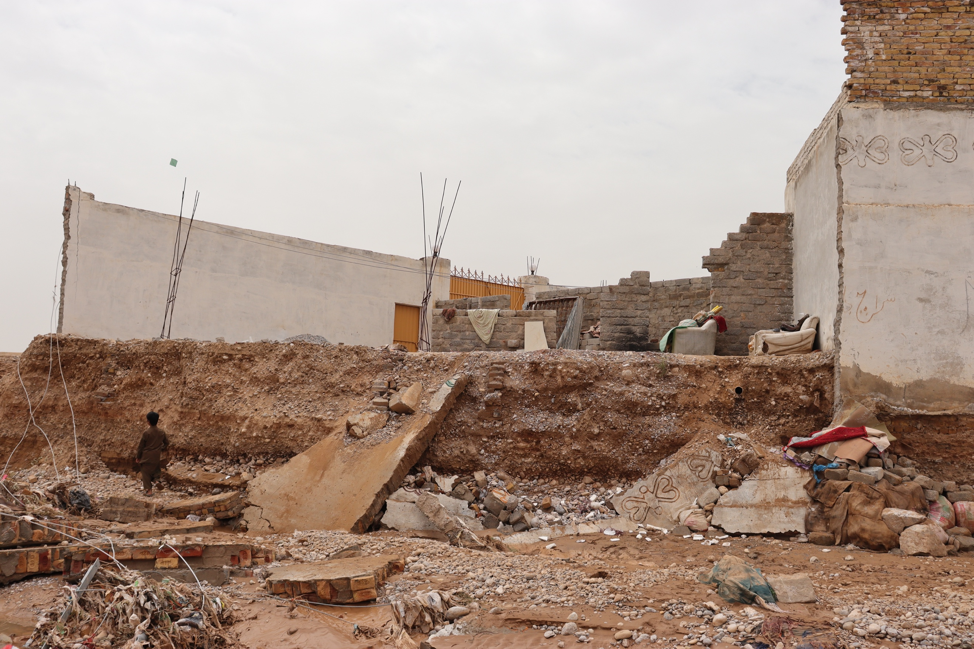

CARE has partnered with the Balochistan provincial government to conduct a rapid needs assessment and a rapid gender assessment to inform a just and effective strategy for our response. We anticipate a two-phased approach to meet both urgent and longer-term needs. For the first six months, we will provide emergency supplies to ensure that flood-affected families can meet their immediate needs. These supplies include temporary shelters and tarpaulins, hygiene kits, food baskets, child survival kits (including dried milk and high-calorie cookies), emergency latrine construction and the establishment of safe spaces for children and women. In times of crisis and uncertainty, women and children often face an increased risk of violence. Conducting a rapid gender assessment and establishing safe spaces will help us to ensure the safety and dignity of all those we serve.

Following this initial response phase, CARE will support the recovery of flood-affected communities, helping families rebuild what they have lost. CARE will assist with rehabilitating or constructing permanent shelters, water systems and household latrines that have been damaged or destroyed by flooding. We will also work with local partners to rebuild important community structures, like schools and health facilities. To help farmers restore their livelihoods and ensure nutritious food availability for the rest of the community, CARE will also provide agricultural inputs, like seeds and tools, and poultry kits. Finally, cash transfers will empower families to make their own decisions about what they need most –food, construction materials or medicines.
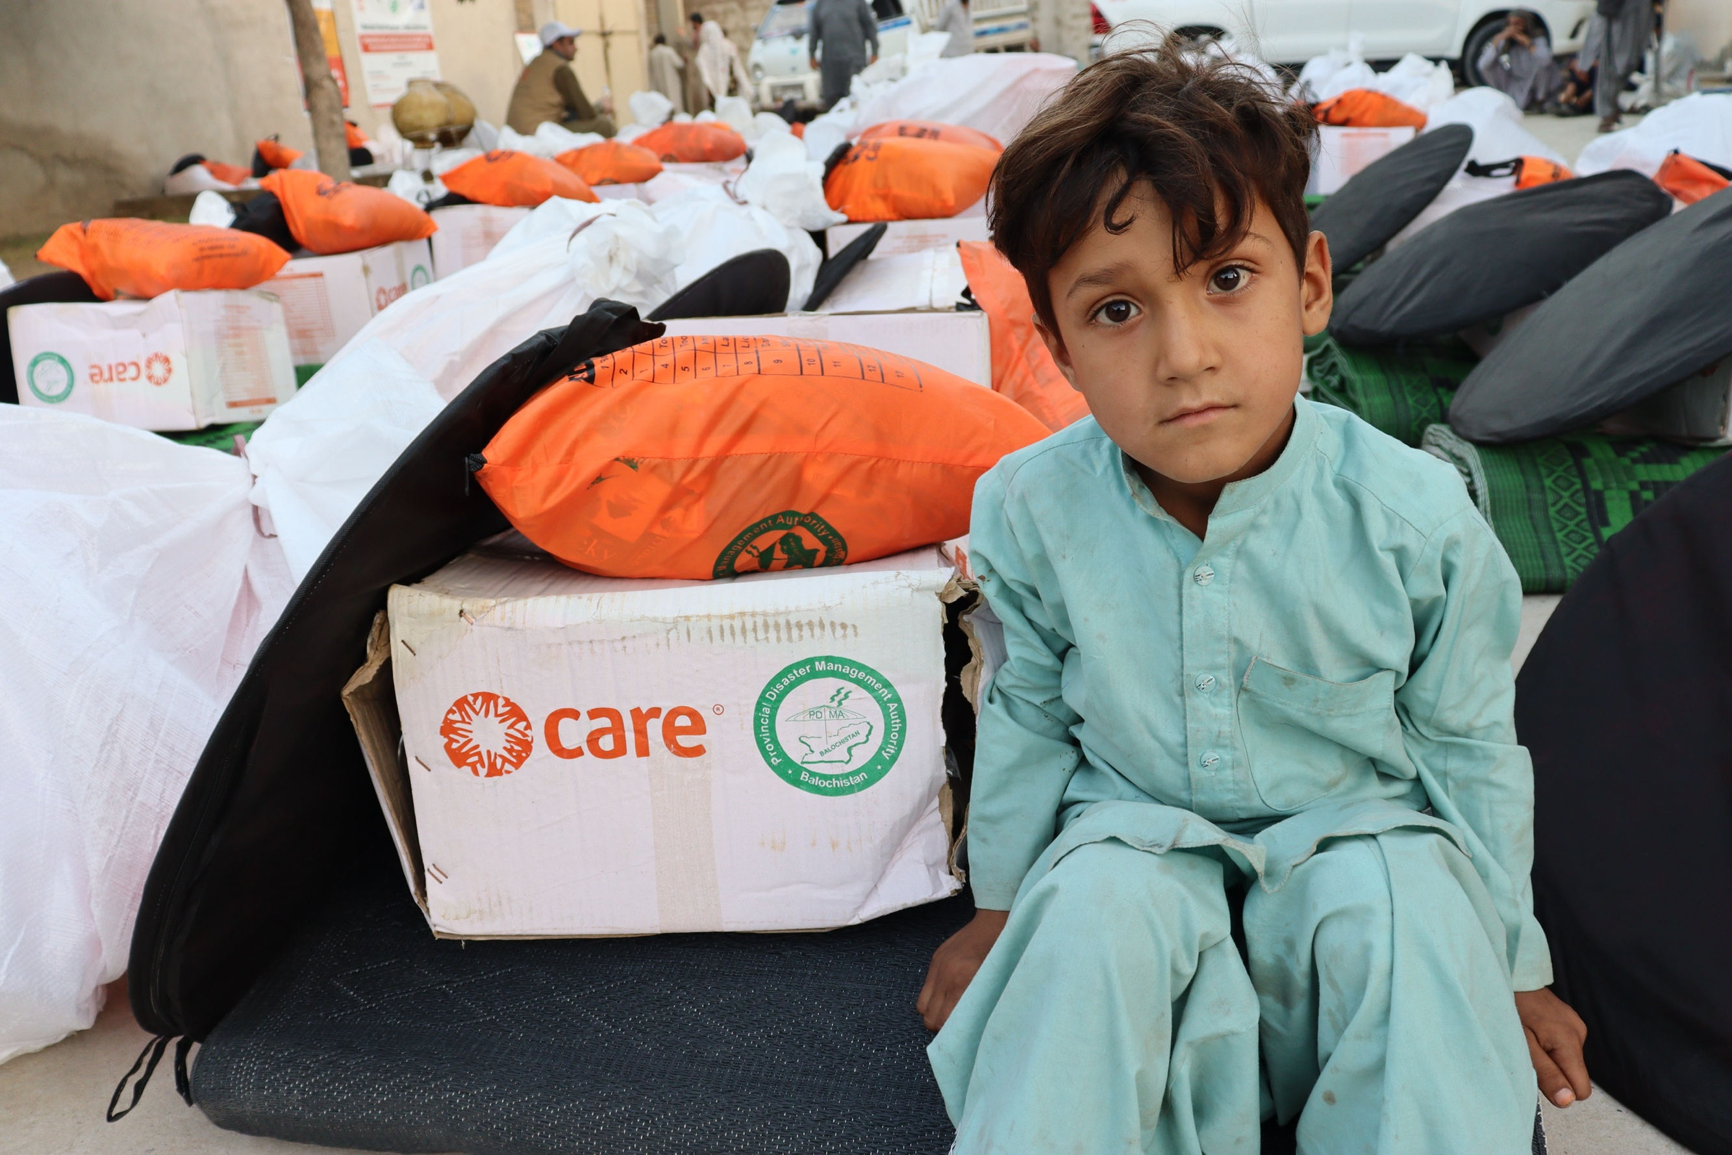

Our teams are currently working closely with the provincial government and our local partner, Bright Star Development Society Balochistan (BSDSB), to launch an initial response in Quetta district to reach 2,250 people. Together with BSDSB, CARE is providing tents to 50 families and constructing emergency latrines to serve 50 families. As more families are being forced from their homes, we will also provide temporary shelter materials, like tarpaulins, to 400 families. We will provide essential non-food items to 1,100 households and hygiene kits and menstrual hygiene kits to all 2,250 people to ensure their health and dignity. However, there are still many unmet needs, both now and in the difficult months to come.

Funding Target
CARE seeks to raise $12.05 million to expand our response and recovery efforts in Balochistan province over the next 12 months. Some examples of how your gift could help families affected by the floods include:
- $100 can provide a family with a hygiene kit;
- $200 can cover the cost of constructing a block of emergency latrines;
- $300 can provide a displaced family with a temporary shelter; and
- $500 can provide a family with a winterized tent to protect them from the elements.
“The sheer scale of the disaster has led the Government of Pakistan to declare a national emergency. CARE and our implementing partners are distributing relief items to affected communities including tents and tarpaulins, emergency latrine kits and everyday essentials including menstrual hygiene items. Our highest priority is supporting women, children and people with special needs. So many have lost just about everything and need our collective support now.”

Adil Sheraz, Country Director of CARE International in Pakistan

Conclusion
The crisis is far from over – the typical monsoon season in Pakistan lasts well into September. With your support, CARE can provide lifesaving assistance during these uncertain and dangerous times. Your donation to the Pakistan Flood Response fund will help us to provide shelter, food and other essential items to families who have been displaced. CARE thanks you for your generosity.

August 29, 2022

To effectively manage the current emergency response and continue to be able to deploy resources for other emergencies, CARE will reserve 20% of donations to the Pakistan Flood Response to cover technical support, administration and emergency preparedness expenses, including the rapid deployment of staff to emergencies such as this one.

