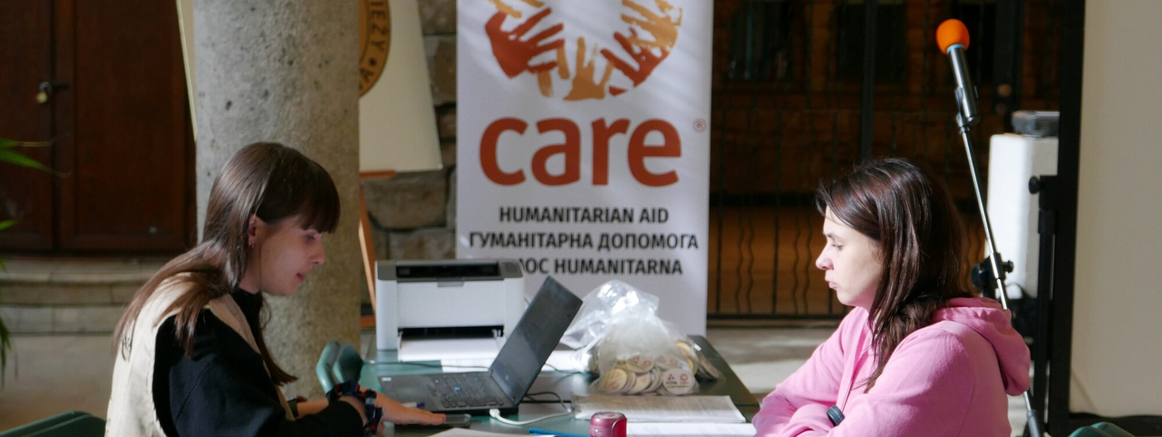

UKRAINE

CARE and our partners are delivering life-saving aid in Ukraine and across the region

Introduction
The conflict in Ukraine continues to escalate, resulting in massive displacement and destruction not seen in Europe since World War II. Some 15.7 million people inside Ukraine need humanitarian assistance, including 2.1 million children. More than 6.3 million people are displaced within the war-torn country, and approximately 5.5 million have registered for temporary protection in neighboring countries. Documented civilian casualties have exceeded 10,000, although the actual number is likely much higher, and hostilities are worsening. For Ukrainian refugees and internally displaced people (IDPs), the most immediate needs include food, clean water, shelter and protection from violence, including gender-based violence (GBV). Moreover, once it is safe to do so, they will need assistance returning home and rebuilding their lives.
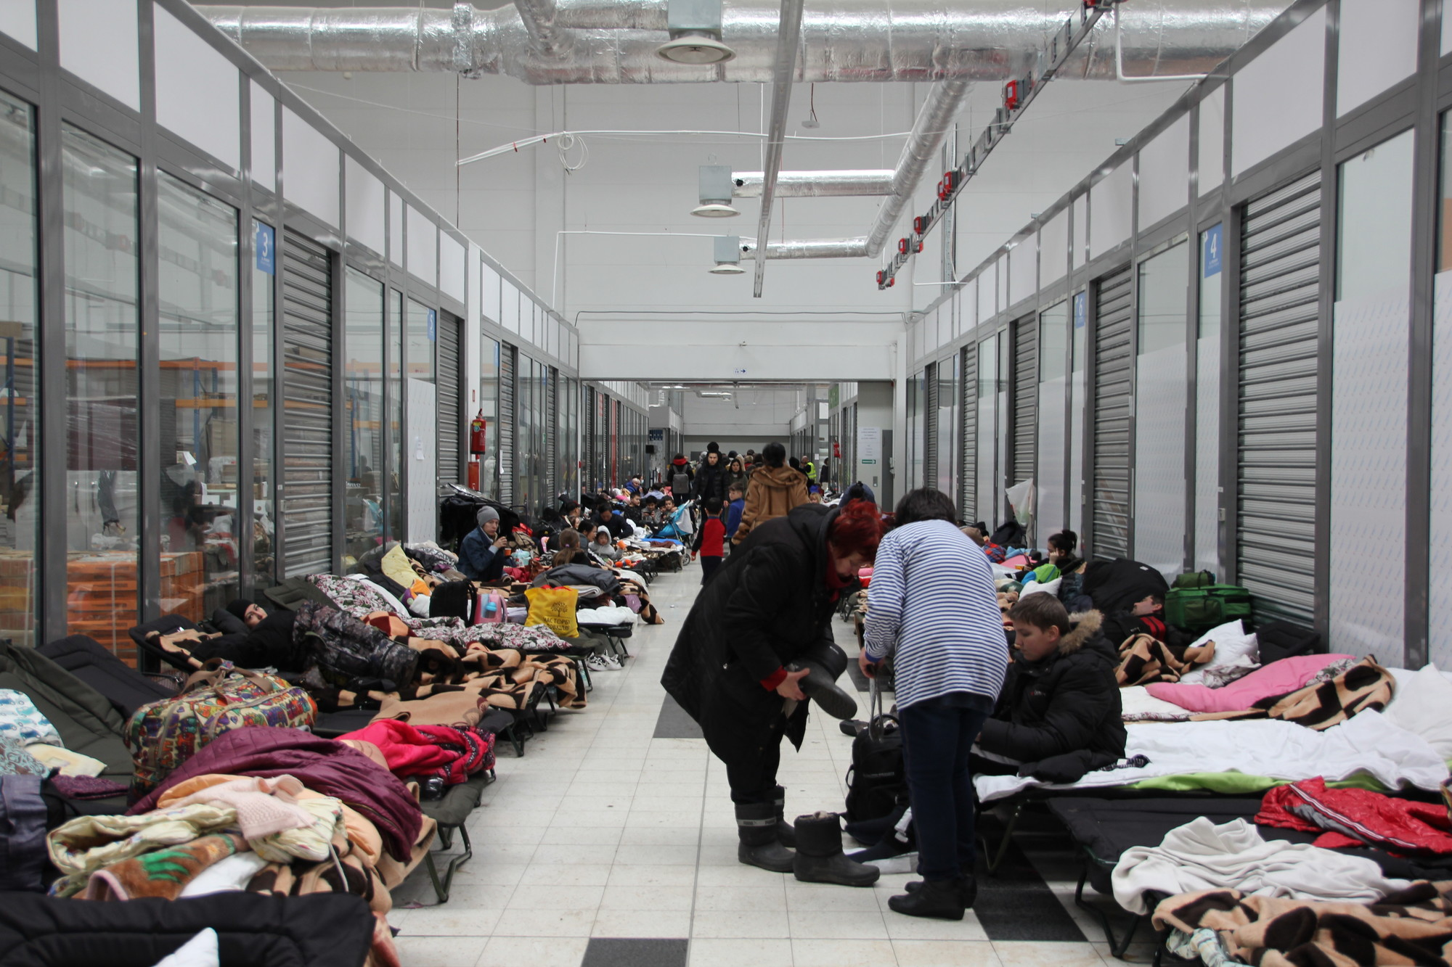

In addition to disrupting food supplies in the region, the conflict significantly impacts global food security. For decades, Ukraine has been the breadbasket of the Global South. Ukrainian and Russian grains provide more than one-third of the wheat imported by 45 African and least-developed countries. A global hunger crisis looms for an estimated 861 million people in 92 countries facing hunger and insufficient food consumption. Put simply, the Ukraine crisis – and its global impact – represents one of the most significant humanitarian challenges of our time.

CARE and our partners are on the ground in Ukraine and neighboring countries, providing life-saving assistance to people affected by war and displacement. We also are responding to the food security crisis that is impacting vulnerable families around the world. This update highlights accomplishments made possible through CARE’s Ukraine Humanitarian Crisis Fund, which helps conflict-affected families to meet their most urgent needs and to rebuild and recover in the challenging months and years to come.

Humanitarian Response
CARE’s response plans by country, including achievements to date, are described below.

Ukraine
Within Ukraine, CARE and our partners seek to reach 400,000 people nationwide, focusing on hard-to-reach communities with high numbers of IDPs. Our response focuses on providing food parcels or cash and vouchers to purchase food and other needed items; sexual and reproductive health services; protection services and GBV prevention; shelter; and water, sanitation and hygiene (WASH). To deliver this assistance, CARE is working with 10 partners across Ukraine. As a key strategy of our response, CARE is helping build the capacity of our partners in areas including monitoring and evaluation, reporting and gender considerations in programming to improve the impact of the relief provided.

To date, we have reached 380,932 people inside Ukraine, including 64,000 who were assisted through cross-border operations from Romania. We have delivered 249,953 meals in eastern Ukraine (Chernihiv, Sumy, Kyiv and Kharkiv) with our partner, the Ukrainian Red Cross Society. Items distributed included canned goulash and tuna, pasta, cookies, cereal bars, baby food, fruit purees, and bottled water. CARE also provided an initial group of 250 people in Mykolaivska with multi-purpose cash assistance to help meet their basic needs.
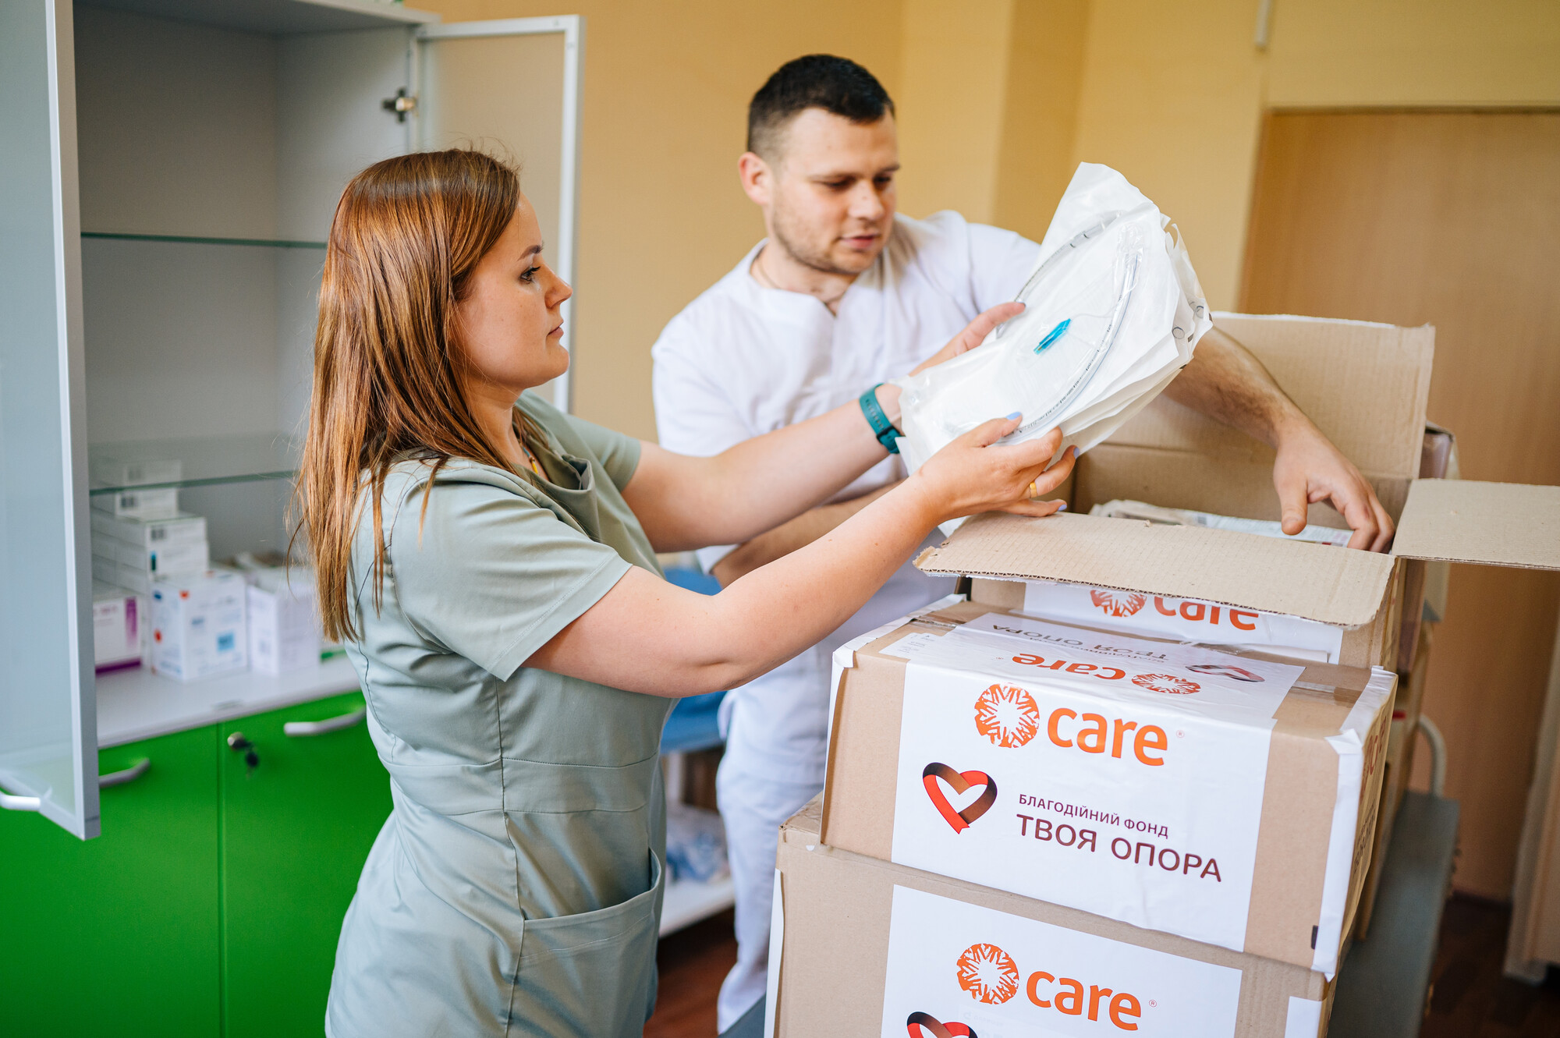

Some highlights since the previous update are as follows:

GBV prevention and support: CARE is working with the International Planned Parenthood Federation and Women’s Health and Family Planning to assist sexual and gender-based violence survivors by supporting health facilities with supplies and equipment, building local capacity to provide survivor-centered care, and conducting outreach to ensure survivors know where and how to access services.

WASH: We have distributed family hygiene and dignity kits with local partners (HEKS/HER and Ukrainian Women’s Fund). We also identified two new WASH partners to reach additional people in need in southern and eastern Ukraine. Our efforts continue to focus on reaching the elderly and people with special needs, who are often left behind in conflict-affected areas when others flee, leaving them incredibly vulnerable and without support. To date, our WASH activities have reached 10,300 people. CARE, alongside UNICEF, now co-leads the Gender and Inclusion in WASH technical working group in the national WASH cluster.

As described in a previous update, CARE provides lifesaving healthcare, including medical equipment and medicines, through mobile services in Donetsk, Kharkiv, Khmelnytska, Rivnenska and Zaporiska in partnership with the International Renaissance Foundation. To date, CARE has reached 56,429 people through our health programs.

Recognizing the heightened vulnerabilities of women and girls in times of crisis, CARE is working with four women’s rights organizations in Ukraine to fund their humanitarian response activities. These partners include:

- Women’s Perspectives Center (CWP): CWP is a women’s rights umbrella network for civil society organizations in western Ukraine. With CARE funding, CWP is providing grants to eight grassroots women’s organizations to assist IDP women and children, including supporting pre-school children in daycare centers, offering psychosocial support and counseling for women and girls, and providing livelihoods training (sewing) and social assistance and advice.
- Democracy Development Center (DDC): With CARE’s support, DDC is providing targeted assistance to IDPs in six communities in Lvivska and Chernivetska oblasts, including non-food emergency items and psychosocial services. Following a session with IDPs in Kamianka-Buzka in late May, DDC psychologist Yulia Tereshchuk said, “The meetings show how important it is for people who have been forced to leave their homes due to hostilities to be heard and how difficult it is to find words to describe their emotions. The most common questions [they have] is what will happen tomorrow, and what to do when emotions of anxiety, fear and hopelessness become overwhelming.”
- Ukrainian Women’s Fund (UWF): UWF is a women’s rights network with members across Ukraine, including organizations representing marginalized women, LGBTQ+ people, national minorities, women living with HIV/AIDS, and women engaged in commercial sex work. With CARE funding, UWF has provided grants to five of its members to provide humanitarian assistance (non-food items) and psychosocial support to vulnerable, displaced women and girls in Chernivtsi, Lutsk, Odesa, Vinnytsia and Khmelnytsky oblasts. CARE’s support enables UWF to purchase and distribute dignity kits and develop guides and courses in humanitarian assistance and other relevant topics.
- Zhiva-Ya: With CARE funding, Zhiva-Ya (a small grassroots women’s organization) works with volunteers in Kherson to provide cash assistance to women and families. They are prioritizing single mothers, women with multiple children and LGBTQ+ people in rural areas to purchase essential goods and help cover costs related to evacuation and relocation.

Poland
In Poland, CARE has partnered with the Polish Center for International Aid (PCPM), ADRA Polska, Polish Humanitarian Action (PAH) and other organizations to launch a comprehensive response. Program activities focus on providing multi-purpose cash assistance, including paying the salaries of refugee teachers; support for temporary housing; protection, including GBV prevention and support; sexual and reproductive health; and promoting women’s leadership. To date, we have reached 27,392 people directly and more than 55,000 people (including family members) indirectly. In addition to the partnerships already in place, we are formalizing agreements with new partners, including:

- Centrum Pomocy Humanitarnej in Shehiye, which is working in the Medyka border area. Through the partnership, we will distribute food in Ukrainian towns and cities affected by the war.
- AgroPermaLab: The partnership will engage refugees and local populations in community gardens and kitchens, focusing on the integration of the Ukrainian community. These efforts will equip refugees with skills that can help them find gardening and horticulture jobs in Poland and upon their eventual return to Ukraine.

Along with PCPM and local municipalities, CARE has expanded our program to hire refugee Ukrainian teachers in Polish schools to give the teachers much-needed income and help Ukrainian children, who are vulnerable and traumatized, to better integrate into their new environment. To date, 612 people have benefitted from the program, including teachers in Warsaw, Lublin, Mińsk Mazowiecki, Garwolin, Siedlce, Białystok, Bydgoszcz, Szczecin, Wrocław, Goleniów, Jastrzębie Zdrój and Starkowo. Additionally, 40 refugees were employed in a refugee center in Warsaw.

Also on the educational front, CARE is working to create after-school and summer programs for Ukrainian children in Poland. To enable Ukrainian refugees’ participation in the labor market, children need access to afterschool care during the school year and daycare during the summer and winter holidays.

In addition, CARE and PCPM’s multi-purpose cash assistance program has supported 1,909 people across 790 households. The program targets refugees in Lublin, Dąbrowa Górnicza, Kętrzyn, Srokowo, Białystok, Warszawa Wschodnia and Łódź. Also with PCPM, CARE has launched a targeted cash assistance effort focusing on the most vulnerable refugees, including the elderly, people with disabilities and mothers with young children. This program has reached an additional 438 people in Kraków and Katowice.
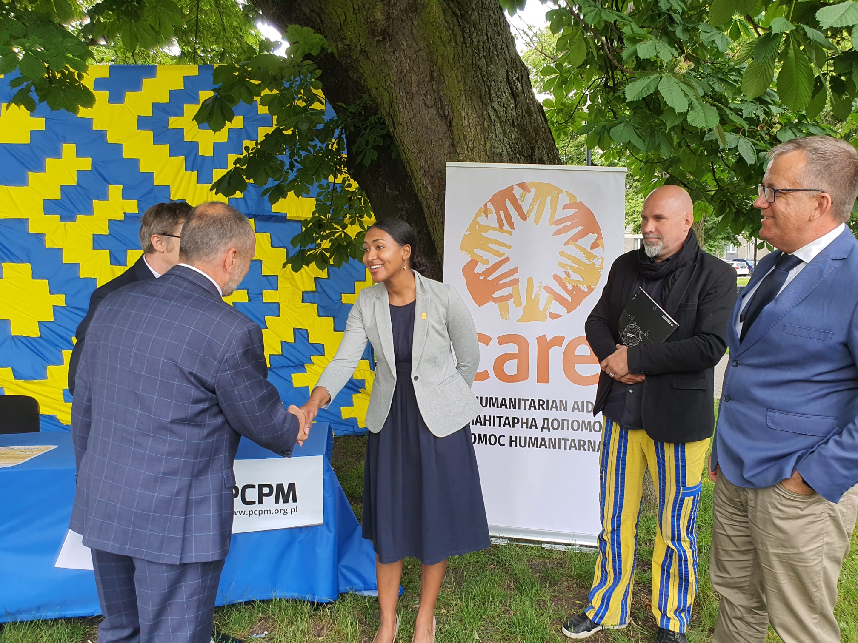
CARE recently kicked off the Summer in the City program, which will provide workshops and other recreational activities during the summer months for Ukrainian and Polish children across Poland. These programs not only help integrate Ukrainian kids into Polish society but also provide childcare for Ukrainian families who have found employment in Poland. The initiative will become a part of ongoing after-school programming offered to Ukrainian refugees in Poland to support them to stay employed.
Leading the event was Camille Davis, CARE team leader, Banach Mariusz, vice-mayor of Lublin, Poland, Rafal Kozinski, director of the Lublin Center of Culture and Dr. Woltjek Wilke of PCPM.

CARE also supports a cash card assistance program in partnership with PAH that has reached 2,591 households (6,088 people in total). The cash cards are for 710PLN (approximately $170) for the first family member and 610PLN ($145) for each additional family member per month. With these cards, refugees can choose and buy what they most need. Starting this month, PAH is launching new registration points (including two specifically targeting people with disabilities and their relatives) in Kraków, Warsaw, Stargard, Koszalin and Olsztyn. In addition, CARE and PAH provide psychosocial support to refugees who have experienced significant trauma in recent months.

With our partner ADRA Polska, CARE is helping outfit 61 refugee shelters across Poland with beds, furniture and needed equipment. To date, 48 of the 61 shelters are operational and have provided services to 16,700 people. Also in partnership with ADRA, we have helped facilitate the evacuation of 1,950 vulnerable people from Ukraine to Poland and delivered 31.5 tons of food and non-food items, including baby food, cribs and hygiene items, across the border to people in Ukraine.

CARE has forged partnerships with multiple women’s rights organizations (FEDERA, Feminoteka and Automomia, and the Polish Migration Forum and their women’s program) to address specific vulnerabilities of women and girls, and we are formalizing partnerships with Ocalenie and Niebieska Linia (Blue Line). These organizations provide holistic services and support for GBV survivors, access to life-saving sexual and reproductive health services, and individual and group counseling. In addition to partnering in delivering humanitarian support to refugees, CARE will provide technical assistance and training, coordination and networking across women’s organizations, and advocacy support to these groups.

In a related activity, CARE produced an initial 3,000 urgent information cards (pocket cards) providing contact information for women’s health, GBV and health services in Ukrainian and Russian. CARE distributed these cards to first responders at border crossings and at reception and transit centers. CARE will also make these cards available to our partners and include them in the dignity kits that we plan to distribute to female refugees. Each kit will include sanitary pads, leggings, undergarments, a dental kit, battery pack and a flashlight.
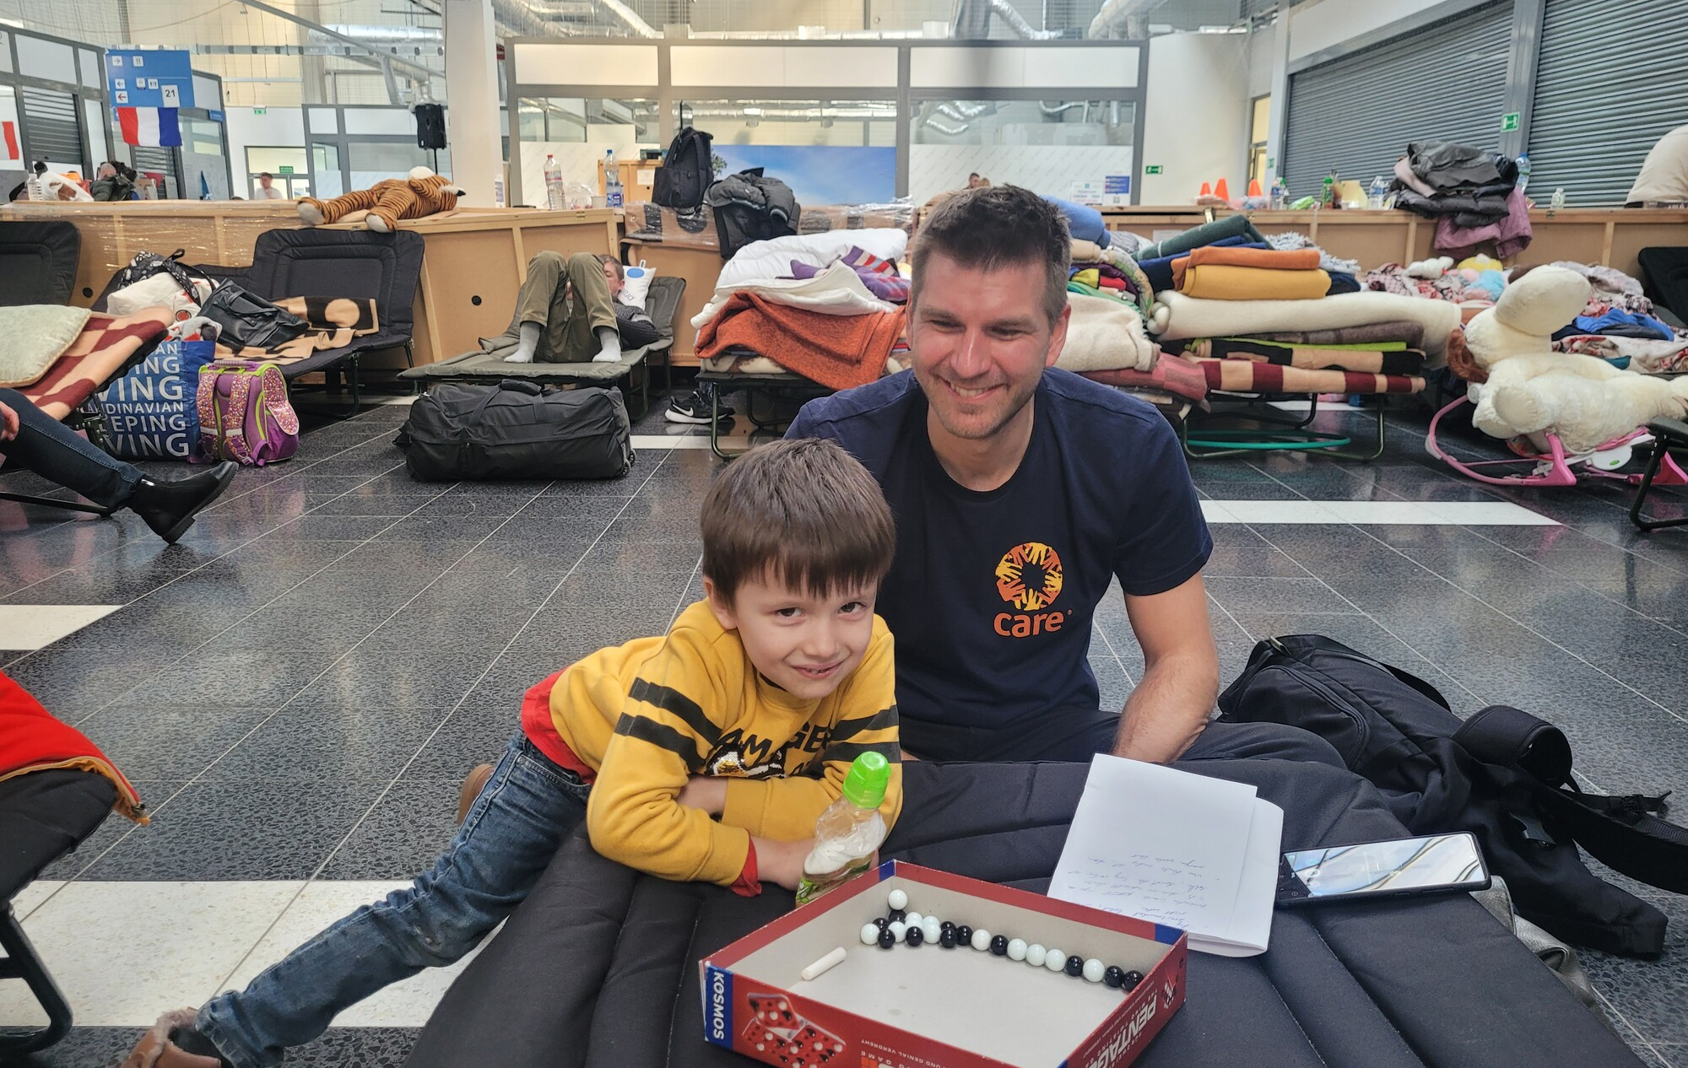

In addition to these partnerships, we have identified potential women’s rights organization partners in Slovakia and Hungary to support Ukrainian refugees, with future programs to include increased access to GBV and health support services, psychological counseling and programs for children.

Romania/Moldova
In Romania, CARE is working with our long-time partners SERA and the Federation of Child Protection NGOs (FONC) to help affected families. SERA has delivered relief items, including diapers and blankets, at a key border crossing and has trained 900 clinicians in emergency psychosocial support in border areas to help refugees process and overcome the trauma of war and displacement. CARE, SERA and FONC also are supporting the efforts of social services and child protection departments to assist vulnerable children on arrival and at transit routes, particularly unaccompanied children.

In addition, CARE is working with the Red Cross in Romania and Slovenia to provide cross-border assistance for families seeking safety. CARE has signed agreements with 29 local partners, and our ongoing protection and emergency assistance efforts have reached 5,100 people. Our cross-border work delivered 77,484 tons of food for distribution in western and central Ukraine in May, and, more recently, 10 additional tons of dried food (250,000 meals) distributed in early June in partnership with Red Cross Romania’s networks.

In Moldova, CARE is finalizing partnerships with three organizations with national reach and programs focused on disability inclusion and protection. Our support will include multi-purpose cash assistance, protection services and the provision of needed items to people crossing the border from Ukraine.

Georgia
In Georgia, CARE continues to distribute relief items to Ukrainians arriving in the country. In addition, 1,810 people have received multi-purpose cash assistance to cover their emergency needs. CARE is working with a local service organization to provide legal, psychological and protection support, and case management for refugee women and children. We have provided protection service information (police, emergency, and GBV/harassment services) to more than 2,500 people, and our partner legal provider has supported 375 people with information about documentation, communication with banks, border-crossing issues, school registration, etc. On the advocacy front, CARE is working with local governments in Tbilisi, Kutaisi, Batumi and Zugdidi to help them design a response based on the needs of Ukrainian families seeking safety.

Funding Target
CARE’s Ukraine Humanitarian Crisis Fund seeks to raise $150 million to fund our relief and recovery efforts. Some examples of how your gift could help families displaced by conflict:
- $26 could provide a family fleeing to Romania with an emergency hygiene kit, including soap, laundry detergent, toothbrushes, wet wipes and sanitary materials.
- $38 could provide a person fleeing Ukraine with a mobile phone, SIM card and external battery to connect with friends and family back home and help plan their onward route.
- $81 could provide a family arriving in Romania with diapers, wet wipes, baby food and a thermos.

Conclusion
With humanitarian needs worsening and more people fleeing their homes every day, CARE and our partners are providing support where the needs are greatest – inside Ukraine and in border countries where refugees seek safety. CARE thanks you for helping us to deliver life-saving aid and longer-term recovery assistance through your generous support of the Ukraine Humanitarian Crisis Fund.

July 13, 2022

https://news.un.org/en/story/2022/04/1116152?msclkid=a6509192cf9d11ec8a46224fc042ff3a
To effectively manage the current emergency response and continue to be able to deploy resources for other emergencies, CARE will reserve 20% of donations to the Ukraine response to cover technical support, administration and emergency preparedness expenses, including the rapid deployment of staff to emergencies such as this one.

