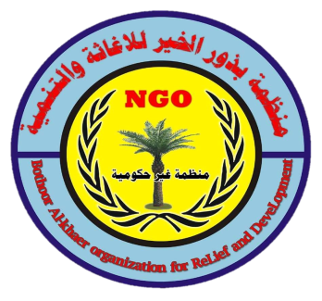

Feeling uncertain of what to expect

Text or email us to ask for an initial assessment
appointment. At the assessment you will be invited to
share relevant issues to assess if counselling is suitable and appropriate for you. On occasion referral to other agencies may be suggested. Issues covered may include: Depression
Bereavement and Loss Anxiety Anxiety Survivors of Child Abuse Adults and Girls Sense of Suicide Self-harm Panic Attacks Desperation Anger Management Rejection Finding Meaning in Life Post-Abortion Syndrome

!There is Hope

Interested in knowing what
other services we can
offer?

BAORD (part of BAORD a
registered Iraq charity) have
produced materials suitable to
support those affected by suicide
and self harm.

- DVDs called Life Matter
Choose Life and
A booklet called Journey
to Wellness stories of hope

- A book called Equipped
to Care covering four
workshops on developing
appropriate skills to help
connect with people in nee
- Through Hope Community Bereavement Support Groups where requested

- Through Hope Ministry — confidential prayer ministry in Athlone by appointment

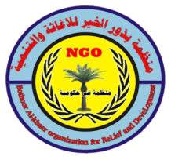
who are we Bothoor Alkhaer Organization, a registered Iraqi charitable organization. We aim to help people with life's problems by listening, healing and preparing people for an effective life. Our service aims to provide professional and confidential advice by appointment within the community or online as appropriate. Staff are fully trained and certified members of a professional body
There are times in one’s life when a listening ear is needed; when it would be helpful to speak to someone with the skills to hear at a deep level the issues that concern us. The

counselling service aims to help in a friendly, courteous, respectful and professional manner. Through empathic listening skills counsellees are helped to find their own solutions to issues.

Our counsellors are able to offer non-directive and non-judgmental help. We believe that where problems have affected clients ‘body, soul or spirit’ we can offer holistic and appropriate help.

We can provide a secret service available to all - males, females, adolescents and people from any religion or no religion who have qualified employees of humanity.
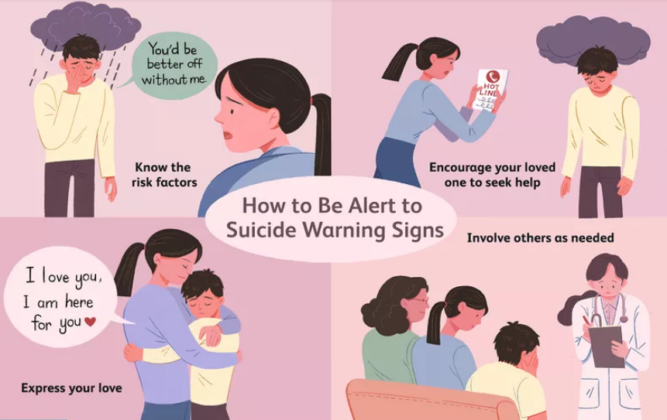

phone: +964 790 593 2247
Email: ngo2iraq@gmail.com
Skype: Bothoor
For further information, visit our website at www.baord.org

