HEREAFTER GHANA (MHP)
QUARTERLY REPORT FOR GLOBAL GIVING (APRIL-JUNE 2025)
PROJECT TITLE: ONE CHILD ONE NHIS

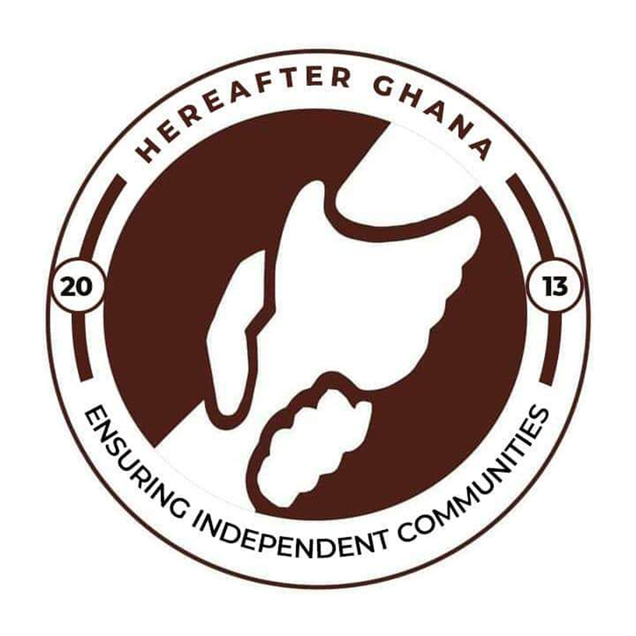
Date: June 23rd 2025
Prepared by Sulemana Suabira Suhuyini
Administrative Assistant

INTRODUCTION
The One Child, One NHIS initiative is a flagship program at Hereafter Ghana aimed at facilitating access to healthcare for children, pregnant women and the aged by ensuring that every child, pregnant women and the aged in our target communities is registered under the National Health Insurance Scheme (NHIS).
In the second quarter, Hereafter Ghana visited four (4) communities namely Tuutingli, Datooyili, Foshegu and Cheshe in the Tamale Metropolis.
This report outlines the number of beneficiaries of each community and the total number of beneficiaries reached through the program. The report also outlines some key challenges faced by the team during the registration process.
OBJECTIVES OF THE NHIS MEMBERSHIP CARD REGISTRATION EXERCISE
- To increase NHIS coverage among children in various communities.
- To facilitate both new registrations and renewals of NHIS cards for children.
- To enhance awareness of the importance of health insurance in underserved communities.
- To foster collaboration between Hereafter Ghana, the NHIS Tamale Metro Office, and local community stakeholders.
TUUTINGLI COMMUNITY
A number of 222 beneficiaries were successfully registered to the One Child One NHIS program which included both new registrations and renewal of cards.
There were 64 new registrations of children and 158 renewals of cards. This ranged from children, pregnant women and the aged.
CHESHE COMMUNITY
The Cheshe community had a total number of 70 new registrations and 209 renewals. Reaching a total number of 279 beneficiaries in the community.
The new registrations were all children ranging from 3 months to 18 years while the renewal also benefited more children., with just a few pregnant women and aged.
DATOOYILI
The Datooyili community, a total number of 328 benefited from the NHIS registration.
The total number of new registrations were 110 and the total number of renewals recorded was 218.
FOSHEGU
A total of 610 beneficiaries were recorded in the Fooshegu community. With 510 renewals and 100 new registrations.
OVERVIEW OF THE ACTIVITIES FOR THE NHIS REGISTRATION
The registration process spans a period of one to three days, depending on the scope of activities involved.This variation is influenced by factors such as the number of individuals to be registered, network availability, and potential technical challenges.
The activities involved in the registration include
- Data collection of beneficiaries by Hereafter Ghana team. The data is arranged and sent to the NHIS team.
- Issuing of Receipts by NHIS team.
- Biometric capturing by the NHIS team.

CHALENGES ENCOUNTERED DURING THE REGISTRATION PROCESS
- Unsuitable Working Environment
- Technical Difficulties
This included challenges with the NHIS officers Machines
Network failure
CONCLUSION
A total number of 1436 beneficiaries were registered during the second quarter under the One Child, One NHIS initiative. This marks another milestone in Hereafter Ghana’s mission to ensure universal health access for children in vulnerable communities. Despite environmental and technical challenges, the exercise succeeded in reaching beneficiaries, an achievement that underscores the dedication of the field team, the support of the NHIS Tamale Metro Office, and the enthusiasm of the communities.
ACKNOWLEDGEMENT
Hereafter Ghana extends its heartfelt appreciation to all our esteemed donors, the dedicated team from the National Health Insurance Scheme (NHIS), and the committed staff and volunteers of Hereafter Ghana for their invaluable contributions to the One Child, One NHIS project.
Your unwavering support and collaboration have been instrumental in ensuring that vulnerable children in underserved communities gain access to essential healthcare services. The success of this initiative reflects your shared commitment to safeguarding the health and well-being of every child, and we are deeply grateful for the trust and partnership you continue to show.

GALLERY
