HEREAFTER GHANA

ONE CHILD ONE NHIS PROJECT
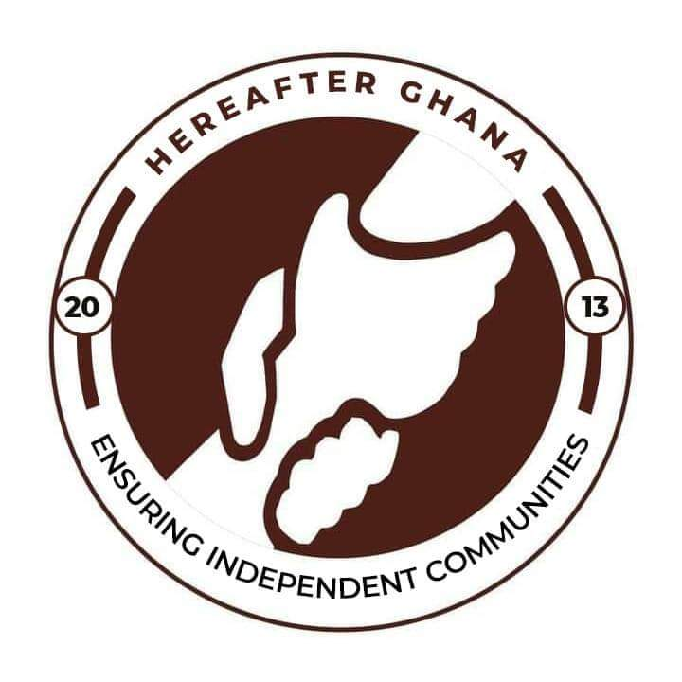
FOOSHEGU COMMUNITY
A REPORT PREPARED AND PRESENTED TO HEREAFTER GHANA OFFICE BY THE ONE CHILD ONE NHIS TEAM

JUNE, 2025
Hereafter Ghana is dedicated to improving healthcare access through its flagship initiative, "One Child One NHIS Card," conducted a registration exercise in Fooshegu, a community under the Tamale Metropolitan Assembly. The activity aimed at enrolling children, pregnant women, and the aged onto the National Health Insurance Scheme (NHIS) to enhance their access to essential health services.

OBJECTIVES OF THE NHIS MEMBERSHIP REGISTRATION AT FOOSHEGU
The primary objective of the exercise was to:
- Increase NHIS enrollment among vulnerable groups in rural communities.
- Sensitize the community on the importance of health insurance.
- Contribute to the government’s efforts to achieve universal health coverage

OUTCOME OF THE REGISTRATION AT FOOSHEGU
The registration commenced at Fooshegu but witnessed participation from neighboring communities including Chanshegu, Gblahbila, and Kamonaa Yili. A total of 610 community members including students (pupils) were successfully registered, comprising:
- 100 new registrations (fresh registration).
- 510 renewals of existing NHIS cards

COMMUNITY ENGAGEMENT AND PARTICIPATION
The registration was well-received by the community. Notably, school pupils constituted a significant proportion of those registered, demonstrating strong community interest in ensuring that children benefit from health insurance coverage. The involvement of the elderly further underscored the relevance of the initiative in addressing the healthcare needs of vulnerable populations.
The strategic location of the registration center in Fooshegu allowed for broader participation from surrounding villages, making the exercise inclusive and far-reaching.
The immediate outcome of the exercise includes:
- Increased NHIS coverage in Fooshegu and neighboring communities.
- Enhanced community awareness of the importance of health insurance.

CHALLENGES OF THE NHIS MEMBERSHIP REGISTRATION AT FOOSHEGU
The process was not without challenges. On the first day, persistent network disruptions hampered the smooth flow of activities, leading to fewer registrations than anticipated. On the second day, an unexpected power outage across the entire community brought the registration to a complete standstill, with no individuals registered. In response to these setbacks, the registration team extended the activity to the following week, specifically Monday, to conclude the exercise successfully.

RECOMMENDATION
The challenges encountered during this exercise highlight the need for:
- Prior technical assessments of network coverage in rural areas.
- Backup power solutions (generator) to mitigate the effects of power outages.
- Flexibility in scheduling to accommodate unforeseen challenges.

CONCLUSION
The NHIS membership registration exercise at Fooshegu reflects Hereafter Ghana’s unwavering commitment to advancing healthcare accessibility through the "One Child One NHIS Card" program. The registration of 610 individuals, despite logistical and technical challenges, marks a significant contribution towards universal health coverage in the Northern Region of Ghana.
Moving forward, Hereafter Ghana remains committed to scaling up its interventions to reach more underserved communities, ensuring that no child, pregnant woman, or elderly person is left behind in the journey towards equitable healthcare for all.
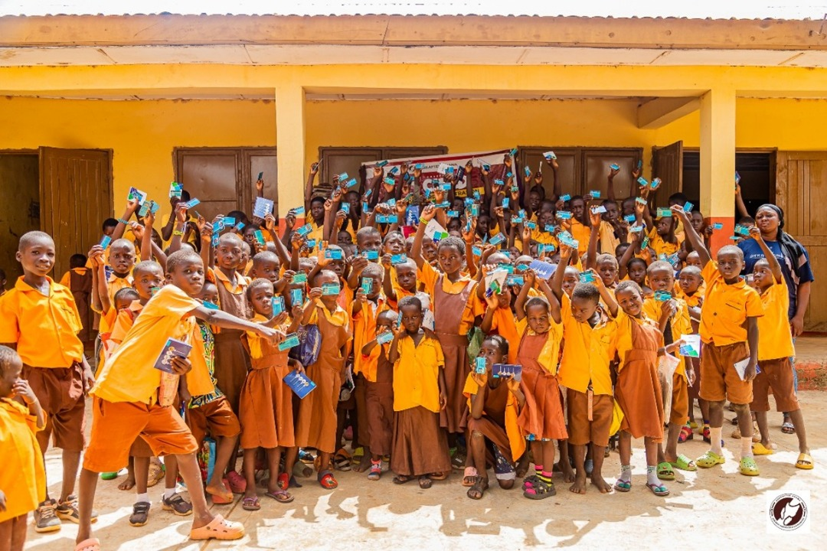
picture 1 Showing a section of the pupils that got registered onto the NHIS at Fooshegu Community

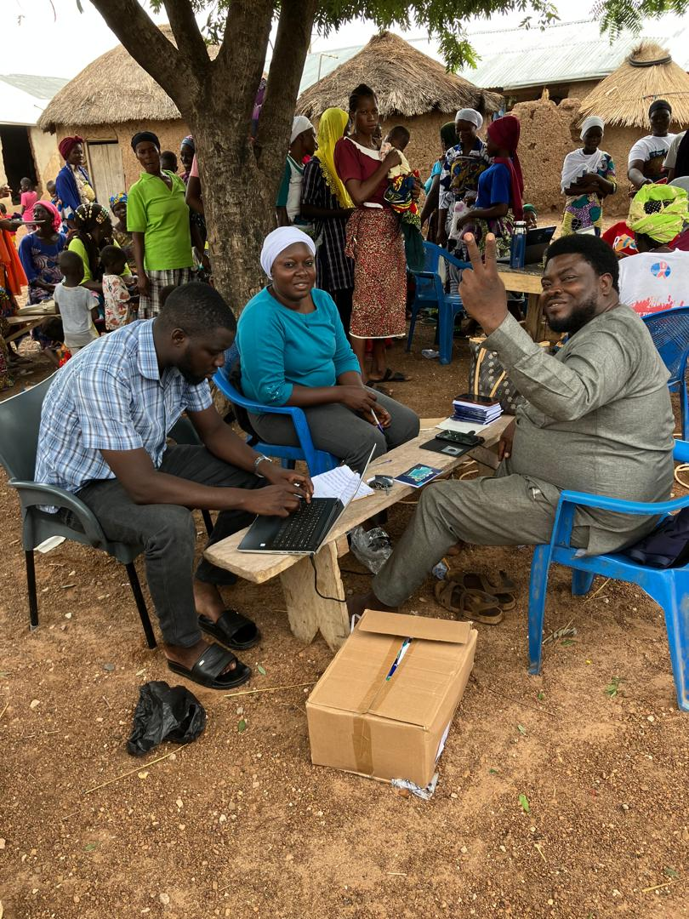
Picture 2 Showing a section of the residents of Fooshegu and officials from Hereafter Ghana and the NHIS Tamale Metro office capturing the details of the beneficiaries

