HEREAFTER GHANA (MHP)
QUARTERLY REPORT FOR GLOBAL GIVING (JULY-SEPTEMBER 2026)
PROJECT TITLE: ONE CHILD ONE NHIS

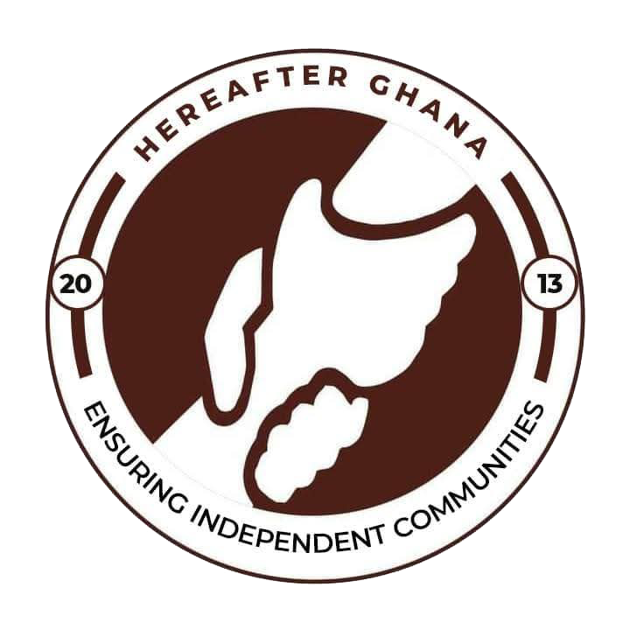
Date Prepared: 23rd September 2026
Prepared by: Sulemana Suabira Suhuyini
Photographer/Videographer and PRF officer

INTRODUCTION
The One Child, One NHIS Initiative is one of the core programs of Hereafter Ghana established to improve access to vital healthcare services for children, pregnant women, and the elderly. Its primary goal is to ensure that all members of these vulnerable groups in our target communities are registered under the National Health Insurance Scheme (NHIS), thereby advancing fair, consistent, and sustainable healthcare coverage.
Access to valid NHIS membership is an important component of healthcare access in Ghana. However, some community members, particularly vulnerable and economically disadvantaged individuals, may experience difficulties accessing NHIS services due to distance, transportation costs, limited information, and other logistical challenges.
During the second quarter, Hereafter Ghana visited two communities within the Northern Region. Lingbin Gundaa in the Tolon District and Bognaayili in the Kumbungu District.
This report presents a summary of activities and highlights the number of beneficiaries under each community.
OBJECTIVES OF THE NHIS MEMBERSHIP CARD REGISTRATION EXERCISE
- To increase NHIS coverage among children in various communities.
- To facilitate both new registrations and renewals of NHIS cards for children.
- To enhance awareness of the importance of health insurance in underserved communities.
- Strengthen collaboration between Hereafter Ghana and relevant government institutions involved in social protection and healthcare access.
ACTIVITY
The NHIS registration was done in two phases for each community. The first phase consisted of identifying and collecting data on potential beneficiaries’ information. The data collection exercise was conducted over days. During this period, the Hereafter Ghana team and community volunteers engaged community members and collected the necessary data from individuals who required either fresh NHIS registration or renewal of their existing memberships.
The second phase involved the actual registration where NHIS officers were brought to the communities to register new members onto the NHIS and renew cards to ensure validity for its usage.

LINGBIN GUNDAA
At the end of the process, there were 522 Fresh Registrations and 17 Renewals making a Total of 539 beneficiaries.
The new registrations were all children ranging from 3 months to 18 years while the renewal also benefited more children., with just a few pregnant women and aged.
BOGNAAYILI
The exercise recorded a total of 264 Beneficiaries Registered and Renewed with 134 being fresh registration and 130 being renewals.

CONCLUSION
A total number of 785 beneficiaries were registered during the quarter under the One Child, One NHIS initiative. This marks another milestone in Hereafter Ghana’s mission to ensure universal health access for children in vulnerable communities. Despite environmental and technical challenges, the exercise succeeded in reaching beneficiaries, an achievement that underscores the dedication of the field team, the support of the NHIS Tamale Metro Office, and the enthusiasm of the communities.
ACKNOWLEDGEMENT
Hereafter Ghana extends its heartfelt appreciation to all our esteemed donors, the dedicated team from the National Health Insurance Scheme (NHIS), and the committed staff and volunteers of Hereafter Ghana for their invaluable contributions to the One Child, One NHIS project.
Your unwavering support and collaboration have been instrumental in ensuring that vulnerable children in underserved communities gain access to essential healthcare services. The success of this initiative reflects your shared commitment to safeguarding the health and well-being of every child, and we are deeply grateful for the trust and partnership you continue to show.
Gallery
