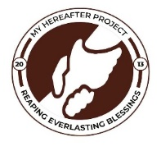
MY HEREAFTER PROJECT (MHP)
QUARTERLY REPORT FOR GLOBAL GIVING (SEP – DEC 2023)
PROJECT TITLE: GIVE A CHILD 10 YEARS HEALTH INSURANCE

THE 1CHILD_1HEALTH INSURANCE (NHIS) PROJECT
This project seeks to register children below age 18 onto the National Health Insurance Scheme of Ghana so they can access free basic healthcare and other benefits associated with this card.
This project also helps widen the scope of the Ghana Universal Health Coverage Goal for rural communities. This will also enhance early detection and treatment of ailments.

Between September to December 2023, 1000 children, which is the goal of the organization for the year 2023 had been achieved. The organization used this period to organize its annual end of year accountability and fundraising forum where we accounts to donors on how the year went and fundraise for the next year.
At the event, a citation was given to the health insurance directorate for facilitating the process for the whole years. Beneficiaries also graced the occasion to give testimonies of how the card has saved them and their families in the aspects of economics and health.
The Tamale Metropolis Health Insurance office has pledged to support the organization this year with 3000 free cards.
This will mean that, the organization would not be paying for the cost of cards for 3000 children but will however have to mobilize resources for transportation, feeding and logistics for the process for the whole year.

Attached are some pictures from the event
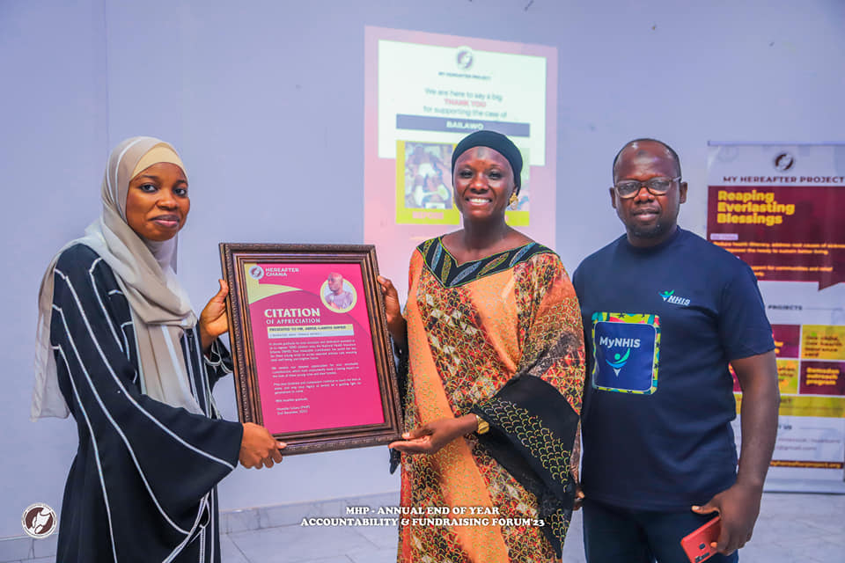
PRESENTATION OF CITATION TO NHIS TEAM

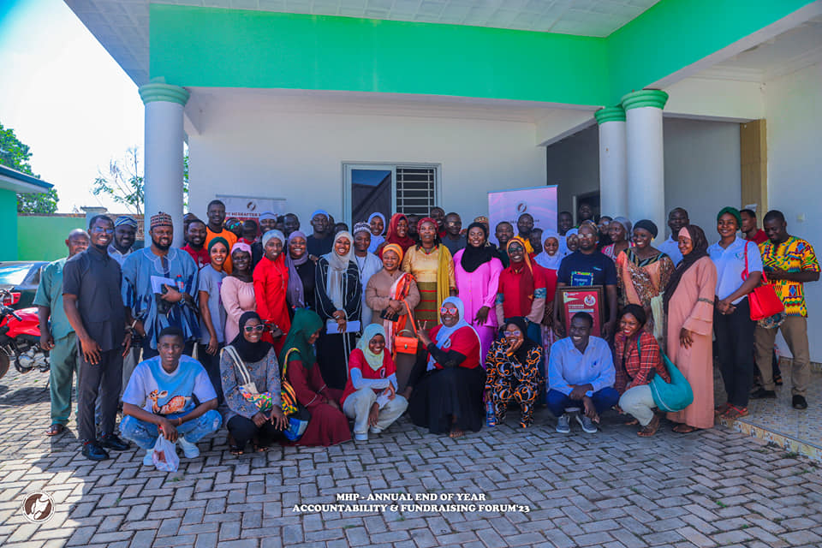
GROUP PICTURE OF AUDIENCE AT END OF YEAR FORUM.

