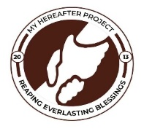
MY HEREAFTER PROJECT (MHP)
QUARTERLY REPORT FOR GLOBAL GIVING (JANUARY – APRIL 2023)
PROJECT TITLE: GIVE A CHILD 10 YEARS HEALTH INSURANCE

THE 1CHILD_1HEALTH INSURANCE (NHIS) PROJECT
This project seeks to register children below age 18 onto the National Health Insurance Scheme of Ghana so they can access free basic healthcare and other benefits associated with this card.
This project also helps widen the scope of the Ghana Universal Health Coverage Goal for rural communities. This will also enhance early detection and treatment of ailments.

Between January to April 2022, 299 more children have been registered and gotten their cards renewed from 3 communities and handed over their Health Insurance cards to access free basic healthcare from health facilities around them and nationwide..
These were done within Zangbalun yipeilgu, Saakuba and Wuba communities respectively in the Kumbungu District of the Northern Region of Ghana.
Community  Name | No. cards registered | No. of cards renewed | Total
Zangbalun yipeilgu | 72 | 32 | 104
Saakuba | 66 | 35 | 101
Wuba | 18 | 76 | 94
Total | 156 | 143 | 299

Attached are some pictures.
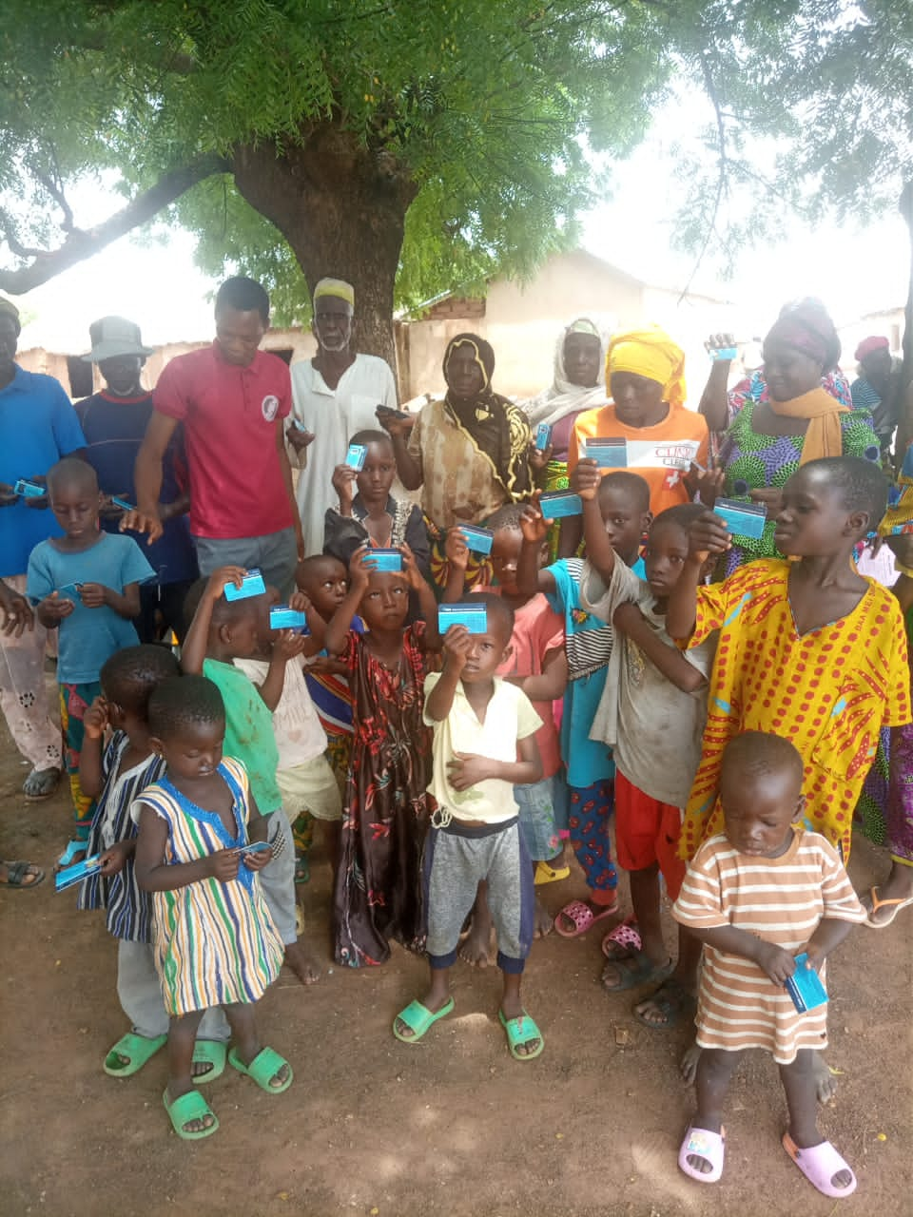
Registered beneficiaries showing their cards in Wuba community
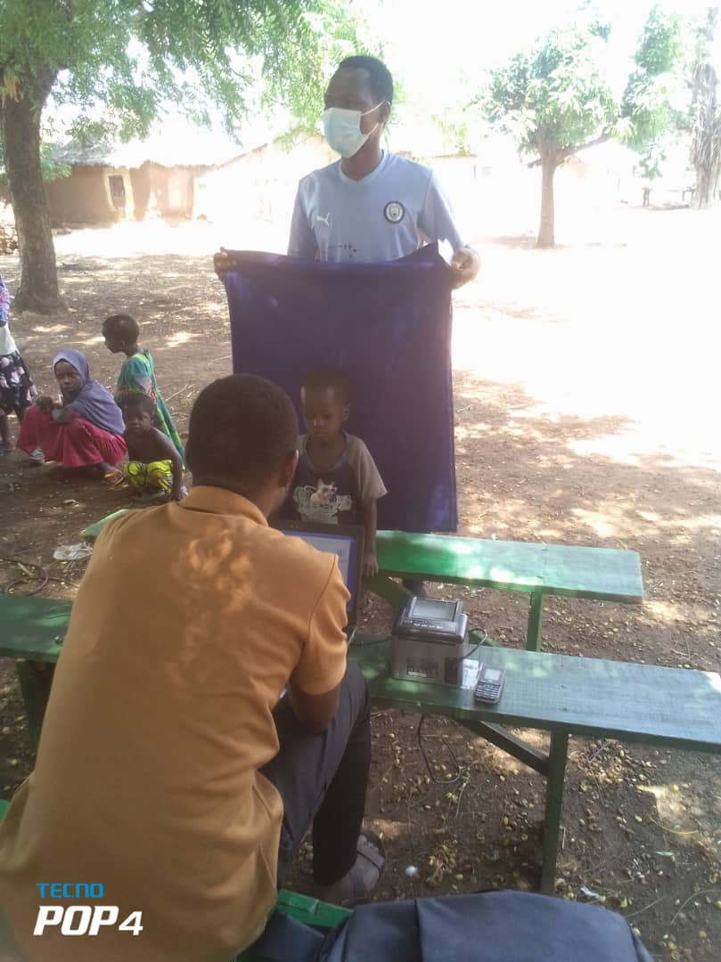
Officers capturing details of student for an NHIS card.
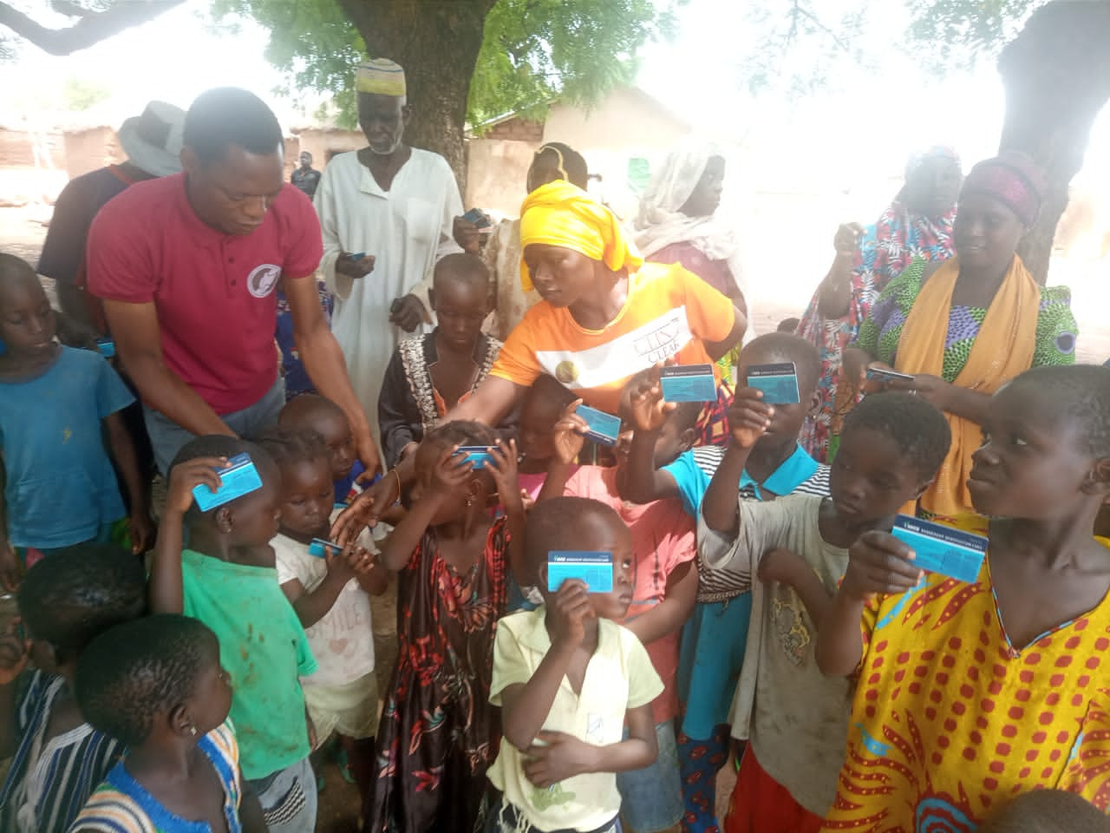
Distribution of cards in Wuba Community.

