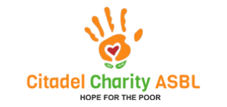
Project  realised | With the donations we receive from members of the association and some small number of persons from the public, we have been able to raise substantial funds to help a few families set up businesses to free them from extreme poverty: small itinerant shops selling vegetables, peanuts, cassava, fresh fish, tie and dye, hair salon, etc. | 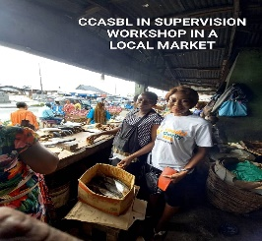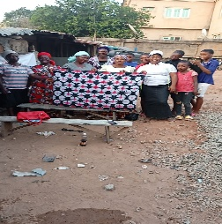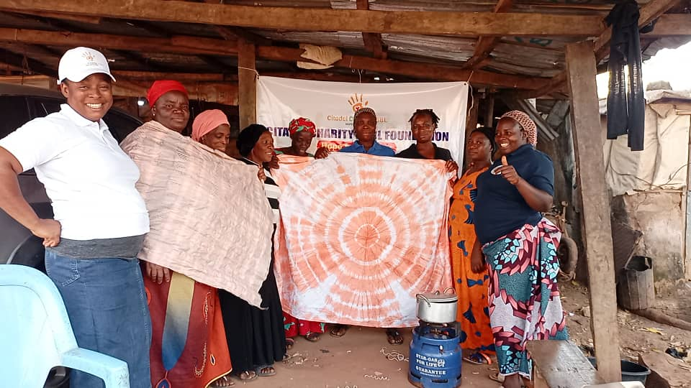
Project  realised | We were also able to send more than 19 children to school by offering them uniforms, shoes, school fees, school supplies... With our small contributions, we have managed to sponsor these children to participate in pedagogy training like, art and crafting activities monthly. | 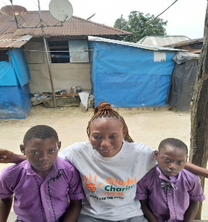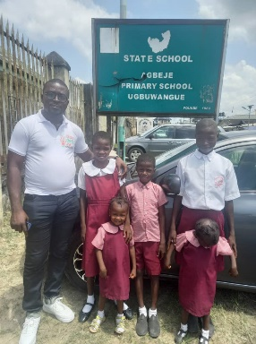
Project In progress | We do organize food palliative for Easter and this coming Christmas. We distributed clothes and money to families of different origins who could not afford a full daily meal. | 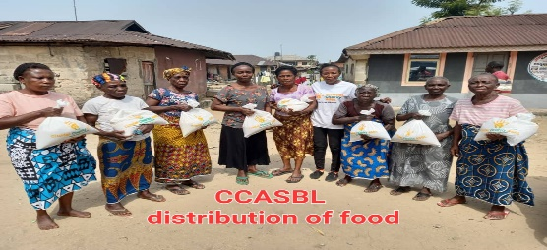
 | We Have the intention to help three single-parent families to secure a home, including two widowed women and their children who are presently living in an uncompleted building, but the finance is not yet available. This project is pending but needs urgent attention as accommodation is very important, especially as children are concerned in this case. | 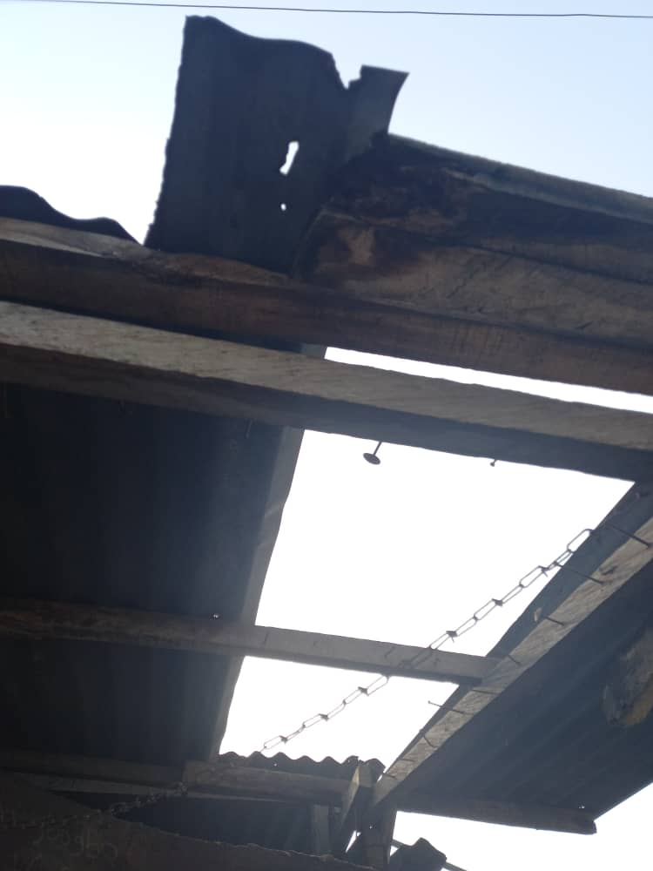

Board of directors Date: 5th day of December 2022 Mrs. Ejiro Oyitaghan

