TEENAGE MOTHERS’ EMPOWERMENT PROJECT REPORT

1.0 Introduction/Background Study
Ajoke Ayisat Afolabi Foundation commenced the Teenage Mothers Empowerment Project in September 2022, as a response to the rising cases of teenage pregnancy at Umuezeagwu, in Abia State, Nigeria. As a much-neglected issue, teenage pregnancy poses a major threat to the lives of young girls in communities and has robbed them of socioeconomic opportunities, such as access to education and healthcare.
Goal
The over-all goal of this project is to strengthen holistic care for At-Risks Teenage Girl (ages 13 to 19) in Umuahia North LGA of Abia State, Nigeria.
In view of the above, the project expectations include:
- Change collective Sexual and Reproductive Health response, in affected communities within the Local Government Area (LGA)
- Influence attitude to eliminate stigmatization and ostracisation of teenage mothers in the LGA
- Strengthen the voice of teenage girls to combat the culture of silence about sexual violence / abuse
- Strengthened SHRH services and accountability systems in the LGA
- Improved skill and knowledge for the empowerment and reintegration of at-risks girls (ages 13 to 19) in the communities
To achieve these objectives, the AAAF is utilizating a combination of qualitative and quantitative methodologies to engage community leaders, teenage mothers, parents, and key stakeholders in government circles using surveys and participatory techniques such as focus group discussions, in-depth interviews and village meetings. This is to generate baseline information and conduct assessment to determine the socioeconomic needs of the teenage mothers.
Programme Duration
The project is ongoing and will last for 36 months; September 2022 to August 2025 .
Stakeholders
The stakeholders in this project include; the teenage girls, AAAF, parents, and the community, as well as government departments and ministries of justice, health, budget, education, information, youth and women affairs at local and state levels.

2.0 PROGRESS REPORT:
The Foundation commenced series of consultations in September 2022 engaging with parents, 10 At-risks Teenage Girls to generate baseline information on rising teenage pregnancy within the communities. See figure 1 below for some affected girls. In addition to deploying questionnaire to generate demographics and socioeconomic information, a Needs Assessment was conducted subsequently to determine the schooling and livelihoods priorities of the girls. Also follow-up was conducted within the last quarter of 2022 to document delivery by four pregnant teenagers.
The next phase of the project, starting first quarter of 2023 is to initiate the process of child support for the just delivered teenage mothers, formalize the screening process for the reintegration of at least four (4) teenage mothers into school system or entrepreneurial / vocational skills training. Similarly, consultation with health and education service providers within the Local Government will commence before end January 2023. Throughout 2023, engagement will be iterative as additional 40 girls will be screened for empowerment.
Figure 1: TMEP Participants

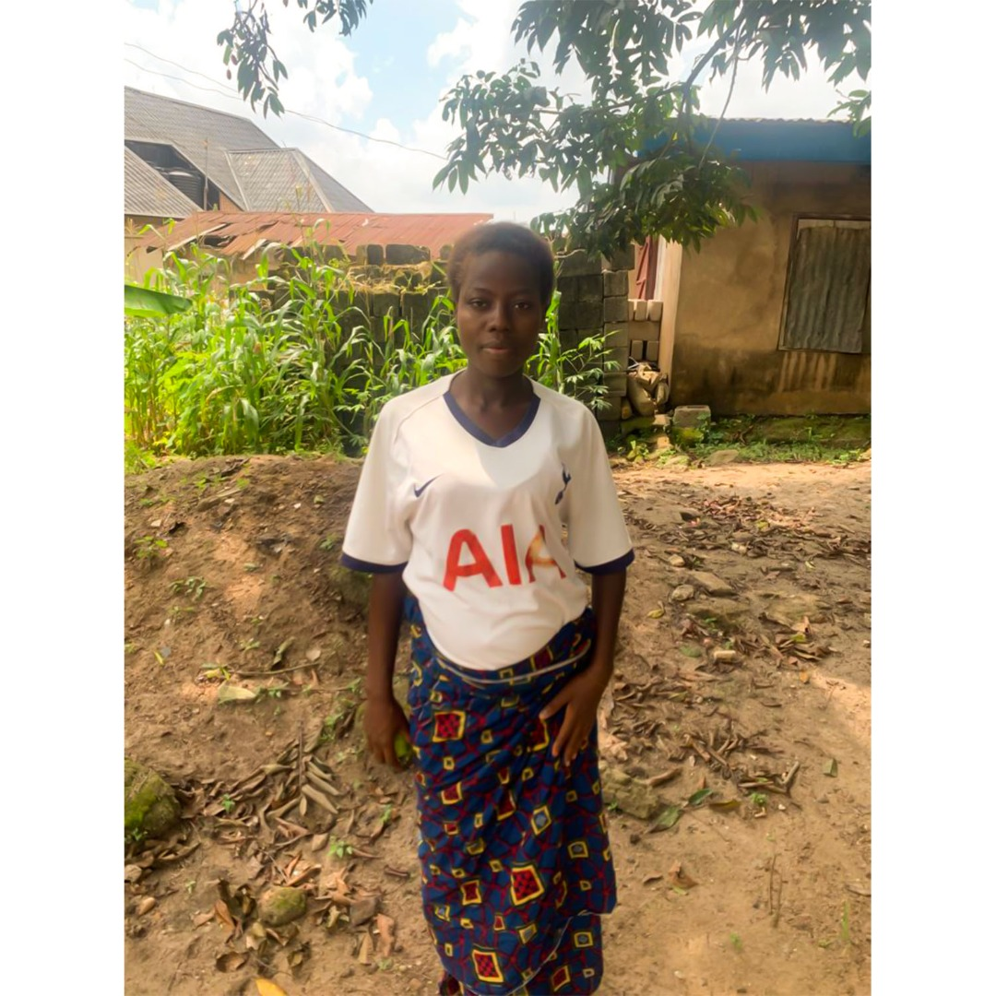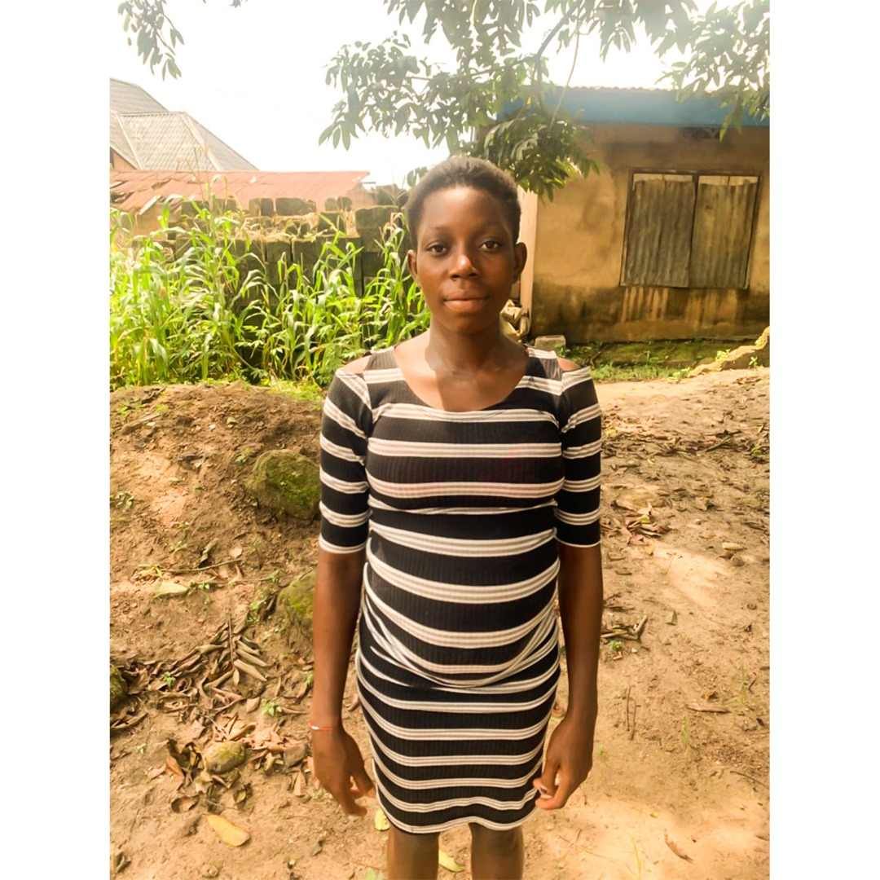

3.0 WAY FORWARD

The next steps of the project will further expand the following processes:

- Stakeholders Engagement to further reinforce advocacy to influence / change practices, laws, policies, behaviour and attitudes inimical to women and girls’ choice over their bodies. This entails improving knowledge on sexual and reproductive health and the rights to justice. This will be followed with meetings with senior level officers in various departments and ministries of Health, Justice, Youth and Women Affairs to set priorities for women and girls in laws, policies, programmes and services as they relate to sexual and reproductive health, education, justice.

- Awareness Campaign on Comprehensive Sexual Education for Secondary school-age girls. This is important because there are emotional, biological and physical implications for pregnancy. Some girls may have attempted abortions in an unsafe manner, while some maybe out of school due to pregnancy
- Link girls to partners providing information and counseling services as well as, HIV / STDs testing, education and management
- Deploy protocols for the prevention, detection and linkages to SGBV / Reproductive Health referrals / services
- Enroll at least four (4) girls in school or entrepreneurial / vocational skills programme latest end January 2023
- Build a network of activist working to stop Teenage pregnancy in Abia state

ANNEXURE 1

Field Report on the First Phase of Empowerment for 9 Girls
Employment Type;
Hair Stylist | 1
Sales girl | 2
Hawking | 2
None/ menial jobs | 4
TOTAL | 9

This showed that out of the 9 girls, one is skilled as a hairstylist, while two are working as sales girls, two girls hawk farm produce, while the other four are into seasonal menial jobs, not gainfully engaged.
Type of Family
Monogamous | 6
Polygamous | -
Single Parent | 3
Total | 9
The above shows that 3 girls come from a single-parent headed household while 6 come from monogamous homes.
Size of Children in the household
1-4 | 2
5-9 | 7
10- above | -
The girls all come from small to medium household sizes, this shows the number of children in each girl’s family and undoubtedly indicates that the girls from large household sizes are more vulnerable in this case.
Future Plans; They also indicated their Future plans;
Wants to continue their education | 1
Want to learn a skill | 4
Already has a skill but needs support to grow | 1
Want to start up a trade/ grow their business | 3

Focus group sessions
With the girls;
The foundation held a focus group session for the teenage mothers and also for their caregivers and parents. The session with the teenage girls was held on the 15th of September 2022, where these girls were able to elaborate their challenges and experiences as teenage mothers.
Findings revealed that the major challenges were
- Difficult adjustment to the new reality that comes from being a pregnant / parent teenager,
- Neglect/abandonment by families,
- Poverty
- Educational setbacks,
- Lack of skill sets.
They highlighted the areas of education, skill acquisition to help reduce idleness and risk of the girls being ensnared with material things. Community acceptance for those who are pregnant is important and should be focused on. According to the girls, there is always stigma that comes with being pregnant out of wedlock and as a teenager.
Number of Kids; The Foundation recorded that out of the 9 girls, 6 have one child, while 3 have 2 children each.
Living Status; On the issue of who they are living with, the Foundation recorded from the report that 4 of the girls live on their own, while the other 5 live with their parents.
With Parents/Caregivers;
The Caregiver/Parent focus group sessions was carried out on 19th October 2022, this was to help the project understand the constraints these caregivers face, the factors that birth the increase of teenage pregnancies and their suggestions and support to a more accommodating society for these girls. The caregivers listed factors that give rise to teenage pregnancy such as; Peer-pressure, Poverty, and Poor Parenting. They also suggested solutions such as; Sex education, Skill Acquisition, Self-leadership, Parent-child relationship, Reduction in childbirth, etc.

Skill Acquisition Enrollment
With the foundation’s intention to help better the lives of these girls, the team engaged the girls on their desired skill acquisitions. The girls indicate interest in skills in the areas of Tailoring, Hairstyling and business, as follows;
Hairstyling | 1
Tailoring | 3
Trade in Plastics and rubber products | 1
Trade in Okirika | 1
Trade in Food Stuffs | 1
Enroll back to school | 1
Where 1 of the teenage girls already has a skill in hair dressing but requires empowerment to grow her skill set. The Foundation intends to enroll these girls by January 2023.
Factors Considered
Certain factors mediated the progress of this stage of the project such as;
- Skill training for all the girls: The team intended to have all the teenagers learn a skill, based on the thought that business would not be sustainable for these girls who may resort to using business for something else.
Suggestion; The team was met with the idea of having them venture into their desired areas of interest, so as not to coarse anyone into what they do not want, thereby resulting to lack of productivity in such areas.
- Enrollment Cost/Transportation; The team also intended to have all the girls interested in tailoring, to learn together at a stipulated center, which would make for easy monitoring, having enquired of centers that charged 45- 75 thousand naira per trainer.
Suggestion; Consideration was made on the issue of daily transportation by the Foundation for the girls for the duration of the skill training which lasts for about a year and decided on an approach to allow them find their desired skill centers for training.one of the girls had indicated that she found a Tailoring Programme, which costs #85,000 for tailoring lessons and was saving up to commence training. While for the One interested in Hair dressing, the team suggested that, the girl who already has the skill in hairdressing should be assessed to determine her skills level and possibly equipped to train the other teenage girl, who in turn will be equipped to commence a hair styling startup.
Other Suggestions;
Community engagements and meetings: in lieu of the project, the intention was to engage the community in advocacy and awareness programs, while skills training is activated for the empowerment of the girls.

