**REPORT ON THE TEENAGE MOTHERS WHO RECEIVED SEWING MACHINES FROM AAAF AFTER THEIR ONE-YEAR APPRENTICESHIP**

**Introduction**

**Purpose of the Report**: To assess if some of the beneficiaries who were trained in fashion, were utilizing the sewing machines effectively for empowerment purposes.

**Background Information:** The apprenticeship lasted for a year. From March 2023 to March, 2024. This was to enable the teenage mother beneficiaries learn sewing skills, pattern drafting, stitching techniques, gain practical experience in handling various fabrics and designs and develop customer service skills relevant to the trade. They were also drilled through technical skills such as basics of sewing and tailoring, business skills such as pricing and negotiation strategies, and marketing and client relationship management. Personal development such as time management and organization and building self-confidence and independence.

**Rationale for Providing Sewing Machines:**

* As an empowerment tool because sewing machine is a critical asset that enables the TMs to immediately apply their skills and start earning an income.
* Sustainability: By owing a machine, they can establish long-term self-employment rather than relying on temporary opportunities.
* Independence: The machine reduces dependency on external resources, allowing them to work from home or set up small workshops.
* Skill Utilization: It ensures that the skills acquired during the apprenticeship do not go to waste due to lack of tools.

**Methodology**

* Visited the beneficiaries’ locations (homes)
* Interacted with them to gather information about the usage of the sewing machines.
* Observed their work environment to verify usage.

**Findings**

I noticed and also observed that two (2) out of the three (3) Teenage Mothers (TMs) are actively using the machines.

Name: Amarachi

Location: Alayi, Bende LGA, Abia State

Amarachi became a TM at 17 and struggled with financial independence. She joined the AAAF sewing apprenticeship program with no prior skills.

Post-Apprenticeship Journey: After receiving her sewing machine, Amarachi Grace set up a small tailoring shop in her mother’s house almost immediately. Currently, she has been able to secure a gradual steady stream of clients for school uniforms, alterations and custom designs. Her income averages #15,000.00 monthly allowing her to support herself and her child. She hopes to expand her services to include renting a shop so as to have enough space to accommodate potential apprentices, increasing her earnings.

Amarachi’s success highlights the program’s potential to empower participants for self-sufficiency and community development.

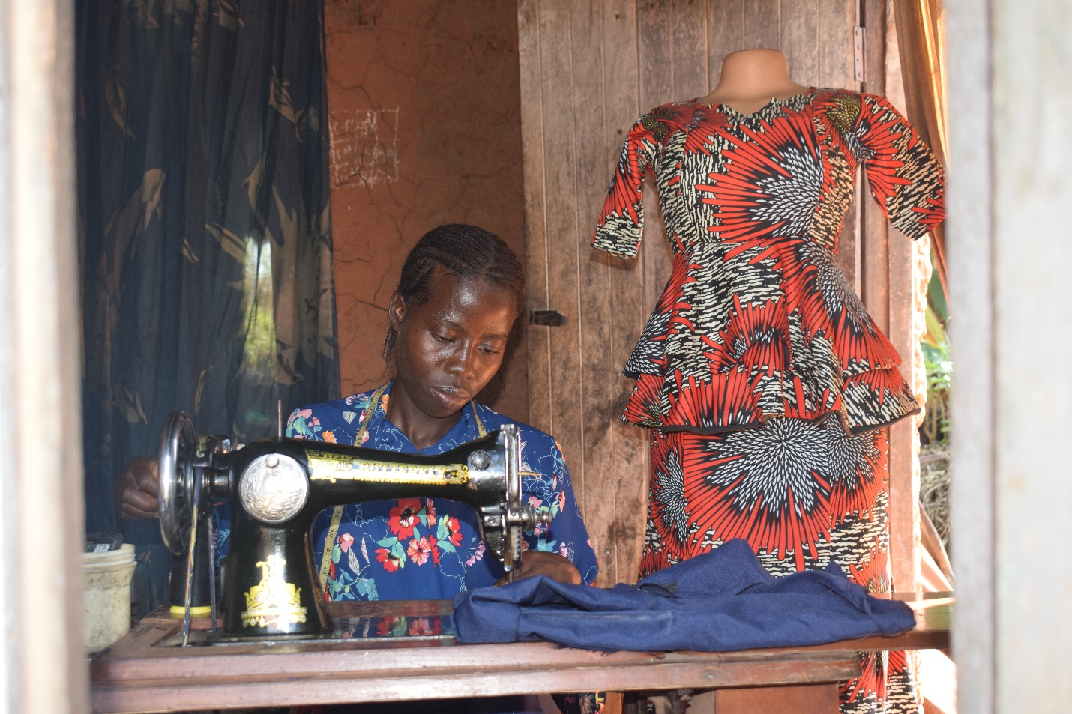**Amarachi focusing on her job**

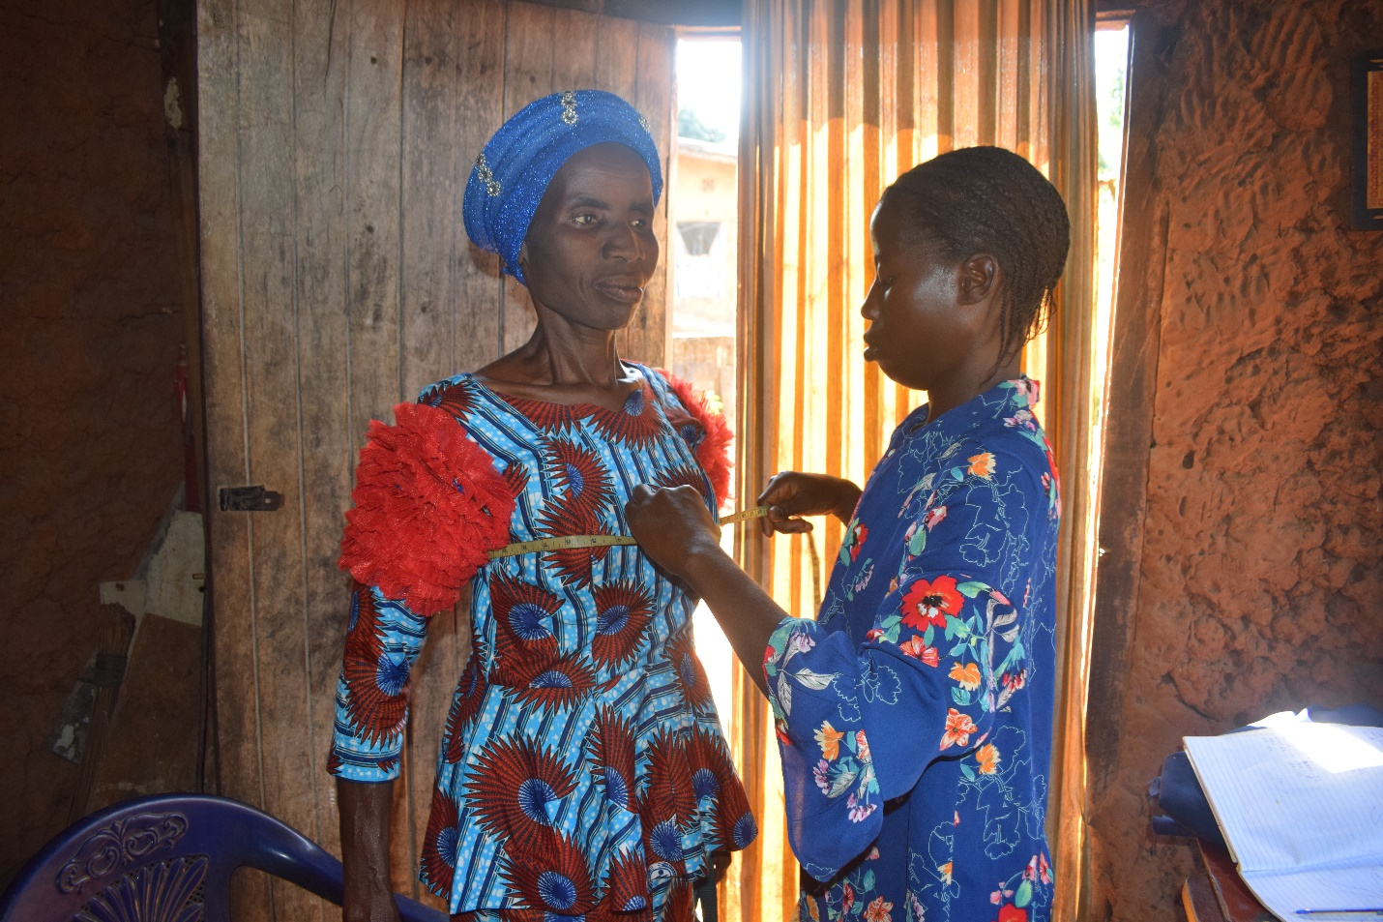**Amarachi taking the measurement of one her clients.**

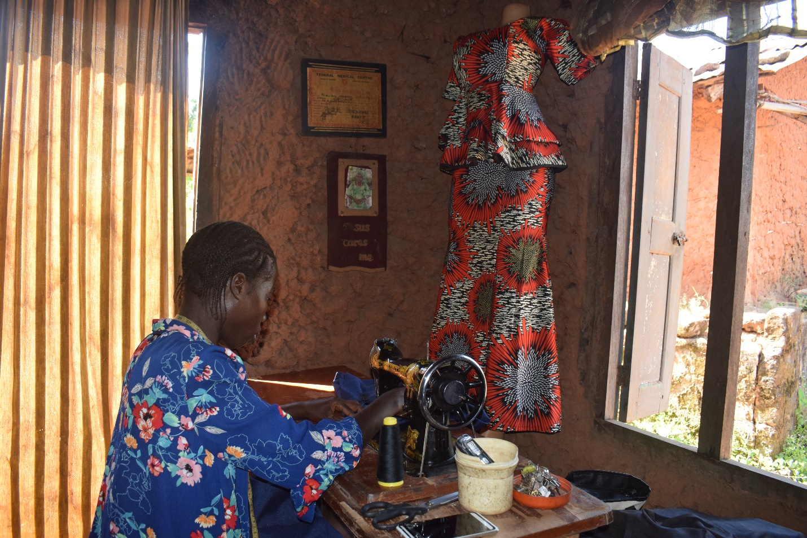

Name: Sopuruchi

Location: Umuezeagwu, Umuahia North LGA.

Sopuruchi earlier had basic sewing skills before joining the AAAF program but lacked confidence and equipment to start her business.

Post-Apprenticeship Journey: After being gifted a sewing machine at the end of the one-year apprenticeship, Sopuruchi has since assumed usage of the machine. She also uses the machine personal sewing, alterations and custom designs. According to Sopuruchi, her income averages #12,000.00 monthly which still allows her to cater for herself and child. She still uses her father’s house as she hopes to expand when things get better for her.

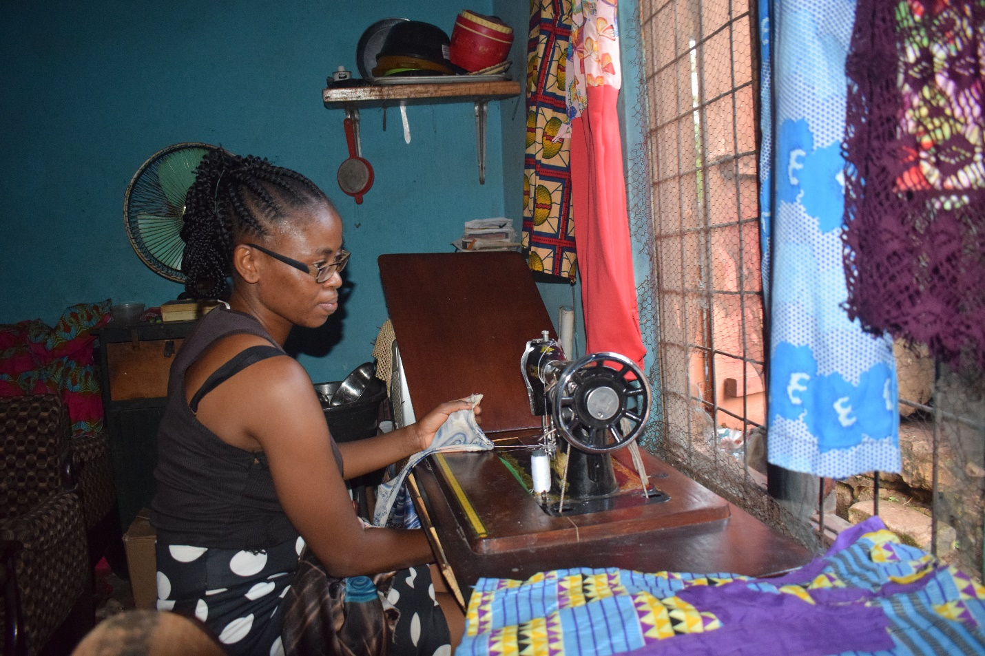**Sopuruchi doing what she enjoys**

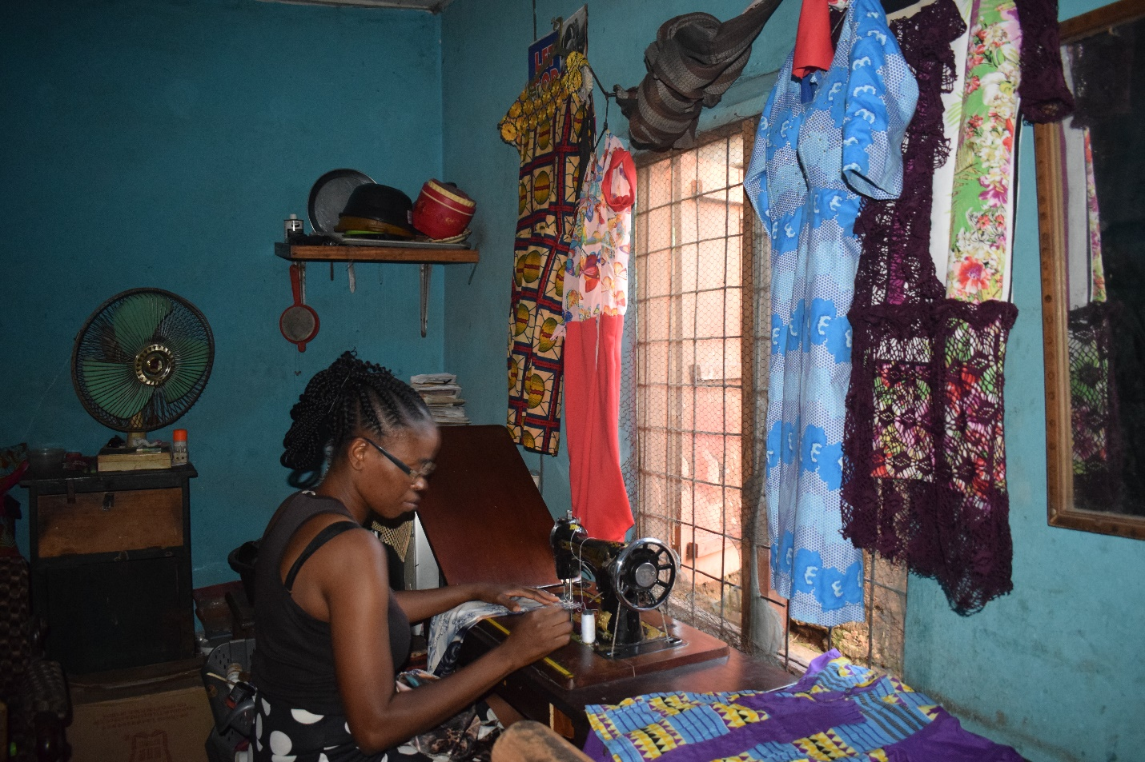

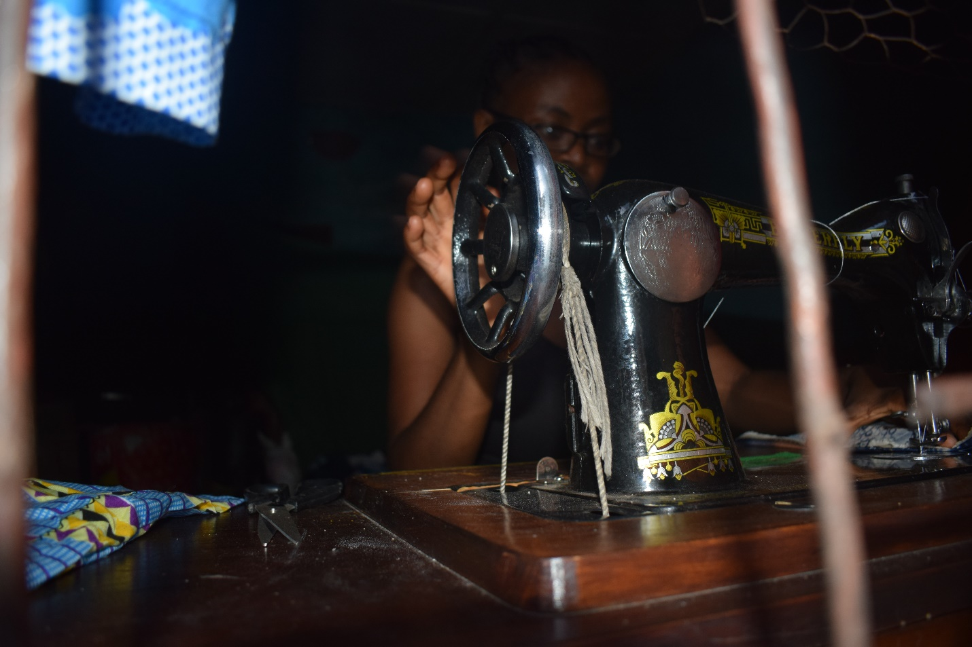

Name: Happiness

Location: Unknown

I learnt during the course of my visitation that she got married and relocated. All efforts to reach was abortive as her mother.

**Analysis**

The skill development component of the Foundation’s mission was largely successful. All participants received sewing machines, ensuring they had the necessary tools for entrepreneurship. The provision of machines was a critical enabler for beneficiaries like Amarachi and Sopuruchi used theirs as startup tools. As the machines were delivered as intended, their impact depends heavily on the readiness and motivation of the beneficiaries. Economic empowerment was achieved.

**Recommendations**

* AAAF to conduct regular visits or calls to assess machine usage, income generation, and challenges.
* Maintain a database of beneficiaries’ progress to identify trends and address challenges early.
* Offer advanced skills workshops in areas like embroidery, fabric printing or digital tailoring to increase competitiveness.