Ajoke Ayishat Afolabi Foundation (AAAF)

Teenage Mothers Empowerment In Abia state of Nigeria

Q4 2023

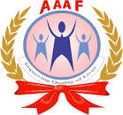

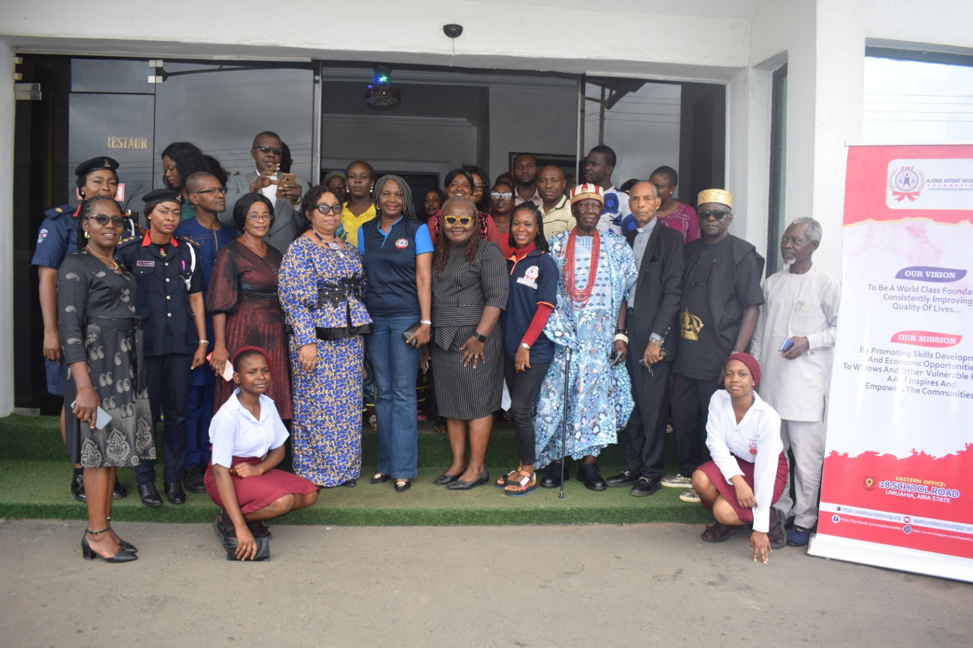
Participants at AAAF’s high level meeting in Umuahia Abia state Nigeria

Background
Nigeria population index reveal that about 44.5 million young women aged between 10-24 years got pregnant in 2016. This figure has increased due to population explosion, and the rising economic hardship. Research on health reveal that this represents the highest death index among teenagers. Unsafe abortion, poor ante-natal care, pregnancy complications, unstable family life, unprepared motherhood are all resultant consequences of teenage pregnancy. Numerous socio-cultural and religious practices, patriarchy contribute to impact how young women are perceived when they get pregnant at an early stage in their lives. Girls who fall pregnant with little or no education face increased levels of poverty and financial dependence.
Trafficking is another major risk factor in teenage pregnancy. Most African cultures are not friendly to pre-marital motherhood, and as such most families do not welcome their unmarried pregnant daughters. Consequently, most of them become homeless, helpless and vulnerable to traffickers, and end up as sex slaves for either baby factories or prostitution. Nigeria serves as a source, transit and destination country for human trafficking, with women and children being primarily targeted for sexual exploitation, forced labour, domestic servitude and child marriage.
Abia state; a state in South-East geo-political zone of Nigeria with an estimated population of over 3,727,347 as of 2016 similarly face challenges related to teenage pregnancy, trafficking, violence against women and girls–Poverty, limited access to education and sex education, and gender inequality which all stand as contributory factor to the prevalence of teenage pregnancy. As a result, there is the need to engage in programmes and activities that aim to address the raised concerns. Though gender based violence persists in Nigeria, more states have been more progressive in tackling this menace than other states. Abia is one of these states with the passage of the Violence Against Persons Prohibition Disability Rights laws. This bold step necessitates the need to strengthen existing leadership institutions and structures within the state towards enhancing the protection and promotion of the rights of women and girls in the state.
Goals of the interventions
- Eradicate or minimize Teenage Pregnancy and Trafficking in Young Girls
- Sensitize and educate the students and other participants on factors responsible for Teenage Pregnancy and Trafficking in Young Girls.
- Build the capacity of the students to know their rights and acquire the skill to protect these rights, prevent any abuse and also take appropriate actions against any violation of these rights.
- Create a platform for interaction between the students and other Stakeholders for collaboration and partnership in order to address causes and also cases of teenage pregnancy and trafficking.
- Stimulate government and community response mechanisms for prompt attention and ownership of initiative.
Objectives of the interventions
- To end or reduce the increasing rate of Teenage Pregnancy and Trafficking in Young Girls.
- To provide knowledge and capacity for the students to make informed decisions over their conducts and sex life.
- To create the platform for collaboration and partnership between the students and their community and government for timely response and ownership.

Report of events
Series of webinars to support staff capacity
Depending on the necessity and activities planned, meetings were undertaken with AAAF staff to support the Teenage Mothers Empowerment interventions in Abia state. One of the first of such meetings was to review existing documents on teenage pregnancy prior to conduction additional advocacy visits and the high level meetings with relevant ministries, departments and agencies.
During the period, the Foundation identified a bright young woman who was a victim of unplanned pregnancy. The girl lacked family support for herself and the new baby. In the course of consultation, the Foundation expressed the commitment to support the young woman and she has since resumed at the Abia office while other additional help for her and her baby’s upkeep is being provided.
Report of Advocacy visits
The organisation commenced advocacy visits from 7th of September, 2023; the AAAF staff embarked on advocacy visits to relevant ministries to gain support for its interventions in the state. Till date, more than 12 agencies have been visited. They include: NAPTIP Ministry for Youth and Sports, Ministry of Justice, Ministry of Education, the office of the Senior Assistant to the governor on vulnerable groups and poverty alleviation, Ministry for health, Nigerian security and civil defence corps, Child Protection Network and FIDA. At NAPTIP, the officer confirmed that it was undertaking sensitization as a means of creating awareness on dangers of trafficking; at the Ministry for Youth and sports, representatives made commitment to support and collaborate with the agency. Other ministries also pledged their support and commitment towards improving the life and well-being of girls in the state. Some of them confirmed that they had partnered with the agency in the past, pledging to support in whatever way required.
Report of high level consultative meeting with relevant stakeholders in Abia state
The Stakeholders’ high level meeting on the Management of Teenage pregnancy in Abia State with Ajoke Ayisat Afolabi Foundation was held on Friday September 29th 2023 at the Harriet Suites located at 1 Macaulay Street, off Bende Road, Umuahia, Abia state. The meeting hosted over 30 Stakeholders from various parastatals in the state such as Ministry of Women Affairs and Poverty Alleviation, Ministry of Education, Ministry of Sports and Youth Development; Civil Society Organizations such as FIDA and Child Protection Network (CPN), Nigeria Security and Civil Defence Corps (NSCDC), Broadcasting Corporation Abia State (BCA), Office of the Special Adviser to the Governor on Vulnerable Groups and Poverty Alleviation, SOARS, Warri. Others include His Royal Majesty Ofondu 11 of Ndume Ibeku Autonomous Community, Umuahia North LGA, Principal, Nchewa Bernard Schools, Umuode Nsulu, Isiala Ngwa LGA, Holy Rosary Secondary School, Umuahia, Umuakwu Community Secondary School, Umunna Comprehensive Secondary School, Isiala Ngwa North, Amazing Grace High School, Umuahia, Idima Abam. Women Farmers leader and AAAF beneficiaries who spoke about the benefits they are reaping from the support provided by AAAF. The highlight of the meeting was commitments made by the relevant agencies present. For instance representative from the Ministry of Education which happens to be a critical stakeholders said the ministry of education is entirely involved and ready to partner with Agencies like the Foundation in the various schools. The representative further confirmed that sex education is included in educational curriculum under subjects such as Physical and Health Education, Social Studies. She pointed out that the present administration, being an education loving Governor, together with the ministry of education is currently running a sensitization programme in different schools both public and private schools on curbing teenage pregnancy. She noted that with what the Foundation is doing, the Ministry of Education will continue to partner with the Foundation. Other agencies also committed to partner with the agency and to pay more attention to the plight of young and vulnerable women in the state. (Detailed report of proceedings has been attached to this report)
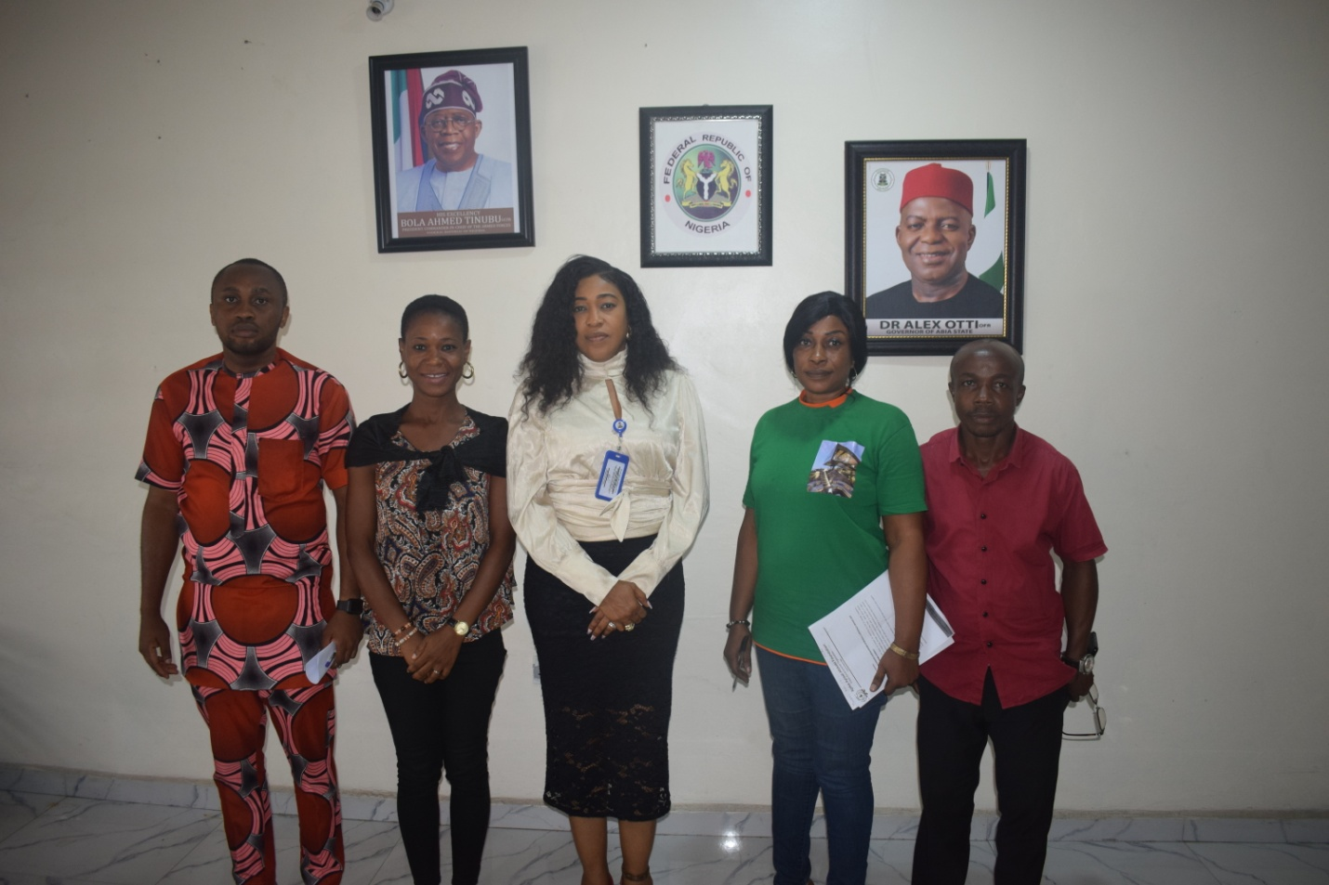
Cross section of AAAF staff and participants at the high level meeting

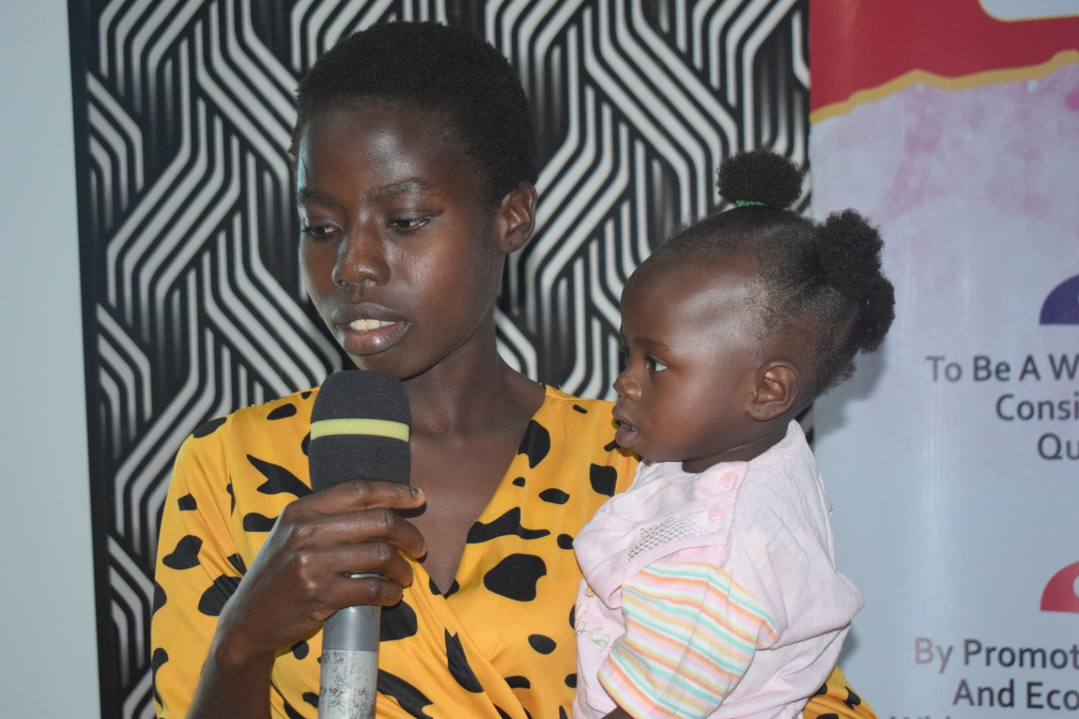
One of AAAF’s beneficiaries speaks at the event
Achievements of the different engagements
- Excellent improvement in the skills of AAAF staff. This was shown by the quality of attendance at the high level meeting hosted by the organization and the presentation made by staff.
- Presence of AAAF Coordinator to provide technical guidance and support was advantageous to facilitation and learning.
- Quality of the participants who attended the high level delegation and their commitment towards partnering with AAAF
- Quality of input made by the participants and the acknowledgement of AAAF earlier work in the state
- Presence of AAAF beneficiaries who spoke passionately increased the commitment of the stakeholders
- Choice of hotels and conducive training environment for participants and meals which energized and satisfied attendees
- Use of real life stories which showed the level of work required to be done in the state
- The advocacy visits led to more awareness of the work and existence of AAAF in the state
- The attendance of traditional rulers and schools is an indication that the message on protection of the girl child will be taken to the communities
- Development of the way forward by participants will lead to sustainability of the projects that benefit girls in the state and draw government attention to their plight.
Recommendations
- There is the need to continue to engage relevant stakeholders considering that there is a new dispensation willing to support development
- There is the need to take the messages to the communities and support teachers and students with knowledge on sexual and reproduction health and rights as a means of ending unplanned and early pregnancy.

