PROGRESS REPORT: TEENAGE MOTHERS EMPOWERMENT PROJECT IN ABIA STATE
1.0 Project Outputs:
Ajoke Ayisat Afolabi Foundation intervention promoting the empowerment of teenage mothers progressed with the enrollment of 5 girls into different programmes; three in a 12-month tailoring training, one at the terminal class of senior secondary school education and another supported with grants for rents as she sets up a new hairdressing salon (please see figure 1 below). One of the girls enrolled for tailoring started in February 2023 and is in two months into dress-making and trained on the rudiments of threading, machine handling and fabrics tacking. She has progressively moved on to making Kaftans. Currently, she is being taught “skirt and blouse” designs, which will take some two to three weeks. The other two girls started late in March and have just progressed into making baby wears and Kaftans. The tailoring training is a step by step program with a focus on specific style design per time. All students of tailoring will specialize on female apparels / designs ranging from skirts, to blouses, free gowns and jumpsuits as well as baby wears.
Figure 1: Girls in hairdressing and tailoring vocation below
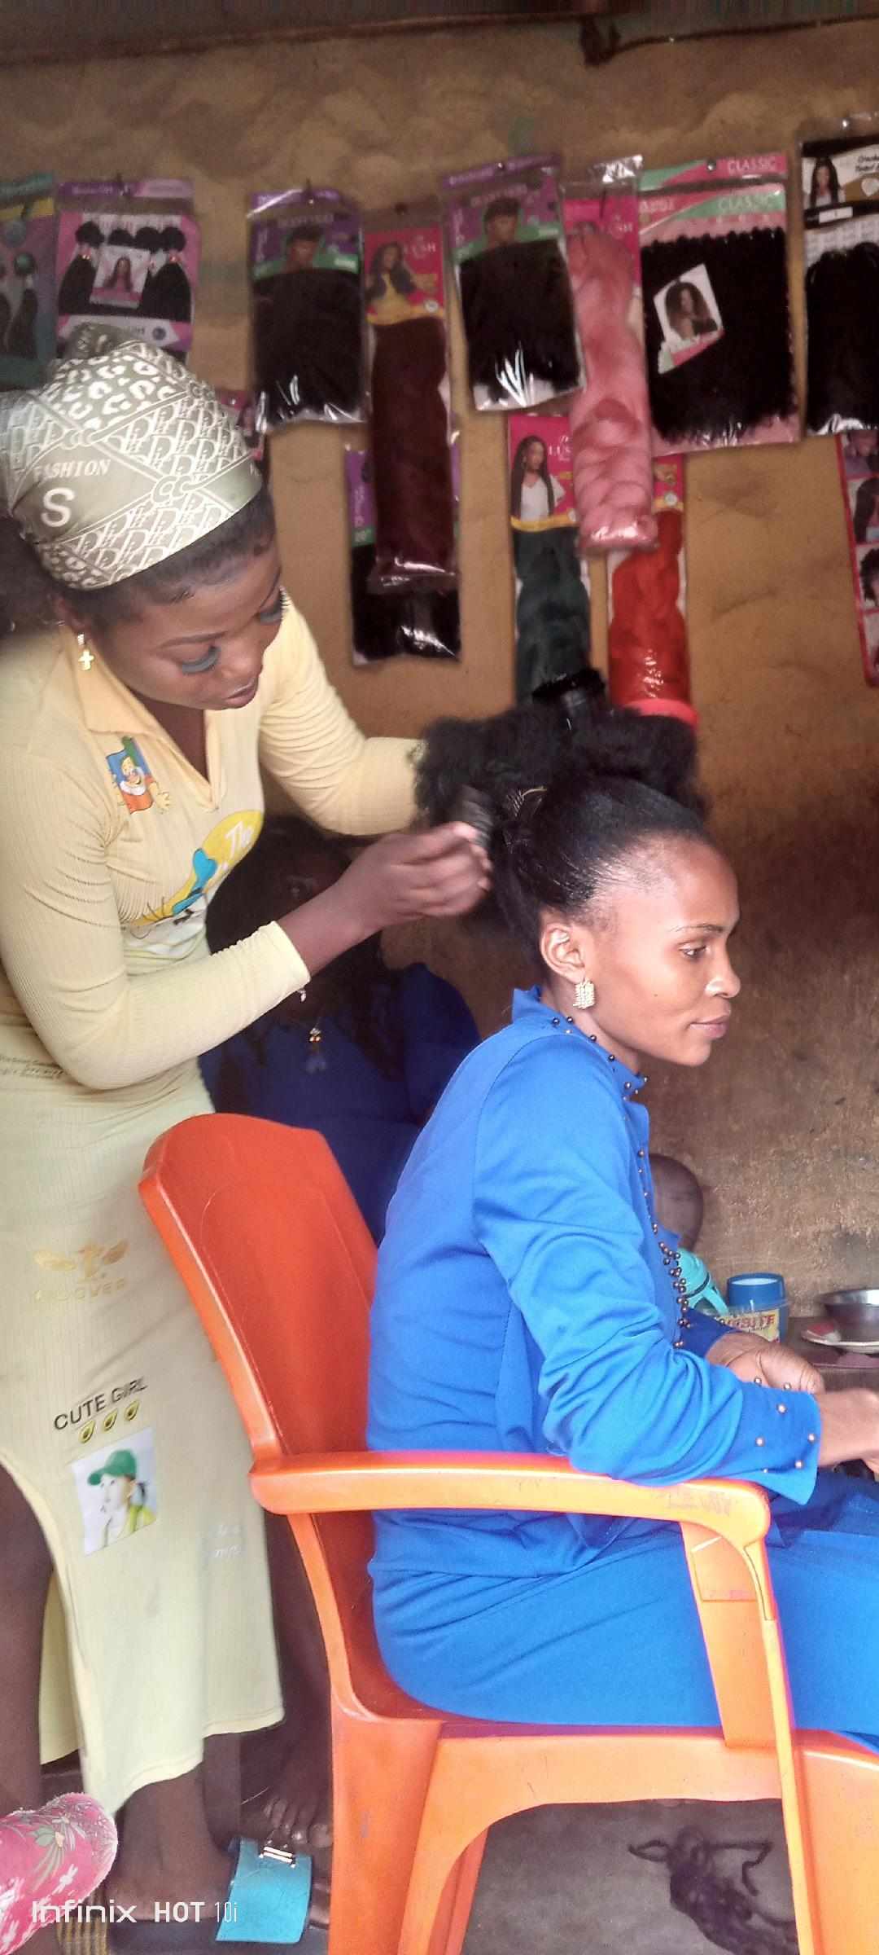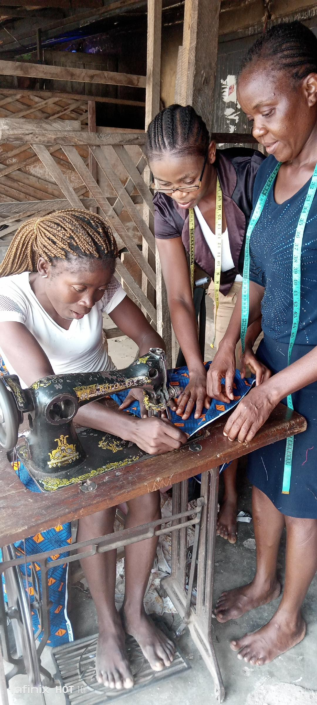
Meanwhile, one of the girls enrolled in school for the West Africa School Certificate Examination (WASCE) resumed classes and will commence writing the examination in May 2023. Also, the hairstylist has moved into a new shop following the resolution of a setback cause by a damage roof prior to moving in. The Foundation supported with 12 months’ rent to enable her work in a conductive and comfortable saloon environment where she could with ease attend to her customers with additional space for apprenticeship. The Salon specializes in various kinds of hair ranging from “Ghana weaving”, “braiding”, fixing, and, pedicure and manicure.

Incidentally, the support for the girls’ education and livelihoods is observed to impact positively in social interactions between the girls and other family members. They are now able to leave their babies in the care of their mothers, while they pursue economic opportunities.
2.0 Next Steps:
Meanwhile, efforts are underway to further engage key stakeholders on existing Sexual Health and Reproductive Rights behaviour and practices promoting unwanted or unplanned pregnancy, particularly, of under-aged girls. Furthermore, the foundation is at the phase of identifying and enrolling a second cohort of teenage mothers for the empowerment programme.

