TEENAGE MOTHERS’ EMPOWERMENT PROJECT…APRIL REPORT

1.0 Monitoring visit to the Teenage Mothers:
The Foundation embarked on series of field visits to monitor the empowered teenage mothers at their respective places of engagement in order to measure their level of commitment and progress, as well as, receive feedback on training. The field team received very positive feedback on trainees’ participation and attitude to work as well as the Foundation’s commitment from the trainer. Please see pictures enclosed: Two girls graduating from their tailoring vocational skills training shall be presented starter-packs in the month of April

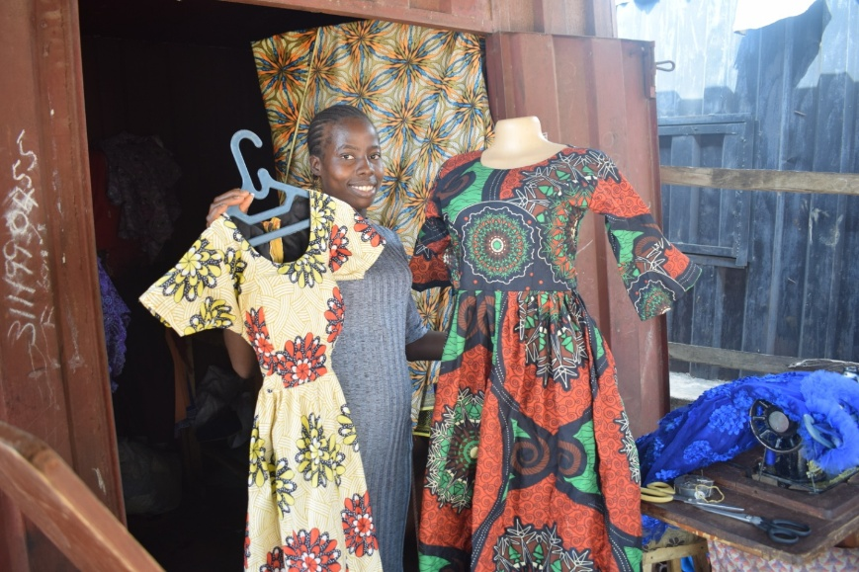
Figure1 A teen mum exhibits her products

Figure 2: Another Teen Mum models her dress
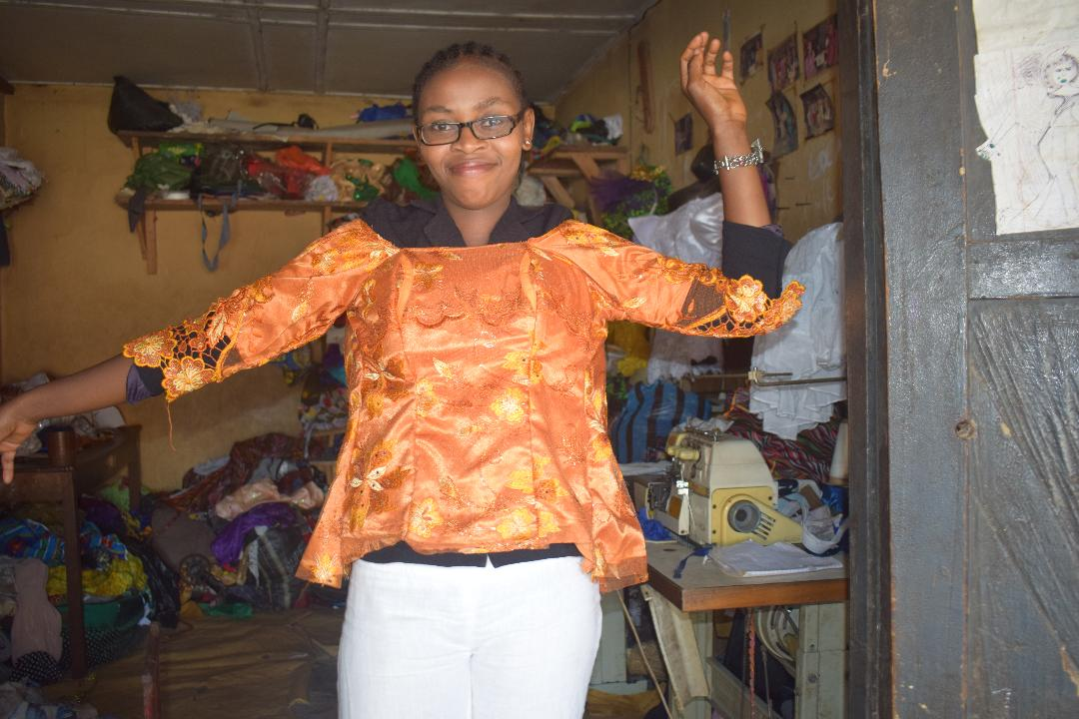

Figure 3: …Demonstrating expertise in baby’s dress
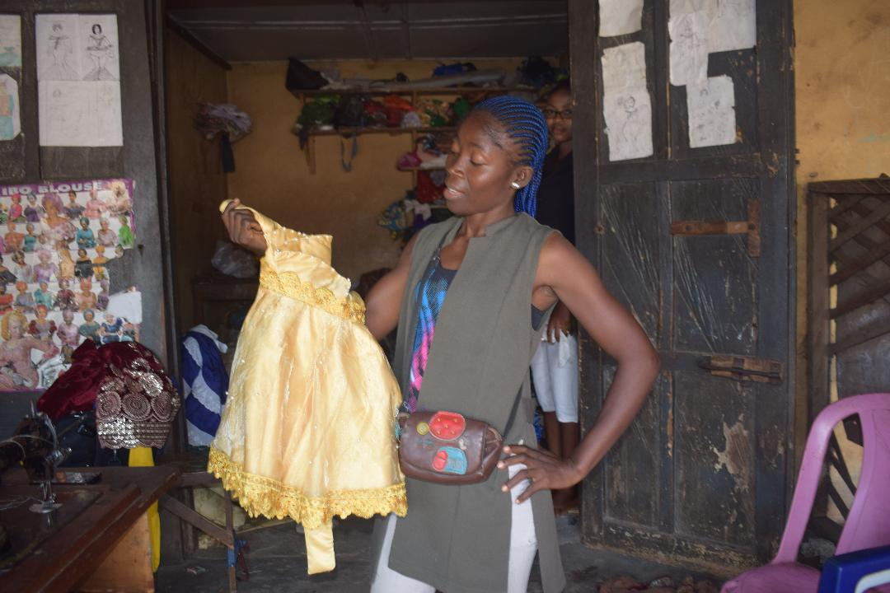

2.0 Survey:
To address pervasive and underreported community level early and repeat pregnancies in Abia state, the Foundation commenced a study to gather data from Schools, Primary Health Care Centers, and the Divisional Police Offices on the Causes, Effects and Solution to Teenage Pregnancy in the state. This is an ongoing study, which findings will be used to address girl-specific barriers and promote girl-child equal enjoyment of right to education.

