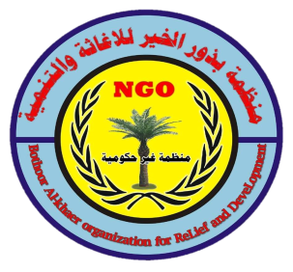

Plant 40,000 Trees In iraq
Trees for children: a prestigious project by Bothoor Al-Khair Organization for Relief and Development for primary school students in rural areas in Diyala, Mosul, Muqdadiya and Baquba: This proposed project builds on the amazing success of planting fruitful trees for the Bouthor Al-Khair organization with the Iraqi students around them. Rural Primary Schools, and its program that engages Iraqi students in conversations about planting fruit trees, Iraq, and measures to support tree planting with families in need. This new initiative with young Iraqi students recognizes the enduring promise of children for our future, and the fundamental good of planting trees for human life. The project is inspired by the memory of Mary's love. This reminds us of his short life fighting cancer and his love of the outdoors. Project description: As part of BAORD's Million Trees campaign, this project seeks US$66,000 to support planting fruit trees with rural school children in Iraq. It is noteworthy that 10,000 fruit trees will be planted in the areas surrounding school buildings, that do not require the use of pesticides, and include almonds, cherries, figs and walnuts in the governorates of Adyali and Mosul, and olive trees in Diyala governorate. Ninety-six schools are participating in this project, and each school will receive approximately 151 trees. The BAORD Project Director and the organization's six Community Facilitators will manage this project and work with teachers, community members, local education delegates, and community council members to coordinate tree planting with student participation and discuss social and environmental benefits with students. Planting trees. Labor for planting trees is provided by local communities. In conjunction with these activities in Iraq, this project also facilitates with Arafa Elementary School students in tree planting activities in the metropolitan area, fundraising activities to plant sister trees in Iraq, conversations about Iraqi geography and culture, volunteering and environmental awareness. BAORD Board Member, Dr. Majid Khalil, Maryam's father, will volunteer together to organize these activities, including an event that raises funds to plant trees in Iraq. The project programs are designed for students in grades one through six, and are planned and implemented in partnership with all community, civic and governmental stakeholders. To contribute to Trees for Kids: Mariam Initiative, you can make a secure contribution online or send a check to the address above. Let's make this happen together. BAORD Mission: Bothor Al Khair Relief and Development works to create development projects in different parts of Iraq designed and managed by local communities, in partnership with governmental and non-governmental agencies. BAORD uses a participatory development approach that includes beneficiaries as active partners in every step of the development process - from prioritizing development goals to project implementation and management to monitoring and evaluation. Key to this approach is to facilitate community planning meetings where beneficiaries together identify the projects they want to implement and create action plans.

