Our Ref: FCDA/BD/A/003/05/23

AGRIBUSINESS ACTIVITY REPORT-JANUARY- MAY 2023, BERTOUA, CAMEROON
The second year of our agribusiness had as focus to raise 10,000 USD for the cultivation and processing of cassava to garri at our 3,750 sq meters of land located at the Koume Goffi neighbour in Bertoua, East Region of Cameroon.
The project is geared towards experimenting the potentials which lies to capacitate the Internally Displaced Persons through generating livelihoods, income, food security, employment from agriculture and technology.
This is a one-year project which commenced in October 2022 and will end in September 2023.
Please find below detailed cashflow of our activities.

Financial Report- Second Experimental Project

We successfully ploughed back 34,000frs from the profit, added to the 100,000frs from a partner, totaling 134,000frs to engage in the second season of cultivation.
The team projected to plant cassava and yam on the 7,500Sq Meters of Gifted Land, amidst the drastic climate situation and poor planning for season, only cassava was planted on 3,750Sq of land where the potatoes had just been harvested, making it fertile for cassava production.
Our outstanding cash at hand as at 1st January 2023 was 34,000frs an equivalent to 75 USD. In addition to cash contributions of 100 USD made by the two co-founders; Etienne Ayuk and Afungchui Jan, making a total of 175 USD. This money was used in maintenance of the farm as rain started much earlier amid the climate effects. Cutting and clearing of unwanted species, purchase of insecticides and maintaining security at the farm were our priorities.
As at date, we have also raised 186 USD through the GlobalGiving Foundation donations platform. We’d hope to participate in the little-by-little campaign to raise more funds through small unique and new donors. However, this was not done as we had encountered difficulties with our two laptops damaged by intermittent electricity supply in the area.
We are planning to participate in the July bonus program and our team of 3 volunteers are being schooled on the type of project we shall be undertaking. We are aiming to introduce two new projects for this campaign which are;
Support of digital materials for far to reach nursery and primary schools which were being affectd by the ongoing crisis in the North west and south west regions of the country which has hindered school activities for almost 5 years and children are timidly getting back to school and they need digital materials to enable them compete with peers following the fast pace in technological trend.
We shall also be working on the development of a mobile and we applications to connect farmers to the markets, storage facilities, transport services, finance, markets, policies development and access to other farming and digital tools. Our team will be conducting needs assessment in the next half of this present month by identifying key stakeholders, engage in focus group discussions with farmers, administer surveys and assess tools used by farmers so as to leverage on programs that can be beneficial to the stakeholders aimed at boosting production and sustaining income to the individuals, groups, households and other agencies.
We shall commence harvesting of the cassava in September 2023 and this will be sold in the local markets instead of transforming into garri amidst lack of finance to acquire machines for processing. We had hoped to raise more funding but to no avail.
In the next quarter, we shall also be attracting 10 volunteers and 2 board members and they will be encouraged to acquire skills through the online courses available in the GlobalGiving platform notably; fundraising, technology and social media skills.
We envisage scaling up our activities by attracting local donors, international donors and keep track of all necessary documentations for our activities.
The total cost by the end of the cassava project will be 300 USD and we hope to harvest 2 tons of cassava which shall be sold at 600 USD with a profit margin of 50%.
From our analysis, we are going to use 188 dedicated hours to attract 300 USD in profit. This amount can be tripled should we have the necessary support from GlobalGiving Foundation Community and dedication of the team.
We shall continue attracting donors into our GlobalGiving Foundation platform. We want to end this year by December 2023 with atleast 25 new permanent donors.

Challenges
- Low donor rate
- Lack of basic tools such as matchets and machine for transformation
- Climate action
- Inadequate capital
- Difficulties recruiting and retaining volunteers
Recommendation
- Provide a means of transportation for workers and goods
- Increase farm land so as to double production
- Recruit 10 IDPs
- Source for more local and international partnerships
- Need to raise 10,000 USD by June 2023 through other sources to increase production and diversify
- Undertake new projects in agriculture, technology and education
- Diversify farming activities by engaging in piggery and plantains cultivation

Name: Etienne Ayuk Ayuk Ndip
Location: Bertoua, Cameroon
Date: 6-6-2023
Signature:

GALLERY

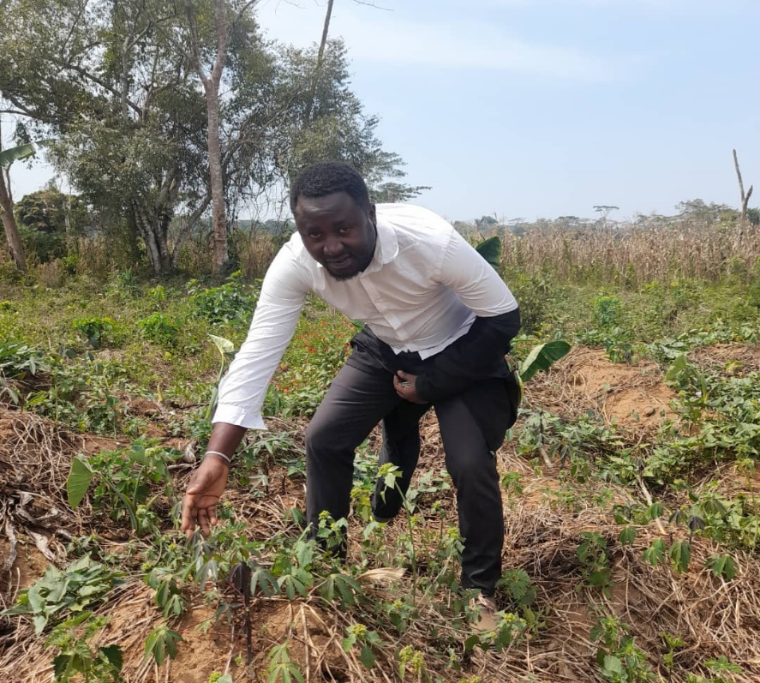
Visit by Project Leader in preparation of Maintenance of Cassava Farm on the 25th March 2023
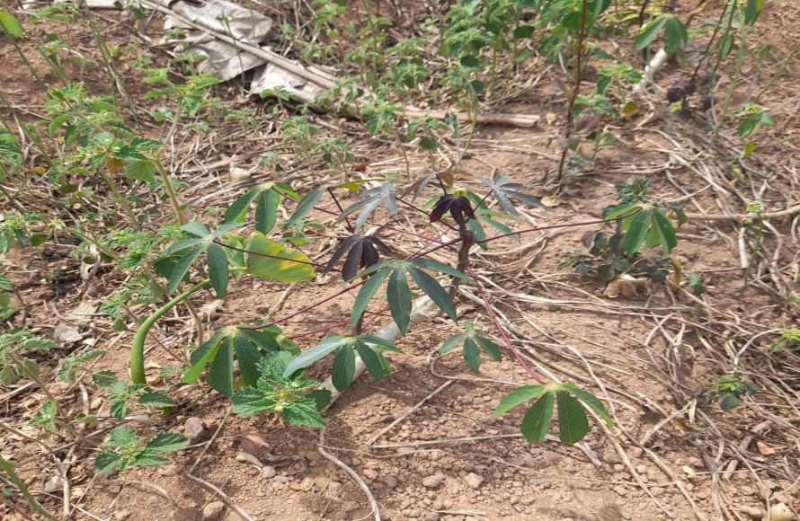

Agri-Business as Income bolster For IDPs Cameroon (56398)

