Our Ref: FCDA/BD/A/001/8/23

AGRIBUSINESS ACTIVITY REPORT-MARCH- DECEMBER 2022, BERTOUA, CAMEROON
The first year of agribusiness experimental phase resulted to a 28% return on investment following the 123,000 frs invested in the project, we recorded 157,000frs in revenue, Gross profit of 34,000frs with source from personal savings of the Founder.
The project was geared towards experimenting the potentials which lies to capacitate the Internally Displaced Persons through generating livelihoods, income, food security, employment from agriculture and technology.
This was a 10 months project which began in March 2022 and ended in December 2022, with a dedicated 159 hours.
In September 2022, Jan Afungchui joined and supported the project idea and initiative partnering with the sum of 100,000frs, also accompanied by eagerness for expansion to Livestock, planting of cassava, support and trainings, documentations and integrated following up with the value chain in Agriculture through learnings and practicality for Moral Leadership and thereby making the World a better place.
Please find attached table for expenditures report for after first phase of experimenting

Financial Report- First Experimental Project

We successfully ploughed back 34,000frs from the profit, added to the 100,000frs from a partner, totaling 134,000frs to engage in the second season of cultivation.
The team decided to plant cassava and yam on the 7,500Sq Metres of Gifted Land, amidst the drastic climate situation and poor planning for season, only cassava was planted on 3,750Sq of land where the potatoes had just been harvested, making it fertile for cassava production.
From September 2022 till 31st December 2022, 96,000frs have been used for production of the latter with a balance of 38,000frs cash at at date.
Please find attached details of expenditure report

We also engaged into digital fundraising for the project through GlobalGiving Foundation platform and raised 111 USD which is yet to be dished out to FCDA following recommendations to reach a certain quota before depositing into the account of FCDA. We look forward to intensify our campaigns through inviting volunteer, other members, encourage atleast 100 IDPs to join and benefit from the projects while also working with other organizations for shared opportunities, learning and sustainable partnerships.
Our goal is to harvest the cassava in July, transform into grains (garri), packaged and to be sold in the local markets. We envisage generating 800 KGs of yellow and white garri. These will be sold at 25,000frs per 100KG. We hope to have 200,000frs as revenue and further expenditures till goods reach the clients is estimated at 45,000frs. Thus, total expenditure of 141,000frs and net profit of 59,000frs by the one-year period in September 2023.
The team is poised to undertake piggery activities and they are set to raise funds and invite other members so as to step up production, generate income and stay in the business.
The next virtual meeting for partners will be on Friday the 6th of January 2023 for one hour.
Partners will discuss on project expansion, outlook and resources needs.

Challenges
Poor transport system. Farm to market roads is deplorable. This makes cost soar and thus preventing farmers to sell at fair price
- Fluctuation in prices
- Lack of storage facilities
- Climate action
- Limited tools
- Inadequate capital
- Covid 19 Pandemic
- Growing insecurity
Recommendation
- Partners should extend project to call for funds
- Build a storage facility
- Provide a means of transportation
- Increase farm land
- Recruit 100 IDPs
- Source for more local and international partnerships
- Need to raise 2,000,000frs by June 2023 through other sources to increase production and diversify
- Undertake Piggery Farming

Name: Etienne Ayuk Ayuk Ndip
Location: Bertoua, Cameroon
Date: 6-1-2023
Signature:

GALLERY

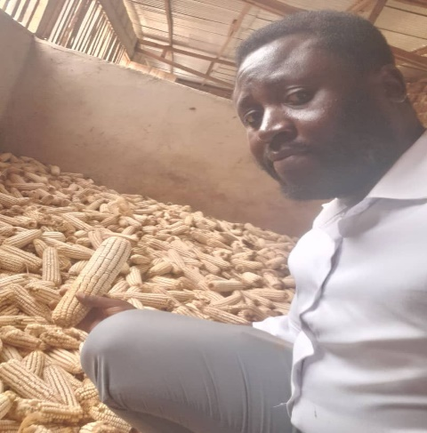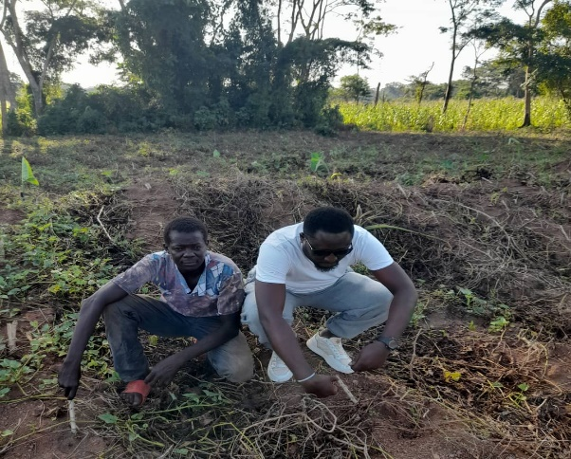
Maize harvested at storage room Farm Coordinator post with Founder Etienne on Cassava Farm

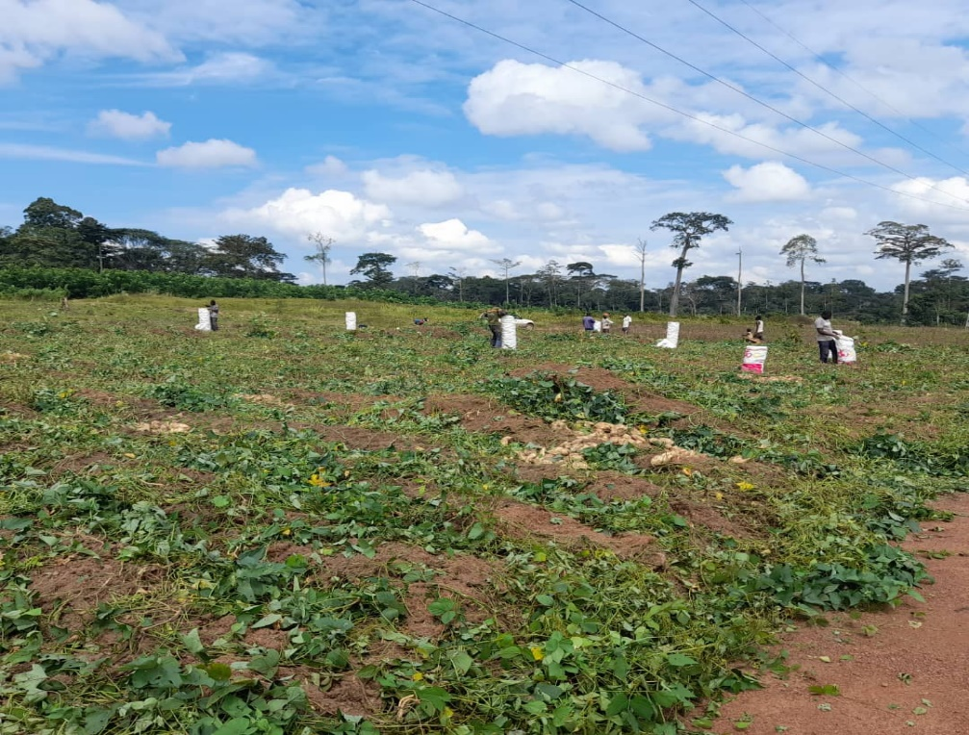
Harvesting of Sweet Potatoes 3/9/2022

Agri-Business as Income bolster For IDPs Cameroon (56398)

