|  |  |
| --- | --- |
| Organization Name | Alawite Islamic Charity Association |
| Project | [Ladies .. It's Your Right to Know Your Rights!](https://www.globalgiving.org/56291) |
| Contact person  *Name, email, and phone* | Nizar Elcheikh  Phone Number: +96170694599  Email: protection@aica-lb.org |
| Reporting period  *From – To* | 13th of October 2022 to 31st December 2022 |
| Submission date | 31 December 2022 |

# Context

# Due to the numerous legal issues, unregistered pregnancies, incidences of violence against women, and crimes because youth people are drawn into dark and dangerous paths.

# Since AICA provides service protection and has a specialized department, it decided to implement the project "[Ladies .. It's Your Right to Know Your Rights!](https://www.globalgiving.org/56291),” with 4 lawyers where it provides legal advice and follow up cases for the vulnerable people and women, especially those who were exposed to violence. The number of consultations reached: 21 legal-civil cases (11 Syrians - 2 No Nationality - 8 Lebanese), and follow-up of 3 cases before the suitable courts between (misdemeanors - felonies).

# Activities implementation

* Activity 1: registration of cases: AICA has continued publishing poster[1] about the new legal service on social media , where the beneficiary registered through the hotline, front desk in AICA centers. AICA also participated in the protection sector meeting and the service was circulated to all partners through email in order to receive referrals.
* Activity 2: Counselling: AICA provided 34 counselling for 34 beneficiaries (6 Syrians - 7 No Nationality - 21 Lebanese), From the Tripoli area, where there were 13 women and 21 men, their cases revolved around legal issues (alimony - nationality) and civil problems between the renter and the home owner and criminal cases issued against judgments.
* Activity 3: Assistance on other issues There was guidance and advice from lawyers, how to follow up cases in the courts in the absence of a law firm, and how to act when there is a court ruling.

Lawyers also coordinated with the Protection Department to provide individuals with other services.

* Activity 4: Follow up The lawyers followed up on 3 case files whose rulings differ between criminal, misdemeanor and personal status. The file was studied and followed up with the investigating judge until the verdict is issued in each case, and one case was closed.

Action plan:

|  |  |  |  |  |
| --- | --- | --- | --- | --- |
| Activities | Description of the activity | Modality (value, frequency…) | Location of activities | Number of individuals and number of households (if HH is relevant) |
| Activity 1: Registration of cases | Targeting people from Tripoli, Jabal Mohsen, Tabbaneh, Kobbeh, Mankoubin Displaced Syrians, Vulnerable Lebanese | All the day ( hotline ) from 8:00 am to 5:00 pm | Tripoli | Interview with each one Displaced Syrians 60  Lebanese 120 |
| Activity 2: Counselling: | raising awareness to help woman and children understand their rights as well as provide support and follow up on different topics and problems from marriage to divorce to registration forms & identification papers leading to advocating their basic rights and standings by their side against injustice. | Every Friday from 11:30 AM to 3 PM | Tripoli | Displaced Syrians 60  Lebanese 120 |
| Activity 3: Assistance on other issues | Referral and coordinate with the protection unit to the beneficiary get other service as per need and advice to how get the paper and follow with the court | Every Friday from 11:30 AM to 3 PM | Tripoli | Displaced Syrians 60  Lebanese 120 |
| Activity 4: Follow up cases | Follow-up cases in civil and criminal courts | One per month | Tripoli | 3 cases |

## Challenges

*Overview of any challenges encountered during the reporting period and how they were tackled*

|  |  |
| --- | --- |
| Challenge(s) | Response(s) |
| Judges yearly holiday | Communication with the judges directly and explain the situation to them to move quickly |
| closing the courts due to political issues in Lebanon | Communication with the judge directly and explain the situation to them to move quickly |
| Closure of official institutions due to political issues in Lebanon | Communication with the judges directly and explain the situation to them to act quickly |
| Agency fees and costs | Referral for legal aid |

## Monitoring

*The number achievement during the reporting period is the sum all targeted participants that have been reached in previous reporting periods and those that were reached during this report’s reporting period.*

*The progress towards target is a percentage calculated as follows = (Number achieved during the reporting period) ÷ (Overall target) × 100*

|  |  |  |  |
| --- | --- | --- | --- |
| Indicators | Number achieved during the reporting period | Overall target | Progress towards target |
| Legal activity 1:  # number of registration | 63 | 180 | 35% |
| Legal activity 2:  # individuals (without duplication) who benefited from legal consulting *If possible, also include disaggregation between male and female Lebanese & Syrian* | 63 individuals 23 female and 40 male  *46 Lebanese & 9 Syrian* | 120 Lebanese  60 Syrian | 38 % for Lebanese  15 % Syrian |
| Legal activity 3:  # individuals who benefited from assistant issue *If possible, also include disaggregation between male and female.* | N/A | N/A | N/A |
| Legal activity 4:  # individuals who benefited from Handling issues *If possible, also include disaggregation between male and female.* | 9 case | 4 | 225% |

|  |  |  |  |
| --- | --- | --- | --- |
| Monitoring tools used (satisfaction surveys, discussions with beneficiaries…) | Sample size | Primary findings from these tools | Actions taken/to be taken in response to these findings |
| Complaints Box |  | is empty |  |
| Hot line | *+961 6 391236* | We didn’t receive any complain |  |
| Individual interviews. | 11 | All the beneficiary are satisfied about the service . |  |

## Coordination and communication

*Please list any coordination meetings or communication with national response actors (Government of Lebanon, municipalities, local community, FGOs, INGOs…)*

|  |  |  |
| --- | --- | --- |
| Date [dd/mm/yyyy] | Response actor | Type of coordination [meeting, email, phone call][2] and purpose |
|  |  |  |
|  |  |  |

# Budget

# Annexes

## Annex I: Pictures, videos

## Annex II: Success Story

## Annex III: Other supporting documents

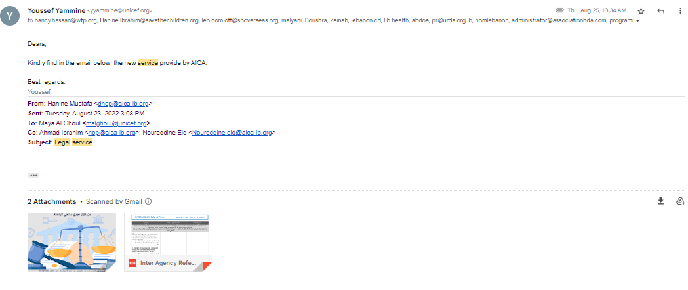

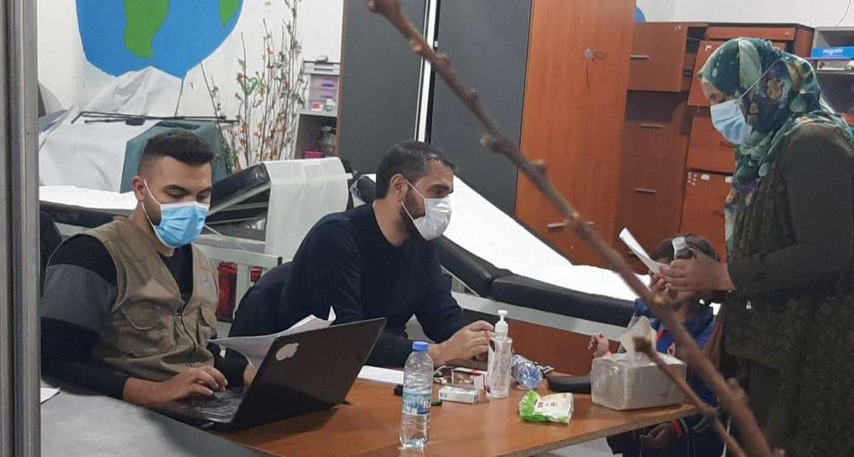

1. <https://www.facebook.com/aica.lb/photos/a.1439278072980716/3084652291776611/>
2.