www.rotaryhealthprofessionals.org

Dr Ravi Vibhuti
Treasurer IRFHP
RCGP & British Medical Association Fellow
Past Chair Rotary International District 1120
Rotary International Lead RC Kings Hill Kent-GB

Butterfly Palliative Home
Tarryn Bell
Managing Director/Co-founder
Butterfly Children’s Palliative Care

Butterfly Palliative Home is a foster care home in rural Kwazulu-Natal, south Africa, where we provide end-of-life care to babies and toddlers with severe disabilities and life limiting conditions

Who are we?

- The only facility in KwaZulu-Natal providing full-time palliative care to children.
- All services are free of charge.
- We provide a loving and stable family to children who would otherwise die alone

Why funds needed?

The Home provide continuous, quality year-round care to the orphaned and abandoned children without any funding from the government. Hence, we must rely solely from the funds raised by public donations. The present accommodation that we have is only for six children. But if additional fundings are available, we could extend our services to another six children.

Monthly Budget:
South African Rand Approx. GBP

Staff R 6700.00 £3415.00
Utilities R 8500.00 £435
Premises Lease R 7000.oo £360.00
Transport & Fuel R3500.00 £180
Groceries/Toiletries R 8000.00 £410.00
General upkeep R 2000.00 £101.00
Pharmacy R 1000.00 £51.00
Sundries R 2000.00 £101.00

Total R100,000.00 £5100

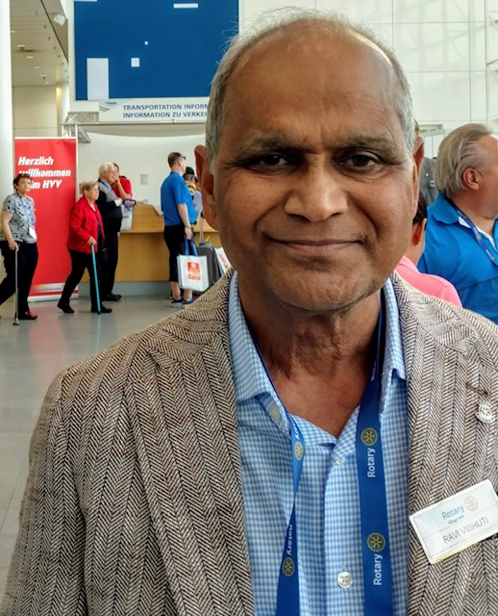

Project Lead: Dr Ravi Vibhuti
Treasurer IRFHP
RCGP & British Medical Association Fellow
Past Chair Rotary International District 1120
Rotary International Lead RC Kings Hill West Malling Kent-GB

Tarry

