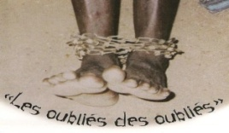
Communiqué juillet 2025
Amis St-Camille

Hello, dear colleagues,
2025 Annual General Meeting
First of all, let me inform you that Les Amis de la St-Camille held their annual general meeting on June 12th, during which changes were made to the board of directors:
-Richard Strezlec, our invaluable treasurer for a dozen years, has resigned. We would like to thank him sincerely for all his hard work over this period.
- Martine Gauthier has accepted the presidency of our NGO, and Jenny Briand will take over as vice-president and treasurer.
- We are also delighted to welcome a new member, Joanie Druyère.
What's more, we still have vacancies and are open to any suggestions.

ACTIVITY FOLLOW-UP
Our major project for this year has been the development of the Gbedavo 1 and Gbedavo 2 farms and this is progressing very well, with remote support from Jean-Paul Cyr. This will remain our flagship project for the coming year.
- The banana plantation is now a significant source of income and will be expanded next year. Market gardening continues to evolve with the seasons, as you can see in the photos.
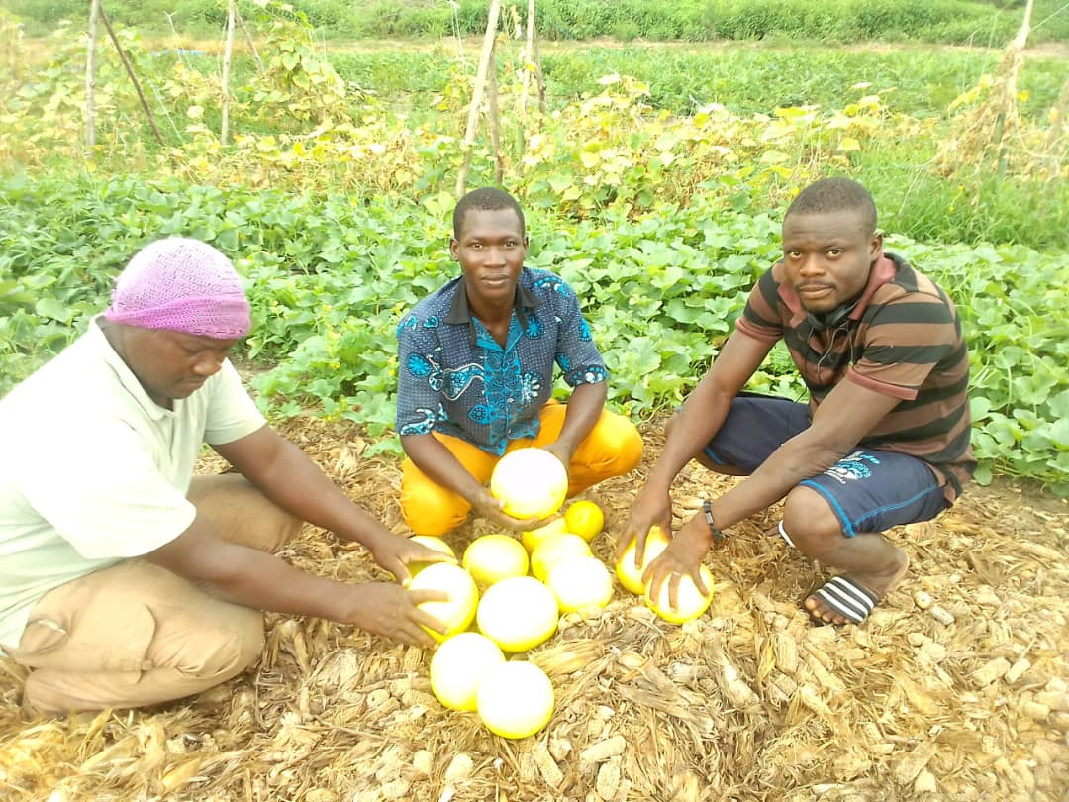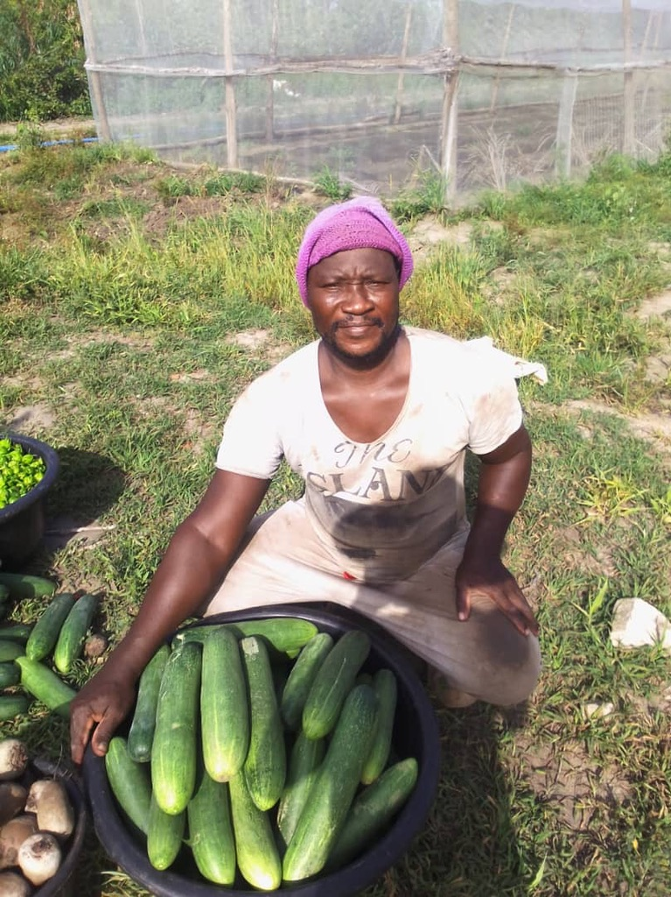

- A tricycle with tipper has just been purchased to bring production to the Dassa market.
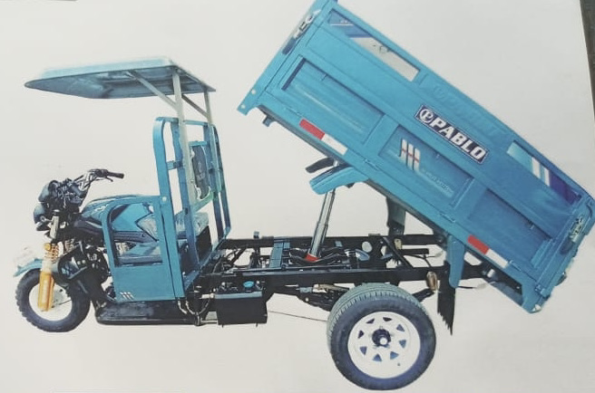

- Thanks to a $32,000 grant from the Roncalli Foundation, solar electrification of the farm will be completed shortly, which means that in a few months' time, the first patients undergoing social reintegration will be able to be accommodated there.
At Gbedavo 2, a 20-hectare teak plantation is under way.
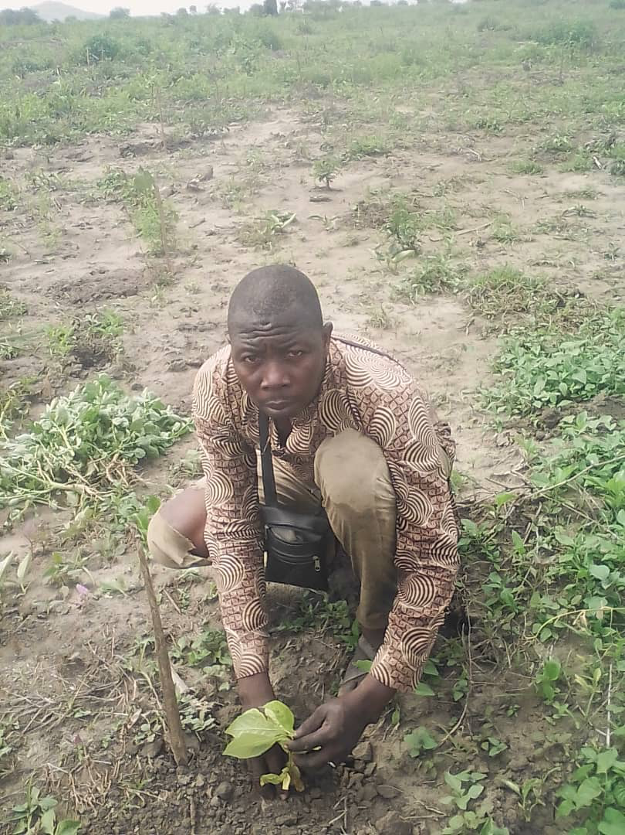
Given the successful development of these two projects, the Logos Foundation and Transport Bourassa have agreed to contribute $60,000 this year, which we greatly appreciate.
____________________
To make a donation : All cheques should be addressed to « Les Amis de la St-Camille, 1448 avenue d’Orléans, Montréal, H1W 3R1 ». Paypal donations and monthly withdrawals are also possible via our website or by calling our treasurer, Jenny Briand au 873-662-9036 to obtain the form. You can also call this number for an Interac transfer. Bequests in wills are welcome. Tax receipts are issued for contributions of $10.00 or more.
Our website : www.amis-st-camille.org

