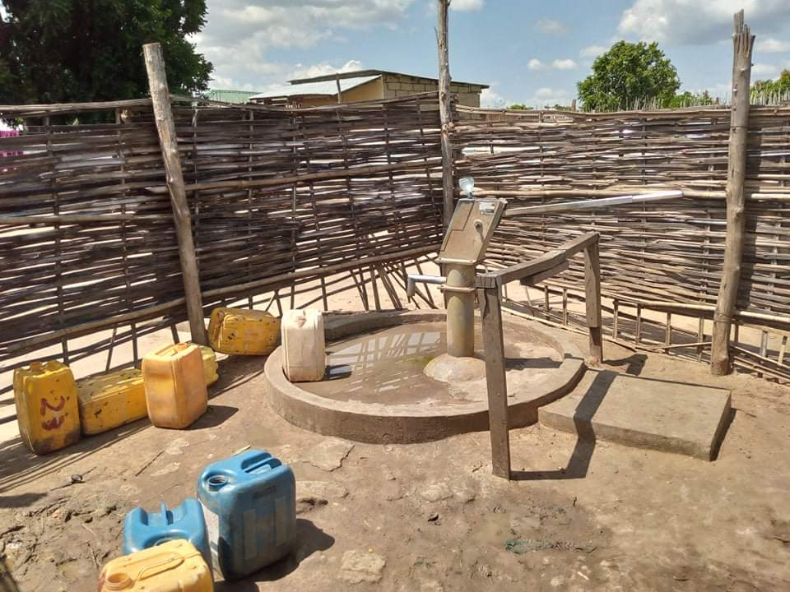
This is the only borehole at North Gudele outskirt of Juba City it has been fenced when the area was demarcated and that is the only borehole 4000 people fetch water from. Community agreed that borehole be locked for few hours as a strategy to sustain its function.

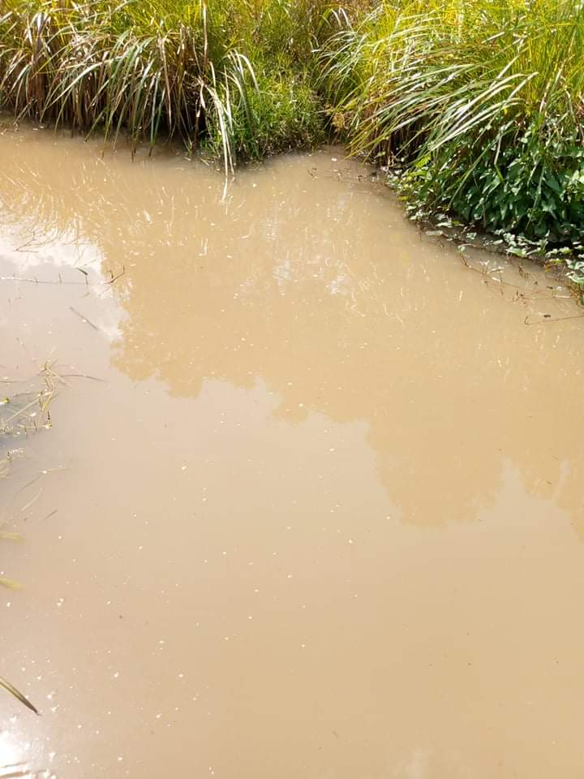
This is the stream the population living in this area fetch water from for washing and bathing completely unhealthily for human consumption

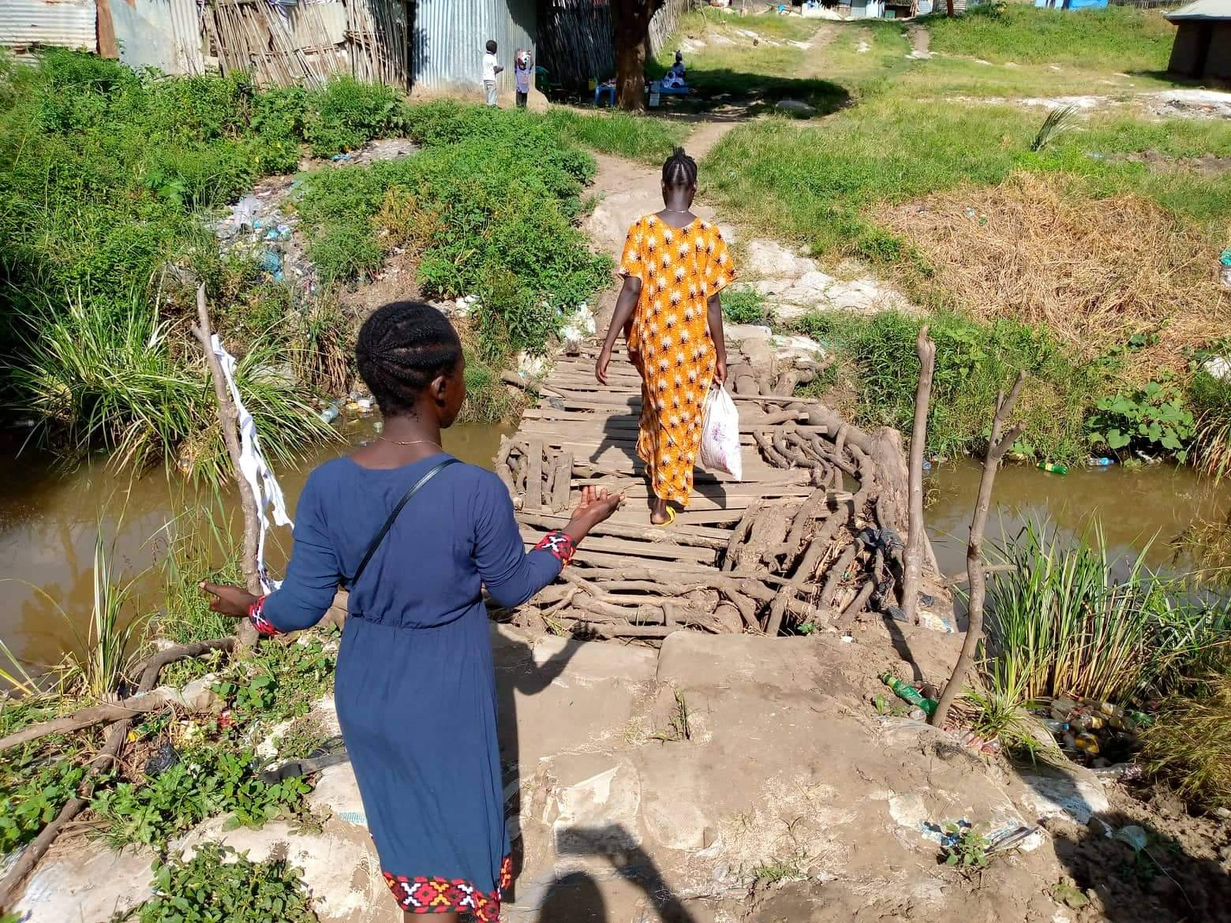
Need for support
Facilitating Action for Community Empowerment (FACE) mobilized community members to construct temporary bridge to enable the people cross to access markets and connect their livelihood With support from FACE, the Community has done what it could and seeking for support to easy their crossing by establishing semi-permanent bridge for easy crossing

