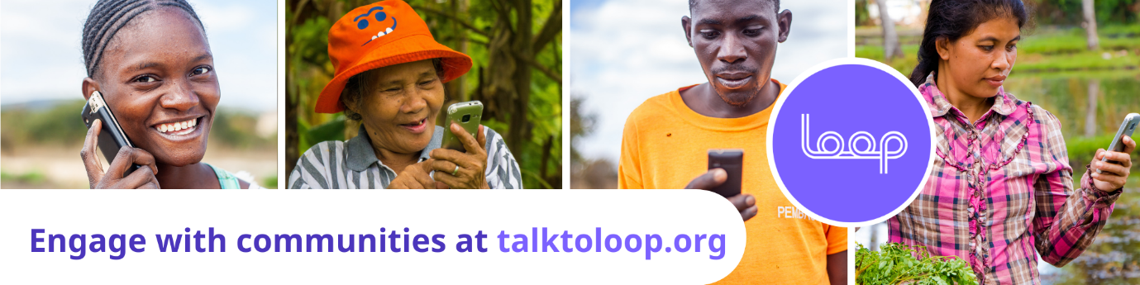

Quarterly report to Global Giving on Ukraine Response
12th of June 2022

Introduction
Loop is an independent digital feedback monitoring system encouraging and enabling greater engagement with citizens globally. It is a tool that Aid organisations and service providers can use across all program types and cycles, to support their existing work of engaging with, empowering and better understanding the needs and experiences of people at an individual level, at scale.
Loop is already in the Philippines, Zambia and about to launch in Indonesia and Somalia. Loop launched on the 30th of March in Ukrainian and Polish in response to the urgent crisis in Ukraine. We had a moderator in each language and the platform working with a specific WhatsApp number for this context by that date. Since then, we have been actively sharing information with communities, organisations and government actors about being able to use Loop to help provide a safe, independent and common feedback mechanism for local people in a sustainable long-term way.

Analysis of Stories
As at the 12th of June we have had 25 stories and 7 sensitive stories from Poland, and one open and one sensitive story from Ukraine. More than half of these have been ‘Thanks’. They have also been predominantly asking questions and requests for support or advice and they have been coming in from individuals, rather than direct feedback to an organisation requesting it.
We can see that every story submitted has been responded to at least once, with a total of 21 different authors of replies.
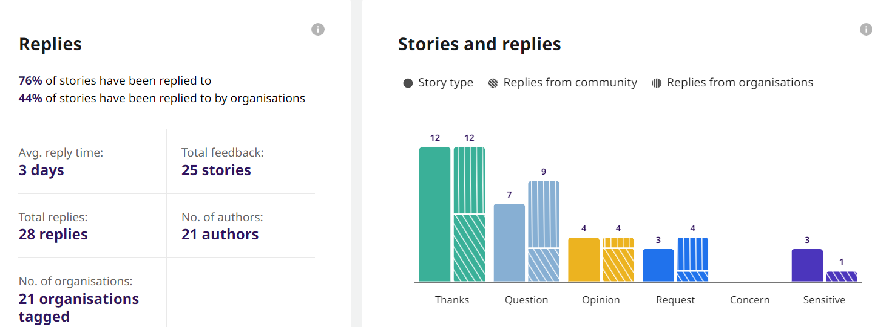
Uniquely to this context, every single story has been submitted by a woman and they have all been between the ages of 18 and 59 years old. This shows the gendered nature of this crisis.
There is also a very high percentage of sensitive stories compared to other countries, nearly a fifth of all feedback has been of a sensitive nature. All of which has been women seeking specific support for a group of people: family, children, relatives, a group in a similar situation. This is also a unique aspect of the stories we have received from Ukraine, compared to other countries where Loop operates. All stories and sensitive stories (except for one) have been about more than one person. For example, authors have been speaking on behalf of 60 people in the same situation or for 7 people in one bunker, or for a family of 5 people etc.
Every sensitive story, aside from one ongoing case, has been closed and the requested support provided. This includes for example: Delivery of urgent medical supplies to elderly people in a bunker in Ukraine by volunteers, provision of support to a trafficked survivor by a national CSO.
Similarly, for some of the open requests for support, the assistance or information requested has been provided as a result of reporting through Loop. Such as: Information on visas when travelling back into Ukraine (Embassies), finding needed accommodation for a family (CARITAS) etc.
All of the sensitive stories to date have been tagged as Protection stories. We do not expect the get PSEA reports in through Loop until there is wider buy in from the larger International Organisations who promote Loop for such purposes.
The vast majority of stories have come in through WhatsApp and in Ukrainian, one was in Russian. We have recently had a few stories from Facebook messenger as well. We will continue to push out communications to raise awareness across both channels.
There is a very strong social media presence by volunteers and grassroots organisations. They are primarily using Telegram in Ukrainian or Facebook if ‘international’ or Polish groups. There have been requests to enable people to feedback through Loop using Telegram to get a broader reach among Ukrainians. This would be possible, and we are seeking £10,000 to build and deliver that integration.
We see that Loop can provide added value to the least heard and most marginalised groups. To this end we are able to add on the language Roma and this would cost £3,000 but we would need to train and recruit a Roma speaker part time to process stories (approximately £20,000 per annum).

Coordination and Collaboration
We see that the 9 organisations who have signed up to be notified of feedback coming in through Loop are national organisations, three of whom are subregional Polish authorities, another is La Strada, an NGO working on trafficking as well as the Polish NGO Forum.
Loop staff have delivered numerous online and in person trainings to these and other networks and organisations. For example: staff from the Department of Social Welfare, Polish Border Patrol staff, Universities, The NGO Forum.
Some local organisations have just now started to actively promote Loop to receive feedback in an accountable way on their services, in Polish or Ukrainian.
No international organisations have signed up yet for this specific crisis.
We hope to scale Loop further over the coming months across Poland and increasingly to places where Ukrainian speakers could be supported, including in Ukraine. Due to the increased bombing in Kiev, we have not allowed our Ukrainian moderator to travel back to her home.
Loop has tried to raise awareness of Loop in a variety of ways. On social media, on Polish Television and two radio stations as well as doing training at universities, with government social welfare teams and non-UN reception centres. We also regularly attend a variety of Coordination meetings, including:
- Ukraine weekly updates
- Ukraine Gender Based Violence sub cluster meetings
- Poland Sexual Exploitation, Abuse and Harassment weekly meetings
- Poland Accountability to Affected People weekly meetings
- Poland NGO Forum weekly meetings
- Sub regional Coordination meetings (in person)

At the outset of the Coordination meetings there were discussions about Collective or Common feedback and reporting mechanisms in the PSEA and AAP working groups. Some INGOs said ‘if not now [early on before the large Humanitarian actors set up their own systems] then when’? However, this was not agreed upon collectively. Since this time there has been a process for organisations to list their feedback mechanisms, including those organisations which are in the process of setting up feedback mechanisms. Loop has reached out to these organisations to offer assistance or integration with our service. Sadly, this has not yet occurred, and the proliferation and fragmentation of feedback and safe reporting mechanisms continues to expand.
We will continue to position Loop as a useful tool for organisations working with vulnerable populations to use. Also, for national, smaller or grassroots organisations to use as part of their organisational feedback and safe reporting mechanisms on an ongoing sustainable basis. We will try to integrate these local and national voices into international discussions about needs and local voices.

Looking forward
We expect the need for Loop to grow over the coming months. This is because as the flow of people across the order decreases, we are seeing a number of trends:
- The scale of need of the people arriving is increasing. They are more impacted by the crisis, have had a harder time to evacuate (have seen terrible things/ been abused)
- The people arriving now come with fewer resources/ safety nets and have no support network outside of Ukraine (if they did they tend to have left earlier) and are likely to be staying longer (unlike onward movement of many in the early months).
- The official response services are decreasing as the scale of the flow of people decreases. For example, the IOM reception centres are closing down etc.
This is leaving a greater responsibility to national organisations in Poland to deliver longer term advice, guidance and support. Often these smaller local actors have had to scale up quickly and may not have had a mechanism to receive feedback, complaints or SEA reports prior to the crisis. We hope that Loop can support these actors and the people they are serving.
The long-term sustainability of Loop for this response continues to be worked on. Initial promising funding avenues have not come to fruition due to the fragmented and siloed approach of international organisations to feedback and safe reporting mechanisms.

