**Annual Report 2021**

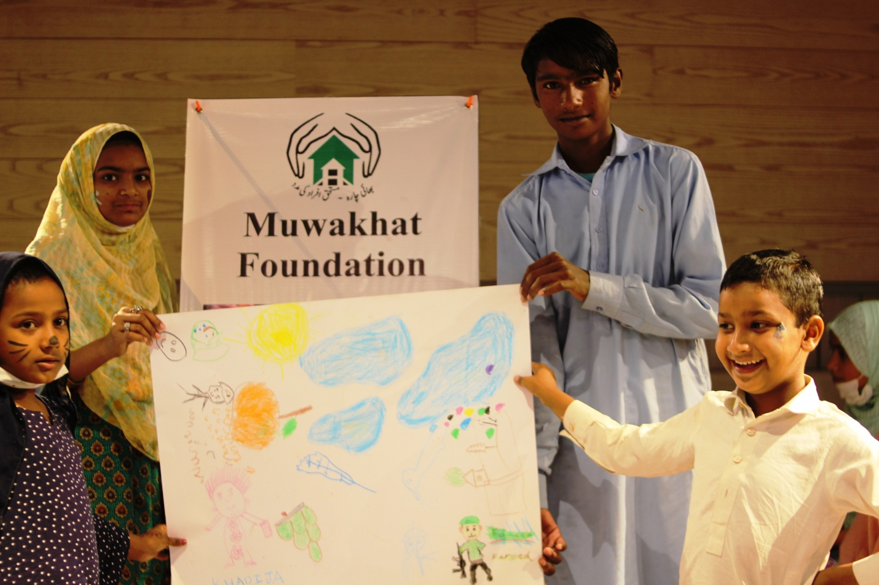

**MUWAKHAT FOUNDATION**

_____________________________________________________________

**Central Office:** House# 46 C Block A-1, Board Of Revenue Society, Lahore Pakistan

Tel: 92-042-35236233 Email: [**info@muwakhat.org**](mailto:info@muwakhat.org) URL: [www.muwakhat.org](http://www.muwakhat.org)

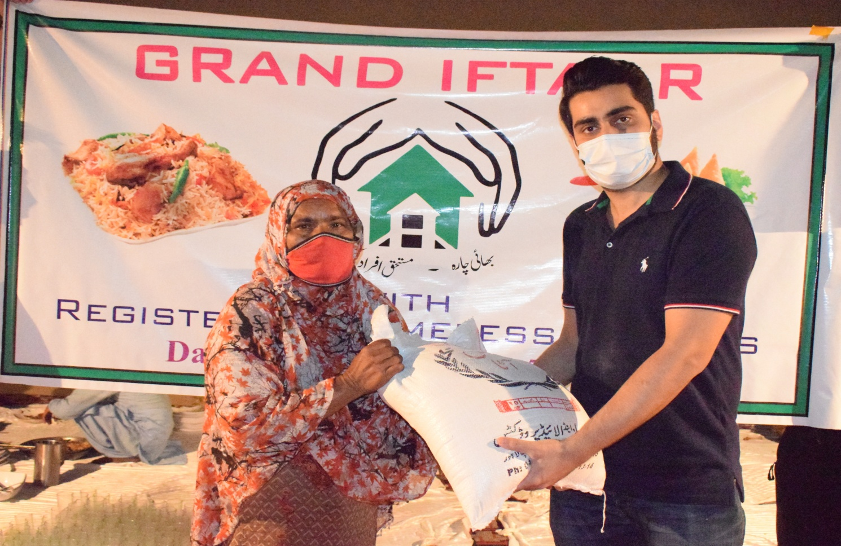

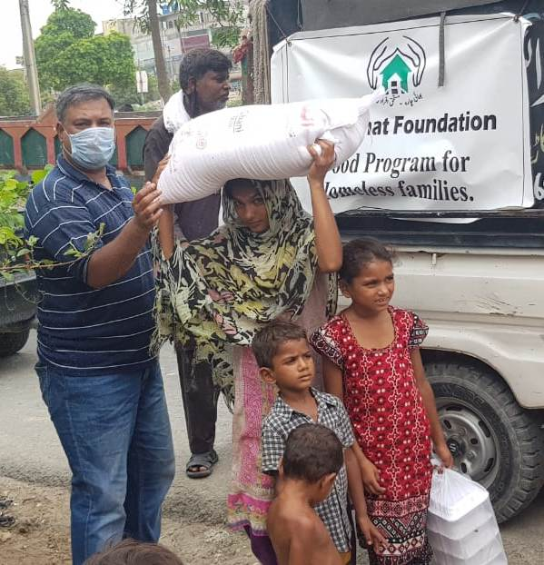

**Table of Contents**

1. **Chairperson Talk**
2. **How Muwakhat Works**
3. **Programs**
4. **List of Activities**
5. **Campaign Giving Tuesday 2020**
6. **Gallery**
7. **Financial Statements- Audited**
8. **Thank you/How you can contribute**

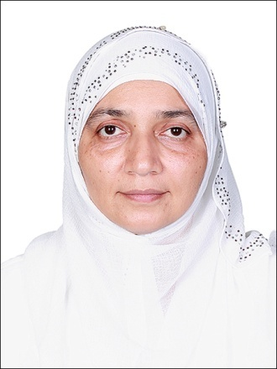

**Chairperson Talks**

I took over Muwakhat Foundation as the chairperson in January 2020. In March 2021, Muwakhat worked solely on COVID-19. Muwakhat was one of the seven organizations who took immediate action for the global pandemic and the community. As a chairperson, I think Muwakhat Foundation faced three challenges. The first challenge was foreign funding. It was difficult to get clearance of the funding from EAD (economic affairs division). Muwakhat was granted permission to receive funds by EAD within 2 months after all the paperwork was done and submitted. The credit goes to the team of Muwakhat and the volunteers. The second major challenge was the documentation process and the awareness about the foundation. Muwakhat started a volunteer program. Muwakhat believes that the youth has full potential to be an entrepreneur under proper guidance. They can also pay back to the community. In the first phase, 32 volunteers joined our program and they spread our program in their respective areas and supported the community in their areas. The best volunteers from phase 1 were given certificates. This was a really successful program. Muwakhat works through the volunteer program.

The last challenge was to spread awareness about Giving Tuesday which is celebrated in November . Muwakhat gave awareness about Giving Tuesday to 921 people with the help of volunteers, social media and one to one sessions. One to one sessions were challenging during COVID-19 but Muwakhat succeeded with the help of its team. Muwakhat gave safety health kits to COVID-19 affected families which included masks, soap and sanitizer. Hand washing awareness was also given to the children. In winter, branded warm clothes were given. Children were given egg trays to help survive the winter.

Muwakhat Foundation has two purposes. First is to support COVID-19 affected families and second is to professionally educate girls and educate 500 homeless children so they can be empowered as this is the biggest challenge in Pakistan.

In the coming year, Muwakhat will start its next program with entrepreneurs known as Youth Leadership and Entrepreneur Program. It has three phases. Phase one of connecting the entrepreneurs with the community has already been completed. The second phase is to encourage them to bring their business ideas forward and how to continue doing jobs as an entrepreneur. In the third phase, after giving them Youth Leadership and Entrepreneur training, their businesses will be run as pilot programs.

The purpose of educating girls is that Pakistan’s 49% population consists of women but the literacy rate is less than 16%. If we want to improve Pakistan’s macro-productivity then we need to enhance every citizen’s macro-productivity. We aim to enhance macro-productivity in women through education and work. We aim to empower them. We aim to encourage the youth to pay back to the community.

Another achievement, Muwakhat Foundation got several points known as GG rewards from GlobalGiving (international online fundraising organization).

Chairperson

Tabinda Alkans Jaffery

**Impacts**

| **Grants & Donations**    Rs 11.61m | **Food packages to homeless**      # : 23,586    Value : Rs 85 m | **Clothes distributed to street children**    # : 3,700    Value : Rs 2.98 m |
| --- | --- | --- |
| **Promoting Girls Education**:  awareness sessions to  4,998 parents | **19% of 500 dropout girls back to school** | **Free legal aid and awareness sessions** to women & girls    # :1960 |

**HOW MUWAKHAT MODEL WORKS**

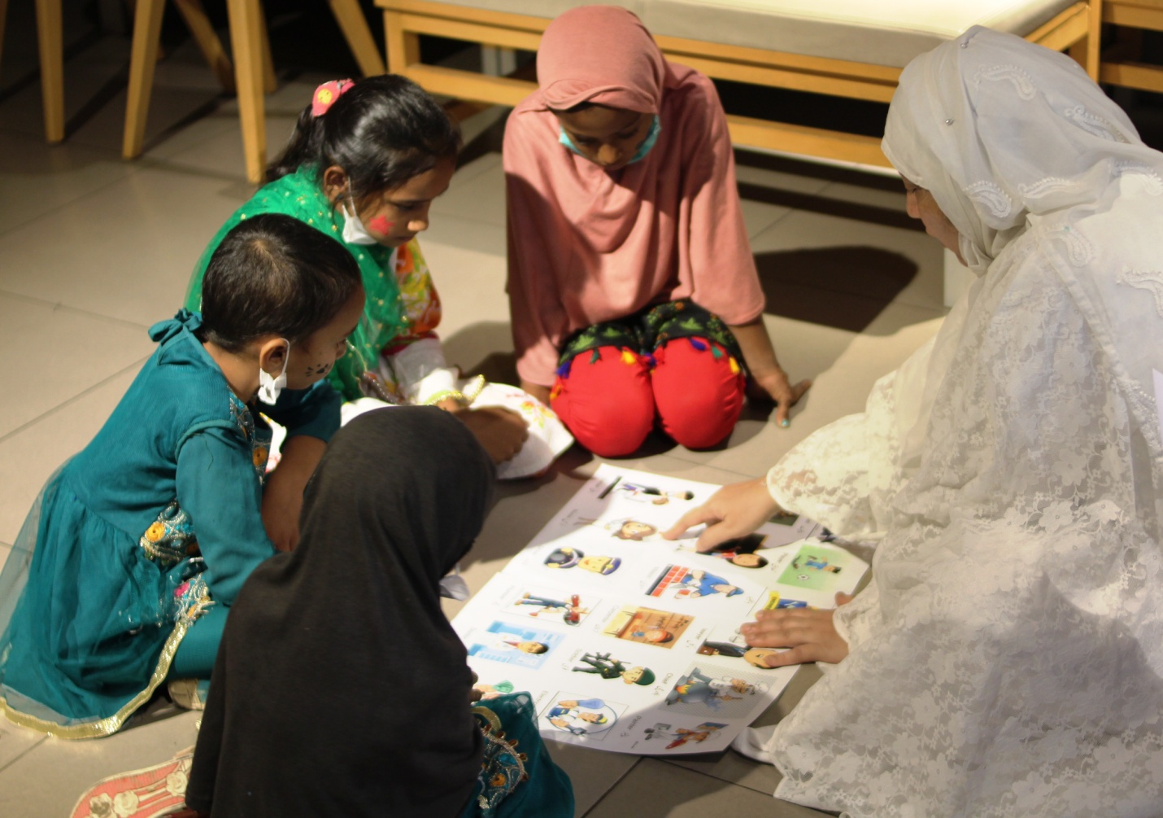

**Unique cost effective model:** Volunteer program

We have introduced our first internship program in November 2020. Internship tenure took 2 months and finally came to an end in January 2021.

The major purpose of this internship is to promote youth in serving the community.

It could be said as a self sustainable program without loopholes.

People from different cities of Pakistan voluntarily join us and work as a team from the platform of Muwakhat Foundation to help the deserving bodies of the country.

The role of interns was to work in the field, volunteer in events, do social media marketing of programs, and identify people in need. The main aim for the interns was to pay back to the community by sharing their skills, raising funds for the needy, sharing programs on social media and increasing followers on Muwakhat Foundations social platforms.

**Program Activities**

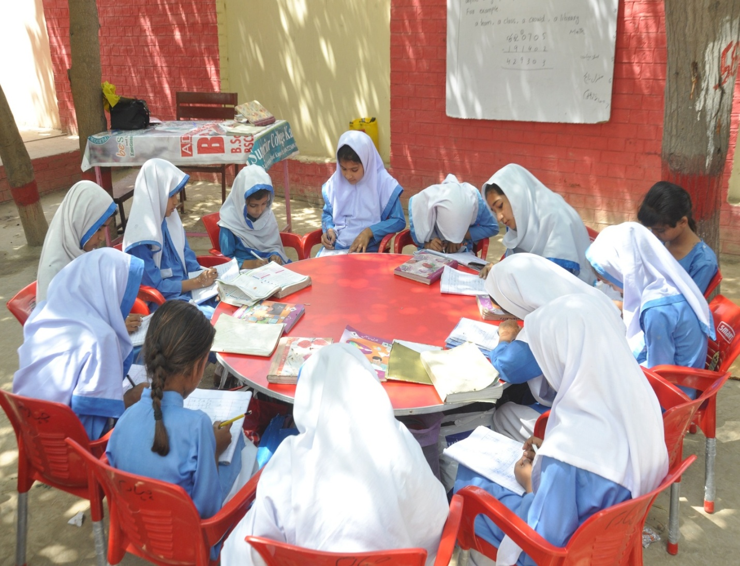

**Project 1: Help Affected Families Sustain in COVID-19**

In this project, Muwakhat Foundation wants to support families affected by COVID-19 and get them back on their feet, so they do not have to depend on others for feeding themselves. This was one of the reasons Muwakhat provided some of these families with funds and fruits/vegetable carts. Now, Muwakhat will give medicines to the patients testing positive, especially the mothers. Muwakhat believes when the mother is safe, the whole family is safe. Till now Muwakhat Foundation has supported 1900 families and aims to support 10,000 more families.

**Highlights of the year:**

**FRESH LUNCH BOX MEALS TO 77 CHILDREN**

On Eid-ul-Azha (Muslim festival) animals are sacrified and the ultimate purpose is to share meat with poor but in reality, most poor families never receive sacrifice animal meat. One day before Eid, Muwakhat foundation arranged 150 barbeque lunch boxes and distributed them to 23 families. When children open the boxes and see meat, it brings happiness on their faces and our volunteers catch photographs.

**DISTRIBUTION OF FLOUR BAG**

Muwakhat Foundation distributed floor bag (weighing 20 kgs) to 23 homeless families before one day of Eid (Muslim festival) to save them from starvation. Selected homeless families did not have enough food to feed their children due to non-availability of work during COVID-19 pandemic.

**Ramadan Report**

In the month of Ramadan, Muwakhat Foundation served poor & homeless families with food, ration packages, iftar meal boxes and Eid clothes. We did four activities for poor children, women and their families.

**Activity1: Ramadan Food Packages**

The food packages were purchased from branded shops and they included:

10kg Flour Bag, 5kg Rice, 2kg Sugar, 1kg Cooking Oil, 1kg Ghee, 1kg each 4 types of lentils, 2kg gram Flour, 1kg Dates, 500gm Tea – Tapal, 2 Bottles of Rooh Afza, 1kg salt.

These boxes were distributed with support of our volunteers and 283 homeless families received the Ramadan food packages.

**Activity 2: Iftar Meal Boxes**

With the help of grass root level organizations, we prepared meal boxes and distributed them every day for 30 days in the month of Ramadan! Boxes were given to poor children, security guards, food delivery men and laborers.

**Activity 3: Grand Iftar Meal**

This is the first time Muwakhat Foundation held a Grand Dinner for poor families at their own place in their home. Children and women actively participated in arranging and distributing food. Lavish quality food (chicken, rice, fruits and snacks along with drinks) was served to them.

We invited these poor families to dinner with honor like no other and flour bags were also distributed by the end of dinner.

**Activity 4: Eid clothes distribution to poor children**

Our volunteers picked children from their homes and took them to the market for clothes and shoes shopping. These children purchased new shoes and clothes of their own choice from branded shops. This small act of kindness helped us wipe tears off these poor and needy children's faces.

**EDUCATION PROGRAM**

Muwakhat Foundation is a primary working for Girls education. It includes awareness sessions for parents and the community on the importance of “educating a girl”. Muwakhat Foundation is the only organization working on 4 tiers or level for support girls age from 4 to above for academic, professional and health,

**Level/Tier1**: Primary education for girls and boys provide holistic approach education for development of mind, body and character.

**Level/Tier 2**: Dropout girls sent back to school for secondary education. In Pakistan, the dropout school rate of girls is very high especially after completion of primary education. This program gives awareness sessions with parents and financial support for school fees.

**Level/Tier3**: Life Changing Program for girls who complete their secondary school and do not know where to go in life. This program helps to set a vision of life, direction for professional education and career.

**Level/Tier4**: Girls who complete secondary school or “A” levels and are willing to further study in or out of Pakistan. Muwakhat Foundation helps for university expenses including fees, books, accommodation and travel

**Long Term Impact:**

**Every Girl in school and become investment instead of liability**

**TIER/LEVEL 1**

**Educate rural children to break poverty trap**

Muwakhat Foundation provides quality education to rural children in Pakistan who cannot access or afford it. The selected schools adopt a holistic approach for education, help them to come out from personality problems, make their healthy mind and strong body for a bright future.

Quality Education helps rural children to break the poverty trap. Muwakhat Foundation selected 12 community schools and introduced a holistic approach in education providing quality infrastructure, easy and joyful learning materials, computers, English language program, physical and mind development through sports, yoga & nutritious noon meals. The schools actively promote girls education. provide dry ration on monthly basis & donate three goats to each family for milk and malnourishment.

**Success Story:**

Muwakhat Foundation saved Sataish's year of education by paying her due fees.

Sataish studies in grade one in Faisalabad, Pakistan. She is an intelligent child. She was unable to pay her fees due to which the school was not letting her continue her studies. She could not pay her recent fees' because her father was unable to go to work because he had lost his job due to the pandemic and the strict lockdown. He was a laborer who lived from daily paycheck. He could not find any jobs due to the lockdown, so he had to temporarily quit his job. Because of no income since the past year, he could not pay Satiash's fees for one whole year. Now they have no means of earning. Also, there were no other arrangements to help Sataish. If she had not paid her fees, then she would have lost a year of her early school years and had to repeat again. After Muwakhat Foundation paid her fees, she was given permission to sit in her class again. Her father is still struggling to find work so Muwakhat Foundation plans to further fund Sataish's education if need be.

Muwakhat Foundation aims to support 10,000 families. Many children are dropouts or are just waiting to go to school for once. Parents are unable to fund their children’s studies. Muwakhat Foundation aims to support these children and help them study further. Muwakhat Foundation is a strong supporter of education and wants to help these children continue their education without the fear of dropping out.

Help us to continue their studies!

**TIER/LEVEL 2**

**Dropout 500 Girls Back to High School in Pakistan**

Pakistan has one of the lowest literacy rates in the world. Women are 51% of the total country population and their literacy rate is alarming especially in rural areas due to social and cultural obstacles. Of Every 100 girls in rural Pakistan, only 18 will reach the 8th grade, only 1 complete high school.

Educating a girl is our joint responsibility. Muwakhat foundation's goal is "Education and food for every girl" Muwakhat Foundation will do counseling for parents for send back dropout girls from high school. Once parents agree to allow her to get an education, she will receive benefits on rejoining school for education i.e One time school admission fee, books, and uniform Monthly school fees Monthly pick & drop car rent because parents did not send girls to faraway high school.

**TIER/LEVEL 3**

**LIFE CHANGING PROGRAM FOR GIRLS**

Muwakhat Foundation develop 8 weeks life changing program for girls age from 14 to 26 help to remove all fears, negative thoughts and lack of confidence believe, we are asset not liability clear about gender equality know importance of girl education set vision of life and set goals set professional carrier Result: After attended 8 week Life Changing Program, every participant will know "she is asset not a liability" and she able to compete with world to achieve her dream.

**Workshop for 20 girls**

Pakistan has a common culture for marrying girls early and somehow if luckily some girls receive education till graduation, they are married off immediately and they get no use out of their degree.

Twenty girls were selected in the first round to be a part of the Life Changing Program held by Muwakhat Foundation. These girls had never set life goals or life visions before. They never got an opportunity to think about their own life.

An eight week workshop was conducted for girls in Pakistan who did not have the privilege to get higher education and be educated in the vision of life.

After the training was given, girls were able to identify their ultimate vision. All of them set at least thirty five life goals and decided their line of professional career. Lastly, they were taught how to plan their daily life according to their goals.

**Way Forward:** After the success of their first training, Muwakhat Foundation will choose more specifically teenage girls for the second round. This training will help them set their life vision at an early age and give clarity about future goals.

**/LEVEL 4**

**Support every year 20 Girls’ dream for Professional Education**

Our project aims to provide scholarships to youth girls to help pursue their educational goals and achieve their higher education dreams. Scholarships will be available for only girls who completed secondary school and are willing to get higher or professional education from abroad.

Every year the foundation selected 20 girls who passed secondary education, talented and willing to get professional education from abroad. Foundation helps to send their application for admission to related universities abroad. Scholarship covers fees, boarding, lodging, travelling, food and books for four years.

Funding women's higher education has a multiplier effect on improving the development of their communities and countries as a whole. Together, we can give women the opportunity to achieve and the future to create change in honor of the whole world.

Case Studies:

First:

Our candidate Mehreen, 22 years old, has something to say:

"Greetings, My name is Mehreen studying Bachelors of Psychology from the one of University of Pakistan.I always wanted to get self-dependent in terms of financial state. I took a gap year after my intermediate and learned a lot in this time. This year brought a lot of changes in my life. I've learned how to be an accomplished woman at a young age, from last year till now I am doing Freelancing. I have realized that the freelance market has a great scope in the current era. Due to Covid-19 this thing came in front of me in the form of solid evidence. During this I was having terrible problems with my devices in the work space.

Let me tell you about one major gain in these circumstances. I got linked to **Muwakhat Foundation**. This Organization helped me a lot! They are working on **‘’Women Empowerment’’** and considered me as a girl dedicated towards career. The major issue was that I was having lack of resources to enhance my skills and I was having difficulties in online field, so I discussed this with **Muwakhat** and they gave me an opportunity to work with their team as well as they helped me to fix my lack of resources. At that time I was running low on cash for buying a new device but By the Grace of ALLAH they fulfilled my need in that terrific time. I am so Thankful to Allah and after him to **Muwakhat Foundation**. When there was no one, **Muwakhat** stood by me! Alhumdullilah now I am learning new skills in “Digital Market Industry’’. To be honest, **Muwakhat** made it possible. They are truly working and giving their Head to Toe efforts to the community. I have seen their work, and now starting working with them in order to serve people and make a collective effort to bring change in our beloved country PAKISTAN."

In five years, Muwakhat Foundation has planned to send 5000 dropout girls to high school after counseling their parents and overcoming obstacles. Results with collective effort will be that we can help educate girls and change their world.

Keep on supporting Muwakhat Foundation to help more women like them break the chains of society and poverty trap!

**Second:**

**Muwakhat foundation** has been working since **2012**. Our major perspective behind working is to provide education facilities to deprived children of our society, also their protein diet and last but not the least how to make females empower through education and financial state.

As time passes, now we are done with a random case. Back in **January 2021**, this case was reported by one of our interns. **Muwakhat** and its governing bodies took immediate action over this case. **Muwakhat** has its identification criteria. After the verification process this case has been registered.

**Ms. Mishal**, her father, died when she was in Grade 6. She has been living in Bahawalpur. Currently she is living in Lahore. After her intermediate she got admission in **College**. As per father’s death they have no strong source of income. She was fulfilling her educational expenses from donations. This time she had a deficit of **35,000pkr/- (Thirty Five Thousands)** in her semester fee. During verification she told us about her circumstances and we worked over this issue.

Alhumdullilah by the **Grace of ALLAH**, our **Operational Head** and **Ambassador** visited her home **Lahore, Pakistan** and handed over the amount of **35,000 pkr/-.**

As per we believe in **“WE ARE ONE’’**, Finally we handed over the **Amount** and it happened just because of the efforts of our respected donors, our team and above all ALLAH.

**Reviews from Ms. Mishal:-**I was in depression due to my fee issue but you guys came as a divine helping hand to me in this crucial time. May God bless **Muwakhat** and you with more. I wish God will make me from one of you. Thank You! **Mawakhat Foundation** for being a helping hand in this problem.

Third:

Muwakhat Foundation saved Kainat's year of education by paying her due fees.

Kainat studies in a government college in Lahore, Pakistan. She was unable to pay her fees due to which the college was not allowing her to sit for her exams. She could not pay her recent fees' because her father got tested positive for COVID-19 and was unable to go to work but even before that he had lost his job due to the pandemic and the strict lockdown. He was an auto-rickshaw driver. He could not find any rides due to the lockdown, so he had to temporarily quit his job. Later on, he sold his autorickshaw. Now they have no means of earning. Also, there were no other arrangements to help Kainat. Kainat has only her father. If she had not paid her fees, then she would have lost a year of college and had to repeat again. After Muwakhat Foundation paid her fees, she was given permission to sit for the exams. Her father is still struggling to find work so Muwakhat Foundation plans to further fund Kainat's education if need be.

Muwakhat Foundation aims to support 10,000 families. Many children are dropouts or are just waiting to go to school for once. Parents are unable to fund their children's studies. Muwakhat Foundation aims to support these children and help them study further. Muwakhat Foundation is a strong supporter of education and wants to help these children continue their education without the fear of dropping out.

#### **FOOD & EDUCATION FOR HOMELESS CHILDREN**

43,000 poor Gypsy families (homeless) live in Lahore, Punjab's largest city, half of them women. They are the most neglected vulnerable group in Pakistan who lack basic needs of life. Muwakhat Foundation selected 500 families to support for three years by giving food, clothes, health facilities, education for children, clean water and finance for startup business. With collective effort, they come out of poverty and live respectable lives.

Muwakhat Foundation has been helping vulnerable groups since 2013 by giving food , new or used clothes, free health services and clean water. We believe that a collective effort to address the issues affecting the lives of more than seven million Pakistanis, it is possible for the gypsy community to be brought back to safety, and into the fold of society. We selected 500 gypsy families to help come out from poverty trap by providing basic needs and financial support for business.

Highlights of the year

1. Around **16** kids along with 1 mother were invited to have a Dine-In Food at KFC with us on **30 October 2020.** There was not only food but also we were focused to make them aware about **how important education is.**
2. December 01 2020, Muwakhat team distributed warm clothes to homeless children to save them from the harsh winter. The children were taken to a branded textile warehouse (Ismail Warehouse) to choose clothes of their own liking.
3. Miss Nabila was given monthly ration and bedding to protect herself from the harsh winter.
4. Eggs were distributed to poor and homeless children to help them survive the winter months of Pakistan. Total 685 trays of branded and quality eggs distributed to orphan and homeless children. This activity was done twice in the season.

**List of Activities**

| **Month** | **Activity** | **beneficiaries** | **household** | **safety**  **kit** | **Aware**  **ness** | **meal**  **boxes** | **flour bags** | **egg trays** | **girl's education** | **ration** | **clothes** |
| --- | --- | --- | --- | --- | --- | --- | --- | --- | --- | --- | --- |
| July | safety tool kit distributed to covid affected families | 1800 | 300 | 1800 |  |  |  |  |  |  |  |
|  | awareness of washing hands given to covid affected families | 4800 | 800 |  | 4800 |  |  |  |  |  |  |
|  | safety tool kit distributed to covid affected families | 1600 | 267 |  |  |  |  |  |  |  |  |
|  | fresh cooked meal boxes distributed to covid affected families | 4950 | 825 |  |  | 4950 |  |  |  |  |  |
|  | food packages distributed to covid affected families | 1890 | 376 |  |  |  |  |  |  |  |  |
|  | cash packets distributed to covid affected families | 1340 | 376 |  |  |  |  |  |  |  |  |
| August | fresh meals distributed to covid affected families | 150 | 23 |  |  | 150 |  |  |  |  |  |
|  | flour bags distributed to covid affected families | 138 | 23 |  |  |  | 23 |  |  |  |  |
| September | protein meals distributed to covid affected families | 150 | 23 |  |  | 150 |  |  |  |  |  |
|  | helping 20 young girls set life vision | 20 | 20 |  |  |  |  |  |  |  |  |
| October | helping young mehreen buy laptop | 1 | 1 |  |  |  |  |  | 1 |  |  |
|  | monthly ration distributed to covid affected families | 33 | 198 |  |  |  |  |  |  | 33 |  |
| November | protein meals distributed to covid affected families | 16 | 16 |  |  | 16 |  |  |  |  |  |
| December | warm clothes distributed to covid affected families | 33 | 33 |  |  |  |  |  |  |  | 33 |
| January | blanket and mattress for Nabila | 1 | 1 |  |  |  |  |  |  |  | 1 |
| February | helping Mishal pay her fees | 1 | 1 |  |  |  |  |  | 1 |  |  |
| March | monthly ration for Nabila | 1 | 1 |  |  |  |  |  |  | 1 |  |
| April | egg trays distributed to covid affected families | 132 | 22 |  |  |  |  | 22 |  |  |  |
| May | egg trays distributed to covid affected families | 132 | 22 |  |  |  |  | 22 |  |  |  |
|  | grand iftar for covid affected families | 150 | 25 |  |  | 150 |  |  |  |  |  |
| June | ramadan food packages distributed to covid affected families | 1698 | 283 |  |  |  |  |  |  | 283 |  |
|  | iftar meal boxes distributed to covid affected families | 25 | 25 |  |  | 750 |  |  |  |  |  |
|  | eid clothes distributed to covid affected families | 4 | 1 |  |  |  |  |  |  |  | 4 |
|  | helping Kainat pay her fees | 1 | 1 |  |  |  |  |  | 1 |  |  |
|  | helping Sataish pay her fees | 1 | 1 |  |  |  |  |  | 1 |  |  |
|  | helping Saima pay her fees | 1 | 1 |  |  |  |  |  | 1 |  |  |
|  |  |  |  |  |  |  |  |  |  |  |  |
|  |  | 19068 | 3665 | 1800 | 4800 | 6166 | 23 | 44 | 5 | 317 | 38 |

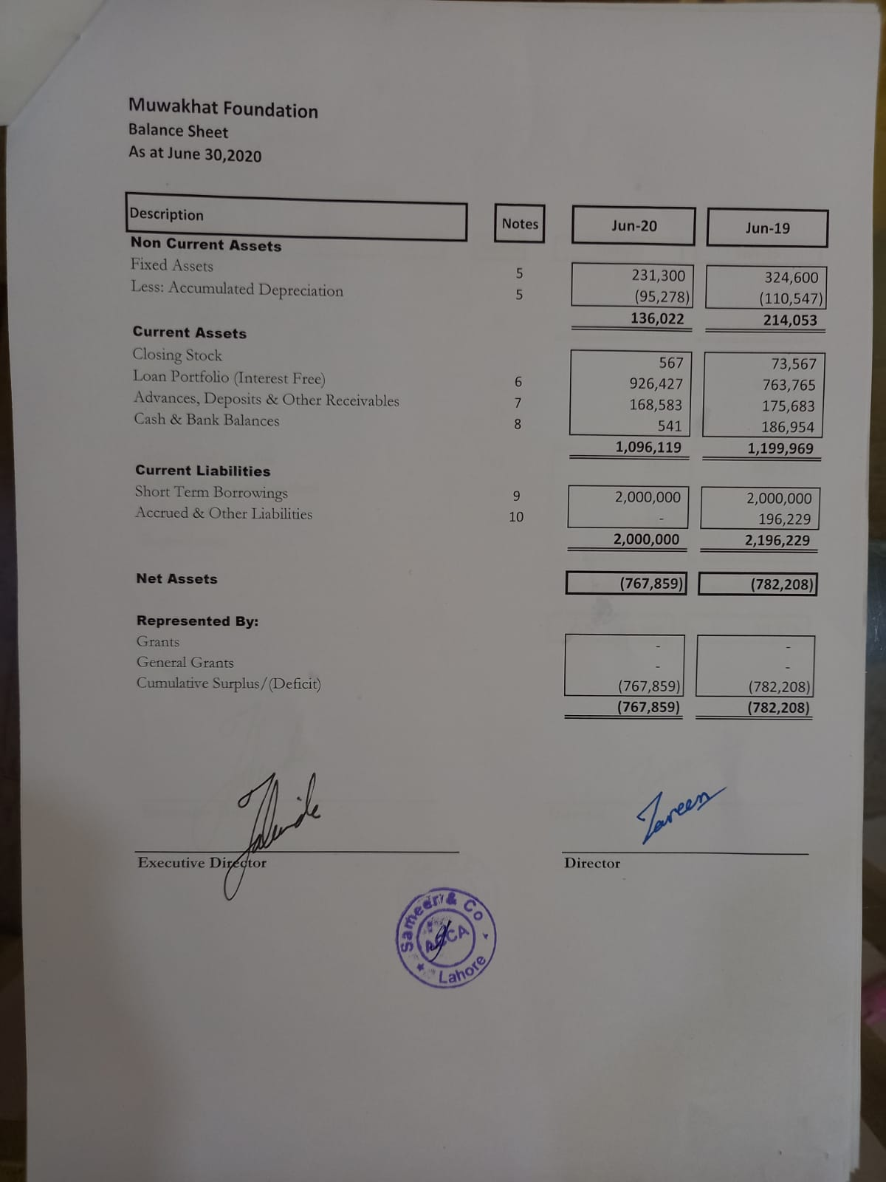

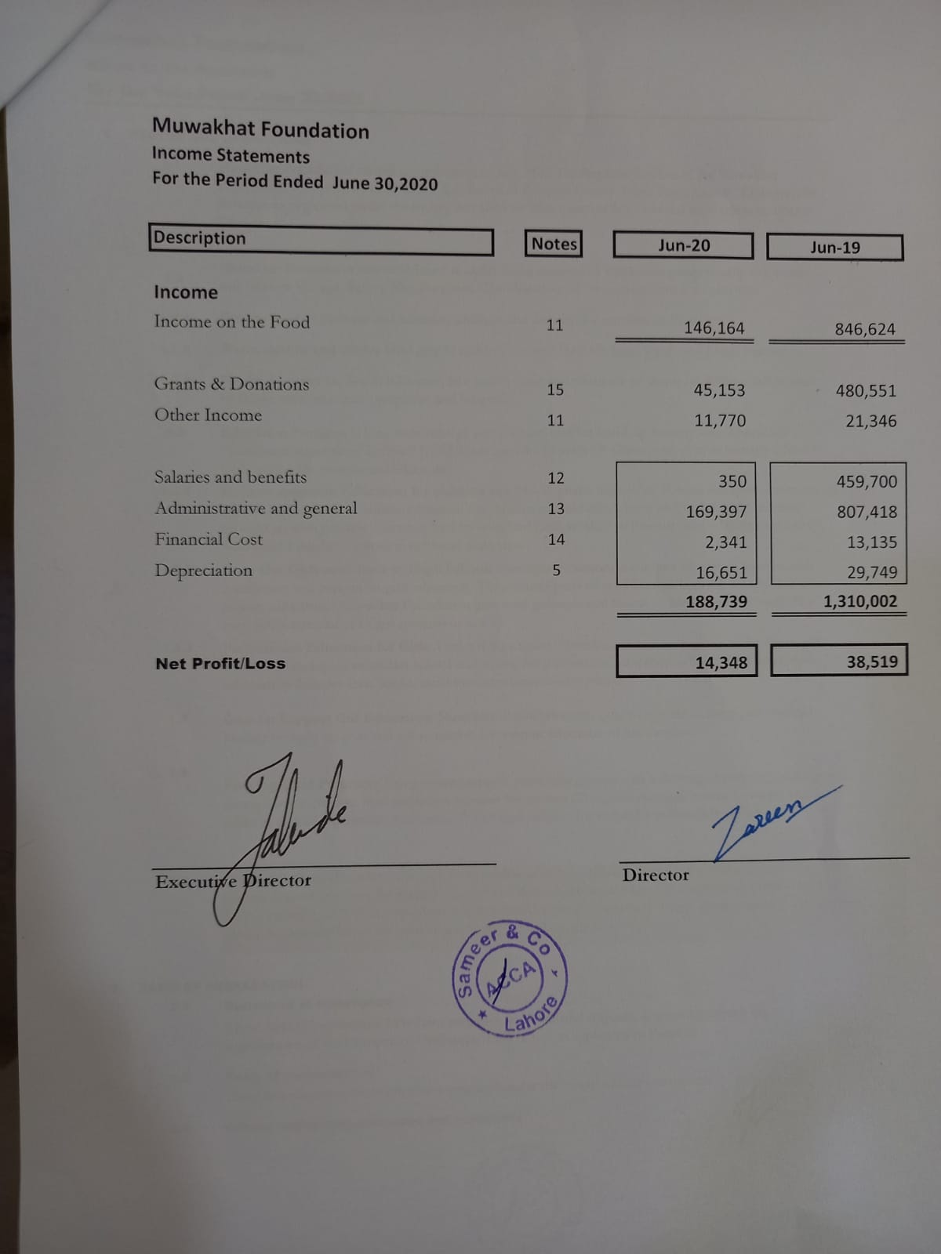

**Gallery**

|  |  |
| --- | --- |
| https://www.globalgiving.org/pfil/25093/WhatsApp_Image_20210818_at_11.38.35_PM_Large.jpeg | https://www.globalgiving.org/pfil/25093/pic29_Large.JPG |
| Protein meal distributed to homeless families | *Kids have enjoyed their fried chicken meals a lot!* |
| https://www.globalgiving.org/pfil/25093/WhatsApp_Image_20200801_at_8.36.40_PM_Large.jpeg | https://www.globalgiving.org/pfil/47812/WhatsApp_Image_20210615_at_3.39.07_PM_Large.jpeg |
| Meal Box distributed to children | Muwakhat Foundation saved Kainat's year of education by paying her due fees. |

|  |  |
| --- | --- |
| https://www.globalgiving.org/pfil/47812/WhatsApp_Image_20210320_at_1.58.34_AM_Large.jpeg | https://www.globalgiving.org/pfil/47812/IMG_20200809_120633675_1_Large.jpg |
| *Muwakhat team purchasing grocery for Nabila* | *family received dry ration affected covid19* |
| https://www.globalgiving.org/pfil/43053/WhatsApp_Image_20210912_at_5.03.25_PM_Large.jpeg | https://www.globalgiving.org/pfil/51690/WhatsApp_Image_20210606_at_10.28.43_PM_1_Large.jpeg |
| Free health camp for children and mothers of covid19 affected families | Dry ration package distributed in Ramadan |

**Thank You**

GlobalGiving

We are grateful for our donors who help us bring a change in the society. We can only fulfill our aims with their help. Whatever we do today is because of their donations.

We thank Global Giving with a huge heart. With the help of Global Giving, we can connect with these donors.

Helping homeless people and people in need is a reward in itself. We have the opportunity to serve our community and we put our whole self in it.

**How you can contribute**

**Share at Social Media**

Through the use of Social media and Social Networking Sites like Facebook, Instagram or Twitter, you can post the project of Muwakhat Foundation with your personal message to create awareness and get a helping hand.

**Donate Old Belongings**

In order to help the poor and needy, one can donate the old stuff from old clothes to appliances, furniture and other materials. Donating clothes especially in the winter season when the weather is too cold is of great help to homeless children and families. Unneeded stuff can be donated to brighten someone else’s day.

**Donate Food Package for feeding hungry**

Donate dry ration package value from Rs. 1000 (US$ 7) till Rs.5000 (US$ 35) for homeless families to fill their stomachs and stay healthy.

**Adopt a child**

You can adopt one poor child to support food, clothing and education expenses to help her/him come out of poverty, learn skill, earn and sustain.

**Donate goat to educate girl**

Donate three goats to 180 school girls and their parents. Goats reproduce quickly and their offspring can be sold, providing parents with cash-to pay for their daughters' school materials and tuition fee.