Joy Foundation (Pakistan)

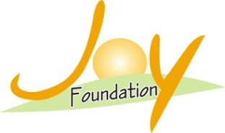

Stop Violence against women in Pakistan

Project Summary
3,721 cases Approx of violence against women are registered in police station year 2021 in Punjab, Pakistan, The main objective of this project is to bring gender equality within the male dominated society, respect for women, end social malpractices, and decrease in dowry system, END child Marriage and women should also have equal rights in society.

Challenge

More than 35 complaints a day of violence against women are registered in police stations 15 rape cases in every 24 hours and 10 women are assassinated for dowry in every 48 hours. This is not any story. These are fearful facts of which is being happened against women in Punjab, Pakistan.
According to Punjab Gender Parity Pakistan, 5,460 cases of violence against women, 780 rape cases and 7,545 cases of domestic violence were registered in different police stations of Pakistan in 2021. 540 women were assassinated for dowry.

Solution
Assistance will be provided to the women & girl through this project so that the moral of her will soar and they will get courage to fight against violence. Awareness programs such as Road shows, posters, street play, wall painting etc. will bring awareness in the society, so that the cases of gender inequality may reduce in number. Women will be cautious towards their legal rights through legal awareness camp, and violence against women will be eliminated.

Long-Term Impact
The attitude of men towards women will be changed from which this male dominated society will respect women. Child marriage, dowry, gender discrimination will be reduced. Women & girl will live respectfully. The society will openly support her fight against violence, the resulting, fear will be pervaded in culprits and the violence against women will be decreased.

Project Budget:-

Sr.No | Details | Amount in US dollar
1 | Awareness Workshop/Seminar | 571
2 | Puppets/Video Show | 342
3 | Poster/Debate Competition | 285
4 | Public Rally | 314
5 | Wall Painting | 200
6 | Staff Salary | 1,704
7 | Road Show | 400
8 | Counseling | 444
9 | Awareness Campaign | 1,200
10 | Social Days | 200

