Everhart Village Update
Thanks to better weather and your donations, construction is proceeding more quickly on the site of Everhart Village. Our community building is being delivered this weekend! Extensive trenching and the placement of sewer, water, and electrical lines is well underway.
CHAT recently received two major donations to the village – $300,000 from an anonymous donor and $20,000 from a local Emergency Food and Shelter Program grant to spend on food, supplies, and bedding. The $300,000 gift brings us much closer to covering all construction costs.
CHAT looks forward to inviting our supporters and the community at large to the Everhart Village grand opening. We’re keeping our fingers crossed that this will happen this summer.
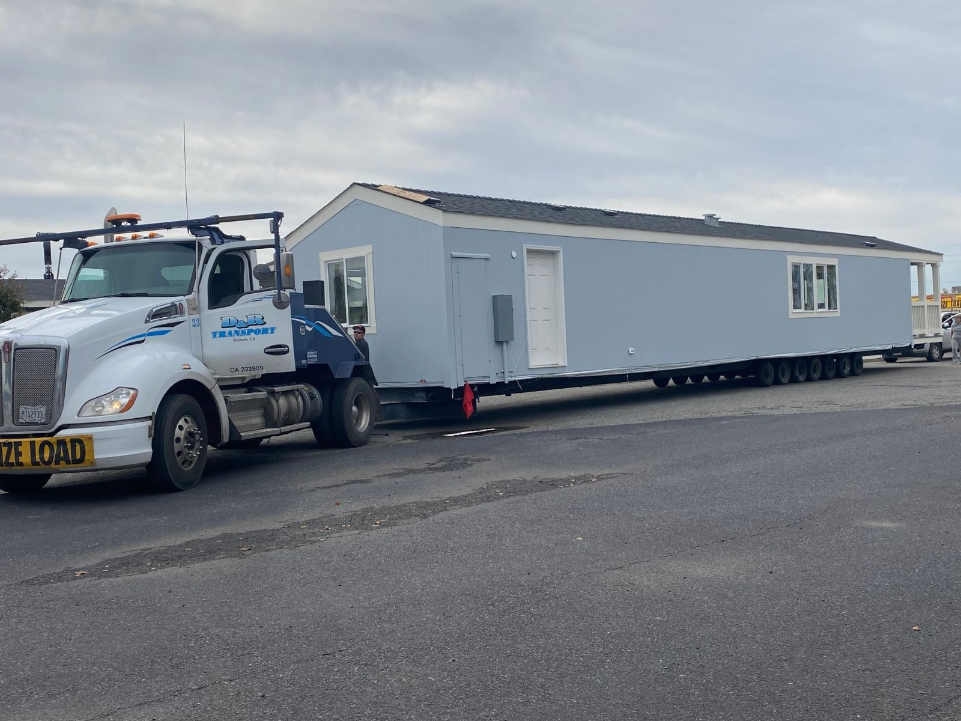

Everhart Village Update
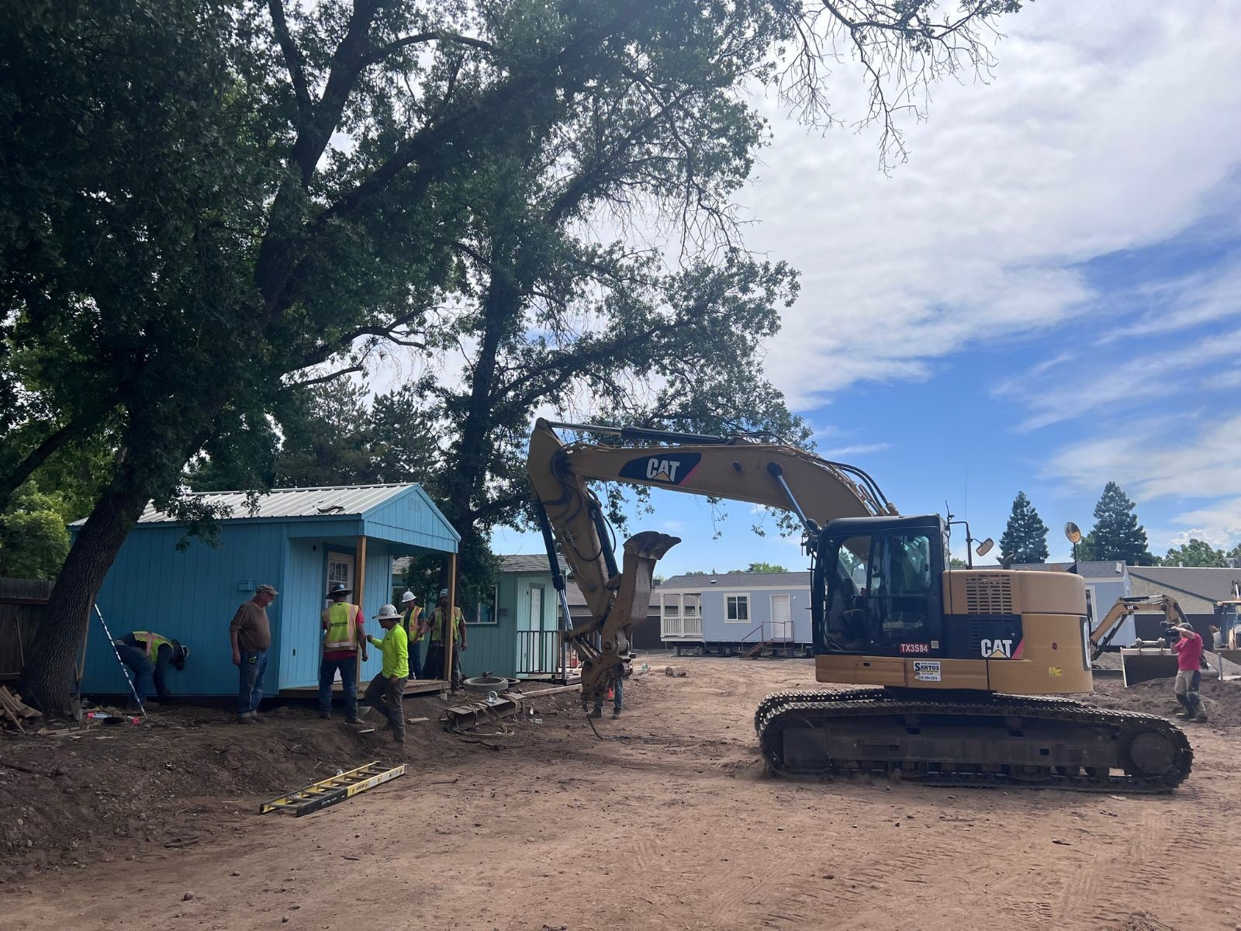
BIG DEVELOPMENT!!!! The first five of our sleeping cabins have been delivered by Santos Excavating, Inc.
- Our tiny home sleeping cabins have finally arrived at Everhart Village! Check out this report in Action News Now.

Everhart Village Update
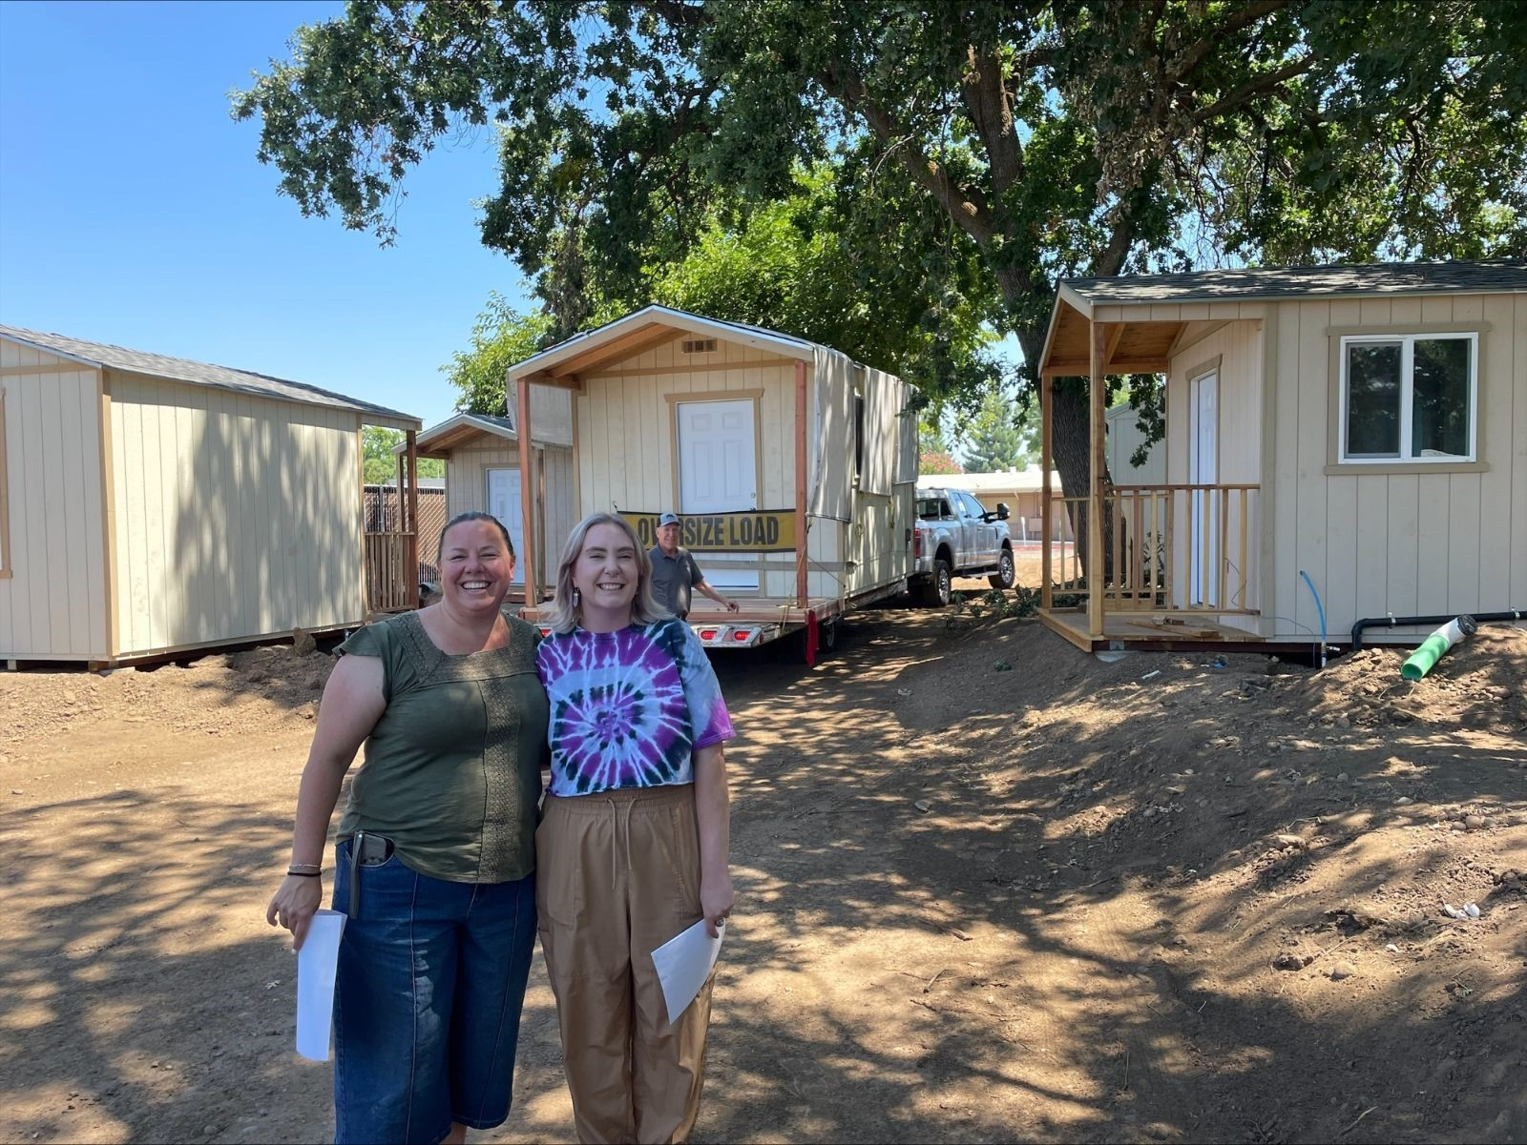
Our last Everhart Village cabin was placed today! We are so excited about the progress we have made on this project that is really one-of-a-kind in our community.
There is still a lot of work to do to finish Everhart Village, and we'll need our community's help to finish the interior of the cabins, including texturing, painting, electrical, plumbing and built-in furniture.
If you're interested in volunteering and helping us with the build, check out the next section of this email!

