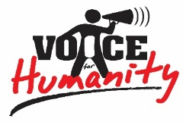
VOICE FOR HUMANITY UGANDA
PROJECT PROPOSAL JULY 2022

PROJECT SUMMARY
Project Title | Hope for Deaf and Hard of Hearing Children
Project Location | Katakwi District, Teso Region-Eastern Uganda
Target Beneficiaries | 25 Deaf and Hard of Hearing children in the ages of 0-18 years. Specific target will be those enrolled in school and those who dropped out of school due to hearing challenges but wish to return to continue their education.
Project Duration | 12 months (1st August 2022 to 31st July 2023)
Contact Details | Elungat David  Executive Director  Voice for Humanity Uganda  Tel: +256 774 803086  +256 706 316964  Email: voh.humanity@gmail.com  Elungat30@gmail.com  Web: www.vfhuganda.org
Project Total Cost (United States Dollars) | $64,875
Project Goal | The overall goal of this project is to improve on communication, school enrollment, retention and completion among Deaf and Hard of Hearing children in Katakwi district.
Project Specific Objectives | - Improve communication among 25 Deaf and Hard of Hearing children in Katakwi district  - Promote education of 25 Deaf and Hard of Hearing children in Katakwi district.  - Provide sources of incomes and livelihood among 25 Deaf and Hard of Hearing children and their households in Katakwi district.
Key Project Activities | - Conduct an assessment of the 25 Deaf and Hard of Hearing children to determine their individual level of hearing loss.  - Provide hearing devices.  - Provide school requirements including tuition fees, stationery and school uniform.  - Provide start-up capital for Income Generating Activities.
Expected Outcomes | - Improved communication among beneficiary Deaf and Hard of Hearing children hence improving on their social life.  - Improved academic performance among the beneficiaries due to their enhanced capacity to hear and understand their teachers while in class.  - Increased enrollment, retention and completion of school by Deaf and Hard of Hearing children in Katakwi district.  - Improved quality of life among beneficiary Deaf and Hard of Hearing children.  - Increased income levels, self-reliance and improved standard of living among the targeted 25 Deaf and Hard of Hearing children and their households.

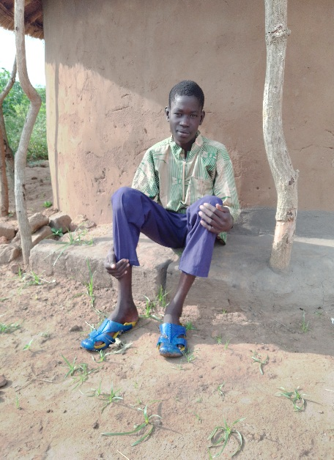
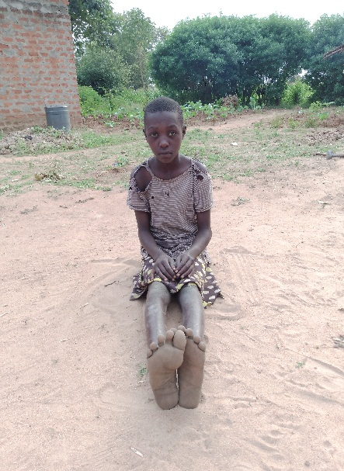
The stories of Michael (17 yrs) and Betty (13 years) expound the everyday challenges that deaf and hard of hearing children go through in accessing education. Michael is not only Deaf but is also living with HIV/AIDS, and suffers from Epilepsy. While Michael dreams of becoming a medical doctor, he lacks a hearing aid device and the support needed from his family and school, which has affected his studies to the extent that he has repeated one class for 3 years as he cannot properly hear the teacher and other children just laugh at him calling him a fool. Betty is not only Deaf but she is an orphan whose mother died when she was 6 months and up until recently, was being cared for by her grandmother who also unfortunately passed on just a month ago. Furthermore, Betty is living with HIV/AIDs. At her age of 13 yrs, she is still at the lowest level of primary education because she cannot meet the school requirement and she is considered a fool by relatives who are not willing to support her education despite the big dreams that Betty has in life.

Project Background:
Globally, 360 million people (about 5% of the world’s population) live with hearing loss, of whom 32 million are children. It is estimated that there are above 300,000 Deaf and Hard of Hearing children in Uganda. In all different communities across Uganda, Deaf and Hard of Hearing people are commonly called or known as ‘Kasiru’ meaning ‘Stupid’ or ‘Foolish’. Deaf and Hard of Hearing children are seen as evil or cursed. These kind of beliefs, attitudes and negative naming given to Deaf and Hard of Hearing children, makes them extremely vulnerable, poor and illiterate as their education is not taken as a priority. In Katakwi district, over 95% of Deaf and Hard of Hearing children have never gone to school or have dropped out of school as they lacked the necessary assistance to meet the school requirements by parents and relatives. Even those persisting to be in school, have no hearing aid devices and most often try to learn without the necessary assistance of a teacher trained in sign language. Katakwi district has 1 teacher trained in sign language for primary level education only.
It is with this knowledge that Voice for Humanity Uganda, a local Non-profit supporting the education of vulnerable children in Katakwi district seeks funding of 64,875 USD to support in meeting the basic needs and school requirements of 25 at risk Deaf and Hard of Hearing children. The funds will be used to assess the level of hearing loss of the targeted children, provision of hearing devices where needed, and provision of basic and school requirements including tuition fees, school uniforms, stationery and food.
Problem Statement:
Goal #4 of the Sustainable Development Goals (SDGs) concerns Quality and Inclusive Education. Unfortunately, the realization of this goal for Deaf and Hard of Hearing children not only in Katakwi district but in all of Uganda may remain elusive if the urgent needs of children with hearing loss are not attended to including provision of hearing devices and basic school needs.
The World Health Organization (WHO) has identified over 1 billion disabled people of whom 93 million (almost one in ten) are children. 20% of these people live with great functional difficulties in their day-to-day lives and to be more precise this constitutes for: 2% with blindness and visual impairment, 6% with deafness and hearing loss, 6% with intellectual disability (IQ below 75) and 1% that use the wheelchair on a daily basis.

In Uganda, about 16% of children have a disability, this suggests that most children with disabilities are not able to attend school and that learners with special needs fail to transition from one educational level to another. Only 5% of children with disabilities can access education through Inclusive Schools and 10% through special schools (UNICEF, 2014). This situation is even more precarious for Deaf and Hard of Hearing children whom a combination of social and economic factors denies them accessing health, education, transportation, information and work services thereby impacting their quality of life. For example, the Uganda Ministry of Education estimates that only 10% of school going children with hearing loss are enrolled in school.

Data on children with hearing loss in Katakwi district is nonexistent pointing to the lack of interest and attention to these categories of children by stakeholders. This lack of accurate and concrete statistics, makes it impossible to discern the real picture of the problem and the needs of Deaf and Hard of Hearing children and their families. To most people in Katakwi district, sending a Deaf and/or Hard of Hearing child to school feels impossible and/or is a waste of time. Most parents and families feel very ashamed to have a Deaf or Hard of Hearing child. The children suffer the most because their parents and communities reject them. They can be locked in a cage, tied to a tree or post, starved or brutally abused. While more research and data is needed, it is important that the needs of the identified Deaf and Hard of Hearing children are urgently attended to in order to improve on their quality of life.

Proposed Action:
Through this project, Voice for Humanity Uganda seeks to attend to the basic needs of Deaf and Hard of Hearing children who are currently enrolled in school and those that have dropped out of school and willing to return. With the requested funding the organization will partner with Kampala Audiology and Speech center to assess the level of hearing loss of the 25 identified and targeted children, and provide hearing devices for those qualifying to receive them. The project will also provide the basic needs and school requirements to the beneficiary children including tuition fees, school uniform, stationery and food. This will not only improve the learning outcomes of these children but will also improve on their quality of life. For sustainability purposes, the project will support the children and their households to start Income Generating activities by providing them with start up capital and training in various business enterprises of their choices.

Project Objectives:
The overall goal of this project is to improve on communication, school enrollment, retention and completion among Deaf and Hard of Hearing children in Katakwi district while improving on their quality of life. Specifically, the project seeks to fulfill the following objectives:
- Improve communication for 25 Deaf and Hard of Hearing children in Katakwi district
- Promote education of 25 Deaf and Hard of Hearing children in Katakwi district.
- Provide sources of incomes and livelihood among the identified 25 Deaf and Hard of Hearing children and their households in Katakwi district.

Project Activities:
The project will undertake the following key activities so as to achieve expected impact:
- Conduct an assessment of the 25 targeted Deaf and Hard of Hearing children to determine their individual level of hearing loss and provide appropriate support.
- Provide hearing devices for the Deaf and Hard of Hearing children to enhance their communication at school and community.
- Conduct community sensitization on the rights of Deaf and Hard of Hearing children including their right to quality education and wellbeing.
- Provide school requirements including tuition fees, stationery and school uniform.
- Provide other immediate personal basic needs like food, bedding, and clothing.
- Provide start-up capital for Income Generating Activities to promote their self-sustainability and reduce poverty among these children and their families.

Expected Outcome from the project Intervention:
Voice for Humanity Uganda envisions improved quality of life among the 25 targeted Deaf and Hard of Hearing children. Specifically, the organization hopes to realize the following outcomes upon successful implementation of this project:
- Improved communication among beneficiary Deaf and Hard of Hearing children hence improving on their social life.
- Improved academic performance among the beneficiaries due to their enhanced capacity to hear and understand their teachers while in class.
- Increased school enrollment, retention and completion by Deaf and Hard of Hearing children in Katakwi district.
- Improved quality of life among beneficiary Deaf and Hard of Hearing children.
- Increased income levels, self-reliance and improved standard of living among the targeted Deaf and Hard of Hearing children and their households.

Implementation Strategy:
Voice for Humanity Uganda will seek the technical services of Kampala Audiology and Speech Centre- for profit company based in Kampala Uganda and is a renowned, well trusted and experienced provider of audiology services and equipment in Uganda. The company will be hired to:
- Carry out the assessment of the target beneficiary children to determine their level of hearing loss and ascertain hearing aid needs.
- Carry out general ear cleaning for all targeted children to remove any accumulated wax and dirt.
- Supply all needed hearing devices and related accessories based on the needs of the children identified to benefit from the hearing aid.
- Fit and program the digital hearing aid on the identified children who quality for them. They will also carry out ongoing monitoring of children fitted with hearing devices.
- Provide any other technical guidance, advice to the beneficiary children and staff of Voice for Humanity Uganda who will continue to support the children.

For children who are enrolled in school, Voice for Humanity Uganda will provide all necessary school requirements including paying for their tuition and school feeding fees, as well as buying their school uniform and scholastic materials. Children who cannot go back to formal school will be supported to undertake non-formal skills training and provide startup capital to ensure they become self-reliant.

Sustainability Strategy:
All targeted children and their households will be supported to start an Income Generating Activity that will enable them generate their own money to meet every day needs including other medical and school related needs once the project phases out. The children supported with hearing devices will be trained on the care and management of the devices to ensure they continue being functional over a long period of time.

